INFOE 3 | LABORATORY 2

- Run Cell 1 with the original sampleDB.csv file.
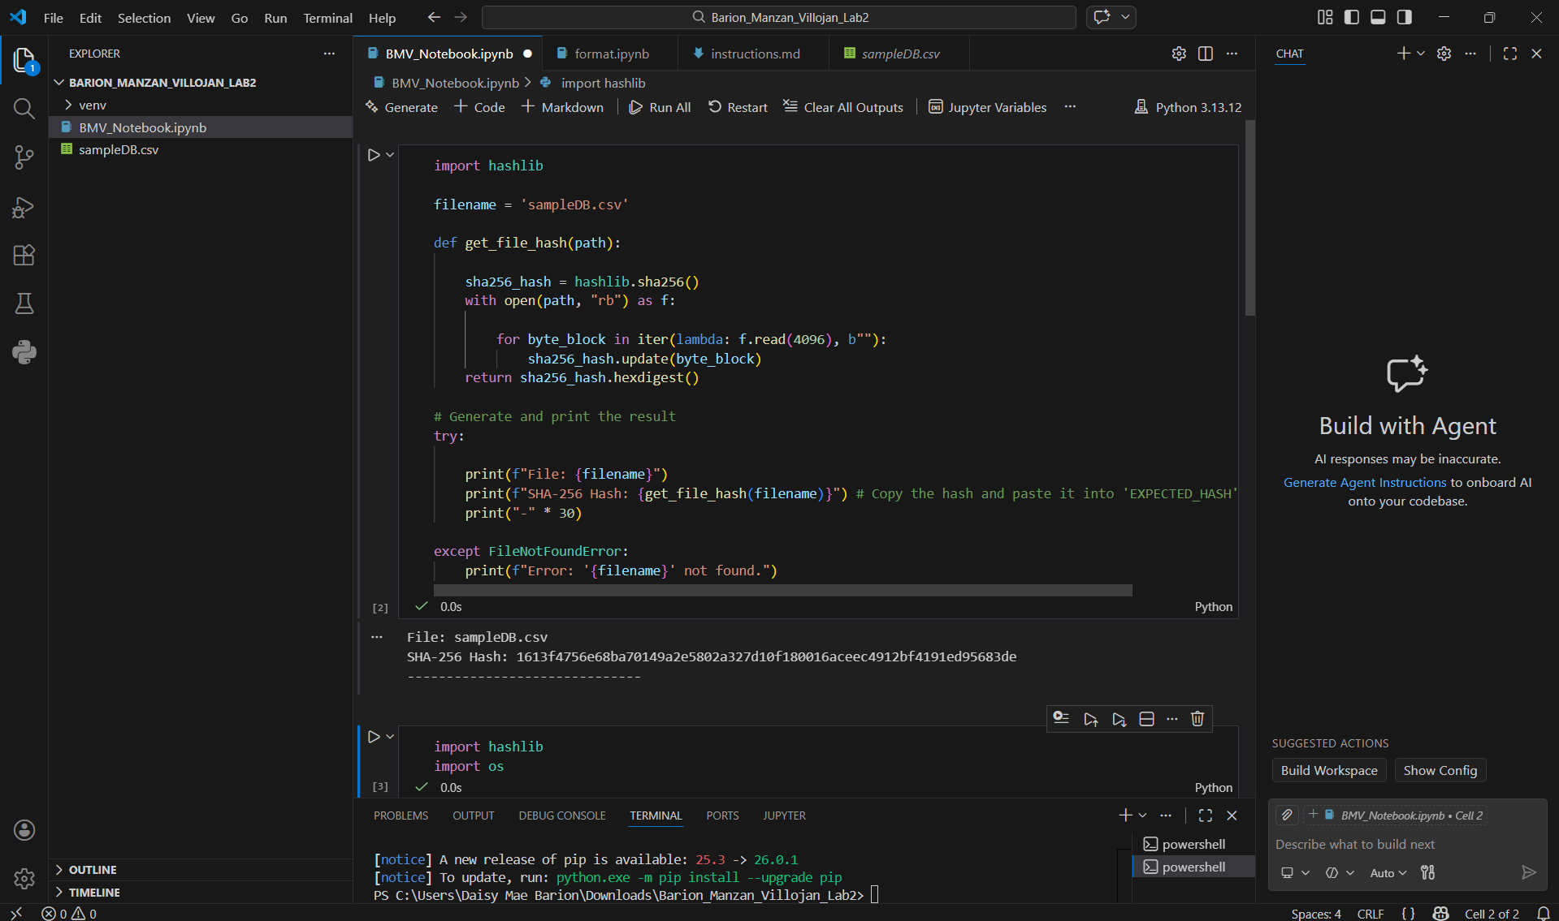
Establishing the original file hash.

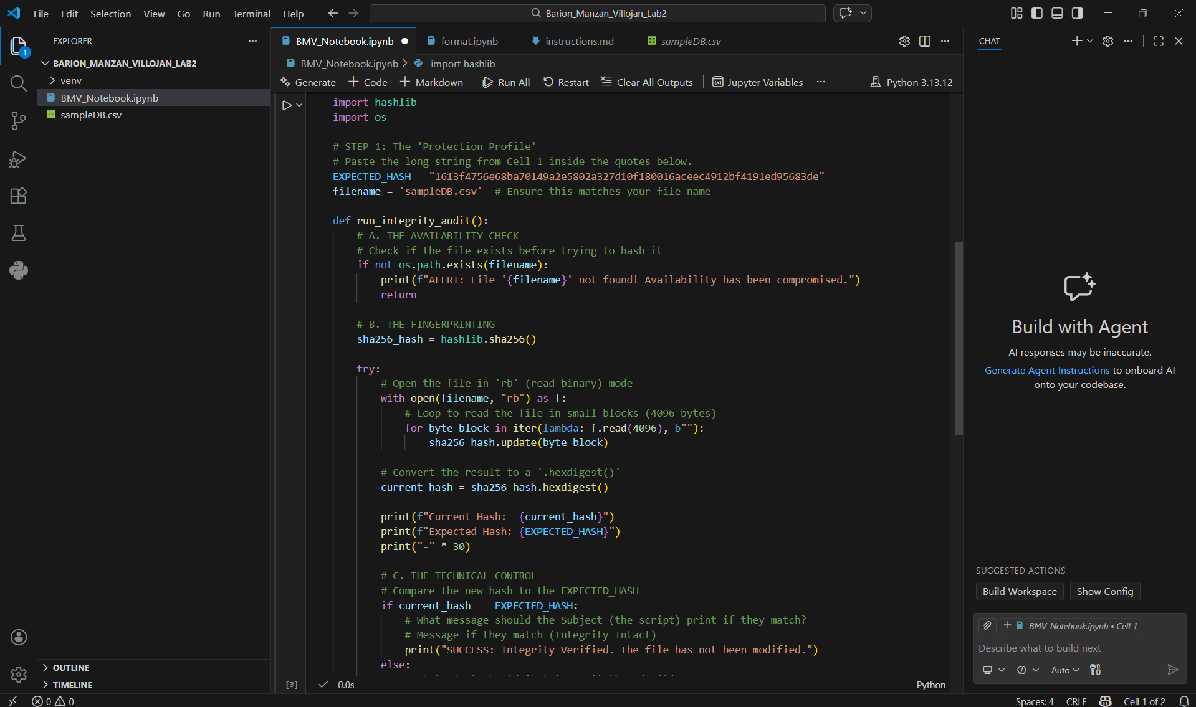
- Run Cell 2.

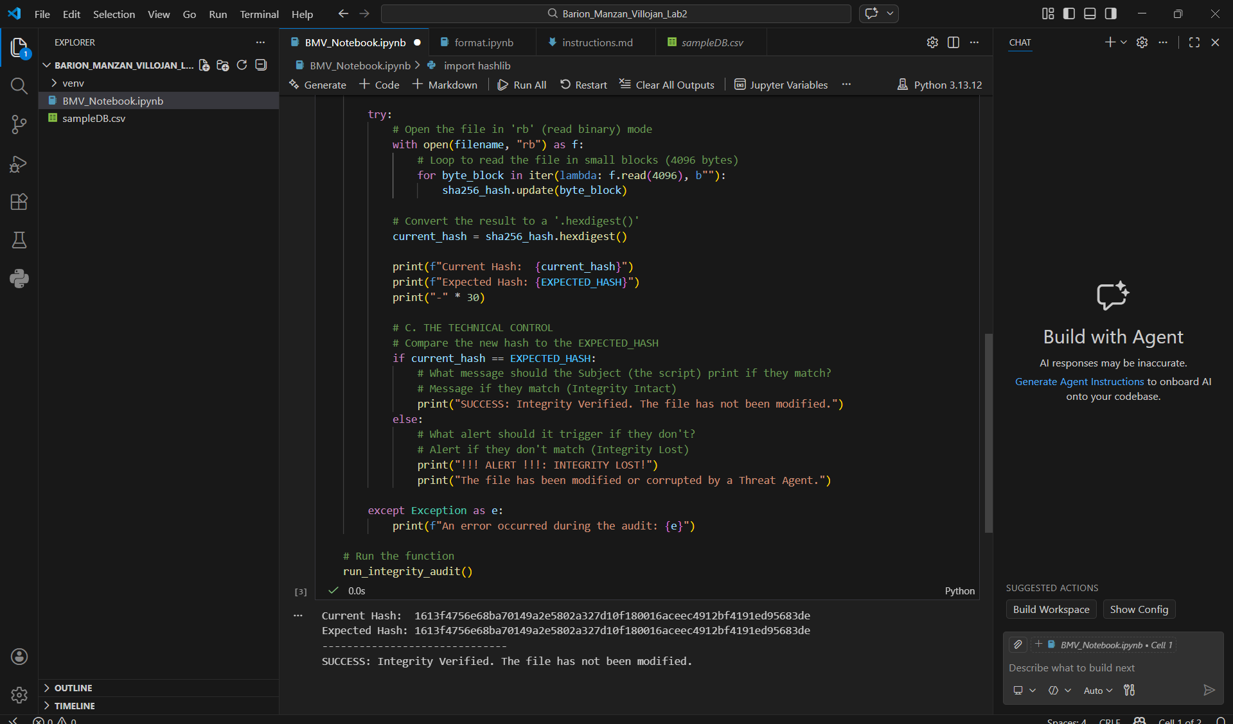

Verifying the initial state of the asset to ensure integrity is intact.

- Manually modify a value in the sampleDB.csv file.
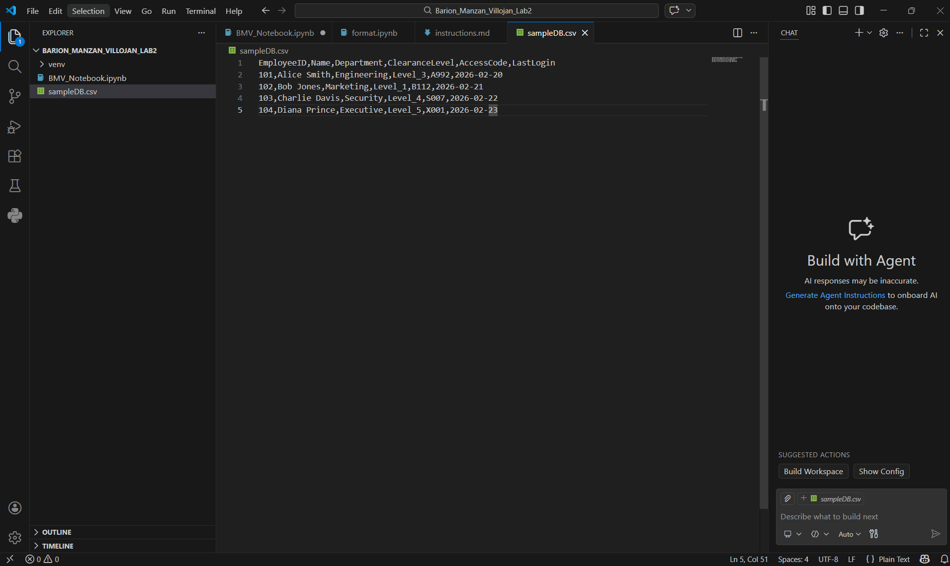

Simulating a Threat Event by unauthorized modification of the data.

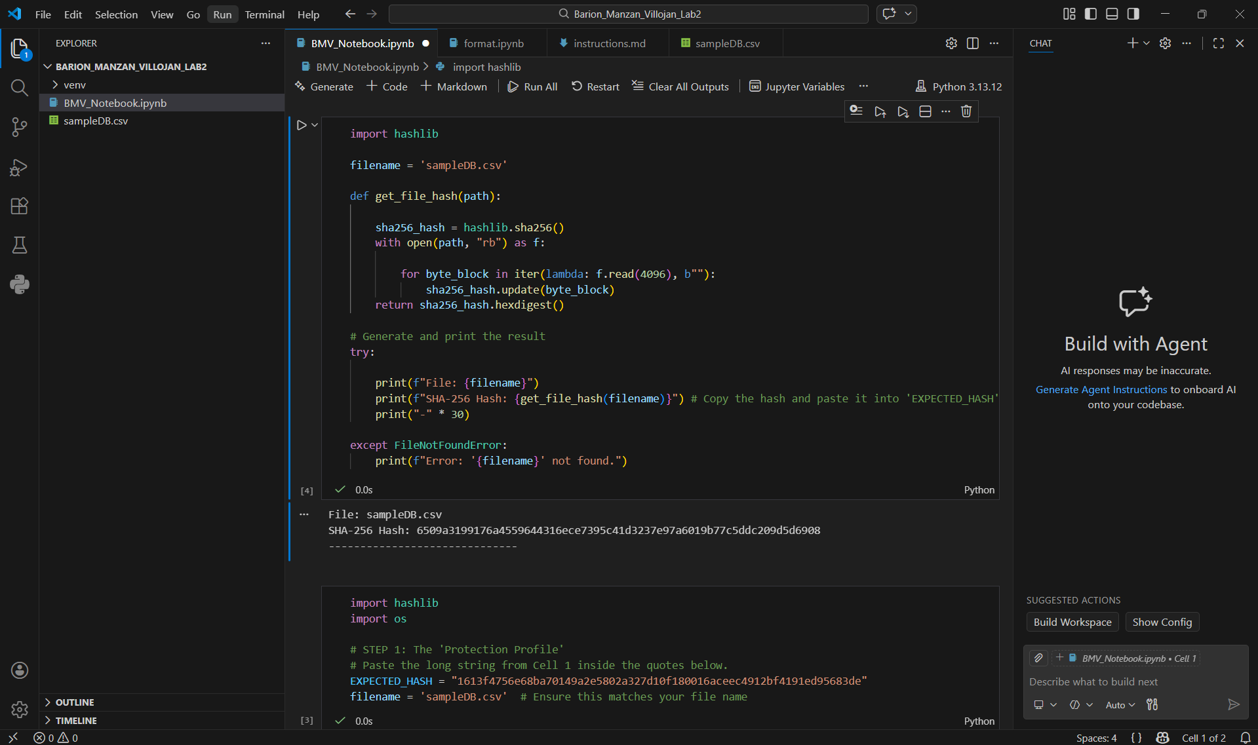
- Run Cell 1 again after the modification.

Re-hashing the modified asset to identify the change.

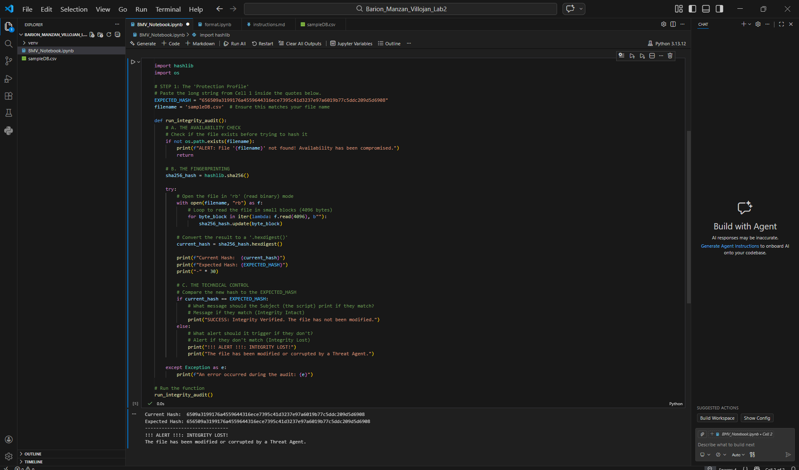
- Run Cell 2 to compare the hashes.

Detection of the integrity compromise by the technical control.

- Modify a value in separate window (Excel)
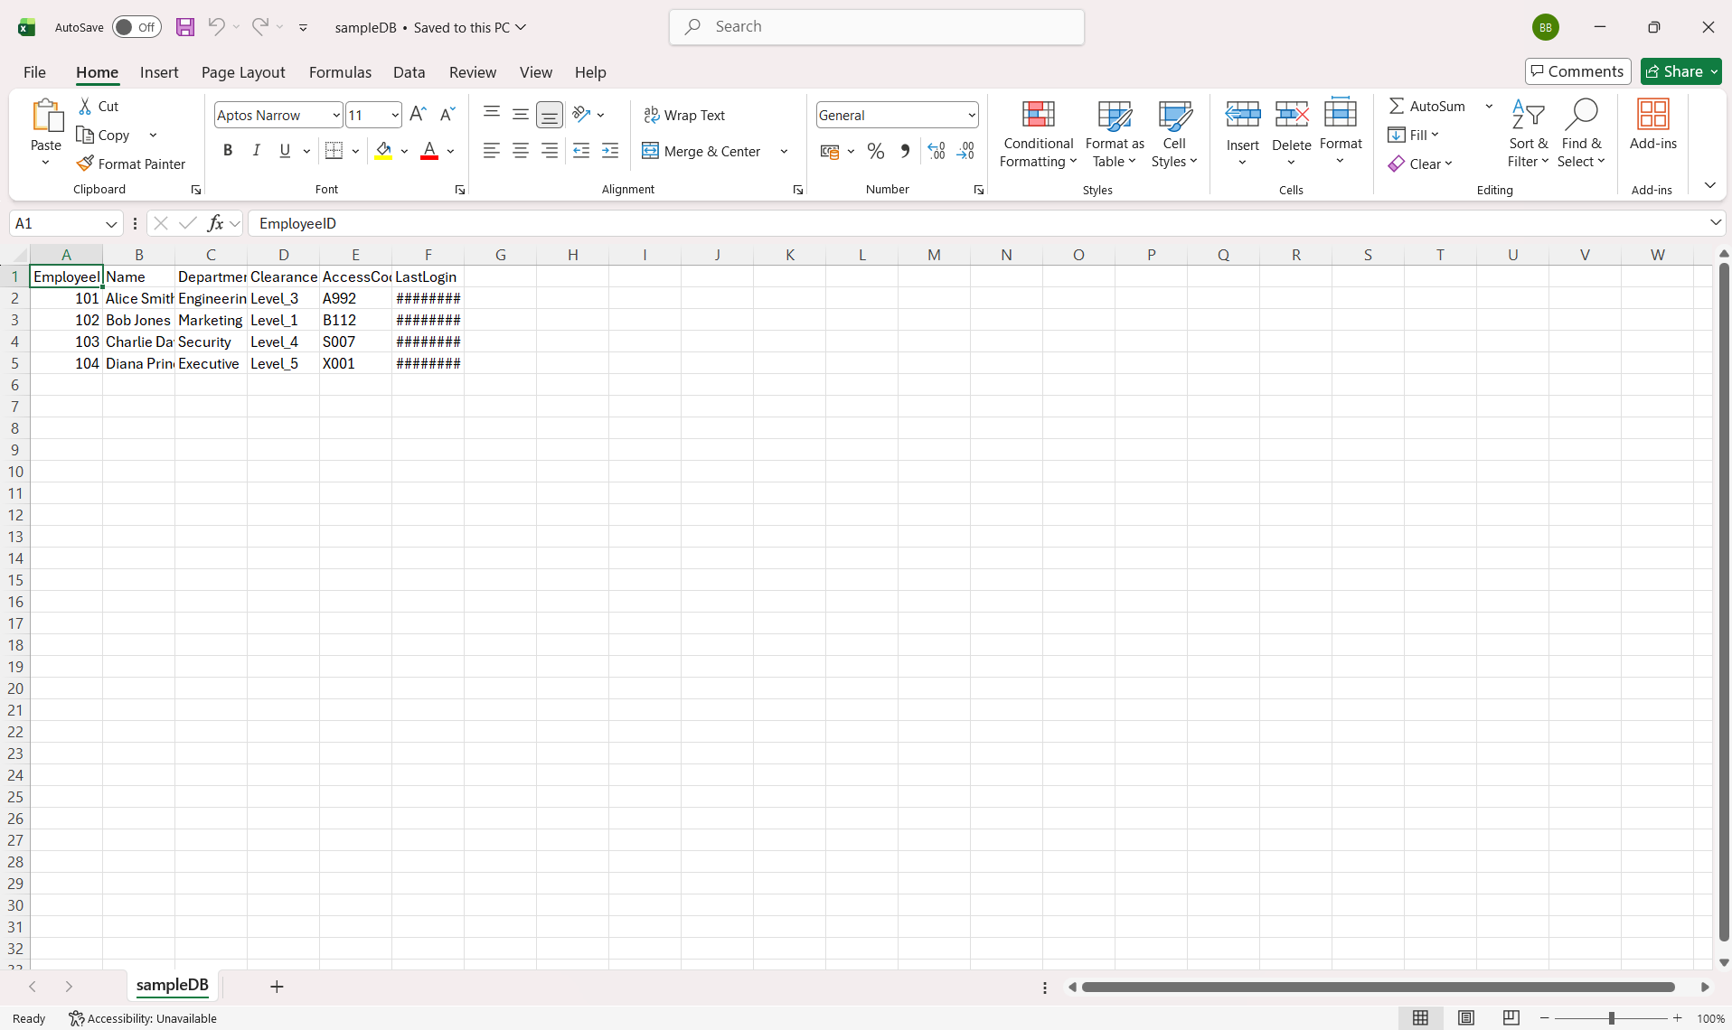
Unmodified
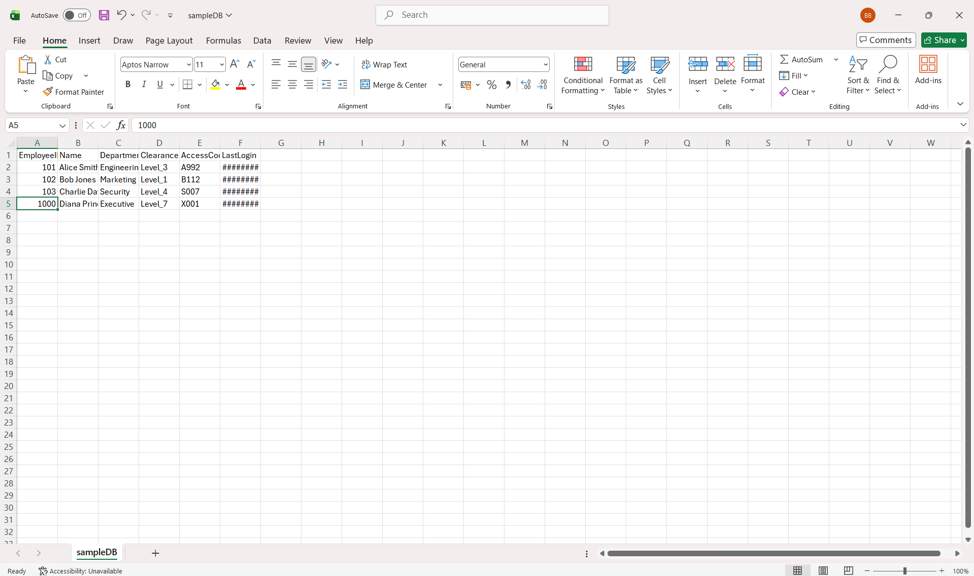
Modified

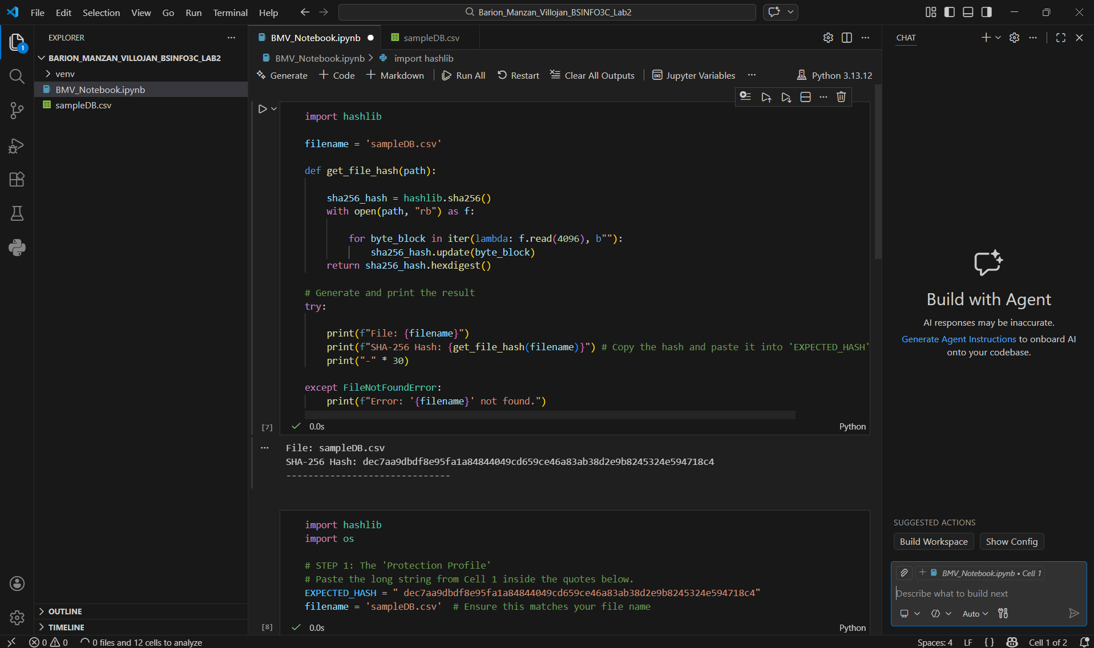
- Run Cell 1 again after the modification.

Re-hashing the modified asset in separate window (Excel) to identify the change.

- Run Cell 2 again to compare the hashes.
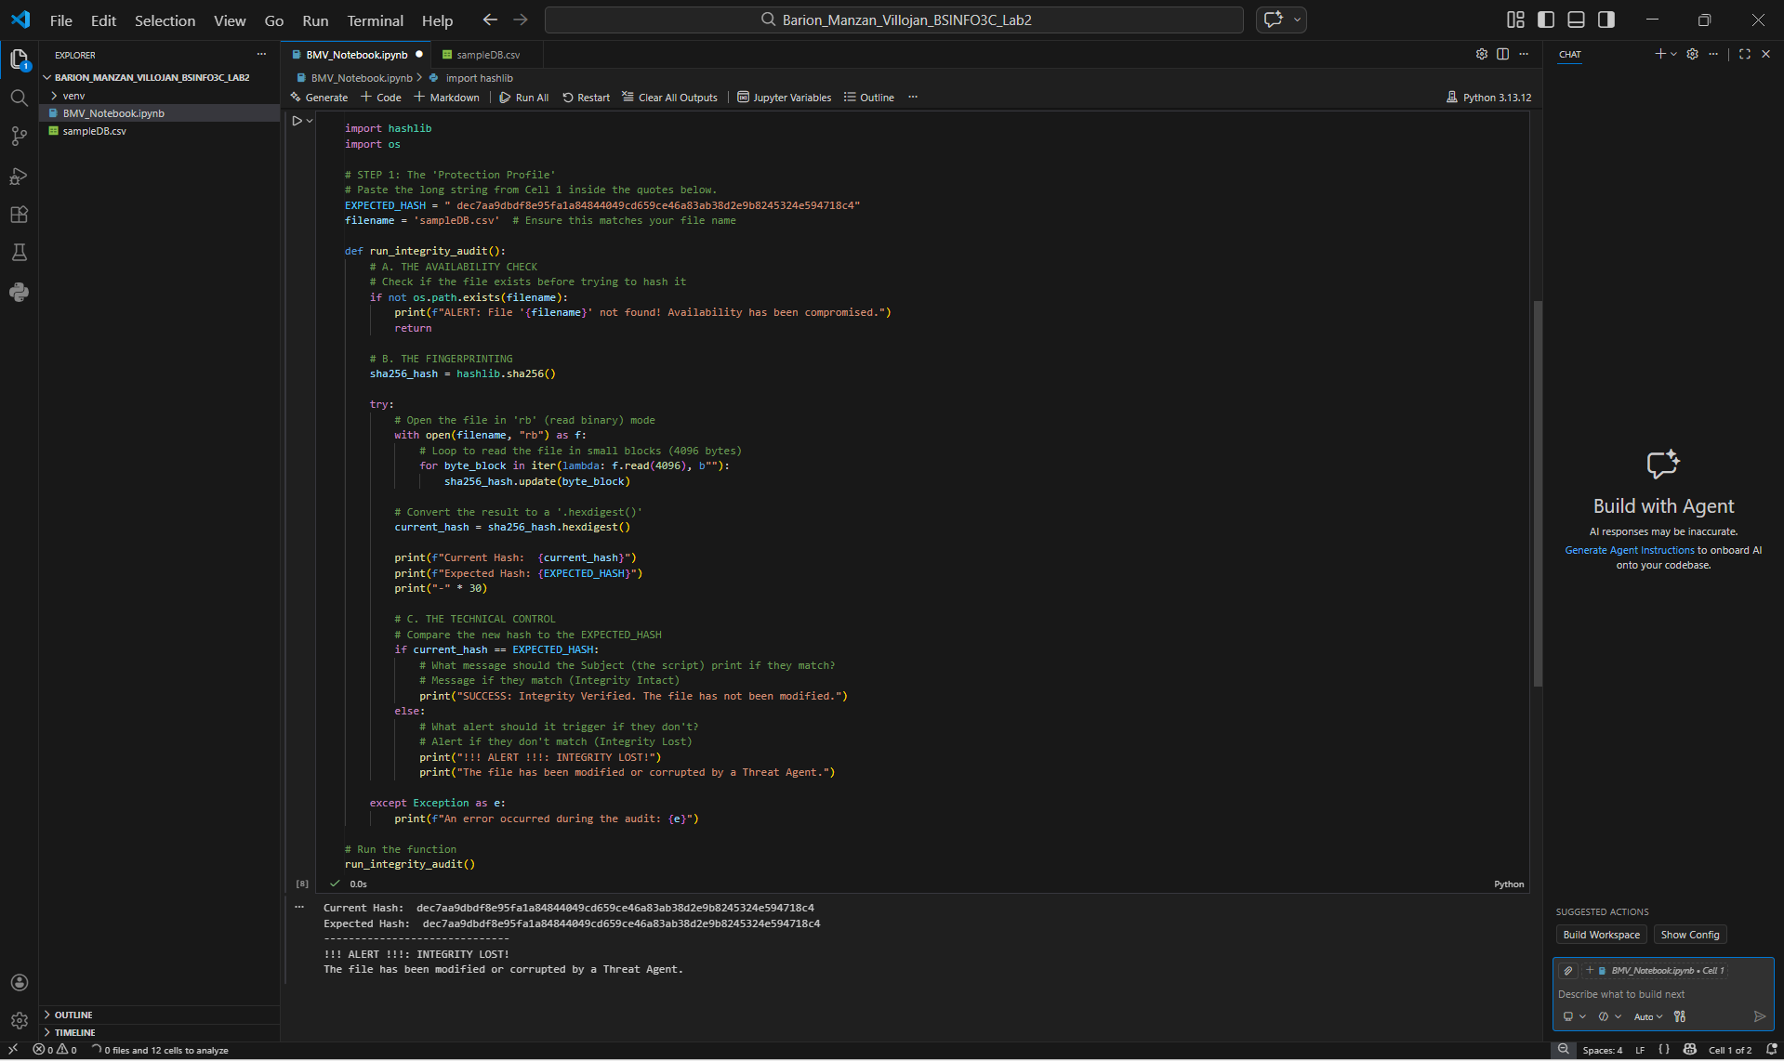

Integrity Compromise Detected by the Technical Control.

Post-Analysis
- In this specific activity, which one is the Subject (the entity that acts to conduct the check) and which is the Object (the entity that is the target of the check)?

Answer: In this activity, the subject is the Python auditor script (run_integrity_audit function), and the object is the database.csv (the protected asset)

- If you manually open the file and change one variable (from Instructions), is that action considered a Vulnerability or a Threat Event?

Answer: If we manually open the file and change one variable, that action is a Threat Event because it is an actual unauthorized action. The fact that the file is not protected or locked is a Vulnerability. While the actual action of changing the data is the Threat Event.

