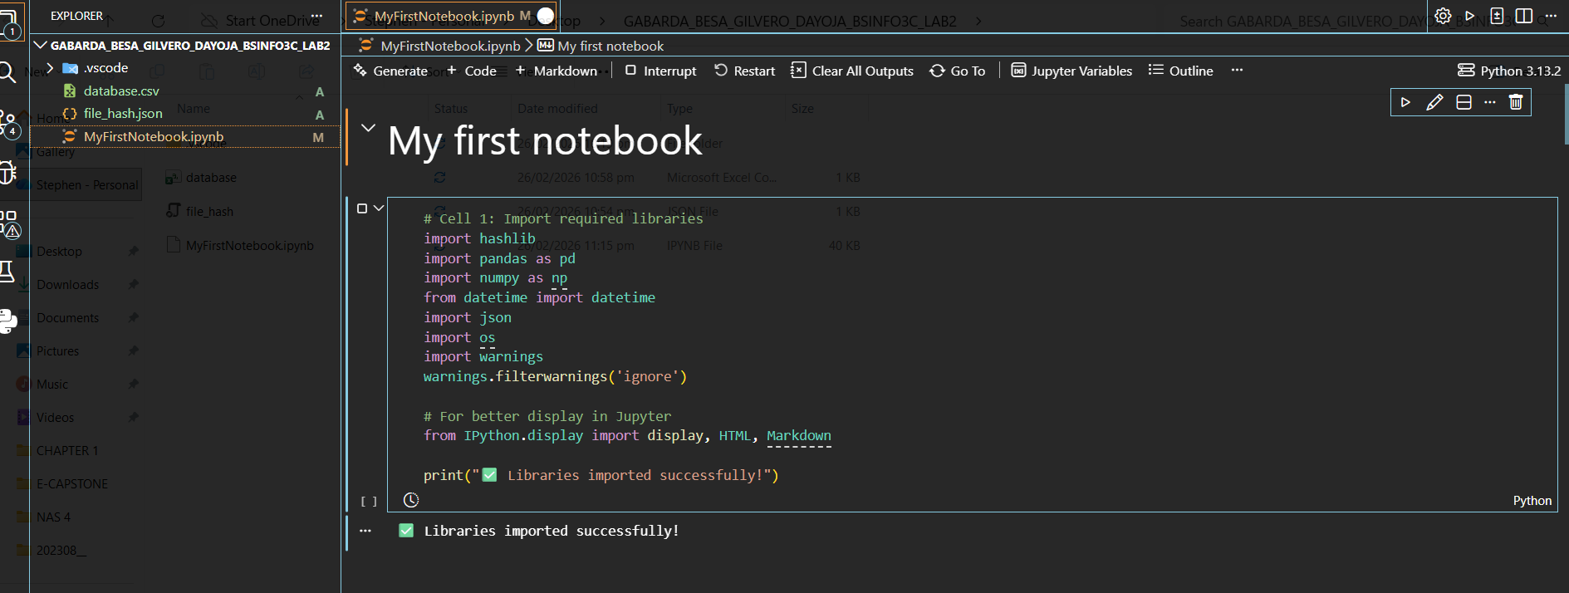
Cell 1: Installing pandas and importing all required libraries (hashlib, pandas, datetime, json, etc.) for the Integrity Guardian tool.

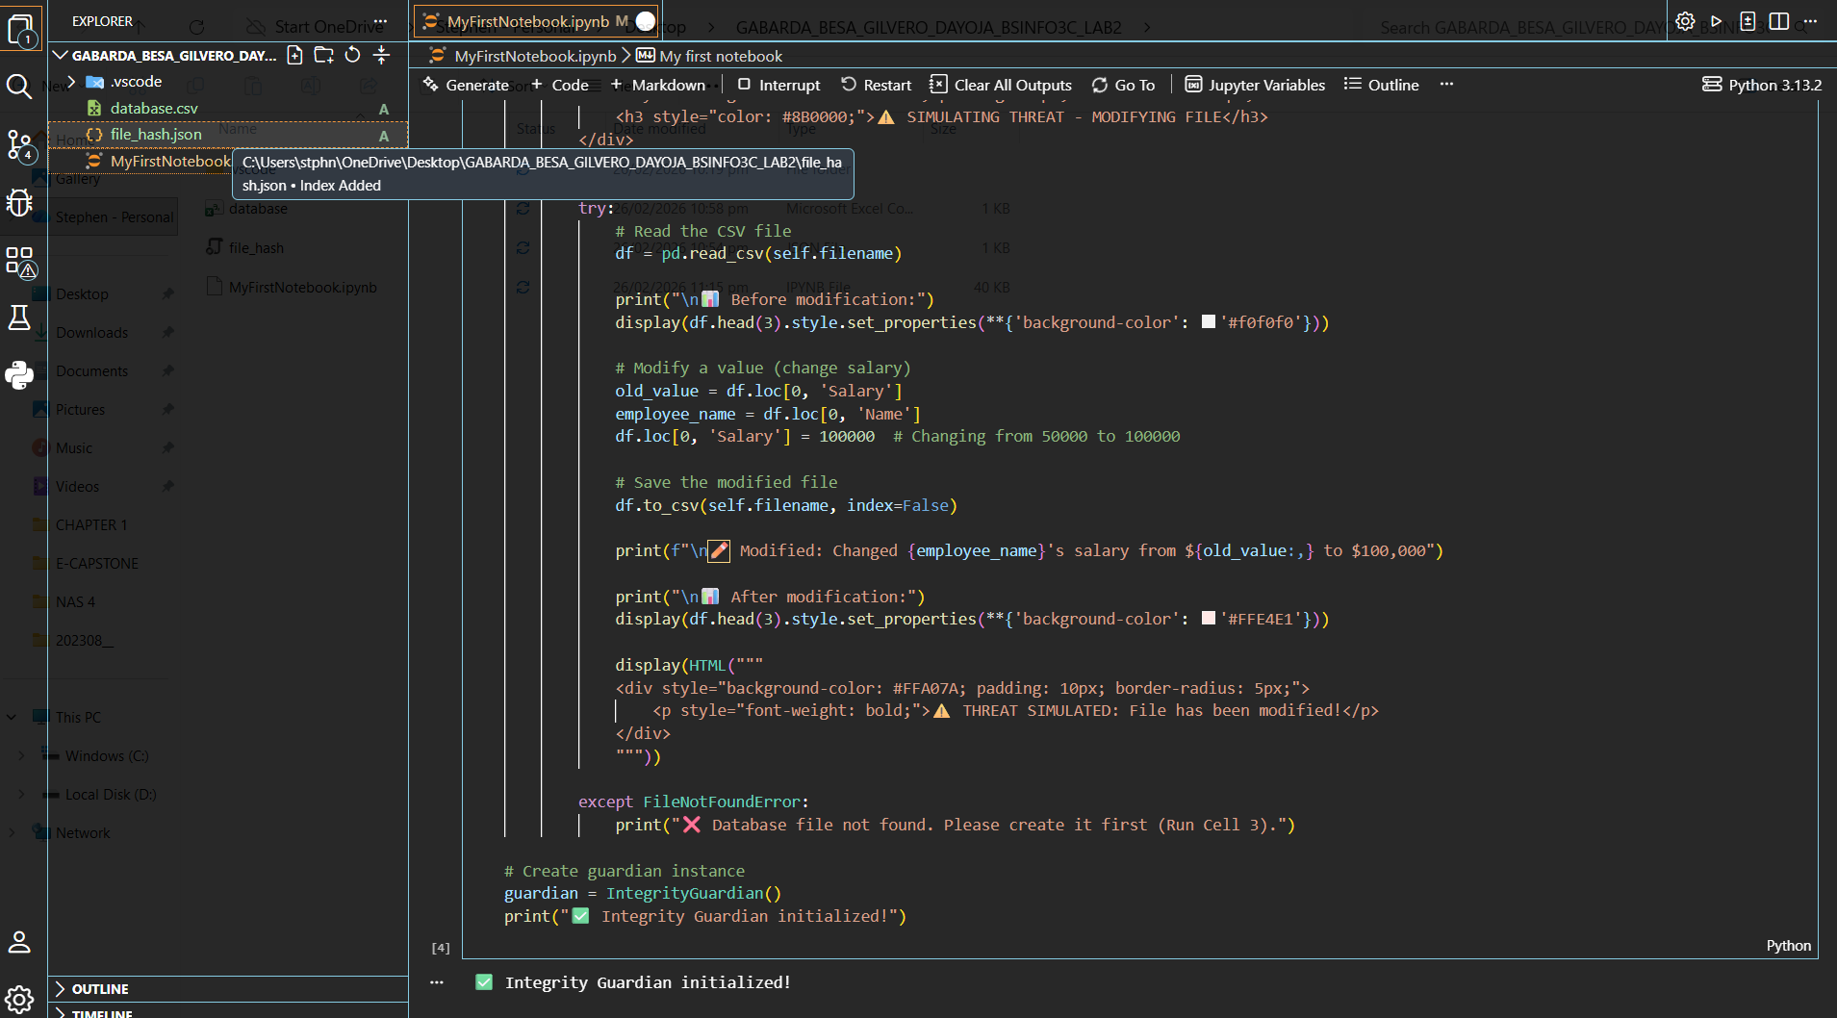
Cell 2: Defining the class with methods for creating files, calculating hashes, initializing protection profiles, verifying integrity, and simulating threats.
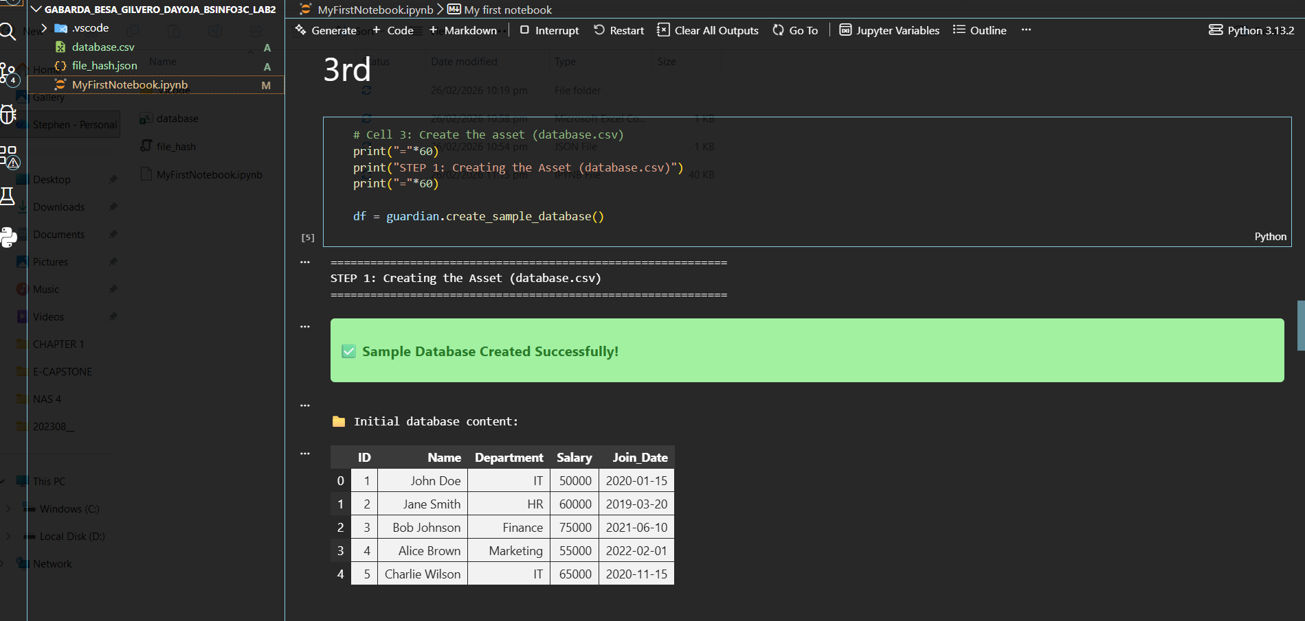
Cell 3: Creating the sample asset (database.csv) with employee data including ID, Name, Department, Salary, and Join Date.

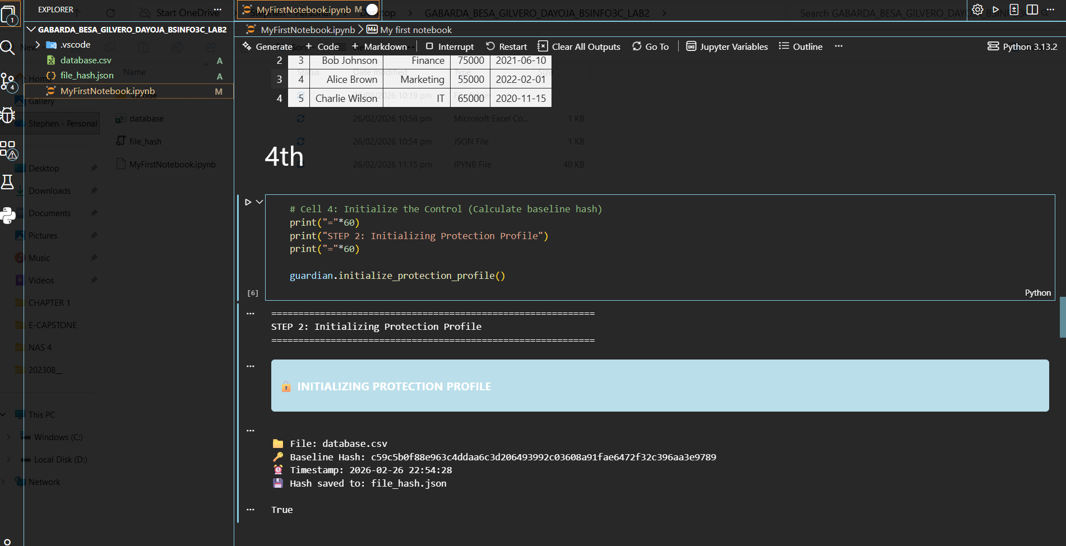

Cell 4: Initializing the Protection Profile by calculating and storing the baseline SHA-256 hash of database.csv in a JSON file.
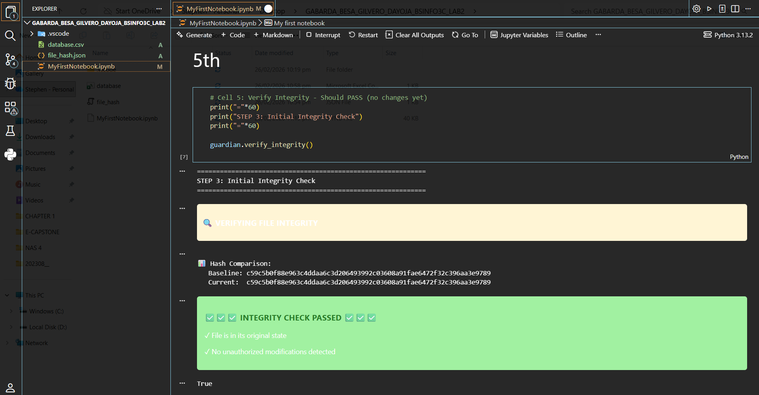
Cell 5: Performing the initial integrity check - verifying that the current file hash matches the baseline hash (should pass since no changes yet).

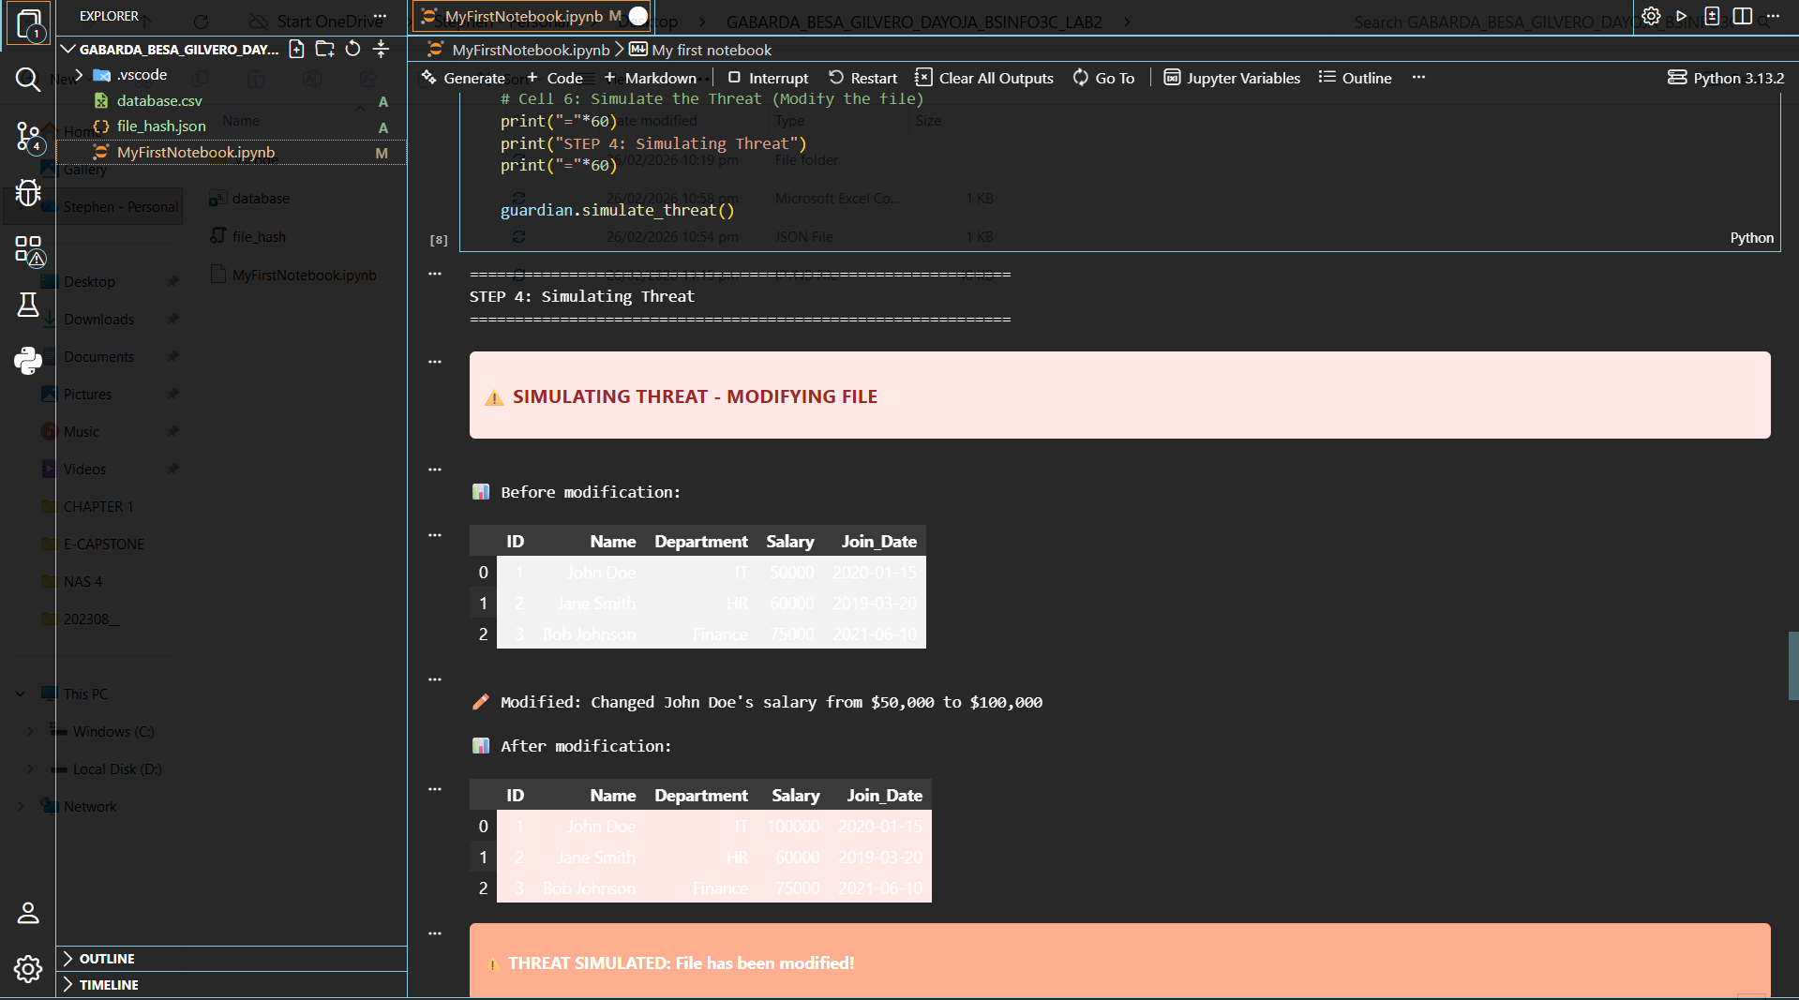

Cell 6: Simulating a threat by manually modifying the file - changing John Doe's salary from $50,000 to $100,000.

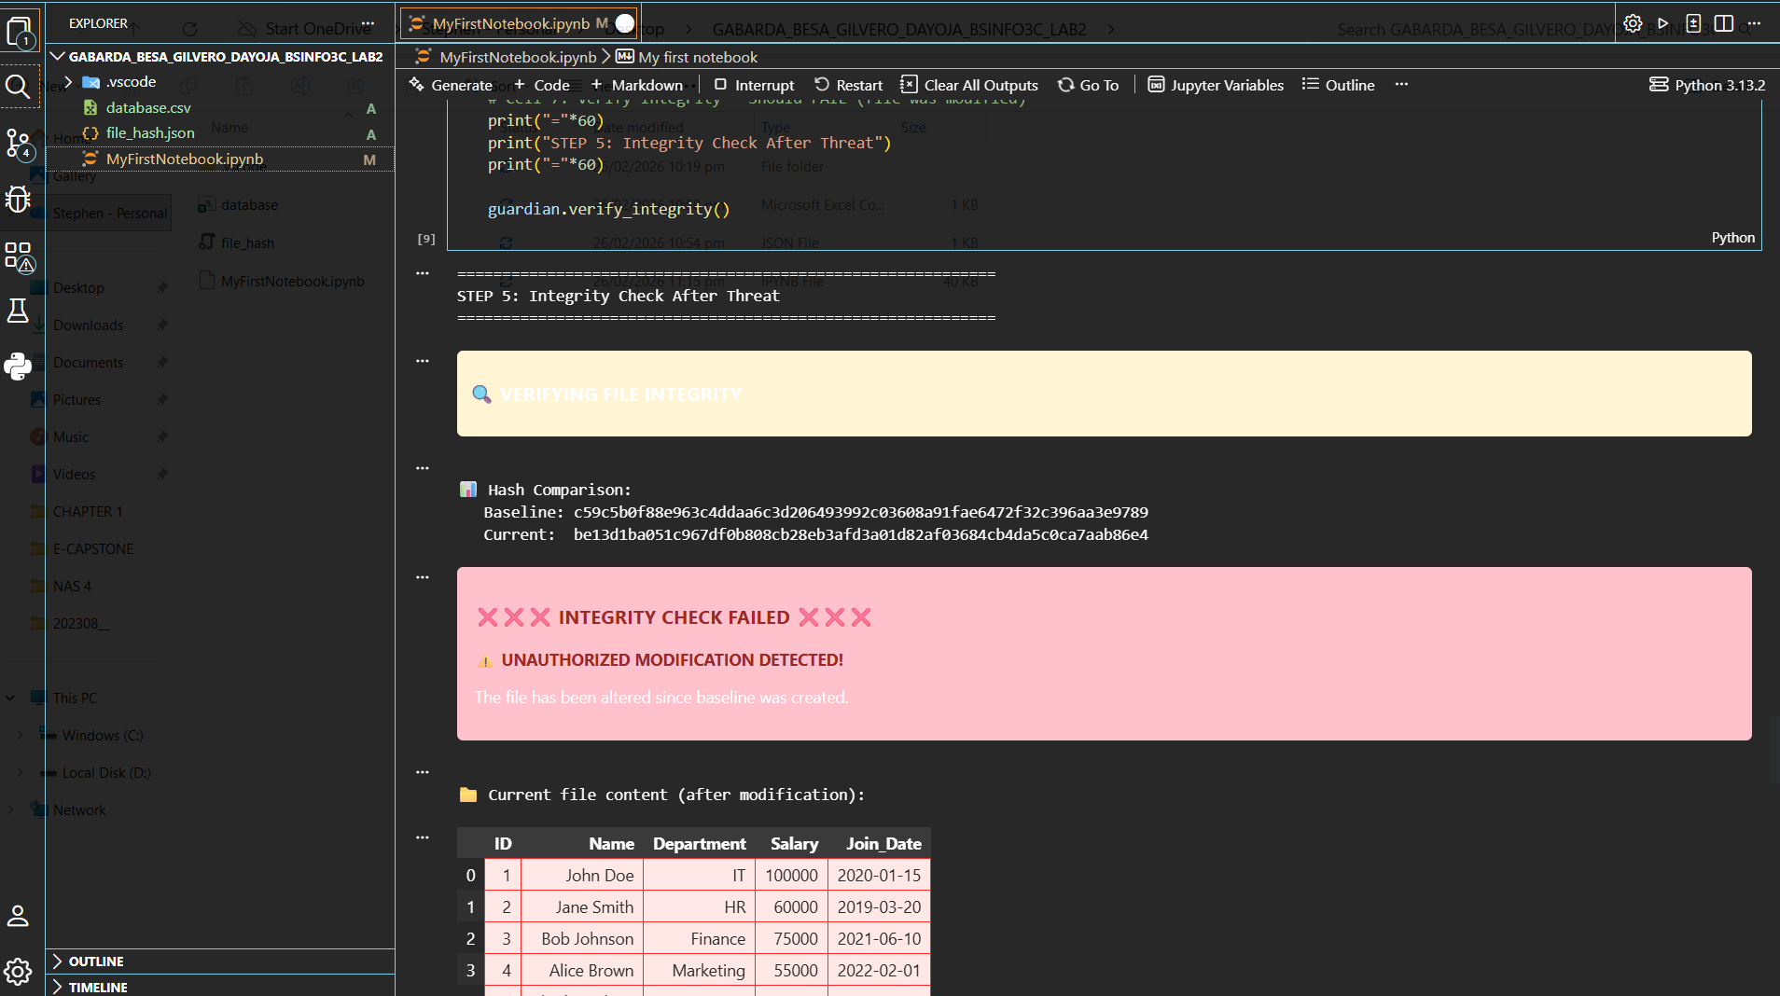

Cell 7: Performing integrity check after the threat - verifying if the current file hash still matches the baseline (should fail and detect modification).

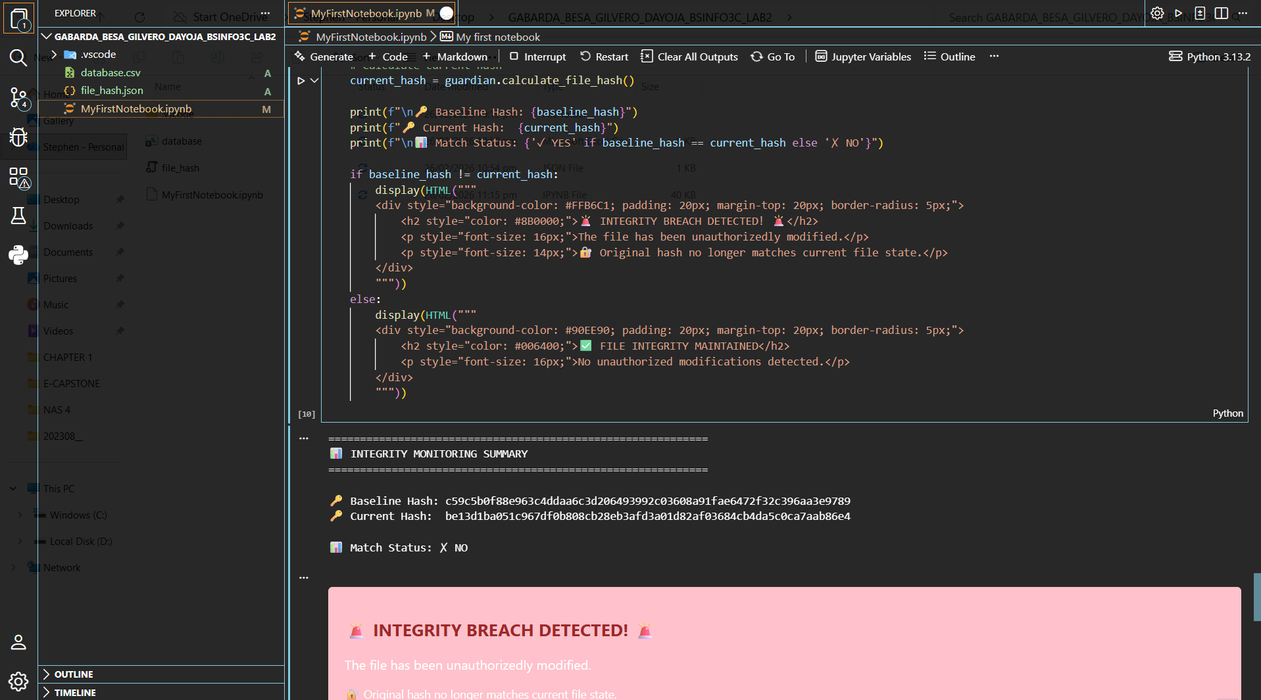
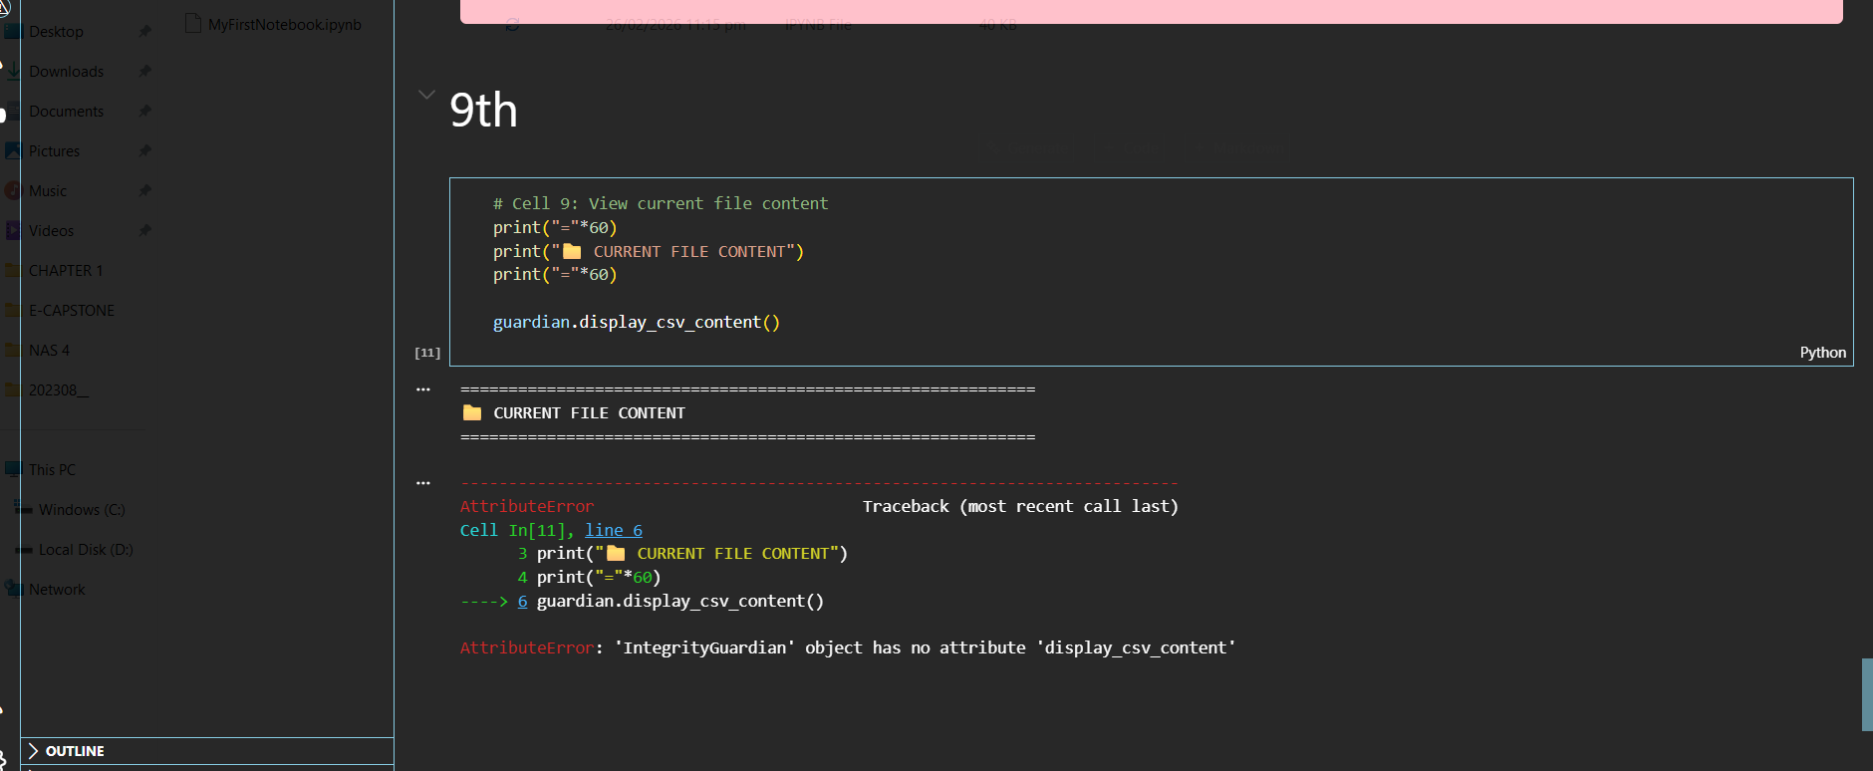

Cell 8: Displaying a summary comparing baseline and current hashes, showing the integrity status (compromised after modification).

Cell 9: Viewing the current content of database.csv to see the modified values.

