Tracker concept

Summary
The tracker overall concept can be described visually as:
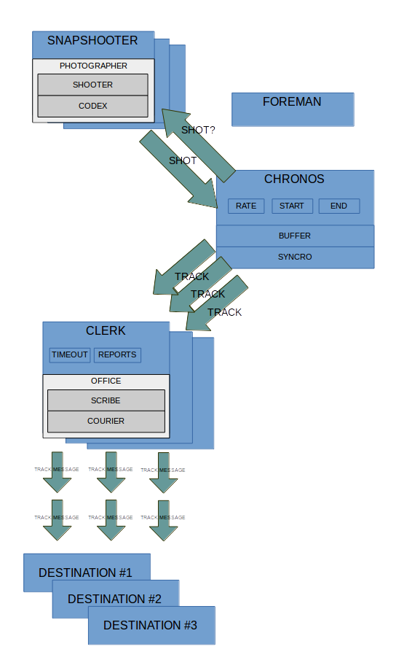
Tracker main purpose is to emit track data originating from different data sources to several endpoint using different service technologies.

Tracker is composed by three main components:

- Snapshooter
- Chronos
- Clerk

The snapshooter main responsibility is to translate raw data into track data regardless the origin of that data.

It can operate in two modes:

- Proactive
- Reactive

On the proactive mode, the data domain in which the snapshooter will work encompasses the alphanumeric, spatial and temporal information of the state of all datasource elements at a given period in time.

His job is to gather, by request, a slice of information from the datasource in which alphanumeric, spatial and temporal data must be decoded from the collected data.

A element of data containing one spatial and temporal reference is called a track.

A collection of tracks with matching time instances (or withing a temporal narrow interval) is denominated a shot.

Therefore, in this mode, snapshooter will gather shots from the datasource when it is commanded to.

On the reactive mode, the snapshooter receives events from external datasource and decodes them into either shots or individual tracks.

If the reactive mode is set in shot mode, the snapshooter is configured in order to accept a certain input data which then the decoder will decompose into a shoot.

If the reactive mode is set in track mode, the snapshooter is will decode the input data into individual tracks.

In this mode, snapshooter will forward the receiving shots or tracks directly to the chronos for further processing

Chronos is the time syncronization component that can operate in two modes:

- Hearthbeat
- Reactive

In the Hearthbeat mode, Chronos will periodically fetch shots from the snapshooter at a configured rate in order to serialize them into tracks.

The shoot will contain potential tracks on its internal data, and Chronos will have the responsibility to slice the shoot into a track collection and store it.

After obtaining the collection of potential track from a given shot the chronos will consistently issue each track to the clerk for further handling.

In the reactive mode chronos must turn off the synchronization features and be listening for the snapshooter events either in shot or track formats.

The operation mode of snapshooter and chronos must match: Chronos and snapshooter must be both in reactive mode and on the same submodes (shot or track) for this mode to operate correcly.

When a snapshooter event is received, chronos will proxy the data to the clerk as in the heartbeat mode.

The clerk will receive tracks in order for them to be transmitted as track messages.

It will handle all communication aspects as timeouts, connection status, endpoints between the system and several track receiver services

Chronos

Hearthbeat
…

The consistency between tracks originated from consequent shots will focus on having a track set that is suitable for the system capability of issue all the tracks at a given instant.

The chronos track issuing rate is bounded to the overall system performance and, at this point, is constrained by the clerk capability of issuing all the tracks that is being given by chronos.

Therefore chronos must not flood the clerk with tracks to send beyond its capacity and must not give track to issue if they are past due their timestamp.

There must be evaluators and tolerance parameters for establishing the time validity of a track on this process. If a track is delayed by the system beyond the tolerance parameter it should be discarded.
Therefore the following concerns must be taken into consideration:

- Chronos rate adjustment
- Track issuing validity evaluation
- ...

