Lesson 9: RGB LED

Objectives:
  - At the end of this lesson, you should be able to:
    - Describe an RGB LED;
    - Design a circuit using RGB LED and Arduino Uno; and
    - Create a program using RGB LED with Arduino IDE.

RGB LED (Red-Green-Blue Light Emitting Diode)
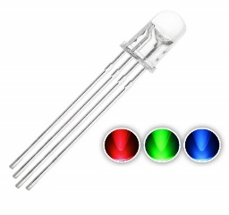

These are LED lights that can display three
primary colors. When these are mixed,
they can produce a million hues of light.

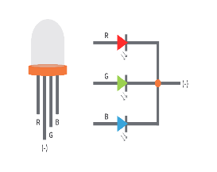

An RGB LED has four pins, one for each
color, and the common cathode (negative)
is the longest leg among the four. Each
color value ranges from 0 to 255.

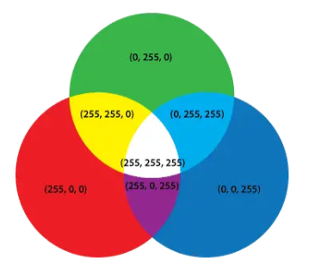

- You can mix any color by varying the
- quantities of red, green, and blue light.

- Our eyes have three types of light
- receptors, and our brain processes the
- amount of red, green, and blue color and
- convert it onto color spectrum.

- Through this process, we can display any
- color in our LED bulb using the duty
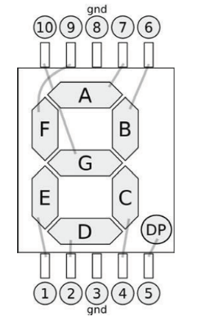
- cycle of the PWM signal to the RGB
- digital pins.

- The PWM is a technique for controlling the value that allows us to control the brightness of each LED.

- Looking at the PWM diagram, the PWM output produces a pulse approximately every 1/1500 of a second.

- The length of each pulse is controlled by the analogWrite function (0-255).
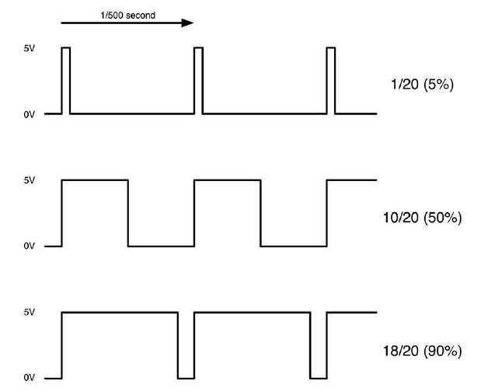

We can a specific pulse value in the analogWrite between 0-255. If the output pulse is only at 5% per second, then it receives 5% of the total power. However, if the output is at 5V for 90% per second, then the load will get 90% of the full power.
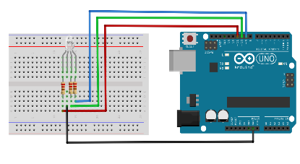
Materials Needed:
  - 1 pc. RGB LED
  - 1 pc. Arduino Board
  - 1 pc. Breadboard
  - 4 pcs. 220 Ohms Resistor
  - Jumper wires

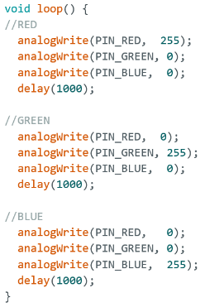
RGB LED

Sample Code:
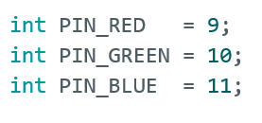

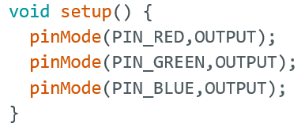

Lesson 10: 8-Segment

Objectives:
  - At the end of this lesson, you should be able to:
    - Describe an 8-Segment;
    - Design a circuit using 8-segment and Arduino Uno; and
    - Create a program using 8-Segment with Arduino IDE.

8-Segment

A segment is an electronic component that displays
decimal numbers. It has 8 segments that can be
turned on or off based on the pattern to be produced.

A Light Emitting Diode (LED) arranged in the shape
of number 8, can be visible for display.

8-segments are commonly found in different
electrical devices such as digital stereos, air
conditioners, microwave ovens, digital clocks,
scoreboards, and cashier counters. They are simple to
use, inexpensive, and highly visible in both low and
highlight conditions.

There are two types of eight-segment displays: Common Cathode and Common Anode
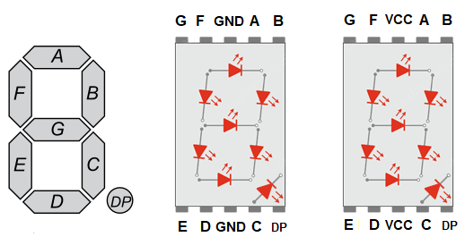

Both segments are almost identical. The only difference is the polarity of the LEDs and the common terminal. In the Common cathode display, the GND is connected to the negative pin; in the common anode, the VCC is connected to the positive pin.

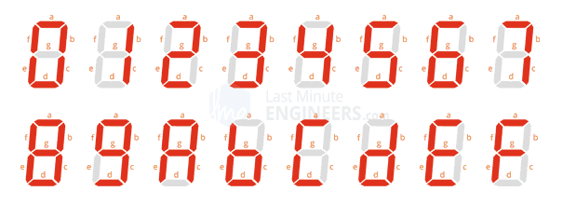

Both segments are almost identical. The only difference is the polarity of the LEDs and the common terminal. In the Common cathode display, the GND is connected to the negative pin; in the common anode, the VCC is connected to the positive pin.

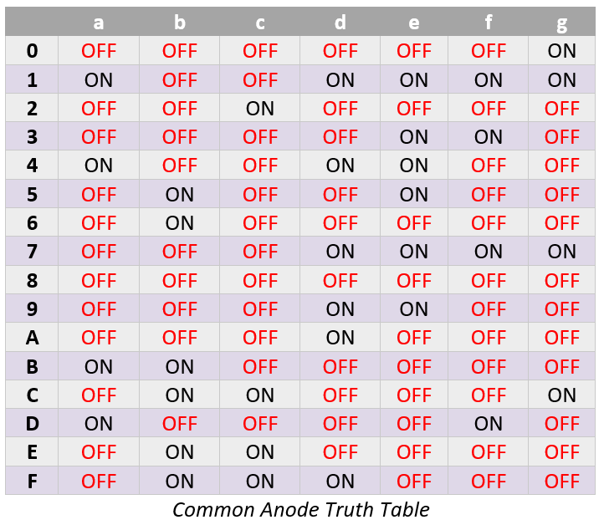
Using the Truth table will guide you
in which must be lit to produce digits
or single charter in the 8-segment.
Common Anode Truth Table is the
exact opposite for the Common
Cathode 8-segment display.

Take Note, if a segment is a common
anode type, HIGH means OFF,
and LOW means ON.

Picture Diagram
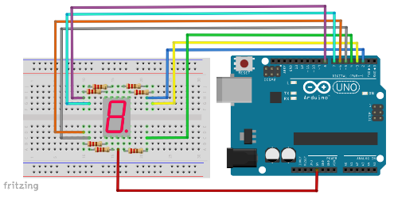

Materials Needed:
- 1 pc. 8-segment
- 1 pc. Arduino Board
- 1 pc. Breadboard
- 7 pcs. 220 Ohms Resistor
- Jumper wires

Sample Code:
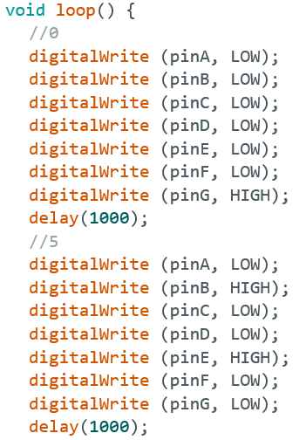
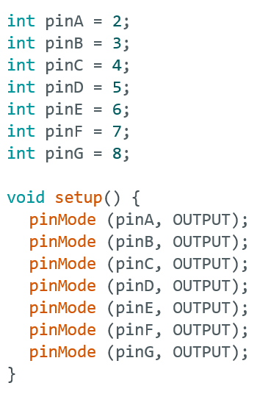

This code will display digital numbers 0, 5, and 9 in a loop.

Lesson 11: Night Lamp

Objectives:
  - At the end of this lesson, you should be able to:
    - Construct a DIY project with the use of RGB LED;
    - Design a circuit for project Night Lamp; and
    - Create a program RGB LED Night Lamp with Arduino IDE.

Night Lamp Project

A night lamp is a small piece of light furniture that usually runs on electricity or a battery. It is usually placed in a corner of a room or an in a convenient place in areas where it is dark at a particular time, either at night or during an emergency.
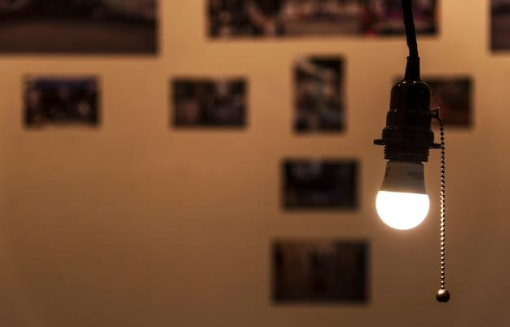
In this DIY project, you will build a simple night lamp using RGB LED with your desired moon light and effects.

Materials Needed:
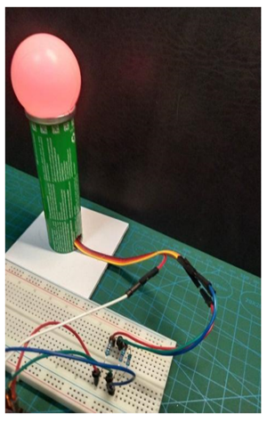
  - 1 pc. Arduino Uno
  - 1 pc. Breadboard
  - 1 pc. RGB LED
  - 3 pcs. 220 ohms resistor
  - Jumper wires
  - 1 pc. Ping Pong Ball (White)
  - Cardboard
  - Tissue Roll Tube / Plastic Tube
  - Scissors or Paper Cutter
  - Pencil and Ruler
  - Glue gun and glue stick

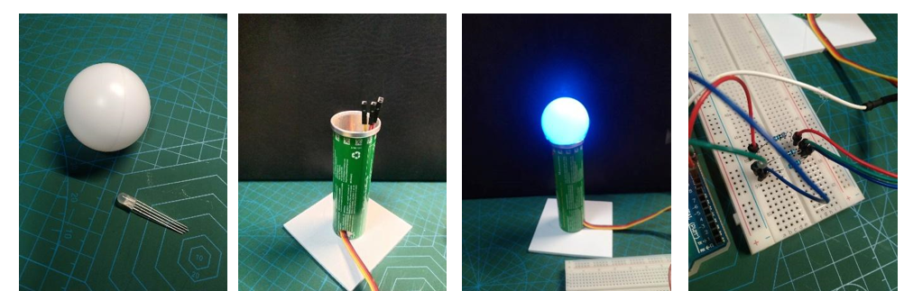
Procedure:

Step 1. Get a white ping pong ball and cut a small x-mark line for the RGB LED to fit. (See figure 1)

Step 2. Cut one set of 3x3 inches of cardboard. (See figure 2)

Step 3. Get a tube, make a hole on the side, and side four jumper wire (female to female) to the other side. (See figure 2)

Step 4. Attach the tube to the cardboard with a glue stick, then connect the RGB LED attached to the ping pong ball at the end of the jumper wires. (See figure 3)

Step 5. Connect three 220 ohms resistors to the breadboard , then connect the jumper wires connected to the RGB LED and to the digital pins in the Arduino Boards. (See figure 4)

Step 6. Create and download the program to test the RGB LED lights. (See figure 5)
Picture Diagram:
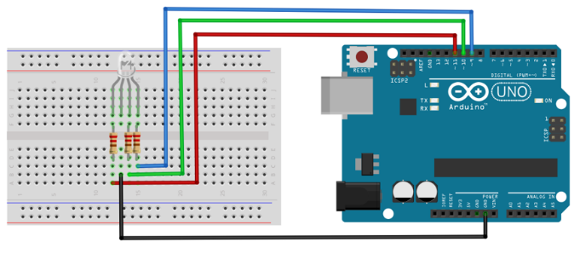

\
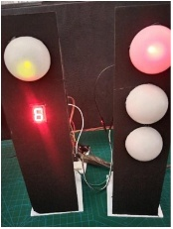
Sample Code:
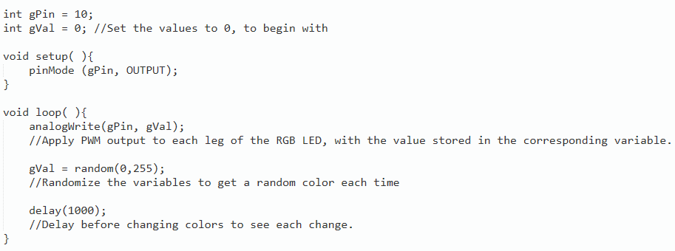

Lesson 12: Traffic Light

Objectives:
  - At the end of this lesson, you should be able to:
    - Construct a DIY project with the use of RGB LED and 8-Segment;
    - Design a circuit for the project Traffic Light System; and
    - Create a program for Traffic Light system with Arduino IDE.

Traffic Light Project

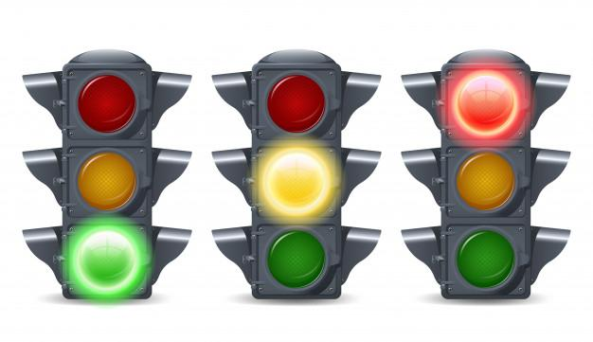
A traffic light is an automated colored light used as a traffic control signal for vehicle drivers at any intersection or crosswalk in the streets.

The colors of a traffic light are:
- RED for stop;
- YELLOW for caution; and
- GREEN for go
A traffic light is an automated colored light used as a traffic control signal for vehicle drivers at any intersection or crosswalk in the streets.
The colors of a traffic light are:
- RED for stop;
- YELLOW for caution; and
- GREEN for go

Uses of a Traffic Light
  - It conveys messages to the people crossing the street, by just looking at the color signals.
  - It provides orderly movement of the vehicles and people for traffic control.
  - It increases the traffic-handling capacity of the intersection.
  - It reduces vehicular accidents or collisions at intersections.

- This DIY project will demonstrate how to make a simple traffic light system using LEDs and 8-segment with Arduino. This projects involves coding and simple electronic wiring and connection.

Materials Needed:
  - 1 pc. Arduino Uno
  - 1 pc. Breadboard
  - 2 pcs. Red LED,
  - 2 pcs. Green LED
  - 1 pc. Yellow LED
  - 12 pcs. 220 ohms resistor
  - 1 pc. 8-segment
  - Jumper wires
  - 2 pc. Ping Pong Ball (White)
  - Cardboard
  - Scissors or Paper Cutter
  - Pencil and Ruler
  - Glue gun and glue stick
  - Soldering Iron and soldering lead (Optional)

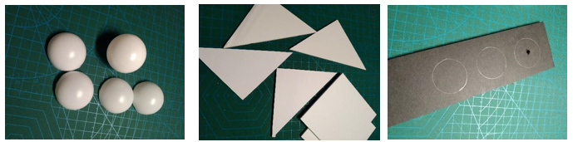

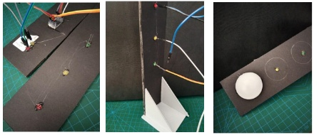

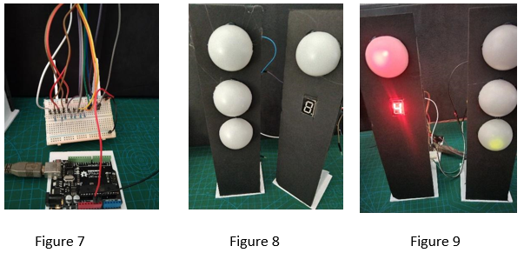

Step 1. Get a white ping pong ball and cut in half. (See figure 1)

Step 2. Cut two sets of 3x3 inches of cardboard and two sets of triangular shapes. (See figure 2)

Step 3. Cut one 6x25 cm piece of a cardboard, then draw three circles with the same radius as a ping pong balls, then create a small hole for the LED to fit. (See figure 3)

Step 4. Cut one 6x25 cm piece of a cardboard, then draw three circles with the same radius as a ping pong balls, then create two small holes for the LED to fit. Create a square shape for the 8- segment to fit. (See figure 4)

Step 5. Attach the LEDs and 8-segment to the cardboard with a
glue stick, then connect the jumper wires. (See figure 4)

Step 6. Put the cut cardboard with a triangle shape at the side and the 3x3-inch piece at the bottom that will serve as the base of the spotlight. (See figurev5)

Step 7. Place the cut ping pong balls at the marked circle on the cardboard . (see figure 6)

Step 8. Connect all the 220-ohm resistors at the breadboard, then connect the jumper wires to the designated LEDs, 8-segment, and the digital pins in the Arduino Board. (See figure 7)

Step 9. Create and download the program to test the LED lights and 8-segment. (See figure 8 and 9)

