Laboratory Practical Assessment
Topic : Functional Testing – Software Testing Course : TESTQUA 31
Type : Laboratory Practical Assessment Student Name: Tabañag, Gil A.

- Instructions
  - Read each task carefully.
  - Perform the required activities using any tool (manual, spreadsheet, or simple code).
  - Submit:
    - PDF of your answers
    - Screenshots of executed tests (if applicable)
    - Completed test case table

Laboratory Scenario
You are assigned as a QA Tester for a new web application: “UC Student Portal Login Page”. The login page has the following requirements:
  - A user must enter a valid username and password.
  - If the username or password is incorrect, the system must display:

“Invalid login credentials.”
  - If fields are empty, the system must display:

“All fields are required.”
  - For security, passwords must be at least 8 characters long.
  - After 3 failed attempts, the system must show:

“Your account is locked. Contact administrator.”
Using the Functional Testing concepts from the document, perform the tasks below.

Practical Tasks

Task 1: Identify What to Test (10 points)
Using the “What to Test in Functional Testing” section (Basic Usability, Main Functions, Accessibility, Error Handling) , list at least 5 functional components you will test in the login page.
Example: “Verify login accepts valid credentials.”

Answer:
  - Verifies that the login accepts valid username and password. (Main Function)

  - Verify that the system shows an error the say “Invalid login credentials.” When the inputted username or password is invalid. (Error Handling)

  - Verifies that the system displays “All fields are required.” When both or neither of the username or password fields are empty. (Basic Usability / Error Handling)

  - Verifies that the password entered is at least 8 characters long. (Main Function / Security)

  - Verifies that the system locks the account after 3 consecutive login failure showing a message that says “Your account is locked. Contact administrator”(Main Function / Error Handling)

Task 2: Functional Testing Process Application (20 points)
Apply the 4-step functional testing process from the document (Identify input → Expected outcomes → Execute test → Compare output).
Complete the table below for 3 test cases:

Step | Test Case 1 | Test Case 2 | Test Case 3
Identify Inputs | Username: testuser1  Password: 123123 | Username: testuser1 Password: 321456 | Username: testuser1 Password: short123
Expected Output | Successful login and redirection to the Student Portal Dashboard. | Display error message: "Invalid login credentials." | Display error message: "Password must be at least 8 characters long."
Actual Output | User is successfully redirected to the Student Portal Dashboard page.. | The login page is displayed with the error message: "Invalid login credentials." | The login page is displayed with the error message: "Password must be at least 8 characters long."
Comparison (Pass/Fail) | Pass | Pass | Pass

Task 3: Create Detailed Functional Test Cases (30 points)
Create at least 5 functional test cases using the following format:

Test Case ID Test Scenario Test Steps Test Data Expected Result Actual Result Status
Your test cases should cover:
✔ Valid login
✔ Invalid login
✔ Empty fields
✔ Short password
✔ Account lock after 3 attempts

Answer:

Test Case ID | Test Scenario | Test Steps | Test Data | Expected Result | Actual Result | Statu s
TC- 001 | Valid login  — correct username and password | 1. Navigate to the UC Student Portal Login Page.  2. Enter the valid Username.  3. Enter the valid Password (8+ chars).  4. Click the 'Login' button. | Username: validStudent01, Password: validPassword123 | User is successfully logged in and redirected to the Student Portal Dashboard. | User is successfully redirected to the Student Portal Dashboard. | Pass
TC- 002 | Invalid login (Incorrect Credentials) | 1. Navigate to the UC Student Portal Login Page.  2. Enter a valid Username.  3. Enter an incorrect Password.  4. Click the 'Login' button. | Username: validStudent01 Password: invalidPassword123 | The system displays the error message: "Invalid login credentials." | The login page is displayed with the error message: "Invalid login credentials." | Pass
TC- 003 | Empty field/s | 1. Navigate to the Login Page. 2. Leave both fields empty. 3. Click 'Login'. | Username: (empty), Password: (empty) | The system displays the error message: "All fields are required." | The system displays the error message: "All fields are required." | Pass

TC- 004 | Short password  (Password must at least be 8 characters long.) | 1. Navigate to the Login Page. 2. Enter valid Username. 3. Enter a Password with < 8 characters. 4. Click 'Login' | Username: validstudent01, Password: pass123 | The system rejects the login due to the password length requirement. | The system displays the error message: "Invalid login credentials." (Assuming system treats it as general invalid login) | Pass
TC- 005 | Account lock after 3 consecutive failed attempts | - Open login page.  - Attempt login with wrong password (Attempt 1).  - Repeat wrong password (Attempt 2).  - Repeat wrong  password (Attempt 3). | Username: student01, Passwords:invalidpass1[1-4] | After the 3rd failed attempt, the 4th attempt results in the error: "Your account is locked. Contact administrator." | On the 4th attempt, the system displays the error message: "Your account is locked. Contact administrator." | Pass

Task 4: Identify the Functional Testing Techniques Used (10 points)
For each of your test cases in Task 3, classify them under appropriate techniques such as:

- Unit Testing
- Integration Testing
- System Testing
- Regression Testing
- Smoke Testing
- Sanity Testing
- User Acceptance Testing (UAT)
Use definitions from the document to justify your answers.

Answer:

- TC-001 (Valid login) — System Testing / UAT
Justification: This test verifies the end-to-end functionality of the entire login module, ensuring all components (UI, business logic, and database connection for credentials) work together to meet the specified requirement.

- TC-002 (Invalid login) — System Testing / Negative Testing
Justification: Similar to TC-001, this verifies the complete system's ability to handle incorrect inputs and display the mandated error message, confirming end-to-end negative flow is correct.

- TC-003 (Empty fields) — Sanity / System Testing
Justification: This verifies the system's error handling and validation logic for empty inputs as required, confirming the system behaves correctly under boundary conditions.

- TC-004 (Short password) — Unit (validation) + System Testing
Justification: This specifically tests the security requirement (password length) within the context of the complete system, checking the validation rules applied by the application.

- TC-005 (Account lock after 3 attempts) — Integration / System Testing
Justification: This is a crucial test of the security and business rules implemented across multiple attempts. It confirms the entire system correctly manages state (fail count) and executes the lockout policy.

Task 5: Compare Functional vs Non-Functional Tests (10 points)
Using the comparison table in the document, list 3 functional and 3 non-functional tests applicable to the login page.

Answer:

Functional Tests (what the system should do):

- Valid Login Test: Verify that a user with a valid username and password is successfully granted access. (TC-001)
- Error Message Test (Invalid Credentials): Verify that the system displays the exact message "Invalid login credentials." when the username or password is. (TC-002)
- Mandatory Field Test: Verify that the system displays "All fields are required." when the user attempts to log in with empty username and password fields. (TC-003)

Non-Functional Tests (how well the system works):

- Security Test (Password Length): Verify that the system strictly enforces the 8-character minimum password length.
- Performance Test (Load Time): Measure the time it takes for the login process to complete when 1,000 users attempt to log in simultaneously. This checks the system's responsiveness under expected load.
- Usability Test (Field Focus): Verify that when the login page loads, the cursor automatically defaults to the Username field, allowing the user to start typing immediately, enhancing the user experience.

Task 6: Benefits & Limitations Analysis (10 points)
Based on the “Benefits” and “Limitations of Functional Testing” sections of the document ,
answer the following:
- How does functional testing improve software quality in the login module?

Functional testing improves the software quality of the login module by validating that the system strictly adheres to all specified requirements, ensuring correctness, conformance, and basic security. It systematically verifies every success and failure path, such as guaranteeing that valid credentials grand access, the required error messages are displayed for invalid inputs, and critical security logic like the 8-character password minimum and the account lockout mechanism functions precisely as intended. By confirming the modules behavioral integrity, functional testing provides confidence that the core user access gateway is reliable and meets the documented business rules.

- What limitations may affect the accuracy of your test results?

The accuracy of functional testing results can be limited because it ignores crucial non-functional quality attributes and is entirely dependent on the completeness of the initial documentation. Since it focuses only on what the system does, a successful functional test won’t reveal if the login page is susceptible to SQL injection, takes ten seconds to load, or breaks under high user traffic. Furthermore, any ambiguity in the requirements such as failing to specify exact error codes or case sensitivity rules will lead to gaps in test coverage, making the resulting ”Pass” status an incomplete or potentially misleading measure of the modules true quality.

Task 7: Practical Execution (Hands-On) (10 points)
Perform any 2 of your test cases manually (or using a mock HTML login page you create). Submit screenshots showing:
  - Input entered
  - System response
  - Your interpretation (Pass/Fail)

Answer:

Test Case ID: TC-001
Test Scenario: Valid login — correct username and password

Interpretation: Pass

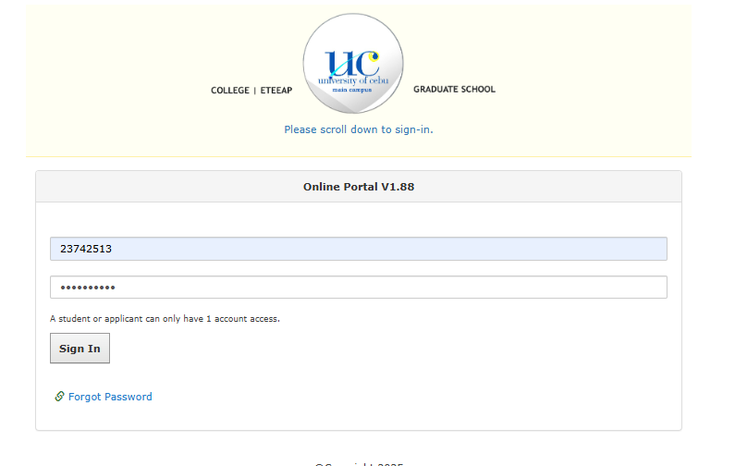

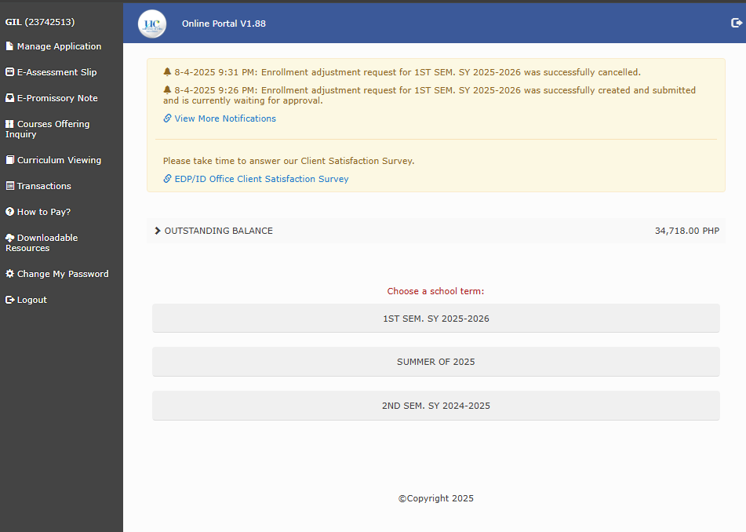

Test Case ID: TC-003
Test Scenario: Empty fields — both fields left blank
Interpretation: Pass

