DFU Instructions

Carl Demolder

3/3/2021

**Process #1**

1. Generate private key. Private key is located inside the folder where the bootloader build files are located.
2. Copy the public key into the DFU application folder that you want to store the DFU zip folder.
3. Build the bootloader file. Copy the bootloader hex file (.hex) into the DFU application folder that you want to eventually store the DFU zip folder.
4. Generate the DFU.zip packet containing the application, bootloader, and soft device hex file. Sometimes, one does not need to update the bootloader and Soft Device. In that case, one would generate the DFU zip packet containing only the application hex file.
   1. To generate the DFU zip packet, go to your command prompt and make sure you have ‘nrfutil’ functionality installed on your system. Run the following script: nrfutil pkg generate --hw-version 52 --application-version **1** --application **nrf52832_xxaa.hex** --sd-req **0x98** --key-file private.key **app_dfu_package.zip**
      1. **‘nrf52832_xxaa.hex’** is the name of the application hex file.
      2. **‘app_dfu_package.zip’** is the name of the output DFU zip folder.
      3. **‘1’** is the number of the application version. The application version must be at least equal or higher than the original version.
      4. **‘0x98’** is the soft device version. For soft device version 7.2.0 is 0x0101
5. Flash Soft Device onto device. For example, flash the following file: “sd-nrf52-s132-7_2_0-X01.hex”
   1. This step should be performed before the chip is mounted on the board.
6. Flash bootloader onto device. For example, flash the following file: “bl-nrf52-s132-X01.hex”
   1. This step should be performed before the chip is mounted on the board.
7. Go to the nRF Connect App or program on your desktop or android device to perform a DFU upload.
8. Once you have the program uploaded, connect to the target device. Make sure it is advertising as “DFUTarg”.
9. Enable the Secure DFU characteristic.
10. Select the DFU zip file stored on your drive and begin secure DFU transfer.

**Process #2**

Steps to combine application, bootloader, and soft device image using a single bootloader. Follow this method to upload firmware onto the chip before mounting the device on a flexible substrate.

1. To combine all three hex files, one must modify the bootloader and change the bootloader settings. The purpose of this is to ‘trick’ the bootloader into thinking that the application is not already loaded onto the device.
2. Run the following script: nrfutil settings generate --family NRF52 --application **yourApplication.hex** --application-version **0** --bootloader-version **0** --bl-settings-version **1** **bootloader_setting.hex**
   1. **“yourApplication.hex”** is the name of the application hex file
   2. **“0”** is the name of the application version. This field is the same as the application version used to generate the zip folder for secure DFU. This application version must be at least equal or higher than the original version.
   3. **“0”** is the bootloader version number. This field is used to enumerate the revision number for the bootloader.
   4. **“1”** is the bootloader settings version. This field is used to indicate what SDK version one is using. For SDK v15.3
   5. **“bootloader_setting.hex”** is the name of the bootloader settings hex file.
3. Next, the **“bootloader_setting.hex”** is going to be merged with the bootloader and with the following optional choices:
   1. Application
   2. Soft Device
4. Run the following script: mergehex --merge hexfile1.hex hexfile2.hex --output output.hex
   1. **“hexfile1.hex”** is the bootloader settings hex file.
   2. **“hexfile2.hex”** is the bootloader hex file.
   3. **“output.hex”** is the output hex file.
5. Then one can merge the bootloader and bootloader settings hex file with the application and soft device.
6. With this method, we can use a single hex file to flash multiple devices and don’t have to do OTA DFU to flash the application.

**Process #3**

This process details how to update the bootloader, application, and soft device through DFU update. The following table highlights what combination of updates are available. Ideally, one would never have to update anything besides the application. However, in the case that one needs to, the following process can be followed. The list of combinations that are available are listed below:

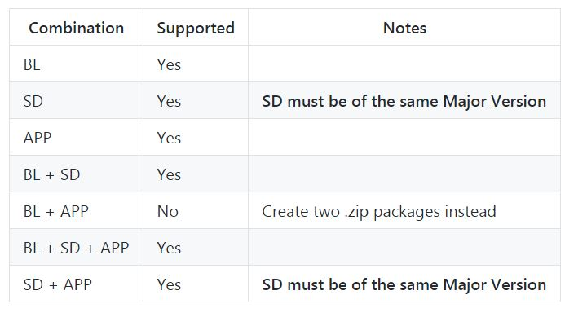

BL = Bootloader; SD = Soft Device; APP = Application

1. Run the following script: nrfutil pkg generate --hw-version 52 --application-version **1** --application **application.hex** --sd-req **0x98** --softdevice **softdevice.hex** --key-file private.key **app_dfu_package_softdevice.zip**
   1. **“1”** is the application version.
   2. **“application.hex”** is the application hex file that you want to use DFU upload.
   3. **“0x98”** is the soft device version. For soft device version 7.2.0 is 0x0101
   4. **“softdevice.hex”** is the soft device hex file that you want to use DFU upload.
   5. **“app_dfu_package_softdevice.zip”** is the DFU upload zip file that will be uploaded through an app or program.
   6. From nRFUtil v3.2 a --sd-id parameter is added. This is required if the package contains SD (+BL) + APP. So that the --sd-id should match the softdevice ID of the new softdevice when the --sd-req should match the softdevice ID of the old softdevice.