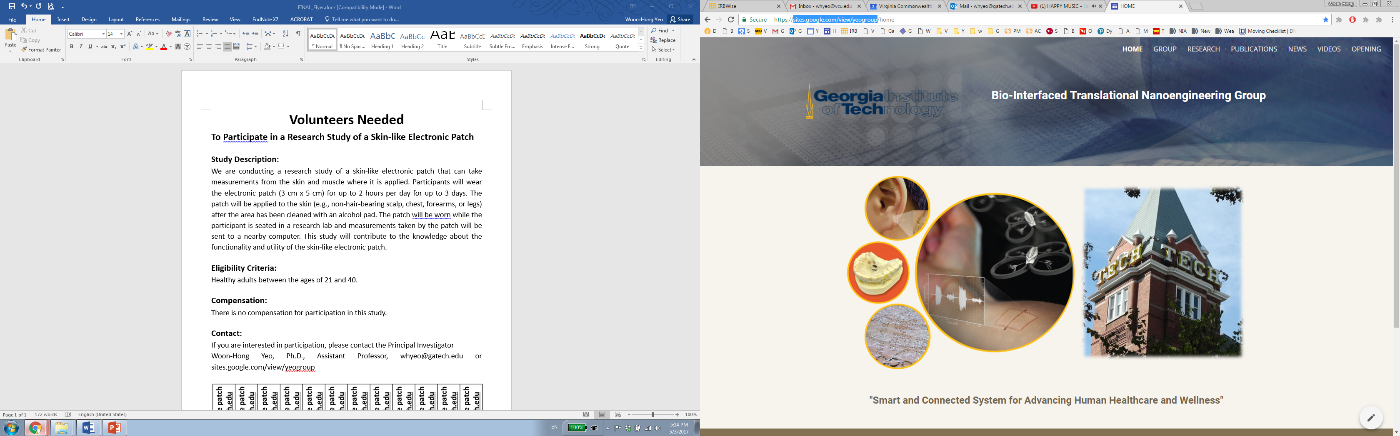

**Volunteers Needed**

**To Participate in a Research Study of a Wearable Sensor Glove**

**Study Description:**

We are conducting a research study of a wearable sensor glove that can take measurements from the applied forces and conditions on the hand. Participants will wear the wearable sensor glove for up to 2 hours for a single study session. The wearable glove will be worn by the participant on their right hand. The wearable sensor glove will be worn while the participant is seated in a research lab and measurements will be taken by the wearable sensor glove and sent to a nearby computer/tablet while the participant completes a set of simple tasks. This study will contribute to the knowledge about the functionality and utility of the wearable sensor glove.

**Eligibility Criteria:**

INCLUSION:

• Can speak, read, and write English fluently

EXCLUSION:

• This study does not include certain participants like pregnant women, since we do not know how pregnancy would affect the physiological signals. During subject recruitment, we will verbally ask about pregnancy

• This study does not include participants who are in EU countries

• The subject is not allergic to the fabric material that constitutes the fabric glove

• Individuals who cannot read, write, and speak English fluently

**Compensation:**

There is no compensation for participation in this study.

**Contact:**

If you are interested in participation, please contact the Principal Investigator

Woon-Hong Yeo, Ph.D., Assistant Professor, whyeo@gatech.edu or sites.google.com/view/yeogroup

