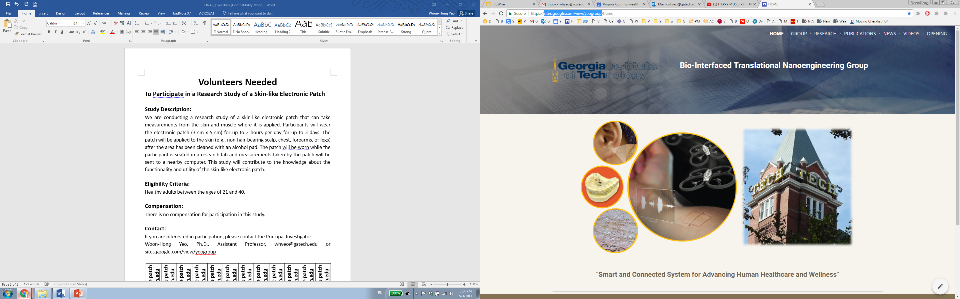

**Volunteers Needed to Participate in a Research Study of a Wearable Sensor Glove**

**Study Description:**

Would you like to participate in a preliminary research study of a wearable sensor glove that will be used in the future to improve the neuromotor control of impaired limbs in children. Participants will wear the wearable sensor glove for up to 2 hours for a single study session. The wearable glove will be worn by the participant on their right hand, while the participant is seated in a research lab. Measurements will be taken by the wearable sensor glove and sent to a nearby computer/tablet while the participant completes a set of simple tasks. This study will contribute to the knowledge about the functionality and utility of the wearable sensor glove.

**Eligibility Criteria:**

INCLUSION:

* Can speak and read English fluently
* Healthy adults between the age of 18 and 40 years old

EXCLUSION:

* This study does not include certain participants like pregnant women, since we do not know how pregnancy would affect the physiological signals.
* There are no minors in this study
* The subject is not allergic to nylon material, as that material is used as the fabric glove
* Individuals who cannot read and speak English fluently

**Compensation:**

There is no compensation for participation in this study.

**Contact:**

If you are interested in participation, please contact the Principal Investigator

Woon-Hong Yeo, Ph.D., Assistant Professor, whyeo@gatech.edu or sites.google.com/view/yeogroup

