A. Supplied by Venue:
1. Furniture:
Podium and small table (front of room)
Classroom table and 2 chairs (middle or back of room.)

2. Electrical:
power and power strip to small table
power and power strip on classroom table

3. AV:
hdmi for projector at small table
XLR at classroom table

B. Pre show setup:

1. Camera and video mixer table:

Tripod:
only operate lower leg latches when uppers are latched.
Unlatch lower first, latch lower last.
to extend legs: unlatch lower, then upper. Pull legs out. Latch upper, then lower.
Over rear right corner of classroom table.

Extra cables go on floor under tripod.

Put desktop video mixer pc on floor near tripod, on side, air vents up.
Power to power strip.
Mouse keyboard on table, plug in usb.

Camera:
open case when tripod is ready. Remove from case, put on tripod.
(Camera should be in the case or on the tripod. don’t put the camera on a table.)
power to power strip.
XLR to input 1
hdmi to bm card in video mixer pc
secure cables to pan handles with velcro
camera audio:
L is input 1 (xlr)
R is mic
both gain to 8
plug in head phones to camera

turn on camera,
do sound check #1, L is working.

LCD monitor for mixer:
un box,
assemble stand
put foam back in box
power to power strip
hdmi to video mixer PC
move headphones from camera to pc

Power on video mixer pc
when booted, click Lucky Cat to launch Voctomix gui

Sound check #2
left is working
levels are orange or a little red – hitting the top is bad.

50’ Eathernet from video mixer pc rj-45 to front of room.

2. Podium hdmi2usb capture:

turn on projector
power strip on small table.

unbox and assemble lcd confidence monitor, Styrofoam back in box.
Power to power strip

Unbox hdmi2usb box,
power to power strip

hdmi port names/locations: output 0, output 1, input 0, input 1 (usb-b port)
note: on power up, output 1 will send a test pattern
note: input0 and 1 – cable end will be labeled “TV”

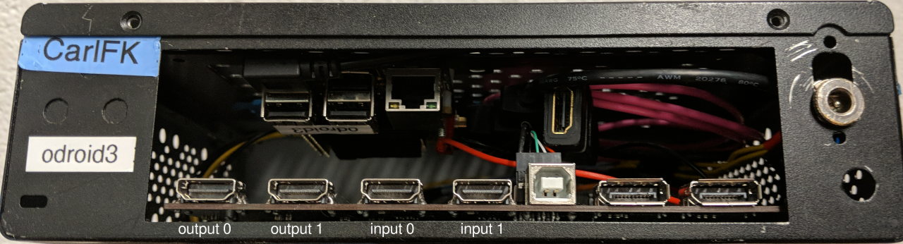
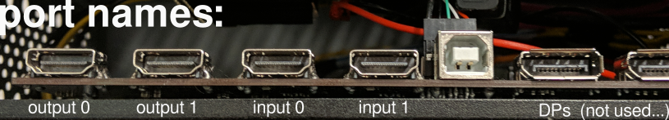

plug cables into ports:

output 1 to LCD (short hdmi)
confirm test pattern on LCD

unplug short from output 1

output 1 to venue projector cable
confirm test pattern on projector screen
move projector cable from output1 to output0

Use “magic cable” (thin, ends labled “source” and “TV”)
connect input 1 to Output 1 (loops test pattern into input1)
plug end labled “TV” into input 1
plug end labeled “Source” into output 1
confirm test pattern on projector screen

Unplug “Source” end from output 1, put on podium for presenter's laptop
short hdmi back to output 1 (to LCD)
confirm test pattern on LCD

Eathernet cable to SBC (single board computer) rjj-45 port
(the other end should be plugged into video mixer in back of room)
test pattern on LCD should go away, replaced with black (or purple?)

mount hdmi2usb box on back of confidence monitor vesa mounts.

Plug in preventer's laptop
confirm preventer's laptop output on:
confidence monitor
projector screen
Grabber feed on voctogui screen

secure eathernet and other cables (tape where needed)

