Introduction to AI and Machine Learning Assignment 1
Module Code: COMP40044
Module Name: Introduction to AI and Machine Learning
Student ID: 2403018

Contents
Task 1 – Classification Models 1
Explanation of Classification Problem 1
Dataset 1
Initial Explorations 1
Exploratory Data Analysis of Dataset 3
Third Party Data Distributions 5
Data Preparation 10
Build Machine Learning Models 13
Test Performance of Models 13
Logistic Regression 14
Decision Tree 14
Artificial Neural Network 15
Task 2 – Clustering Models 15
Explanation of Problem 15
Dataset 15
Data Understanding 16
Data Preparation 19
Build Machine Learning Models 21
K-Means Clustering 22
DBSCAN Clustering 23
Test Performance of Models 25
Task 3 – Association Rule and Linear Regression Models 25
Part A - Association Rule 25
Explanation of Problem 25
Dataset 25
Data Understanding 26
Data Preparation 28
Build Machine Learning Models 28
Test Performance of Models 29
Part B - Linear Regression 31
Explanation of Problem 31
Dataset 31
Data Understanding 31
Data Preparation 32
Build Machine Learning Models 32
References 34

Task 1 – Classification Models

Explanation of Classification Problem
In Task 1, I intend to use a third-party dataset that has similarities to my organisation’s dataset to build a robust classification model that can identify whether a customer is likely to churn (or stop subscribing to a product) based on certain demographic factors, their tenure and various mapping services and products they use. I intend to explore and prepare the data before building three separate classification models and comparing their results. The classification algorithms I intend to use are logistic regression, decision tree and Artificial Neural Network (ANN).

Dataset
The third-party dataset I am using comes from a Telco Customer Churn dataset on Kaggle (BlastChar, 2016/2017) .

Initial Explorations
The customerID and Total Charge columns were removed, with this line of code:
Code to Drop Columns
The customerID was removed because of its uselessness for analysis, and TotalCharges was removed due to missing data, which was discovered with this line of code:
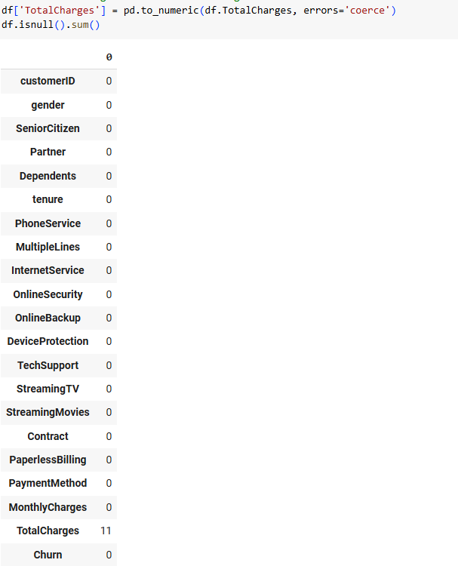
Code Showing Null Values
Further analysis may have found out why the values there were null, but speculation about why could be wrong and change the data, so it was dropped from the dataframe instead of putting in false information.

Exploratory Data Analysis of Dataset
Characteristics | Third-party Dataset | Business Dataset
Classifications / Labels | 2 labels: Churn (Yes/No) | 2 labels: Cancelled (Yes/No), maps to Churn easily
Classifications Table
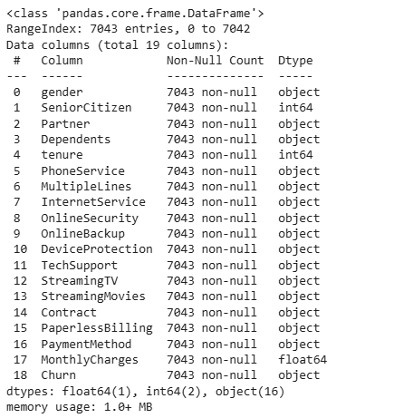
Data Types

Third-party Data Types | Business Data Types
gender: non-null object (Male/Female) | Gender: non-null object (Male/Female)
SeniorCitizen: non-null int64 (0/1) | Age: non-null int64. This numeric value could be converted to a boolean to represent the same form of data as the SeniorCitizen value in the third-party dataset.
Partner: non-null object (‘No’/ ‘Yes’) | Partner: Boolean. Could easily represent the Partner field in the third-party dataset.
Dependents: non-null object (‘No’/’Yes’) | Dependents: non-null int64. This is a numeric value rather than a stringed boolean value like in the third-party dataset but could easily be converted to a boolean value.
Tenure and MonthlyCharges: float64 | Tenure and MonthlyCharges: as the two float variables, would be available, but might have to be converted from DateTime and currency values.
Churn: non-null object (‘No’/’Yes’) | Churn: Boolean, this could be easily converted over.
Other Categorical Variables | The categorical variables won’t be the same, but other variables such as which products the customer uses, would be similar enough.
Data Types Table

Third-party Dataset Size | Business Dataset Size
7043 rows, 18 columns (after dropping customerID and TotalCharges). | Probably around 500,000 rows. Columns could be set to the same demographic columns as the third-party dataset easily, and the rest of the columns could be made up by features/ products the customer is using, so 18 rows.
Dataset Size Table

Third Party Data Distributions
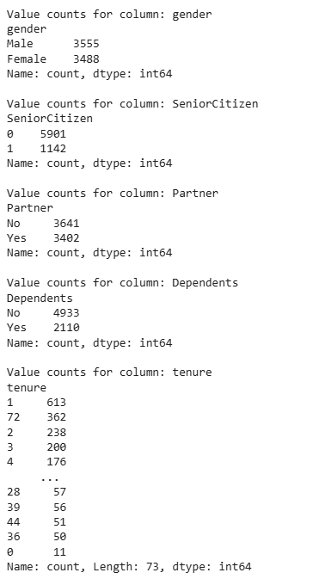
Data Distributions 1
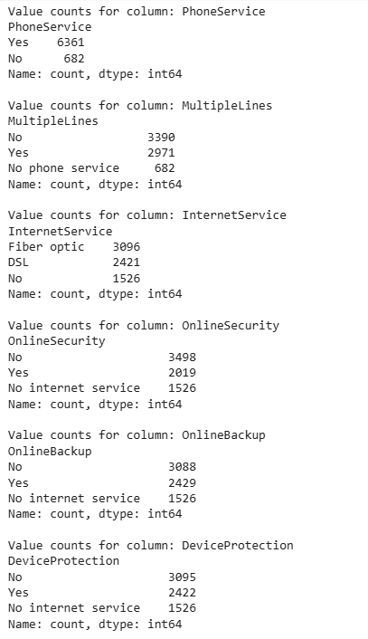
Data Distributions 2
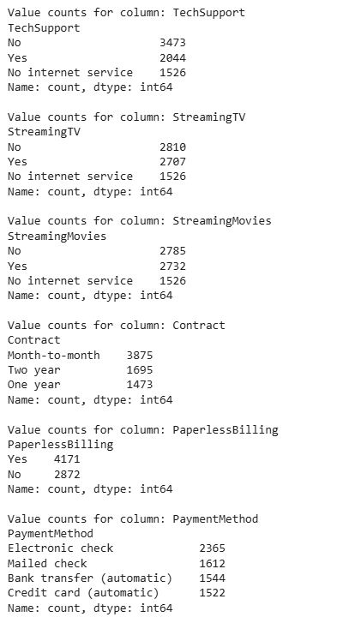
Data Distributions 3
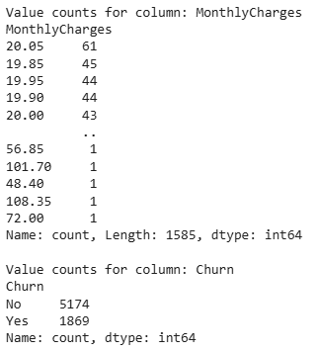
Data Distributions 4
Distributions for the business dataset would be somewhat like the distributions in the third-party data, with somewhat more of a skew towards older people (therefore more senior citizens and those with dependents).
Third-party Dataset Missing Values | Business Dataset Missing Values
There are no missing values in the dataset. The only blank values were in TotalCharges, but that was removed from the dataframe. | There may be missing values for some columns in the dataset, such as Partner or Dependents.
Missing Values Table
Third-party Dataset Outliers | Business Dataset Outliers
Due to the essentially boolean/ numeric and categorical nature of most of the columns, there aren’t outliers there. However, the numeric fields will have outliers, but they are related to MonthlyCharges and tenure and therefore can’t be removed as they are valuable data. | There may be outliers in terms of numeric columns such as Age and Dependents, but because they would be converted to boolean values for the sake of the classification model, this will not be a problem.
Outliers Table

Third-party Dataset Insights | Justification of the Dataset Selection
Gender is evenly distributed.  Senior citizens are underrepresented in the data.  Those with partners and without are evenly distributed.  Those with dependents are underrepresented in the data.  Because partner status and gender are so equally distributed, but senior citizen status and dependents status are so heavily skewed towards non-senior citizens and not having dependents, it is likely most of the data is from young adults who do not have children yet.  Most of the categorical variables are balanced, especially after combining values like ‘No x service’ and ‘No’ into a single False category when encoding boolean columns that originally had three distinct values. | The size of the third-party dataset is smaller than the business dataset but still contains enough records to be useful to prove the model will work, as Huyen (2024) says: “Before investing in curating a large dataset, you might want to start with a small, well-crafted dataset … to see if finetuning can improve the model. If this small dataset is sufficient to achieve your desirable performance, that’s great. Clear improvements suggest that more data will improve the performance even more. If no improvement is observed with small data, a bigger dataset will rarely do the trick.” The distributions for gender and partner status are balanced, meaning there won’t be overfitting for either category. The senior citizen percentage is to be expected, as a percentage of senior citizens in the dataset is 16.21%, whereas the population of people aged 65 and older in the UK was 18.6% in the 2021 census (Office for National Statistics, 2023), which is similar. churn status also lines up with the business dataset’s cancelled status, and dependents status may have some feature relevance to churn due to its uneven nature. The churn status should have its class weight evenly distributed in the models to make up for churn status being uneven, as ‘class imbalance often means there’s insufficient signal for your model to learn to detect the minority classes” (Huyen, 2022). Therefore, as the churn status is weighted heavily towards non-churn, any models must have evenly weighted classes to counteract this problem.
Justification Table

Data Preparation
The following code was run to preprocess the datasets for the Logistic Regression, Decision Tree and Artificial Neural Network Models:
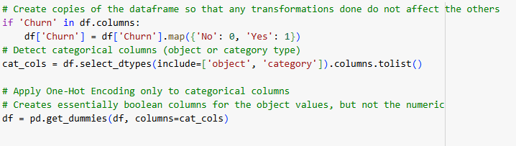
Data Preparation
This turns every categorical variable that is of type object into a boolean column of its own. Like so:
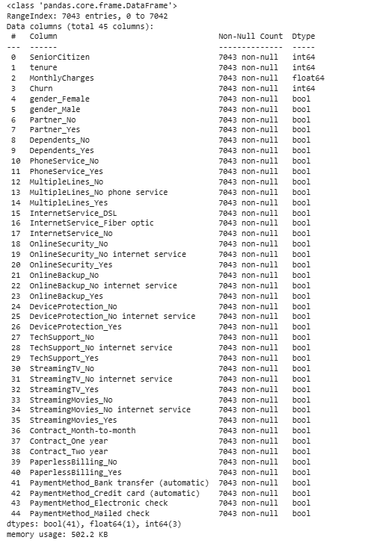
Prepared Datatypes

Logistic Regression | Decision Tree | Artificial Neural Network
The data preparation uses boolean features because they are more easily interpretable for logistic regression models, as “The odds ratio is easiest to understand for a binary factor variable X” (Bruce, Bruce, & Gedeck, 2020), but the number of columns may lead to overfitting. | Decision trees can handle many features, so creating more columns should not affect it too much, but the high cardinality may lead to overfitting. Another reason for this is “decision trees are capable of handling categorical features without the need for encoding. However, its popular implementation in scikit-learn still requires all features to be numerical” (Lewinson, 2020). As scikit-learn was used for the models I created, I had to make some categorical values boolean (which translate to numerical binary). | For neural networks, changing everything into boolean columns is useful because they cannot process string data, which is what most of the object type columns were before. Most of the categorical columns had either two or three categories, so making them boolean made sense. Making sure all the columns were numeric or boolean therefore works for this. Otherwise, for categorical data, ordinal relationships would potentially have to be established using numerical data, which could imply an order that doesn’t exist.
Data Preparation Reasons

Build Machine Learning Models
Here is the code that built the machine learning models:
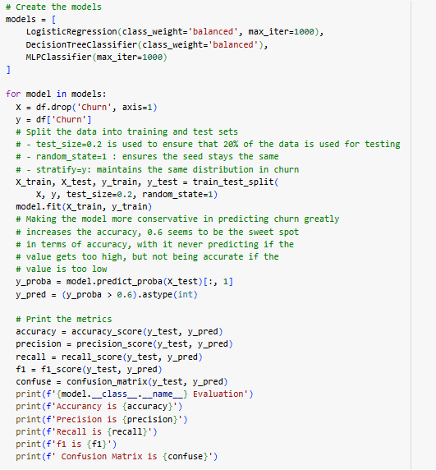
Building and Running the Models

Test Performance of Models
The Churn status percentages were 73.46% for No and 26.54% for the Yes. This means that any accuracy higher than 73.46% is better than a model that only responds with No for every classification, and indicates the model is probably working correctly.

Logistic Regression
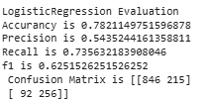
Logistic Regression Model Results

Evaluation Metrics | Logistic Regression Model
Accuracy | The Logistic Regression Model seems to have decent accuracy at 0.78
Precision | Precision is moderately good at 0.54, but still shows it getting many false positives
Recall | The recall shows that most of the actual positives are being correctly identified at 0.74, but this could mean it is overpredicting churn
f1 | There is a decent balance between precision and recall at 0.63
Confusion Matrix | The false positives are relatively high; the false negatives are low
Logistic Regression Model Results Table

Decision Tree
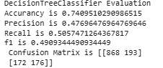
Decision Tree Model Results
Evaluation Metrics | Logistic Regression Model
Accuracy | The accuracy of the Decision Tree is barely better than the churn status ratio at 0.74, which indicates the model is not that accurate
Precision | The precision is low at 0.48
Recall | The recall is low at 0.51
f1 | There is a decent balance of precision and recall, but it is not good at 0.49
Confusion Matrix | The confusion matrix shows a high number of false positives and negatives, making it the weakest classification model of the three
Decision Tree Model Results Table

Artificial Neural Network
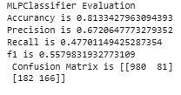
Artificial Neural Network Model Results

Evaluation Metrics | Logistic Regression Model
Accuracy | The accuracy of the ANN is the highest of the three models at 0.81, doing significantly better than the churn ratio
Precision | The precision is strong at 0.67
Recall | The recall is weaker than the Logistic Regression Model at 0.48
f1 | A decent balance of precision and recall
Confusion Matrix | The false positives are low, but the false negatives are high, overall, the ANN is the strongest model of the classification models
Artificial Neural Network Results Table
In terms of the business problem, I would try to map the ANN model to my business dataset to identify whether someone is likely to churn based on data. From there, those customers that are more likely to churn could be specifically targeted to prevent them churning. Potentially this could influence future data, however, which may skew future results and require data about customer targeting to be added to not lead to inaccurate models in the future.

Task 2 – Clustering Models

Explanation of Problem
In Task 2, I intend to use a third-party data set that has similarities to my organisation’s dataset to build a robust clustering model that can identify clusters of customers, so that my organisation can identify potential hidden demographics that we should be targeting as customers for our mapping software. I intend to explore and prepare the data before building two clustering models and comparing their results. The clustering algorithms I intend to use are K-Means Clustering and DBSCAN.

Dataset
The third-party dataset I am using comes from a Shopping Mall Customer Segmentation dataset on Kaggle (Mustafa, 2023/2024).

Data Understanding
Third-party Dataset Clustering Goal | Business Problem Clustering Goal
Group mall customers based on features, after using Principal Component Analysis | Group mapping software customers based on features, after using Principal Component Analysis
Data Goal Table
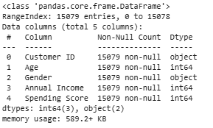
Data Types

Third-party Data Types | Business Data Types
Customer ID: non-null object | Customer ID: non-null object
Age: int64 | Age: int64
Gender: non-null object (Male/Female) | Gender: non-null object (Male/Female)
Annual Income: int64 | Average Income at Postcode: int64 (calculated based on postcode)
Spending Score: int64 (based on customer behaviour and purchase data) | Spending Score: int64 (calculated from purchases of mapping software)
Data Types Table
Third-party Dataset Size | Business Dataset Size
15078 rows, 4 columns (after dropping Customer ID). | Probably around 500,000 rows, 4 columns.
Dataset Size Table
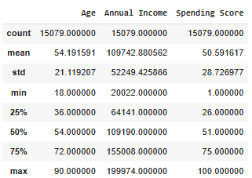
Data Distributions Numeric
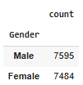
Data Distributions Gender
The variation in annual income, age and spending score is quite large, but based on the distributions it seems to represent a bell-curve and therefore there doesn’t seem to be a need to adjust using interquartile ranges. The gender ratio is also well balanced.

Third-party Dataset Missing Values | Business Dataset Missing Values
There are no missing values in the third-party dataset.  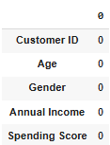  Missing Values Check | There may be missing values for some columns in the dataset, values such as Annual Income and Age would have to be optional for customers.
Missing Values Table
Third-party Dataset Outliers | Business Dataset Outliers
Gender does not have any outliers. Annual Income, Spending Score and Age all follow a bell-curve based on identified minimum values, maximum values and interquartile ranges so there are no true outliers. All three variables show symmetry around the mean. | There may be outliers in terms of numeric columns such as Age and Annual Income.
Outliers Table
Third-party Dataset Insights | Justification of the Dataset Selection
Gender is evenly distributed between Male and Female. The three numeric variables are normally distributed. | The size of the third-party dataset is smaller than the business dataset but should be good to test the model.  The evenly distributed Gender column and the normally distributed numeric columns lend themselves well to K-Means Clustering, as without normal distributions “k-means does not behave very well when the clusters have varying sizes, different densities, or nonspherical shapes” (Géron, Hands-On Machine Learning with Scikit-Learn, Keras, and TensorFlow, 3rd Edition, Chapter 9, 2022). This is not a problem for DBSCAN, although if it was significantly unevenly distributed it could cause problems as “If the density varies significantly across the clusters, however, or if there’s no sufficiently low-density region around some clusters, DBSCAN can struggle to capture all the clusters properly” (Géron, 2025 (early release)).
Justification Table

Data Preparation
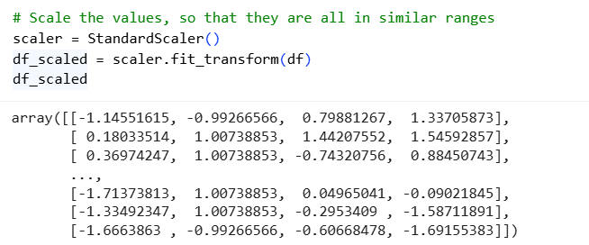
Scaling of Dataset
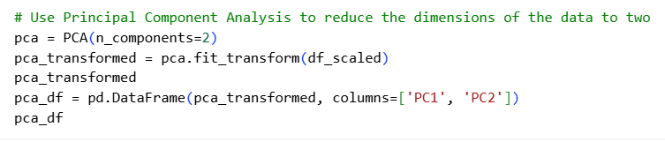
Principal Component Analysis
Data Preparation Step | Reason
Scaling Variables | Principal Component Analysis (PCA) is a variance-based technique, as the scales between Age, Annual Income and Spending Score are so varied, without first scaling the data PCA would be biased toward Annual Income, which has the highest variance. Jafari (2022) writes “to ensure each attribute will get fair and equal attention from PCA, we will standardize the dataset” in reference to what should be done to uneven scales in the dataset.
Conversion to two-dimensions with Principal Component Analysis | Allows the visualisation of clusters in two-dimensions. It can also decorrelate related features. It prevents the problem where “high-dimensional data can be troublesome for many clustering techniques” (Grootendorst & Alammar, 2024).
Conversion of Gender to boolean to act as numeric | This will simply allow it to act as a 0s and 1s for the purposes of the models. For models that can only handle numeric data this is essential.
Data Preparation Table
Here is the representation of the data after applying the transformations on a scatter graph:
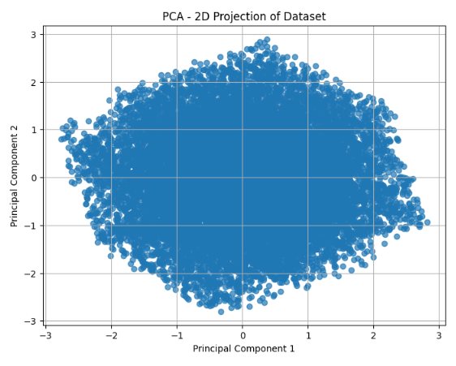
Scatter Graph
Already, at this point, it was hard to see where clusters would be identified to solve the business problem as there did not seem to be distinct clusters in the data.
The Elbow Method was used to identify the optimal number of clusters, which seemed to be 3:
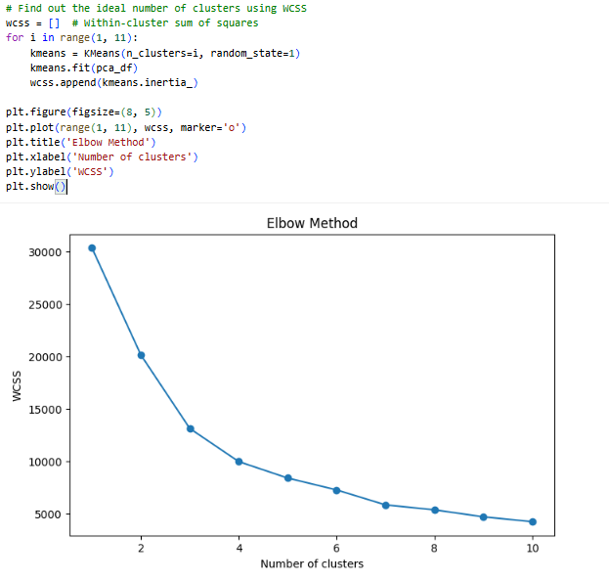
Elbow Method Graph

Build Machine Learning Models
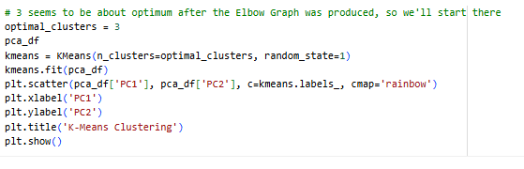
K-Means Cluster Model Building
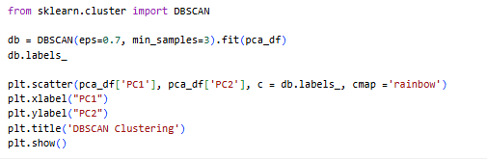
DBSCAN Cluster Model Building

K-Means Clustering
Initially, the K-Means Clustering did not identify any clear clusters:
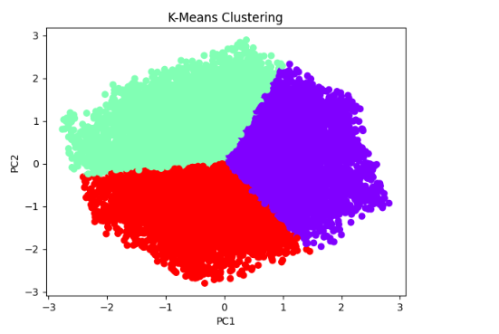
K-Means Clustering 1
Even reducing the amount of data present, to see if there were too many points, did not really identify any real clusters:
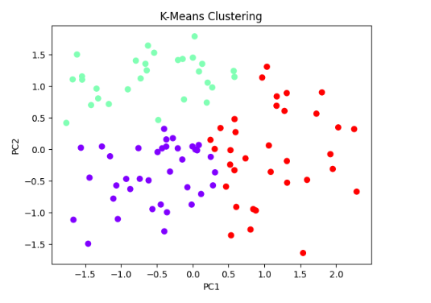
K-Means Clustering 2
This suggests that the data was so evenly distributed that specific clusters or groups of customers are hard to identify and separate from others, except by force (here represented by the fact that we assigned the K-Means model to always present three clusters.

DBSCAN Clustering
Initially, the DBSCAN also did not identify any clear clusters:
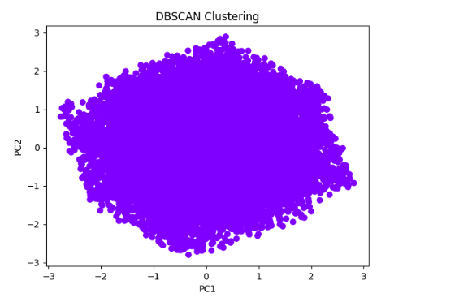
DBSCAN Clustering 1
Reducing the amount of data did discover an outlier (represented by the purple dot).
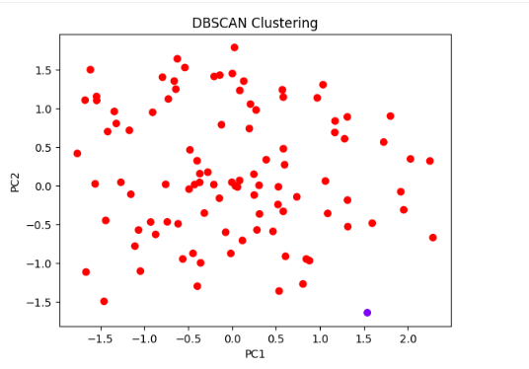
DBSCAN Clustering 2
Although this did not identify any real clusters either. Changing the epsilon and minimum sampling rates ended up leading to nonsensical clusters being formed:
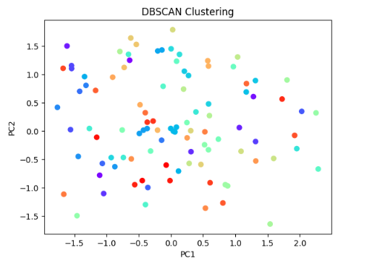
DBSCAN Clustering 3

Test Performance of Models

Overall, in terms of the business problem, it is difficult to say whether either model would map well. It could be that the business data would have more distinctive clusters, but due to the even distributions present in the third-party data, it is difficult to identify clusters and assess the performance of the models.

Task 3 – Association Rule and Linear Regression Models

Part A - Association Rule

Explanation of Problem
In Task 3 Part A, I intend to use a third-party dataset that has similarities to my organisation’s dataset to build a robust association rule model that can identify the likelihood of buying one mapping software product given that another software mapping product has also been purchased so that my organisation can offer recommendations on what to buy to customers. I intend to explore and prepare the data before using the Apriori algorithm to test whether the model works on the third-party dataset.

Dataset
The third-party dataset I am using comes from a Bakery Sales Dataset on Kaggle (Kuila, 2023/2024).

Data Understanding
Third-party Dataset Association Rule Goal | Business Problem Association Rule Goal
Identify association rules between buying one item at the bakery and buying another to offer discounts on certain groups of items together. | Identify association rules between buying one piece of mapping software and another and offer recommendations to customers to increase the likelihood of buying more mapping software per customer.
Data Goal Table
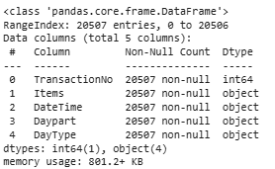
Data Types
Third-party Data Types | Business Data Types
TransactionNo: non-null int64 | TransactionNo: non-null int64
Items: non-null object | Software: non-null object
DateTime: non-null object (represents time of transaction) | DateTime: non-null object (represents time of transaction
Daypart: non-null object (‘Morning’, ‘Afternoon’, ‘Evening’, ‘Night’) | Daypart: non-null object (‘Morning’, ‘Afternoon’, ‘Evening’, ‘Night’) (derived from DateTime
DayType: non-null object (‘Weekend’, ‘Weekday’) | DayType: non-null object (‘Weekend’, ‘Weekday’) (derived from DateTime)
Data Types Table
Third-party Dataset Size | Business Dataset Size
20507 rows, 5 columns | Potentially millions of rows if each purchase is on its own row, 5 columns
Dataset Size Table
Third-party Dataset Missing Values | Business Dataset Missing Values
There are no missing values in the third-party dataset.  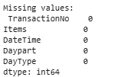  Missing Values Check | There should not be any missing values in the dataset.
Missing Values Table

Third-party Dataset Insights | Justification of the Dataset Selection
The data is split on every single item transacted, and not by the transaction number itself. This means that the transactions can be transformed to aggregate based on transaction number which would allow for association rules to be identified. | The size of the third-party dataset is smaller than the business dataset but should be good to test the model.  The date columns (DateTime, Daypart and DayType) really have no relevance in relation to the business question, therefore they will be removed, and the aggregation of transaction data will be what the association rules are based off. This is because “The objective of this class of data mining algorithms is not to predict an occurrence of an item, like classification or regression do, but to find usable patterns in the co-occurrences of the items” (Kotu & Deshpande, 2014).
Justification Table

Data Preparation
Data Preparation Step | Reason
Removing all DateTime, Daypart and DayType columns | This data was irrelevant to the actual business question being asked, because it would not correlate which items were bought together, and therefore could not be used to map to the business problem of software bought together.
Aggregation of the transactions into a list of items per TransactionNo:  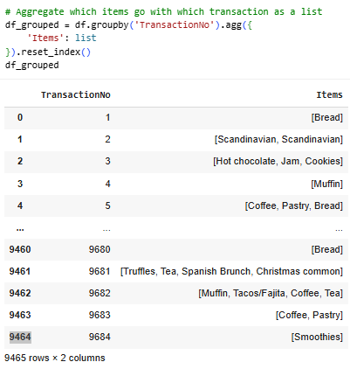  Aggregation Code | Because the purpose of association rule mining is to find usable patterns in the co-occurrence of items. As Kumar (2019) states regarding association rule mining: “Every transaction is identified by a primary key (distinct ID) called, transaction ID. All these transactions are studied as a group and patterns are mined.” This shows that the aggregation around the TransactionNo value must happen, as that is the equivalent of the third-party dataset’s ‘transaction ID’ here.
Data Preparation Table

Build Machine Learning Models
The model was built with appropriate values for the minimum support, minimum confidence, minimum lift and minimum lift to identify an association rule:
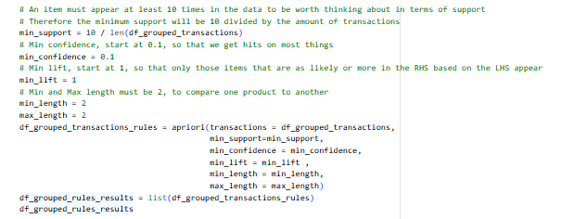
Apriori Algorithm Code
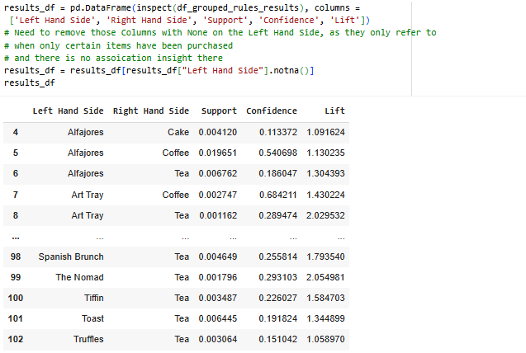
Apriori Algorithm Code 2

Test Performance of Models
The model’s association rules were highlighted using the following code:
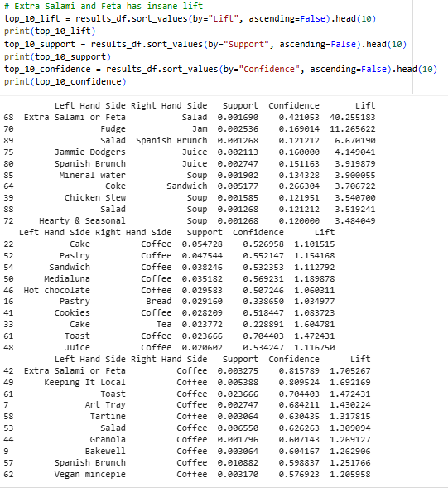
Apriori Algorithm Performance
As can be seen, there are some major outliers that regarding Lift such as the Extra Salami or Feta and Salad being bought together or Fudge and Jam being bought together. Although the actual support for these being bought is low, there is a suggestion that those that they are bought together at exceptionally higher rates than random chance.
In terms of support, Cake and Coffee are the most likely to be bought together in terms of sheer number, but not much higher than random chance.
In terms of confidence and support, Coffee is by far the most likely to pop up as another item in the association rule, which is to be expected.
Because of the highlighting of some outliers in terms of lift, this model would work well with the business problem as it would map well to finding niche software combinations and recommending them as well as finding common association rules that can be recommended to more people.

Part B - Linear Regression

Explanation of Problem
In Task 3 Part B, I intend to use a third-party two-dimensional dataset to create a linear regression model that can determine the relationship between the dependent variable of amount spent on mapping software and the amount of time spent using mapping software.

Dataset
The third-party dataset I am using comes from a Simple Linear Regression dataset using SAT and GPA scores on Kaggle (Apondo, 2022/2023).

Data Understanding
Third-party Dataset Association Rule Goal | Business Problem Association Rule Goal
Represent the relationship between SAT and GPA scores using a linear regression model. | Represent the relationship between the amount of money spent on mapping software and the amount of time spent using mapping software.
Data Goal Table
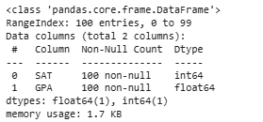
Data Types
Third-party Data Types | Business Data Types
SAT: int64 | HoursSpent: int64
GPA: float64 | MoneySpent: float64
Data Types Table
Third-party Dataset Size | Business Dataset Size
100 rows, 2 columns | Probably around 500,000 rows, 2 columns.
Dataset Size Table
Third-party Dataset Missing Values | Business Dataset Missing Values
There are no missing values in the third-party dataset. Here is the evidence from the code:  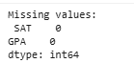  Missing Values Check | There should not be any missing values in the dataset.
Missing Values Table

Third-party Dataset Insights | Justification of the Dataset Selection
The relationship between GPA and SAT scores is positively correlated.  There are no missing values. | The size of the third-party dataset is small, and therefore a linear regression model may not have enough data to work properly. This is because of sampling noise, as stated by Géron (2025 (early release): “if the sample is too small, you will have sampling noise (i.e., nonrepresentative data as a result of chance)” in reference to linear regression models.  However, using Ridge or Lasso regression models may allow the small sample size of 100 to work in creating a linear regression model, and the scores being positively correlated should help as well.
Justification Table

Data Preparation
Data Preparation Step | Reason
There was no initial data preparation step. | This was because there didn’t need to be any scaling done, due to the fact there were only two dimensions, meaning it wouldn’t affect the results. There were also no missing or null values in the dataset.
After the initial run, the interquartile range method was used to remove outliers. Here is the code:  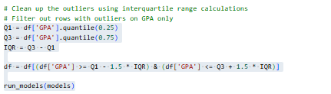  Interquartile Range Method Code | This was done to improve the results of the models.
Data Preparation Table

Build Machine Learning Models
Three machine learning models were built, Linear Regression, Ridge Regression and Lasso Regression. Initially these were the results:
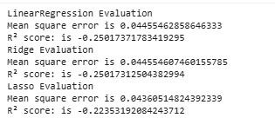
Regression Model Results 1

As can be seen, due to the R² score being negative on all three models, the model performs worse than predicting the mean, although the Lasso model performed slightly better than its counterparts.
After using the interquartile range method to remove outliers, here were the new results:
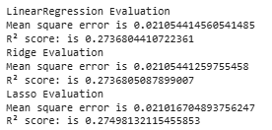
Regression Model Results 2
This shows that the amount of data was not a problem, but there were likely too many outliers affecting the results, as the R² score became positive after removing outliers, again with the Lasso model performing slightly better overall. Although the model is not performing well, it is accounting for some of the variance in the GPA. Therefore, when being used for the business problem, it would need to remove outliers from the business dataset to have any real chance of solving the business problem and identifying a relationship between the amount of money spent on mapping software and the amount of time spent using mapping software.

References
Apondo, J. (2022/2023). Simple linear regression. Retrieved from Kaggle: https://www.kaggle.com/datasets/japondo/simple-linear-regression
BlastChar. (2016/2017). Telco Customer Churn. Retrieved from Kaggle: https://www.kaggle.com/datasets/blastchar/telco-customer-churn/data
Bruce, P., Bruce, A., & Gedeck, P. (2020). Practical Statistics for Data Scientists (2nd ed.). O'Reilly Media, Inc.
Géron, A. (2022). Hands-On Machine Learning with Scikit-Learn, Keras, and TensorFlow, 3rd Edition, Chapter 9. O'Reilly Media, Inc.
Géron, A. (2025 (early release)). Hands-On Machine Learning with Scikit-Learn and PyTorch, Chapter 1. O'Reilly Media, Inc.
Géron, A. (2025 (early release)). Hands-On Machine Learning with Scikit-Learn and PyTorch, Chapter 8. O'Reilly Media, Inc.
Grootendorst, M., & Alammar, J. (2024). Hands-On Large Language Models, Chapter 5. O'Reilly Media, Inc.
Huyen, C. (2022). Designing Machine Learning Systems, Chapter 4. O'Reilly Media, Inc.
Huyen, C. (2024). AI Engineering, Chapter 8. O'Reilly Media, Inc.
Jafari, R. (2022). Hands-On Data Preprocessing in Python, Chapter 13. Packt Publishing.
Kotu, V., & Deshpande, B. (2014). Predictive Analytics and Data Mining, Chapter 6. Morgan Kaufmann.
Kuila, A. (2023/2024). Bakery Sales Dataset. Retrieved from Kaggle: https://www.kaggle.com/datasets/akashdeepkuila/bakery
Kumar, R. (2019). Machine Learning Quick Reference. Packt Publishing.
Lewinson, E. (2020). Python for Finance Cookbook. Packt Publishing.
Mustafa, Z. (2023/2024). Shopping Mall Customer Segmentation Data. Retrieved from Kaggle: https://www.kaggle.com/datasets/zubairmustafa/shopping-mall-customer-segmentation-data/data
Office for National Statistics. (2023, April 3rd). Profile of the older population living in England and Wales in 2021 and changes since 2011. Retrieved from ONS: https://www.ons.gov.uk/peoplepopulationandcommunity/birthsdeathsandmarriages/ageing/articles/profileoftheolderpopulationlivinginenglandandwalesin2021andchangessince2011/2023-04-03

