Things to do Before Exam
Review the Software Fundamentals VIP
Check the Revision Checklist
Mainly revision notes
Make it look more like the folders in the Revision Checklist
Do the mock papers
Review Personal Feedback
Describe the Problem for the Work Based Project
Define the scope of the Work Based Project
Define the problem in light of the decomposition diagram
Don’t have to code the entire project that is identified in the decomposition diagram
Add references to the work
Need to mention stakeholders, meetings and scope in the methodology question
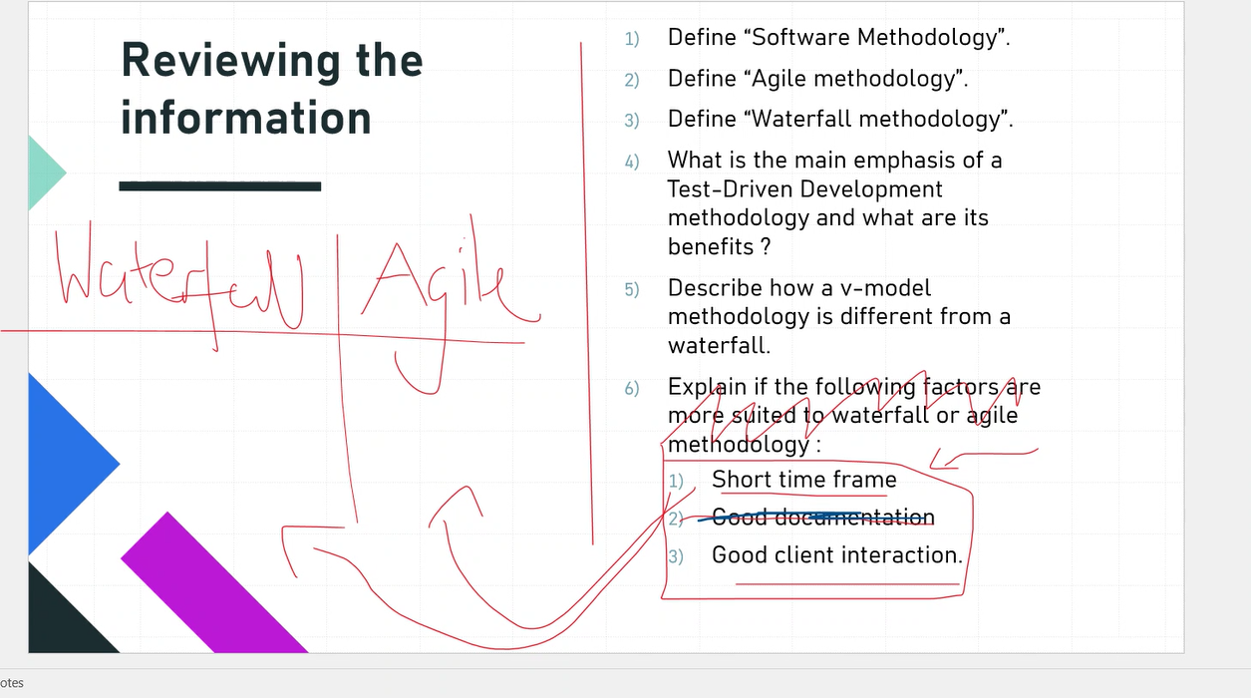
- Define “Software Methodology”
- A set of principles and practices when developing software. It involves all of the components of the Software Development Life Cycle, including requirements gathering, designing, writing documentation, development, testing, fixing and releasing the software.
- Define “Waterfall methodology”
- It is a linear software methodology, where each process flows from the next once completed. It goes from requirements gathering, design, implementation, verification and maintenance.
- Define “Agile methodology”
- It is a software methodology that emphasises flexibility, collaboration and customer centricity. It is iterative, and involves delivering small pieces of work and then responding to customer feedback before deciding on the next pieces of work.
- What is the main emphasis of a Test-Driven Development methodology and its benefits?
- The main emphasis of Test-Driven Development is writing tests before writing code that will pass it. The benefit is that breaking changes are immediately identified through breaking tests, and you can be sure that, for a given environment, the code works. It also helps increase test coverage.
- Describe how a v-model methodology is different from a waterfall.
- Development and testing phases run in parallel, therefore testing occurs much earlier in the process than in the traditional waterfall model. In this regard, it is also more flexible and can respond to things not working correctly much faster than traditional waterfall development.
- Short time frame, for waterfall it might be better if the requirements are known very well before, otherwise agile would be faster as responses to customer feedback can be more frequent and quicker
In terms of client interaction, agile is much better as the clients are often communicated with through the product owner and this can be done frequently. With the waterfall methodology, often it is done through contracts, which are difficult to negotiate.

