Deploying Blob Storage on Azure Using Azure Verified Modules
Module Code: COMP50047
Module Name: Cloud Architecture
Module Tutor: Dean Jones
Student ID: 2403018
Word Count: Total Word Count: 5666 words
Total Word Count for Main Content: 4132 words
Total Word Count for Main Content Excluding Tables: 3978 words

Contents
Introduction 1
Prerequisites for the Tutorial 3
Azure Experience 3
Access to an Azure Tenant for your Organization 3
Access to an Azure Subscription in that Tenant 3
Access to a Resource Group in that Subscription 3
Azure DevOps Experience 4
Access to an Azure DevOps Organization 4
Access to a Project in that Organization 4
An Azure Resource Manager Service Connection 4
Tutorial – Deploying Azure Blob Storage Using Azure Verified Modules 5
Step 1: Creating the Code Repository 5
Step 2: Writing the Bicep Code that Deploys the Blob Storage 9
Explanation of Infrastructure as Code 9
Potential Downsides of Infrastructure as Code 10
Explanation of Bicep 10
Explanation of Azure Verified Modules 10
Resource Modules 11
Pattern Modules 11
Utility Modules 11
Potential Downsides of Azure Verified Modules 12
Writing the Bicep Code 12
Step 3: Writing the YAML Code for Running the Deployment Pipeline 16
Explanation of Continuous Deployment and DORA Metrics 16
Potential Downsides of DORA Metrics 18
Writing the YAML Code 18
Step 4: Running the Deployment Pipeline/ Dealing with Issues 26
Step 5: Checking that the Blob Storage has been Created 29
Conclusion 31
Glossary 32
A 32
B 33
C 33
D 33
G 34
I 34
J 34
R 34
S 34
T 35
W 35
Y 35
References 36

Introduction
This report provides a step-by-step tutorial to deploying Azure Blob Storage using Azure DevOps Pipelines and Azure Verified Modules (AVM).
Azure Blob Storage is Azure’s storage solution for storing BLOb (Binary Large Object) data. BLObs are unstructured data, and Blob Storage is capable of storing massive amounts of this unstructured data (Microsoft Learn, 2025d). Practically, Blob Storage is used for storing images, documents or files. For simplicity, BLObs will be referred to by the more colloquial term ‘blobs’ for the remainder of this report.
Blob Storage is organised into three key resource types:

Resource Type | Purpose
Storage Account | Creates a unique namespace on Azure for your data
Container | Functions like a directory within the storage account to group blobs
Blobs | The actual data objects stored inside containers
Table 1: Blob Storage Resource Organisation

Here is a diagram explaining the hierarchy of resources for Blob Storage:
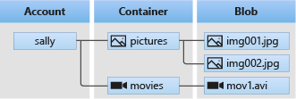
Hierarchy of Blob Storage Resources (Microsoft Learn, 2025d)

The tutorial is valuable for:
- Learning how to deploy cloud resources using Infrastructure as Code for repeatability and version control
- Understanding the benefits of Continuous Deployment in modern software engineering
- Gaining insight into how AVM works, and how it enforces best practices for security and compliance

Prerequisites for the Tutorial
In this tutorial, certain prerequisites are assumed to be in place prior to starting.

Azure Experience
This tutorial assumes a basic understanding, knowledge and familiarity with Azure. The user of this tutorial should be at least familiar with basic cloud concepts and the Azure Resource Hierarchy. This is to allow the user to understand key Azure concepts referenced in this tutorial.
Information about Azure in general can be found here: (Microsoft, 2025b)
Information about tenants, organizations and subscriptions in the Azure Resource Hierarchy can be found here: (Microsoft Learn, 2025l)
Information about resource groups in the Azure Resource Hierarchy can be found here: (Graham, 2025)

Access to an Azure Tenant for your Organization
The user of this tutorial will need access to an Azure Tenant in which they can read and deploy resources.
Information about setting up a tenant for your organization can be found here: (Microsoft Learn, 2025i)

Access to an Azure Subscription in that Tenant
The user of this tutorial will need access to a subscription inside the previously mentioned Azure Tenant to deploy resources into.
A tutorial on setting up a subscription can be found here: (Kumawat, 2025)

Access to a Resource Group in that Subscription
The user of this tutorial will need access to a resource group inside that subscription, in which they at least have the Azure Role-Based Access Control (RBAC) role of Reader so they can see whether their deployment has worked correctly.
Information about resource groups and how to create them can be found here: (Microsoft Learn, 2025m)
Information about Azure’s built-in roles can be found here: (Microsoft Learn, 2025e)
Information about how to assign roles can be found here: (Microsoft Learn, 2025k)

Azure DevOps Experience
Before starting, the user should have a basic familiarity with Azure DevOps, including how to navigate within Azure DevOps Organizations and Projects.
Basic information about Azure DevOps can be found here: (Microsoft, 2025e)

Access to an Azure DevOps Organization
The user of this tutorial will need access to an Azure DevOps Organization in which they can work through this tutorial.
Information about how to create an Azure DevOps organization can be found here: (Microsoft Learn, 2025g)

Access to a Project in that Organization
The user of this tutorial will need access to a Project inside that Azure DevOps Organization. Inside that Project, the user will need permissions to create and edit both repos and pipelines to carry out this tutorial.
Information about how to create an Azure DevOps Project in an Organization can be found here: (Microsoft Learn, 2025f)
In-depth information about Azure DevOps permissions can be found here: (Microsoft Learn, 2025j)

An Azure Resource Manager Service Connection
To allow for the deployment of resources, the user of this tutorial will need to have an Azure Resource Manager (ARM) service connection connecting the project in Azure DevOps to the subscription in Azure. This will allow for the deployment of resources in the Azure DevOps pipelines.
Information about how to create this service connection can be found here: (Microsoft Learn, 2025h)

Tutorial – Deploying Azure Blob Storage Using Azure Verified Modules
Note: for this tutorial, red lines on images are used to protect potentially sensitive information. Green lines with attached numbers are used to visually indicate where the user of this tutorial should carry out steps. Throughout this tutorial, there will be reference to Figures and labels. Figures are captioned for reference and labels are referenced by green lines with attached symbols on the images themselves. So, Figure X label Y would reference the part of the image captioned ‘Figure X: Example Image’ pointed to by the symbol ‘Y’, like so:

Figure X: Example Image

Step 1: Creating the Code Repository
- To start with you will need to be in the Azure DevOps Project that you intend to deploy the Azure Blob Storage from. Below is an example project, called ‘Engineering Academy’. Although your project will differ in the content in the middle, the layout of the page should be similar and look like Figure 1:
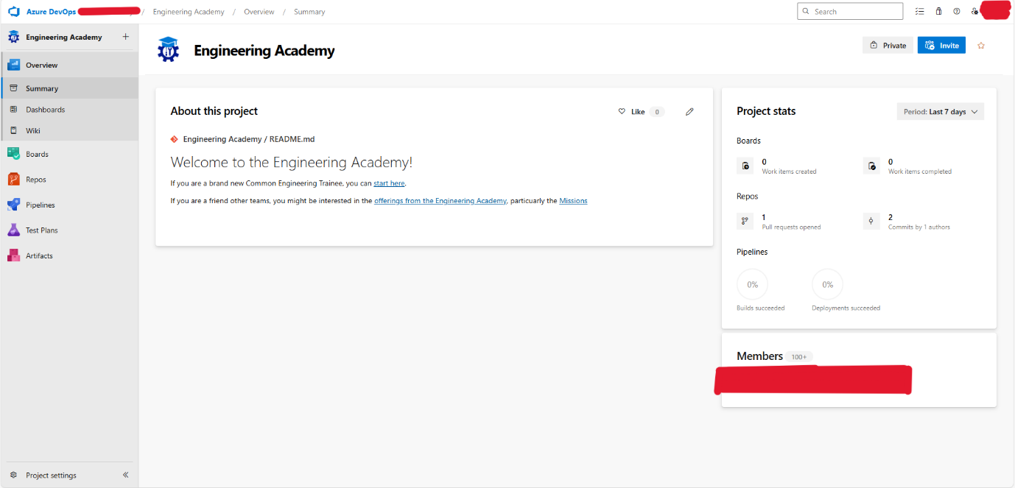
Figure 1: Initial Project Page

- You will then need to click on the ‘Repos’ button (Figure 2 label 1)
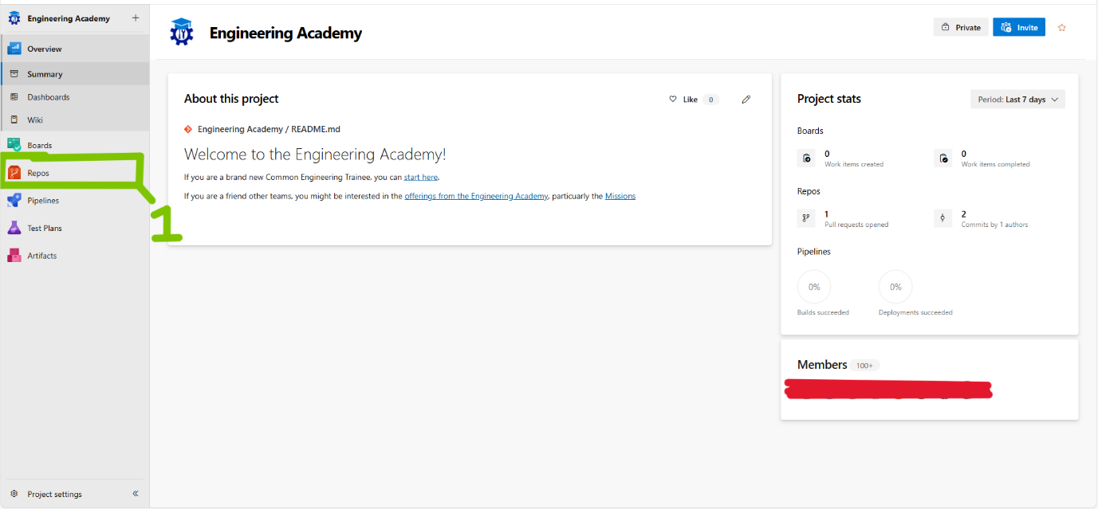
Figure 2: Repos Button on Project Page

- You will then need to click on the ‘Repositories’ drop-down menu (Figure 3 label 1):
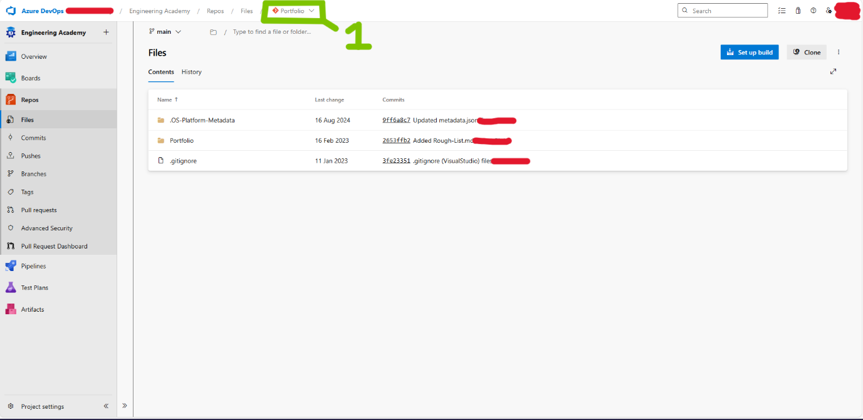
Figure 3: Repositories Drop Down Menu
- Then click on the ‘New Repository’ option in the drop-down menu (Figure 4 label 1):
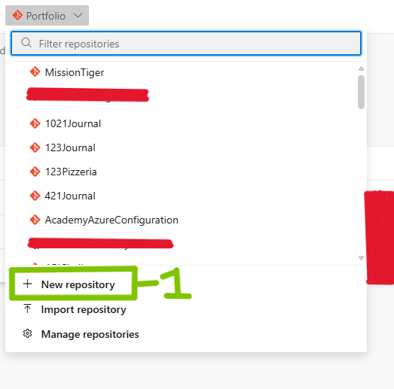
Figure 4: Drop Down New Repository

- Then, in the ‘Create a Repository’ modal, leave the Repository Type as git (Figure 5 label 1), name the Repository what you want (the example at Figure 5 label 2 calls it ‘avm-blob-storage-deployment’, but you may name it whatever you want). Leave the rest the same and then click Create (Figure 5 label 3):

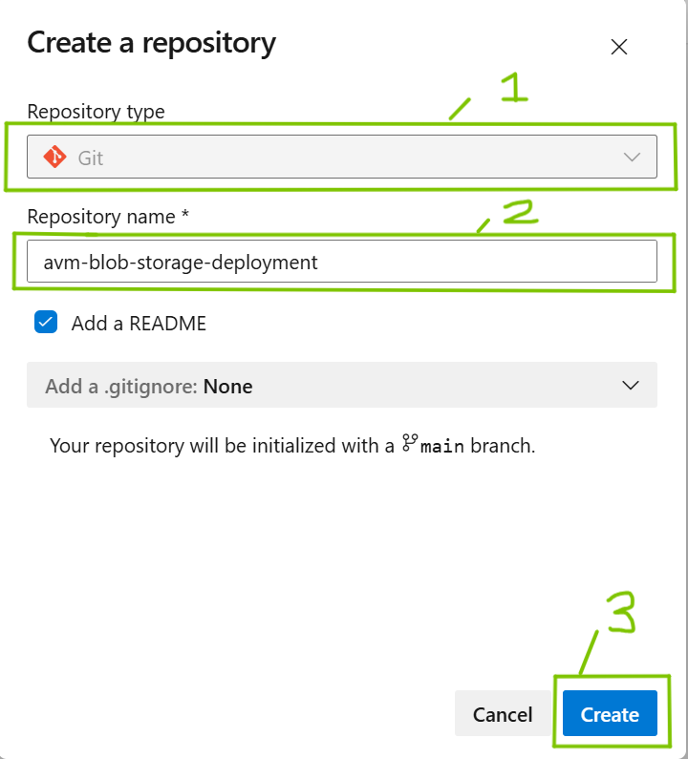
Figure 5: Create a Repository Modal

Step 2: Writing the Bicep Code that Deploys the Blob Storage
Next, you will need to create a Bicep file that will reference an Azure Verified Module that will deploy the Blob Storage into your Azure resource group. To understand why this is being done, instead of using Azure Portal’s Graphical User Interface (GUI), you will need to understand concepts such as Infrastructure as Code, the Bicep language, and Azure Verified Modules.

Explanation of Infrastructure as Code
Infrastructure as Code (IaC) is the practice where “Instead of creating and configuring infrastructure manually, using graphical interfaces, all infrastructure is described in configuration files that are then used to create the infrastructure automatically” (Been, Keilholz, & Staal, 2022). An example of IaC in practice would be creating a virtual machine on a cloud service by getting a deployment pipeline to run a configuration file that describes the specification of that virtual machine.
Using IaC allows for the provisioning of cloud resources to be carried out with “Faster deployment speeds, fewer errors, and consistency” (Lammle & Buhagiar, 2024). This leads to fewer cloud security issues because of the reduced risk of manual error. IaC also allows for version control to be applied to configuration files, allowing for rolling back infrastructure changes in the event of services failing and allows for infrastructure to be provisioned quickly in Disaster Recovery (DR) scenarios. IaC also allows for greener cloud use, as “infrastructure-as-code (IaC) practices ensures consistent and secure deployments, reducing the risk of misconfigurations… Organizations may drastically cut down on manual labor, lower the possibility of human mistakes, and maximize resource use by utilizing automation, which results in a cloud environment that is more safe, effective, and sustainable” (Patel, Dua, & David, 2025).

Potential Downsides of Infrastructure as Code
IaC practices take longer to implement initially than manual infrastructure management, and “There is a learning curve associated with IaC tools and their associated languages and frameworks, which can be a barrier to adoption for some teams” (Sehgal, 2023).
However, as with all automation, this initial investment of time usually pays off in the future and overall reduces the amount of time taken to provision resources in the cloud.

Explanation of Bicep
Resources in Azure are created by ARM. ARM templates are declarative configuration files written in JavaScript Object Notation (JSON) format to provision resources when a particular resource provider is provided with a correct JSON payload. A resource provider is a REST API provided by ARM which orchestrates the creation, deletion and updating of a specific Azure resource.
In Azure, IaC configuration files are written using either ARM templates, Bicep configuration files or Terraform files handled via the AzApi provider which provides “a very thin layer on top of the Azure ARM REST APIs” (Terraform, 2025). For the purposes of this tutorial, the configuration will be written in Bicep, as it is a Domain-Specific Language (DSL) that transpiles to an ARM template and “In most cases, Bicep provides syntax that is less verbose than the equivalent in JSON” (Microsoft Learn, 2025a). Bicep is developed by Microsoft and always supports the latest Azure features, whereas third-party tools like Terraform may have a slight delay in supporting new Azure capabilities.

Explanation of Azure Verified Modules
AVM is a set of pre-built IaC modules that comply with the Azure Well-Architected Framework (WAF). The WAF is “a set of quality driven tenets, architectural decision points, and review tools intended to help solution architects build a technical foundation for their workloads” (Microsoft Learn, 2025n). The pillars of the WAF are Reliability, Security, Cost Optimization, Operational Excellence and Performance Efficiency.
AVM is an “initiative to consolidate and set the standards for what a good Infrastructure-as-Code module looks like” (Microsoft, 2025c). Specific modules are maintained by module owners, who maintain the module throughout the module lifecycle (Microsoft, 2025a). As such, this tutorial is using AVM because it will ensure that ARM provisions resources in such a way that they are configured to comply with the WAF’s pillars and that these resources will continue to be maintained to a high standard for the future.
Modules in AVM are split into two main categories: Resource Modules and Pattern Modules, with a third draft-only category: Utility Modules.

Resource Modules
Resource Modules deploy specific resources in Azure and may deploy other related resources that are required for the specific Azure resources to work. The Blob Storage being created in this tutorial will be created by referencing a Resource Module. In terms of network security, Resource Modules come preconfigured for security.

Pattern Modules
Pattern Modules deploy multiple resources together to implement common architectures or deployment patterns into Azure. As Microsoft explains, “They can be any size but should help accelerate a common task/deployment/architecture.” (Microsoft, 2025d). They represent an efficient way to provision complex, interconnected resources. Pattern Modules, like Resource Modules, are preconfigured for network security, but in a way in which the architecture is still able to function properly.

Utility Modules
Utility Modules are currently in draft status but are intended to provide some piece of functionality that can be reused in resource or pattern modules without deploying resources.

Potential Downsides of Azure Verified Modules
AVM is a relatively new initiative by Microsoft, so the possibility of breaking changes is greater than the more established Bicep modules. Because of AVM’s adherence to the WAF, there is less flexibility in regards to what they can do, potentially restricting customisation in the event of non-standard business requirements.

Writing the Bicep Code
- To begin with, you will need to be in the repo that you set up in Step 1. The page should look like Figure 6:
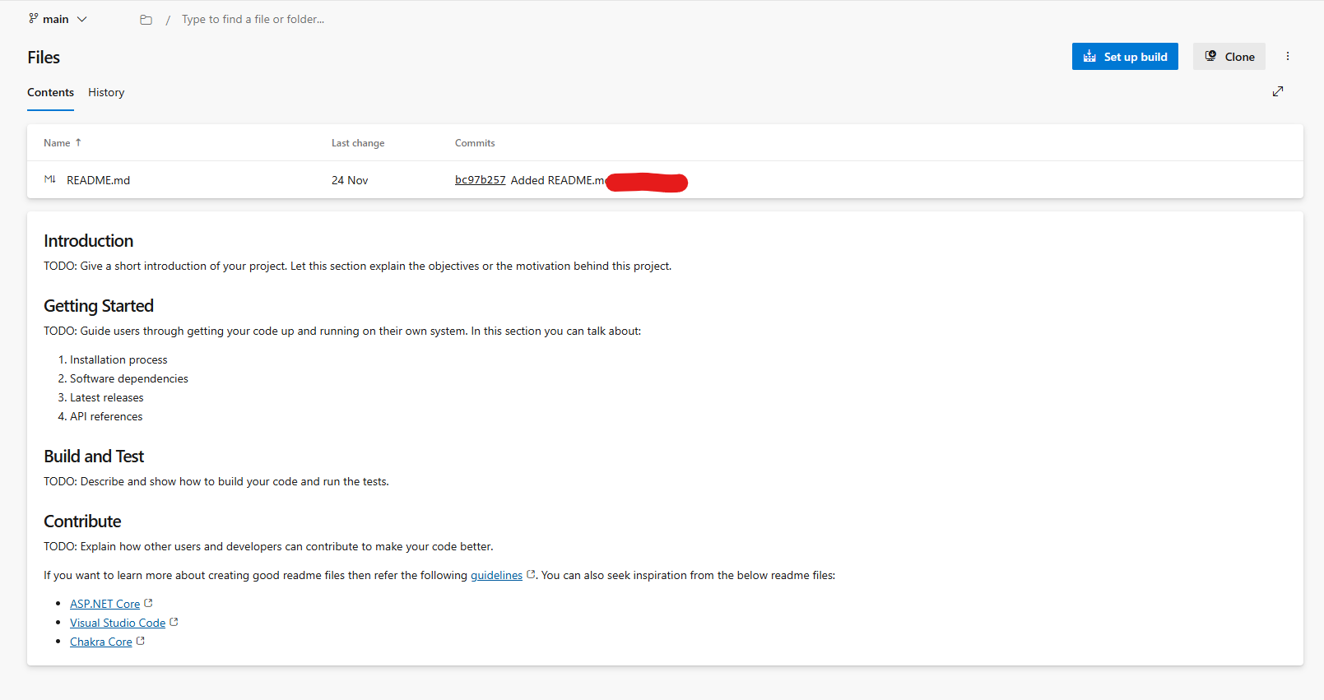
Figure 6: Repo Main Page
- Click on the ellipsis menu (Figure 7 label 1), then click on the ‘New’ option in the dropdown menu (Figure 7 label 2), then click on the ‘File’ button on the side menu (Figure 7 label 3).
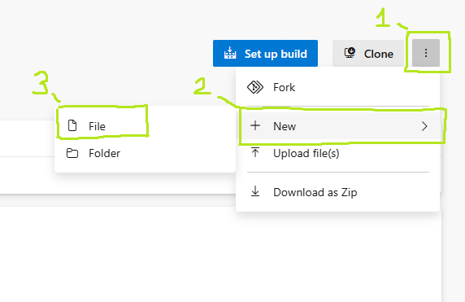
Figure 7: Creating a Bicep File Dropdown Menu

- A modal will appear with a textbox (as in Figure 8). Type ‘blobStorage.bicep’ in the textbox, then click on the ‘Create’ button (Figure 8 label 1). This will create the file ‘blobStorage.bicep’ in your repository, and this is where you will write the Bicep template for the Blob Storage in Azure.
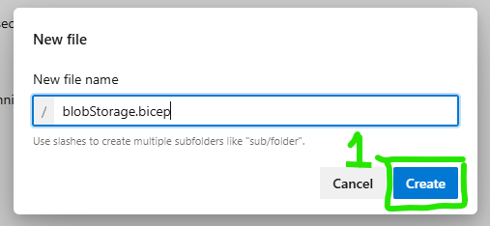
Figure 8: Bicep File Creation Modal
- Then, in the file that shows up, type the code shown in Figure 9. This code will deploy a storage account for your Blob Storage with a single container in it.
Where the version is specified at Figure 9 label 1 (shown as 0.29.0), replace that with the most up to date version specified here in the AVM changelog for storage accounts: (Azure Verified Modules, 2025b). The ‘name’ parameter shown at Figure 9 label 2 can be replaced by the name you want for your storage account.

Where the version is specified at Figure 9 label 3 (shown as 0.3.1), replace that with the most up to date version specified here in the AVM changelog for containers: (Azure Verified Modules, 2025a). The ‘name’ parameter shown at Figure 9 label 4 (shown as ‘fakestorcontainer’) can be replaced with the name you want for the container in your storage account. The ‘storageAccountName’ parameter shown at Figure 9 label 5 (shown as ‘fakestor’) must be the same as the name for your storage account at Figure 9 label 2.
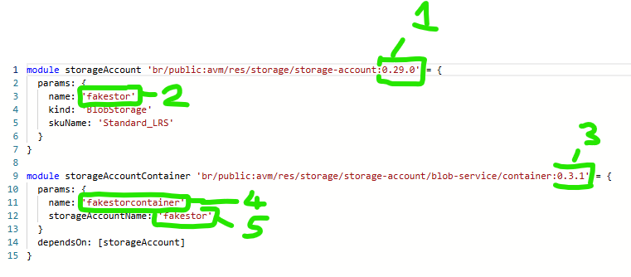
Figure 9: Blob Storage Code

- Click on the ‘Commit’ button in the top-right corner of the screen (Figure 10 label 1).
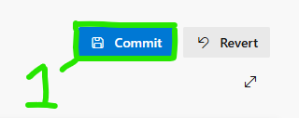
Figure 10: Commit Button
- In the modal that appears, do not change anything and click on the ‘Commit’ button in the bottom-left corner of the modal (Figure 11 label 1). This will add the code to your code repository, for use as the Bicep template for Blob Storage later in a deployment pipeline.
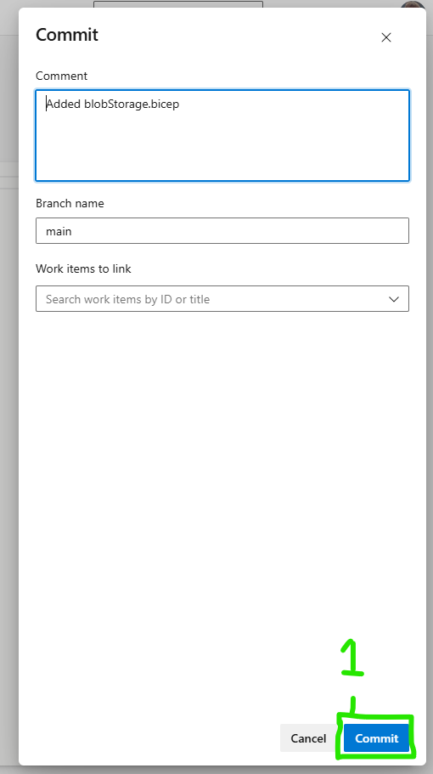
Figure 11: Commit Code

Step 3: Writing the YAML Code for Running the Deployment Pipeline
Next, you will need to create a deployment pipeline for the code in this repository through which the Blob Storage can be deployed to Azure. To understand why a deployment pipeline is being used instead of manually provisioning the Blob Storage through Azure Portal’s GUI, you will need to understand concepts such as deployment pipelines, Continuous Deployment (CD), DORA metrics and Disaster Recovery (DR).

Explanation of Continuous Deployment and DORA Metrics
CD is a concept in software delivery that is defined as “the practice of delivering feature increments immediately to customers, often through the use of small batches of work and automation technology” (Project Management Institute, 2021).
DORA (DevOps Research and Assessment) is a framework that provides a set of metrics to evaluate the performance and maturity of DevOps processes. DORA defines four key metrics of success in this regard (DORA, 2025):

Metric | Definition | Category
Change lead time | This metric measures the time it takes for a code commit or change to be successfully deployed to production. It reflects the efficiency of your software delivery process | Throughput
Deployment frequency | This metric measures how often application changes are deployed to production. Higher deployment frequency indicates a more efficient and responsive delivery process | Throughput
Change fail percentage | This metric measures the percentage of deployments that cause failures in production, requiring hotfixes or rollbacks. A lower change failure rate indicates a more reliable delivery process | Stability
Failed deployment recovery time | This metric measures the time it takes to recover from a failed deployment. A lower recovery time indicates a more resilient and responsive system | Stability
Table 2: DORA Metrics

According to DORA, “research has repeatedly demonstrated that speed and stability are not tradeoffs. In fact, we see that the metrics that the four keys focus on are correlated for most teams. Top performers do well across all four metrics, and low performers do poorly.” (DORA, 2025). DORA also found, in the 2019 Accelerate State of DevOps report that “elite performers consistently automate and integrate tools across nearly all aspects of their delivery pipeline.”
The advantages a deployment has over a manual process, is that any manual process is inherently slower (due to the speed of user interaction in carrying out manual steps) and more fault prone (due to user error). This means that the throughput metrics would suffer and change fail percentage would increase due to user error. A deployment pipeline also would allow for quicker recovery from failed deployments and would be able to more quickly and repeatably deploy infrastructure in a DR scenario, reducing the failed deployment recovery time.
In summary, the deployment pipeline is being implemented as it enables faster and more reliable changes to the Blob Storage and provides a foundation for future enhancements or the provision of additional resources if they are ever needed, as well as encouraging excellent practices seen in elite software teams.

Potential Downsides of DORA Metrics
DORA metrics are subject to Goodhart’s Law, which states: “Any observed statistical regularity will tend to collapse once pressure is placed upon it for control purposes” (Goodhart, 1981). What this means is that, whilst DORA metrics are indicators of good DevOps practices, using them as the goal itself will often lead to ‘gaming the system’ and forgetting the actual reason for them, which is to deliver better software more quickly and reliably. For this reason, DORA metrics should be used as a guide for where DevOps practices can be improved, and not as a target to hit, as real-world context will often lead to these targets not being hit.

Writing the YAML Code

- Back at the main page of your Azure DevOps Project. Click on the ‘Pipelines’ section in the sidebar (Figure 12 label 1).
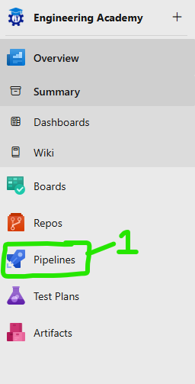
Figure 12: Sidebar for Pipelines

- In the top-right corner of the next page, click the ‘New Pipeline’ button (Figure 13 label 1).
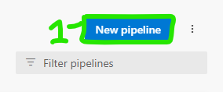
Figure 13: New Pipeline Button

- On the next page, click on the ‘Azure Repos Git’ option (Figure 14 label 1).
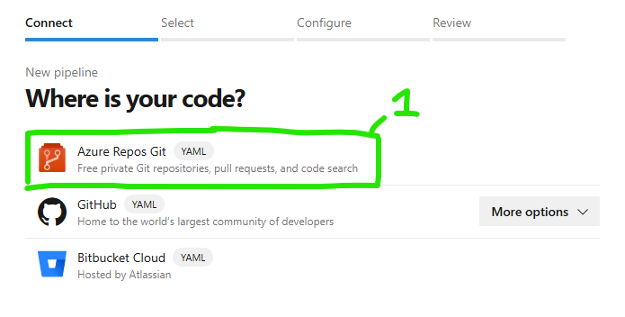
Figure 14: Code Repository Option

- Select the name of the repository you set up in Step 1 (here at Figure 15 label 1 the option ‘avm-blobs-storage-deployment’ is the one set up in Step 1).
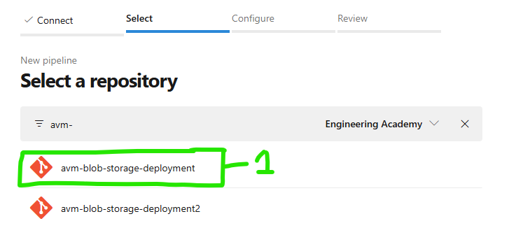
Figure 15: Selection of Repository

- Then choose the ‘Starter Pipeline’ option, as this will create a new deployment pipeline for you (Figure 16 label 1).
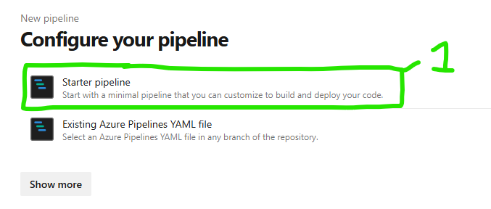
Figure 16: Configuration of New Pipeline

- On the ‘Review’ section, the new pipeline code will be displayed. The code at Figure 17 label 1 indicates that the pipeline will trigger on changes to the main branch of the code repository. This is ideal for you currently, as this will trigger the pipeline the moment we make changes to our code, and when this pipeline is finished being built. The code at Figure 17 label 2 indicates which type of virtual machine will run the deployment pipeline, in this case it will be the latest Ubuntu Linux version. The code at Figure 17 label 3 starts the declaration of the steps that will be carried out by the pipeline. The code at Figure 17 label 4 and 5 can be removed from the pipeline, as they are not needed for this tutorial.
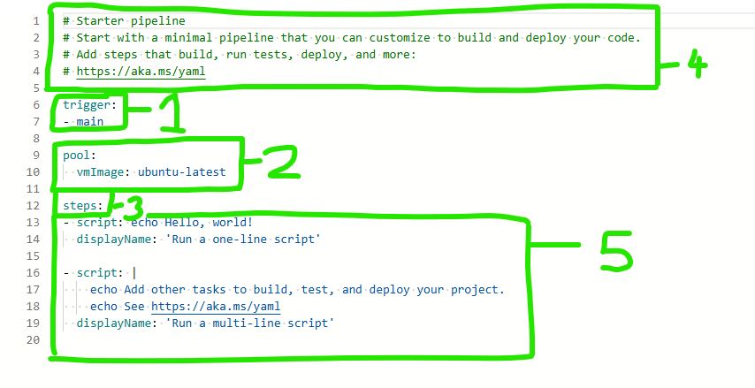
Figure 17: Starter Pipeline (Beginning)
- After amending the code, your pipeline should look like Figure 18.
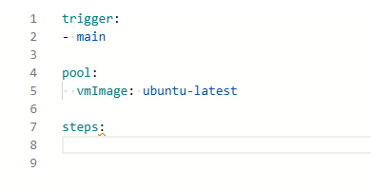
Figure 18: Start Pipeline (First Amendment)

- Click the ‘Show Assistant’ button in the far-right side of the screen (Figure 19 label 1).
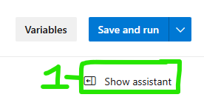
Figure 19: Show Assistant Button

- In the menu that appears, choose the ‘ARM template deployment option’ (Figure 20 label 1). This will give you options for specifying where the Bicep template created in Step 2: Writing the Bicep Code that Deploys the Blob Storage is and where you want to deploy it to in your pipeline.
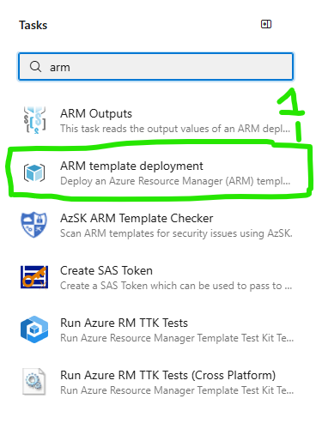
Figure 20: ARM Template Deployment Option

- In the menu that appears, do the following:

  - For ‘Azure Resource Manager Connection’ (Figure 21 label 1), choose the service connection for the subscription that contains the resource group you plan to put the Blob Storage in
  - For ‘Subscription’ (Figure 21 label 2), choose the subscription that contains the resource group you plan to put the Blob Storage in
  - For ‘Resource Group’ (Figure 21 label 3), choose the resource group you wish to put the Blob Storage in
  - For ‘Location’ (Figure 21 label 4), choose which Azure Region you want the Blob Storage to be put into (if in doubt, use the one nearest your location)
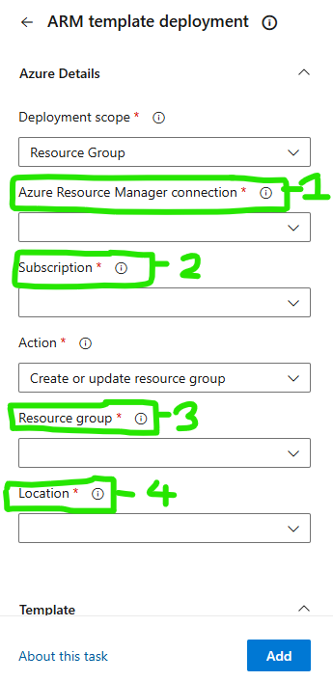
Figure 21: ARM Template Deployment Options 1

  - For ‘Template’ (Figure 22 label 1), type in ‘blobStorage.bicep’ to reference the Bicep Template created in Step 2
  - Leave everything else as is and click ‘Add’ (Figure 22 label 2)
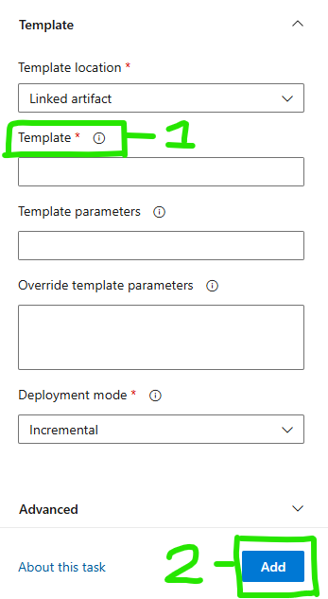
Figure 22: ARM Template Deployment Options 2

- The code should look like Figure 23, except where angle brackets are used around the word ‘fake’, where you should replace these values with your own.
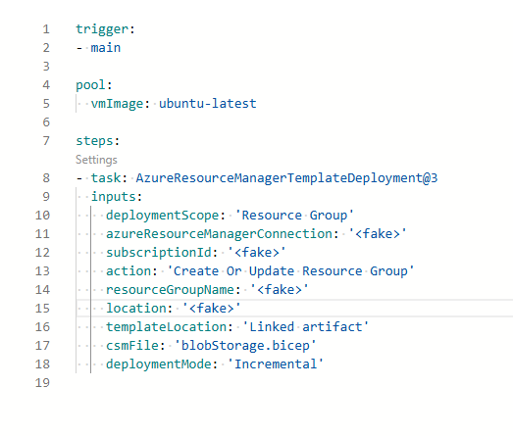
Figure 23: Fully Amended and Complete Pipeline Code

Step 4: Running the Deployment Pipeline/ Dealing with Issues
- Click the ‘Save and Run’ button in the top-right corner of the page (Figure 24 label 1).
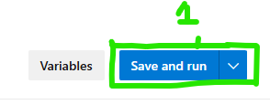
Figure 24: Save and Run Button

- In the modal that pops up, change nothing and again click the ‘Save and Run’ button (Figure 25 label 1).
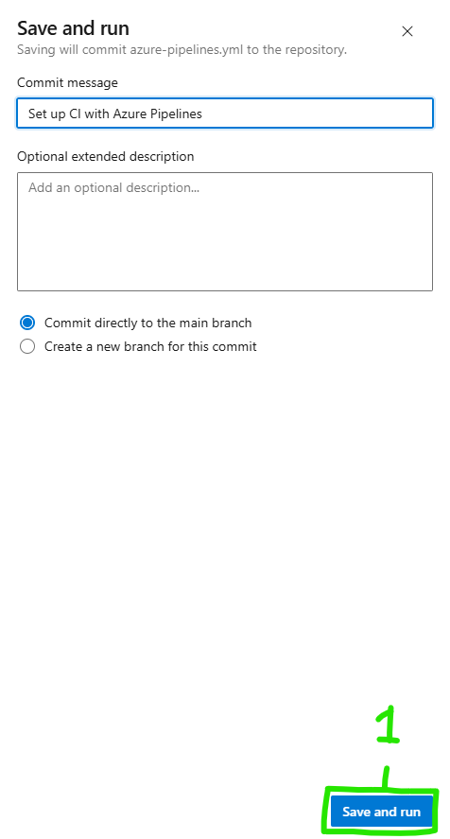
Figure 25: Save and Run Button 2
- You will be redirected to a page for the pipeline you have just created. Click on the ‘Job’ section (Figure 26 label 1).
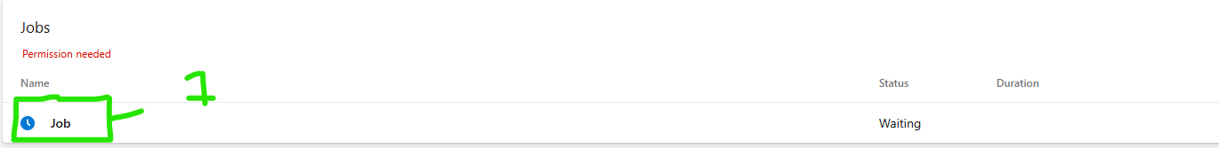
Figure 26: Job on Pipeline

- You will likely have to give permission for the resource deployment (this occurs on the first run of any Azure DevOps pipeline). Click the ‘View’ button (Figure 27 label 1).
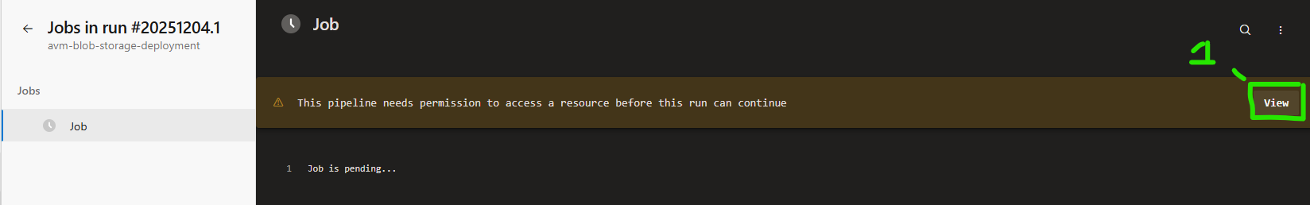
Figure 27: Pipeline Permissions 1

- In the modal that pops up, click the ‘Permit’ button (Figure 28 label 1) to give access to your service connection.

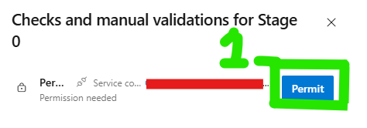
Figure 28: Pipeline Permissions 2

- On another modal, again click ‘Permit’ (Figure 29 label 1).
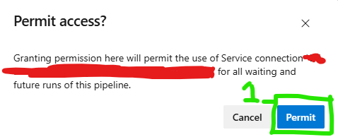
Figure 29: Pipeline Permissions 3

- The pipeline should then run through successfully (such as in Figure 30). If a pipeline does not run through successfully, you will need to debug it through the pipeline logs that will appear on the screen. There are many reasons it could fail, but the prerequisites for this tutorial not being in place would probably be the most likely reason for failure, so please check they are correct if the pipeline fails.
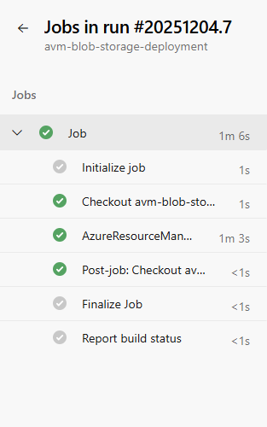
Figure 30: Pipeline Run

Step 5: Checking that the Blob Storage has been Created
- Once the deployment pipeline has successfully run through, you can check that the resource has been created properly by visiting the Azure Portal and logging into your Azure Tenant. From here, type the resource group you deployed the Blob Storage to in to the search bar (Figure 31) and clicking on that resource group.
Figure 31: Azure Portal Search bar

- Your resource group should look something like Figure 32, with the storage account existing in it. Click on the storage account (Figure 32 label 1).
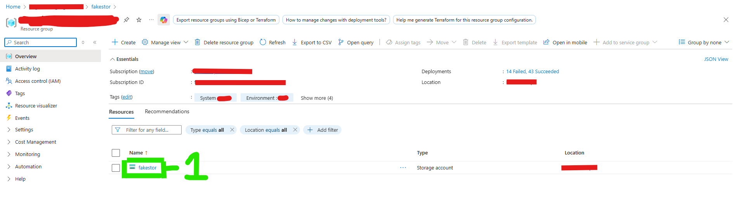
Figure 32: Resource Group View

- You should see it is a Blob Storage account from the ‘Account kind’ (Figure 33 label 1). Click on the ‘Containers’ button under ‘Data Storage’ (Figure 33 label 2).
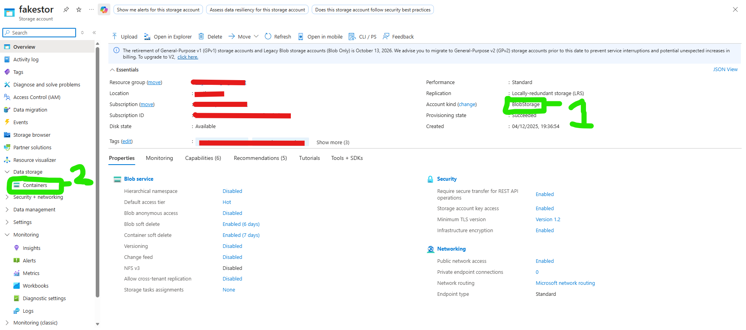
Figure 33: Storage Account View
- You should be able to see a list of containers, including ‘$logs’ (provisioned by default) and the container you provisioned (Figure 34 label 1).
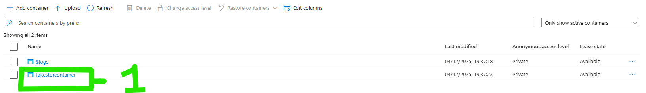
Figure 34: Container View

If you see all these things, then you have successfully deployed Blob Storage to Azure using AVM.

Conclusion
This tutorial has guided the user through deploying Azure Blob Storage using Azure DevOps Pipelines and AVM. It has demonstrated how IaC and CD practices allow deployments to become more consistent and repeatable, reducing manual errors and increasing reliability.
It has also demonstrated what AVM is, how to write the modules into a Bicep template and how they help enforce security and compliance standards for Azure resources whilst simplifying the development process of deployment pipelines.
This tutorial was designed to end with creating a foundation from which other cloud concepts could be explored by the user. Future enhancements could see the user exploring version control systems using Git, or adding Continuous Integration (CI, which compliments CD), pull requests and code reviews to the deployment pipeline. The user could also explore adding unit and integration tests to the deployment pipeline, to improve the DORA stability metrics of services they deploy. Additionally, the user could explore the more complex AVM Pattern Modules, to see how they can easily deploy an entire architecture using AVM.
Ultimately, cloud methodologies and AVM will continue to evolve, and this tutorial has allowed the user to glimpse just some of the technologies that are available today and has also giving them an insight into where cloud best practice is now and where it is heading in the future.

Glossary

A
ARM: See Azure Resource Manager.
AVM: See Azure Verified Modules
Azure: A cloud computing platform by Microsoft that provides services for building, deploying, and managing applications through Microsoft-managed data centres. It offers solutions like virtual machines, storage, networking, and AI services.
Azure Blob Storage: An Azure service for storing large amounts of unstructured data such as text, images and videos.
Azure DevOps: A suite of development tools and services from Microsoft that supports the entire software development lifecycle, including planning, coding, building, testing, and deployment. It integrates with Git repositories and enables CI/CD pipelines.
Azure DevOps Organization: The top-level container in Azure DevOps that groups projects, users, and settings
Azure DevOps Pipelines: A feature within Azure DevOps that automates building, testing, and deploying applications.
Azure Project: A unit within an Azure DevOps Organization that contains repositories, pipelines, boards, and artifacts for a specific application or workload.
Azure Resource Hierarchy: The organisational structure of Azure resources.
Azure Resource Manager: The deployment and management service for Azure. ARM provides a consistent API and supports templates for IaC.
Azure Tenant: A dedicated instance of Azure Active Directory (AAD) that represents an organization. It provides identity and access management for Azure resources.
Azure Verified Modules: Pre-built, tested Bicep modules published by Microsoft to simplify and standardize Azure resource deployments. AVM modules follow best practices and reduce complexity when writing Infrastructure as Code (IaC).

B
Bicep: A domain-specific language (DSL) for declaratively deploying Azure resources. It simplifies ARM templates and supports Infrastructure as Code (IaC).
BLOb/ Blob: Binary Large Object. Unstructured data. See Azure Blob Storage.

C
CD: See Continuous Deployment.
CI: See Continuous Integration.
Container: A logical grouping of data e.g. blobs.
Continuous Deployment: “the practice of delivering feature increments immediately to customers, often through the use of small batches of work and automation technology” (Project Management Institute, 2021).
Continuous Integration: A development practice where code changes are automatically built and tested to detect issues early and maintain code quality.

D
DevOps: DevOps is a set of practices, principles, and cultural philosophies that aim to unify software development (Dev) and IT operations (Ops). Its goal is to shorten the development lifecycle, improve collaboration between teams, and deliver high-quality software continuously and reliably.
Disaster Recovery: A strategy and set of processes to restore systems and data after a catastrophic failure or outage, ensuring business continuity.
Domain-Specific Language: A programming language designed for a specific domain or task, such as Bicep for Azure resource deployment.
DORA: DevOps Research and Assessment. An organization and set of metrics that measure software delivery performance, including deployment frequency and lead time.
DR: See Disaster Recovery.
DSL: See Domain-Specific Language.

G
Git: A distributed version control system that tracks changes in source code and enables collaboration through branching and merging.
Graphical User Interface: A visual interface that allows users to interact with software using elements like buttons, menus, and icons instead of text-based commands.
GUI: See Graphical User Interface.

I
IaC: See Infrastructure as Code.
Infrastructure as Code: A practice of managing and provisioning infrastructure through machine-readable configuration files rather than manual processes. Tools like Bicep, Terraform, and ARM templates enable Infrastructure as Code.

J
JavaScript Object Notation: A lightweight data-interchange format that is easy for humans to read and write and easy for machines to parse and generate.
JSON: See JavaScript Object Notation.

R
RBAC: See Role-Based Access Control.
REST API: Representational State Transfer API—a web service architecture that uses HTTP methods (GET, POST, PUT, DELETE) to interact with resources.
Resource Group: A logical container in Azure that holds related resources for an application or workload.
Role-Based Access Control: An authorization system in Azure that assigns permissions to users, groups, or service principals based on roles. It helps enforce least privilege by controlling access to resources.

S
Service Connection: A secure credential store in Azure DevOps that allows pipelines to authenticate and interact with external services like Azure.
Storage Account: An Azure resource that can be specified for Blob Storage. It supports containers, which can hold data e.g. blobs.
Subscription: An Azure billing and management boundary that groups resources. Each subscription is associated with a tenant and determines cost tracking and quotas.

T
Terraform: An open-source Infrastructure as Code tool that enables multi-cloud deployments using a declarative configuration language.

W
WAF: See Well-Architected Framework.
Well-Architected Framework: “a set of quality driven tenets, architectural decision points, and review tools intended to help solution architects build a technical foundation for their workloads” (Microsoft Learn, 2025n).

Y
YAML: “YAML Ain’t Markup Language”—a recursively-named human-readable data serialization format often used for configuration files, including Azure DevOps pipelines.

References
Azure Verified Modules. (2025a, December 4th). CHANGELOG.md. Retrieved from GitHub: https://github.com/Azure/bicep-registry-modules/blob/main/avm/res/storage/storage-account/blob-service/container/CHANGELOG.md
Azure Verified Modules. (2025b, December 4th). CHANGELOG.md. Retrieved from GitHub: https://github.com/Azure/bicep-registry-modules/blob/main/avm/res/storage/storage-account/CHANGELOG.md
Been, H., Keilholz, E., & Staal, E. (2022). Azure Infrastructure as Code, Chapter 1: Infrastructure As Code. Manning Publications.
DORA. (2019). Accelerate State of DevOps. Retrieved from DORA: https://dora.dev/research/2019/dora-report/2019-dora-accelerate-state-of-devops-report.pdf
DORA. (2025, March 5th). DORA’s software delivery metrics: the four keys. Retrieved from DORA: https://dora.dev/guides/dora-metrics-four-keys/
Goodhart, C. (1981). Problems of Monetary Management: The UK Experience. Barnes and Noble Books.
Graham, C. (2025, November 21st). Microsoft Azure resource groups: Introduction and best practices. Retrieved from IBM: https://www.ibm.com/think/topics/azure-resource-groups
Kumawat, J. (2025, June 21st). Guide to Creating a New Microsoft Azure Subscription. Retrieved from Dewiride Developer Blogs: https://devblogs.dewiride.com/blog/guide-to-creating-a-new-microsoft-azure-subscription
Lammle, T., & Buhagiar, J. (2024). CompTIA Network+ Study Guide, Chapter 17: Data Center Architecture And Disaster Recovery (6th ed.). Sybex.
Microsoft. (2025a, July 27th). Module Lifecycle. Retrieved from AVM: https://azure.github.io/Azure-Verified-Modules/specs/shared/module-lifecycle/
Microsoft. (2025b, October 3rd). What is Azure? Retrieved from Azure: https://azure.microsoft.com/en-us/resources/cloud-computing-dictionary/what-is-azure/?msockid=1bc9435398326c403b04507a99d26dbb
Microsoft. (2025c, November 14th). Azure Verified Modules - Introduction. Retrieved from Azure Verified Modules: https://azure.github.io/Azure-Verified-Modules/
Microsoft. (2025d, November 14th). Azure Verified Modules - Module Classifications. Retrieved from Azure Verified Modules: https://azure.github.io/Azure-Verified-Modules/specs/shared/module-classifications/
Microsoft. (2025e, November 21st). Azure DevOps. Retrieved from Microsoft: https://azure.microsoft.com/en-us/products/devops/?msockid=1bc9435398326c403b04507a99d26dbb
Microsoft Learn. (2025a, April 28th). Comparing JSON and Bicep for templates. Retrieved from Microsoft Learn: https://learn.microsoft.com/en-us/azure/azure-resource-manager/bicep/compare-template-syntax
Microsoft Learn. (2025b, July 17th). Organize Azure resources in multitenant solutions. Retrieved from Microsoft Learn: https://learn.microsoft.com/en-us/azure/architecture/guide/multitenant/approaches/resource-organization
Microsoft Learn. (2025c, July 19th). What is Azure DevOps? Retrieved from Microsoft Learn: https://learn.microsoft.com/en-us/azure/devops/user-guide/what-is-azure-devops?view=azure-devops
Microsoft Learn. (2025d, November 20th). Introduction to Azure Blob Storage. Retrieved from Microsoft Learn: https://learn.microsoft.com/en-us/azure/storage/blobs/storage-blobs-introduction
Microsoft Learn. (2025e, November 21st). Azure built-in roles. Retrieved from Microsoft Learn: https://learn.microsoft.com/en-us/azure/role-based-access-control/built-in-roles
Microsoft Learn. (2025f, November 21st). Create a project in Azure DevOps. Retrieved from Microsoft Learn: https://learn.microsoft.com/en-us/azure/devops/organizations/projects/create-project?view=azure-devops&tabs=browser
Microsoft Learn. (2025g, November 21st). Create an organization. Retrieved from Microsoft Learn: https://learn.microsoft.com/en-us/azure/devops/organizations/accounts/create-organization?view=azure-devops
Microsoft Learn. (2025h, November 21st). Manage service connections. Retrieved from Microsoft Learn: https://learn.microsoft.com/en-us/azure/devops/pipelines/library/service-endpoints?view=azure-devops
Microsoft Learn. (2025i, November 21st). Quickstart: Create a new tenant in Microsoft Entra ID. Retrieved from Microsoft Learn: https://learn.microsoft.com/en-us/entra/fundamentals/create-new-tenant
Microsoft Learn. (2025j, November 21st). Security groups, service accounts, and permissions reference. Retrieved from Microsoft Learn: https://learn.microsoft.com/en-us/azure/devops/organizations/security/permissions?view=azure-devops&tabs=preview-page
Microsoft Learn. (2025k, November 21st). Steps to assign an Azure role. Retrieved from Microsoft Learn: https://learn.microsoft.com/en-us/azure/role-based-access-control/role-assignments-steps
Microsoft Learn. (2025l, November 21st). Subscriptions, licenses, accounts, and tenants for Microsoft's cloud offerings. Retrieved from Microsoft Learn: https://learn.microsoft.com/en-us/microsoft-365/enterprise/subscriptions-licenses-accounts-and-tenants-for-microsoft-cloud-offerings?view=o365-worldwide
Microsoft Learn. (2025m, November 21st). Use the Azure portal and Azure Resource Manager to manage resource groups. Retrieved from Microsoft Learn: https://learn.microsoft.com/en-us/azure/azure-resource-manager/management/manage-resource-groups-portal
Microsoft Learn. (2025n, November 30th). Azure Well-Architected Framework. Retrieved from Microsoft Learn: https://learn.microsoft.com/en-us/azure/well-architected/
Patel, P. G., Dua, I. K., & David, S. (2025). Sustainable Cloud Development, Chapter 5: Security, Observability, and Monitoring in Sustainable Cloud Development. Packt Publishing .
Project Management Institute. (2021). A Guide to the Project Management Body of Knowledge (PMBOK® Guide) – Seventh Edition and The Standard for Project Management (ENGLISH). Project Management Institute.
Sehgal, V. V. (2023). Implementing DevSecOps Practices: Chapter 10: Infrastructure-As-Code (IaC) Scanning. Packt Publishing.
Terraform. (2025, November 30th). AzAPI Provider. Retrieved from Terraform Registry: https://registry.terraform.io/providers/Azure/azapi/latest/docs

