Decision Log Review Monitor
Module Code: COMP50049
Module Name: Low Code Software Development
Module Tutor: Nathan Gajewski
Student ID: 2403018
Word Count: Total Word Count: 4966 words
Total Word Count for Main Content: 4425 words
Total Word Count for Main Content Excluding Tables: 1624 words

Contents
Section A - Proposal and Analysis of Requirements for Low-code Platform 1
Introduction to the Problem 1
SWOT Analysis 3
FURPS Analysis 4
Activity Diagrams 6
Multi-Criteria Weighted Decision Matrix 7
Conclusion 9
Section B - Risk Analysis and Proposal for Securing the Low-Code Platform 10
Risk Analysis 10
Risk Matrix and Register 12
Cost-Benefit Analysis 15
Mitigation Proposal 17
Section C - Discussion of Audit Procedures and Techniques for Low-code Platform 18
Legal Compliance 18
Security 18
Accessibility 18
Scope of the Audit 19
Legal Compliance KPI 19
Security KPI 19
Accessibility KPI 19
Incidents, Breaches and Regressions 19
Final Assessment 20
References 21

Section A - Proposal and Analysis of Requirements for Low-code Platform

Introduction to the Problem
As part of the Software Development Life Cycle (SDLC) at our organisation, we periodically make strategic decisions that significantly influence the behaviour, infrastructure, maintenance, development, and security of our software systems.
Due to changing requirements and contexts, reasons that previous decisions were made are often out of date or no longer aligned with the organisation’s broader strategy and goals.
Because of this, we store decision logs in SharePoint Lists, with each log entry including:
Field | Explanation and Type of Data
Decision | Description of the action that will be carried out regarding the service. Multi-line text.
Reason | The reason for the action being carried out. Multi-line text.
Decision Made | When the decision was initially made. Date in MM/DD/YYYY format.
Decision Reviewed | The date when the decision was last reviewed. Date in MM/DD/YYYY format.
Is Decision Current? | Whether this decision is currently in effect for a software system or service. Yes/No.
Table 1: SharePoint List Decision Log Data Structure
However, these decision logs are often created and then never reviewed, despite the best of intentions. When investigating the effects of this, five different internal stakeholders reported back:

Stakeholder | Stakeholder Feedback | Stakeholder Concern
Chief Technical Officer | “We want to ensure that our technical decisions line up with our goals directly. We also want to be an organisation that is looking towards the future and need to be attentive to what larger tech companies are doing so we do not get left behind technically.” | Without reviewing technical decisions and technologies periodically, we may be too slow to adapt as an organisation, or could be superseded by smaller, more innovative tech companies.
Senior Engineer | “Decisions made by previous engineers or solution architects often leave me baffled and lead to technical debt. Knowing when to review decisions and reviewing them periodically could help prevent this.” | Technical debt hinders the implementation of new features because of past, out-of-date decision making. Reviewing periodically could allow the organisation to come up with solutions for relieving the technical debt.
Engineer | “I want to work with modern technology and more elegant solutions. Sometimes decisions made previously can lead to new features being really hard to implement, whereas if decisions were reviewed simpler solutions could be found.” | The Engineer wants to work with more modern technology, and their morale would improve if they thought that decisions made previously that prevent this were reviewed more frequently.
Solution Architect | “Because of how often the cloud computing space (especially Azure, in our case) changes, it would be good if we could review decisions made previously. Often, new Azure products have better performance, features or security, and using these new products instead of continuing with old ones could reduce technical debt.” | The Solution Architect wants to review the cloud computing products available periodically, to make sure the organisation has the most performant, feature-rich and secure cloud architecture available at that moment.
Stakeholder Engagement Manager | “Sometimes I have to tell customers that a specific feature cannot be implemented for technical reasons. I’m told this is because of legacy software in most of these cases. I would like to be able to tell customers that a feature CAN be implemented, instead of frustrating them.” | The Stakeholder Engagement Manager thinks that legacy software is holding back the ability of our technical teams.
Table 2: Stakeholder Feedback and Concerns

SWOT Analysis
Extrapolating upon these stakeholder concerns, a SWOT analysis can be produced:
Strengths | Weaknesses
- The SharePoint List for the decisions exists currently and can be looked at by authorised personnel.  - Some decisions already exist in these SharePoint Lists, so can be referenced. | - The decisions in the SharePoint Lists are often not reviewed, because of focus elsewhere.  - There is no agreed upon amount of time after which a decision must be reviewed.  - There is no automated alerting for the decision logs, so even if there was an agreed upon time-period after which a decision needed to be reviewed, there is no guarantee that personnel would recognise a decision is out of date.
Opportunities | Threats
- Reviewed decisions could remove long-held technical debt.  - More efficient technologies could be implemented if previous decisions that decided on older technologies are considered out of date.  - Customers could have more features implemented more easily with newer technologies. | - Low morale among engineers from having to put up with inefficient and out of date decisions.  - Startups could take over our organisation’s market niche, using cheaper, more efficient and scalable technologies as they have no legacy or technical debt.  - A lack of review of out-of-date decisions could lead to security vulnerabilities, which when exploited could lead to financial, reputational or legal consequences.
Table 3: SWOT Analysis

FURPS Analysis
From the SWOT analysis, reviewing decisions in the decision log SharePoint Lists would be beneficial to the organisation. A good solution for this would be to create a Decision Log Review Monitor (DLRM) that reviews each decision in each of the decision log SharePoint Lists once a week and then sends alerts to a designated Microsoft Teams channel if the decisions are out of date. This process would be carried out by a low-code solution. Although architectural reviews should ideally occur every sprint (Mistrik, Brown, & Babar, 2013), our organisation operates with small delivery teams that do not have the resources to review architectural decisions so frequently. Adopting a 180 day limit on decisions being out-of-date would therefore not use up undue resource and would reduce pointlessly affirming long-standing decisions. Here is a FURPS model to explain the requirements of such a system:
Category | Specific Requirements
Functionality | - The system must be able to access Microsoft Teams for the organisation and interact with it to post alerts.  - The system should send alerts to the relevant Teams Channel if a decision has not been reviewed in 180 days or more and the decision is still in effect.  - The system must be able to read all the SharePoint Lists for decision logs so that each decision can be evaluated.  - This alerting should happen once a week, on a Monday morning.  - Unreviewed decisions should alert repeatedly, week-by-week, to ensure they are eventually reviewed.
Usability | - The alert should follow the WCAG (Web Content Accessibility Guidelines) 2 (W3C, 2026) standard as closely as possible, with the text being well contrasted (Guideline 1.4.1, 1.4.3), links being understandable from their text (Guideline 2.4.4), with a large enough font size (Guideline 1.4.4).  - The alert should show the information about the particular decision that is out of date.  - A clickable link should be on the alert, to send the user to the particular SharePoint List the decision is in, so the user can review it in depth and edit once the review has been carried out.  - The alert does not need to work on mobile screens, as employees do not use mobiles for work.  - The alert should have an intuitive UI, with the clickable link to the SharePoint List being obviously a link.
Reliability | - The alerting should fire off every Monday morning, without fail. In the event of a failure (such as credentials going out of date), the alert should instead explain that there was a failure of the system so an engineer can fix it.  - Only authorised personnel should be able to access the SharePoint Lists containing decision logs and change information about the decisions.
Performance | - Most employees start work at 9:00 AM, so even if the system needs to access multiple SharePoint lists, process all decisions, and post cards and messages to Teams channels, it only needs to complete within 3 hours (between 6:00 and 9:00 AM)  - During testing on a single SharePoint List, the alert must be posted less within 15 seconds of starting the test, to ensure scalability.
Supportability | - The alerting should be able to be expanded to more SharePoint Lists using parameterisation of SharePoint List links and iteration on these lists.  - It is almost impossible for decision log lists to ever reach the maximum number of records in a SharePoint List, which is currently 30 million (Microsoft, 2026e).  - Version control should allow for rollback of versions of the service.
Table 4: FURPS Requirements

Activity Diagrams
The following activity diagram shows how the current decision log review works at our organisation:
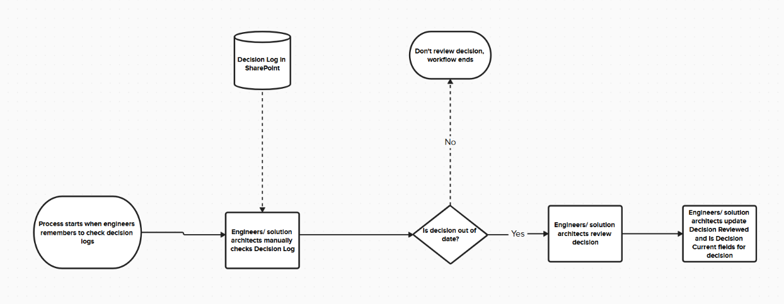
Figure 1: Decision Log Review Current Activity Diagram
The current system does not work well, as engineers and solution architects may not even start the process if they have other work to do, and human error may mean some decisions that are out of date are missed. It would also require more time as every decision would have to be manually checked.
The following activity diagram shows how the process would be improved with the solution proposed from the previous analyses:
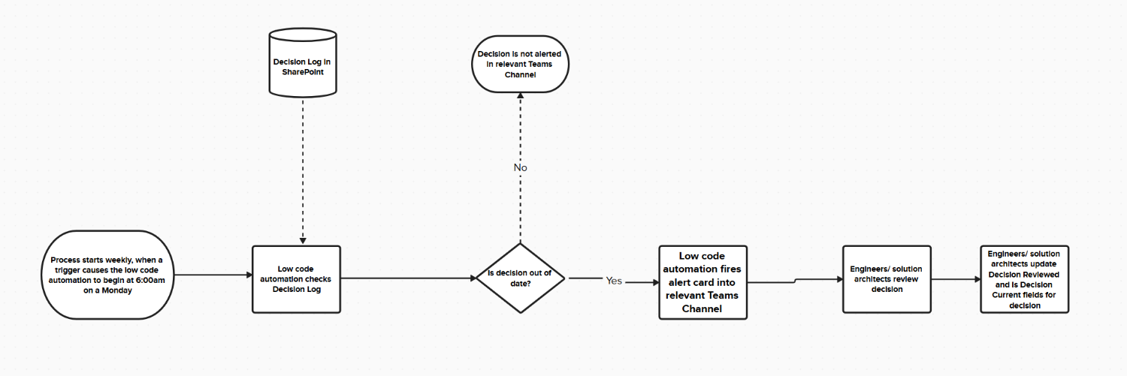
Figure 2: Decision Log Review Proposed Activity Diagram
This proposed system would work better, as it would always trigger, without manual intervention. It would only alert the engineers or solution architects if a decision is out-of-date. It would also inform them in the correct Teams channel and wouldn’t be prone to the human error of missing out-of-date items.

Multi-Criteria Weighted Decision Matrix
To create this solution, a low-code platform would have to selected to create the automation solution. Here is a Multi-Criteria Weighted Decision Matrix for choosing between Microsoft Power Platform, Mendix and the KNIME Analytics Platform.

Decision Making Criteria | Weight | Microsoft Power Platform | Mendix | KNIME Analytics Platform
Integration with Microsoft Teams and SharePoint Lists | 2 | 3 – Microsoft Power Platform has fully-integrated Power Automate connectors for SharePoint Lists and Teams workflows because it is developed by Microsoft. | 2 – Third party Microsoft SharePoint and Teams connectors need to be used, with the latest SharePoint connector being updated on April 3rd, 2024, (Mendix, 2026b), indicating questionable support. | 1 – KNIME does not have a native Teams connector and must connect to SharePoint via REST API or the enterprise extension called SharePoint Online Connector (KNIME Community Hub, 2026).
Cost of Integration with the Organisation | 3 | 3 – Our organisation is already integrated, using Microsoft Entra ID, with every user having a Microsoft 365 E3 subscription, allowing for ‘1 to 5+ TB of cloud storage per user’ (Microsoft, 2026c) | 1 – Mendix Premium would be the product that would have to be chosen, because of needing a platform with more than 4 environments (Mendix, 2026c) and this is only available by direct quote for enterprise. It is likely this would cost above £900 per year (based on the Standard package being smaller) and would be additional cost above the Microsoft 365 E3 subscription already in effect. | 1 – KNIME Analytics Platform would only be available for enterprise in the Business Hub level, with pricing available at request, but likely more than €99 per month based on the previous ‘Team’ tier (KNIME, 2026a).
Usability | 1 | 2 - Power Automate uses a drag-and-drop approach, with the ability to add more complex code should the need arise. Power Automate also has built-in version control for solution-aware cloud flows (Microsoft Learn, 2026a), if needed. | 2 – Similar usability to Power Automate with drag-and-drop functionality. Would likely require more explicit coding with the third-party connectors. | 1 – KNIME would likely have worse usability, due to having to spend more time integrating connectors with Teams and SharePoint. It is also more focused on data analytics, not the alerting needed for the DLRM.
Security | 2 | 3 – Role-based access is already setup, allowing Power Automate connectors to connect to Microsoft Teams and SharePoint Lists for authorised personnel. Role-based access control and restrictions on the Power Platform are already in place. | 3 – Mendix is very strong in terms of security, with it being ISO 27001, SOC 2 and GDPR compliant (Mendix, 2026a). | 3 – KNIME are ISO 27001 certified (KNIME, 2026c), and document their Secure Software Development Framework (KNIME, 2026b).
Total |  | 23 | 15 | 12
Rank |  | 1st | 2nd | 3rd
Table 5: Multi-Criteria Weighted Decision Matrix for Low-Code Platform

Conclusion
From all previous analyses and the Multi-Criteria Weighted Decision Matrix, the Microsoft Power Platform, and specifically Power Automate, would be the ideal low-code platform for developing the DLRM.

Section B - Risk Analysis and Proposal for Securing the Low-Code Platform

Risk Analysis
Because the proposed DLRM will connect lists in our organisation’s SharePoint and our organisation’s Microsoft Teams channel using Microsoft Power Platform, there are many different potential security vulnerabilities that could be exploited by malicious actors. Here is a risk analysis, identifying what risks there are to the DLRM:

Asset | Threat | Threat Reference Number
SharePoint Lists containing decision logs | Unauthorised access to the SharePoint Lists could expose decisions made by our organisation and the reasons for them. Depending on the decision, this could give other organisation’s competitive advantages, could reveal sensitive information, or accidentally expose security vulnerabilities to hackers. | 1
Power Automate workflow | Access to the Power Automate workflow by unauthorised personnel would allow them to run test flows using preconfigured connectors to retrieve information from the SharePoint Lists. It would also allow them to change the workflow, either disabling it, or sharing malicious links (phishing attacks) in the alerts sent to the Microsoft Teams channel. | 2
Alerts being posted into the Microsoft Teams channel | Depending on access to the channel, sensitive information from the decision logs could be shared. As discussed above, alerts from the Power Automate workflow that have been tampered with could allow for phishing attacks. | 3
Credentials/ API tokens used to connect services | Depending on the privileges of the account using the Power Automate workflows, they may be able to add actions to connectors authenticated with credentials or API tokens. They could also try to expose credentials through running test flows in Power Automate. | 4
SharePoint links to SharePoint Lists being posted to Microsoft Teams channels | If the SharePoint List containing the decision logs is not secured so that unauthorised personnel do not have read access to it, then someone who has access to the Teams channel that the alert was posted in may access the potentially sensitive decision logs. | 5
Table 6: DLRM Risk Analysis

Risk Matrix and Register
The following risk matrix scores the combination of likelihood and impact to create a risk score, which shows how much of a threat the particular risk is to the organisation:
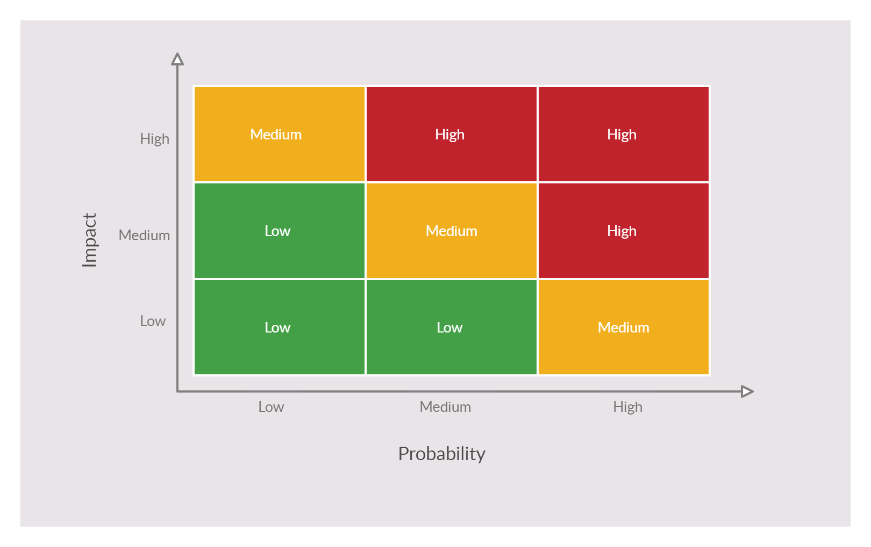
Figure 3: Risk Matrix

Here is a risk register that uses that risk matrix and identifies a risk score for each risk identified in the risk analysis:
Threat Reference Number | Likelihood | Impact | Risk Score
1 | Low - Already enabled Role-Based Access Control backed by Multi-Factor Authentication should reduce the chances of unauthorised personnel accessing SharePoint lists. However, man-in-the-middle attacks or disgruntled employees, or a lack of review on Role-Based Access Control could still lead to circumvention of these protections. | High - Giving our competitor’s business advantages against us could lead to severe loss of revenue as a company. Depending on the advantage, it could lead to organisational failure. Exploited security vulnerabilities could lead to organisational failure due to reputational and financial damage, as “The costs associated with data breaches, ransomware attacks, and other cyber incidents can be exorbitant. These costs include remediation expenses, legal fees, regulatory fines, and compensation for affected parties” (Edwards, 2024a). | Medium
2 | Low – Role-Based Access Control backed by Multi-Factor Authentication on the Power Automate Workflows is already enacted on all our organisation’s environments. It would also require significantly more technical ability and understanding of the SharePoint Lists and Teams Channels or significantly more exploratory work from any malicious actor to gather information or orchestrate a phishing attack through the workflow. | High – Disabling the workflow would not have an immediate impact but deleting it along with version history would cause significant disruption. Phishing attacks through sending malicious links to the Teams Channel could cause significant damage to the organisation depending on what these phishing attacks gather. If the phishing attack steals login credentials or customer data could cause significantly financial and legal damage, as regulatory non-compliance in these situations “incurs financial penalties, increases scrutiny from regulators, and damages the organization’s reputation” (Edwards, 2024b). Unauthorised access to SharePoint data has the same issues discussed in Threat Reference Number 1. | Medium
3 | Low – Role-Based Access Control with Multi-Factor Authentication is already enabled on Microsoft Teams Channels using Microsoft Entra ID groups, so a malicious actor would have to bypass this to view information from any decision log in the Teams Channel. Phishing attacks would be possible if the actor could access the Microsoft Automate Workflows or post to the Teams Channel directly. | High – Information gathered from the Teams Channel could affect the business, but the potential for phishing attacks, covered in the Impact column for Threat Reference 2, remains the largest threat. | Medium
4 | Low – Credentials and API tokens can be refreshed every so often to invalidate those acquired by malicious actors. Role-Based Access Control and Multi-Factor Authentication across environments should prevent most of these threats, but they could be acquired by attacks such as phishing attacks with malicious actors impersonating employees. | Medium – Depending on the credential and API token gathered depends on how severe the attack would be. Ultimately, the level of damage that could be done without having direct access to an environment would be significantly reduced and would require more knowledge on the part of the malicious actor. | Low
5 | Low – Role-Based Access Control and Multi-Factor Authentication should prevent most instances of this problem, as the malicious actor would need access to both the Teams Channel and access to the decision log in SharePoint. | Medium – The impact associated with this is covered for the Impact column for Threat Reference Number 1. | Low
Table 7: Risk Register

Cost-Benefit Analysis
Here is a cost-benefit analysis that includes proposed mitigations for each risk and assesses what the cost of securing the DLRM project would be:
Threat Reference Number | Proposed Mitigation | Cost | Benefit
1 | Upgrading each user Microsoft 365 account in the organisation from an E3 account to an E5 account, to allow for Microsoft Defender to protect against anomalous behaviour and spot advanced identity-based cyberthreats (Microsoft, 2026b). | The cost of the current Microsoft 365 E3 accounts is $36.00 per month, paid yearly (Microsoft, 2026a). The cost of E5 accounts is $57.00 per month, paid yearly (Microsoft, 2026a). Given our organisation has about 1500 employees, this amounts to about $378,000, or about £281,950.20 extra yearly. | Business advantages are hard to quantify, but protecting access to crucial business decisions could prevent organisational collapse in the worst-case scenario. If security vulnerabilities were exploited by looking at technical decisions, then potential GDPR fines can be either the standard maximum of “£8.7 million or 2% of the total annual worldwide turnover in the preceding financial year, whichever is higher” or the higher maximum of “£17.5 million or 4% of the total annual worldwide turnover in the preceding financial year, whichever is higher” (Information Commissioner's Office, 2026a). This means that the upgrade to E5 accounts could be a worthwhile cost to pay to prevent these fines.
2 | Data Loss Prevention policies can be used to prevent certain actions being done by certain connectors in Microsoft Power Platform (and therefore Power Automate environments). Connectors can be classified as either Business (for sensitive data), Default (for non-sensitive data) or Blocked (preventing their access). This could prevent malicious actors changing workflows to extract data or conduct phishing attacks. | The primary cost of this is the setup time it would take for an administrator to classify these connectors without affecting already active workflows in that environment. Otherwise, Data Loss Prevention Policies are already covered in Microsoft 365 licensing (Microsoft Learn, 2026d). | See the Benefit column for Threat Reference Number 1.
3 | Access to Teams channels could be blocked by adding Conditional Access to the Teams channels, so only devices with given IPs could connect to the channels.  Otherwise, see the Proposed Mitigation columns for Threat Reference Number 1 and 2. | Conditional Access does not cost anything more because it requires Entra ID P1 for devices/ users which is covered by Microsoft 365 E3 accounts for users already. The primary cost is the time taken to set up the Conditional Access, which may require weeks of work for network security personnel. This could take months as it would require incremental implementation to prevent Microsoft Teams breaking for the organisation, which could cause significant setbacks to productivity across the organisation. | This mitigation would add more protection and would further reduce the possibility of non-compliance fines and organisational failure outlined in the Benefit column for Threat Reference Number 1.
4 | Upgrading to Microsoft 365 E5 for all accounts would give protection from unusual behaviour which may occur if credentials or API tokens are stolen by using Microsoft Defender. | See the Cost column for Threat Reference Number 1. | See the Benefit column for Threat Reference Number 1.
5 | See the Proposed Mitigation column for Threat Reference Number 1. | See the Cost column for Threat Reference Number 1. | See the Benefit column for Threat Reference Number 1.
Table 8: Cost-Benefit Analysis

Mitigation Proposal
From the cost-benefit analysis, upgrading Microsoft 365 E3 accounts to E5 accounts across the organisation, implementing Data Loss Prevention policies in Microsoft Power Platform and adding Conditional Access to Microsoft Teams would dramatically reduce the potential for phishing attacks happening or technical decision data being compromised. Although this would cost roughly £281,950.20 and take months of employee time, it would greatly reduce the chance of non-compliance fines or competitors gaining an advantage and would help secure the DLRM, as well as many other services. This could prevent organisational failure in the long-term and is worth implementing.

Section C - Discussion of Audit Procedures and Techniques for Low-code Platform
Because the DLRM is going to be using Microsoft Power Platform through Power Automate, it is crucial that this platform is audited beforehand, to make sure that it aligns with our organisation on matters of legislation, security and global issues. It is equally important to establish an audit procedure in advance, supported by regular reviews, to ensure that Microsoft Power Platform still aligns with our organisation’s expectations.

Legal Compliance
Firstly, although the DLRM only handles the decision logs stored in SharePoint, which will not include personal information, it does interact with Microsoft 365 user accounts. This means that there is the potential of data breaches involving personal information of users in our organisation and the potential for data subject requests as well. For our organisation to comply with GDPR and avoid the fines considered in Section B’s cost-benefit analysis, it must be made sure that Microsoft Power Platform has policies in place to help handle GDPR-related scenarios such as Data subject requests and reporting for data breaches. Microsoft provides GDPR documentation to help organisations handle GDPR requests and how that relates to Microsoft services (Microsoft Learn, 2026b) and gives a recommended action plan to organisations to meet the requirements of GDPR in regards to Microsoft 365 (Microsoft Learn, 2026e).

Security
Whilst GDPR-related guidance supports our organisation, it would be better if (in relation to data breaches), our organisation could have some degree of confidence regarding the protection of personal data in Microsoft 365 user accounts. This would greatly reduce the chance of fines considered in Section B’s cost-benefit analysis. This is because cyberattacks are increasing in frequency worldwide and are causing significant harm to organisations. An example of this is when a cyberattack (thought to be a ransomware attack specifically) shut down United Natural Foods Inc.’s food distribution for over two weeks (Sayegh, 2025), causing massive disruption and damage to the organisation. ISO27001 certification would help us to be sure that Microsoft is protecting our data as much as possible. ISO27001 certification is the leading international standard focused on information security (Kosutic, 2026), and Microsoft is certified to it (Microsoft Learn, 2026c)

Accessibility
Whilst the Usability requirements identified the WCAG 2 as a good set of guidelines to build the DLRM, our organisation needs to know that Microsoft Power Platform conforms to either those guidelines, or similar accessibility guidelines to ensure employees with accessibility needs will still be able to do work whilst using the Power Platform. Microsoft’s Power Platform Community Manager, Ilanit Manor, confirms that “At Microsoft, we understand the power of technology, and that is why we continue to innovate, create, and design in a way that gives everyone the ability to achieve more” (Manor, 2024) and that the Power Platform strives to follow the general Microsoft Accessibility guidelines (Microsoft, 2026d). These guidelines encompass more than the web but generally conform or are of a higher standard than the WCAG 2 guidelines.
To make sure that Microsoft Power Platform (and the surrounding ecosystem we are using, such as Microsoft 365) continues to conform to our organisation’s standards, there must be regular audits and Key Performance Indicators (KPIs). Failure to conform to these standards would mean that our organisation would have to consider other low code platforms for the DLRM, so that legal and security issues do not negatively impact us.
Here is the proposed audit procedure:

Scope of the Audit
Every six months an audit will be conducted, to assess whether Microsoft has continued to demonstrate meaningful improvements in the following areas for all the products used by or related to the DLRM:

Legal Compliance KPI
This audit will assess whether Microsoft continues to comply with relevant legislation, such as GDPR. Examples of this include changes to accommodate newly introduced legislation, such as the Data (Use and Access) Act 2025 (Information Commissioner's Office, 2026b).

Security KPI
This audit will assess whether Microsoft has improved its security across the platforms related to the DLRM. Examples of how this could be achieved include better identity management, automation security, threat detection, and compliance alignment.

Accessibility KPI
This audit will assess whether Microsoft has improved accessibility. Examples of how this could be achieved include but are not limited to better screen-reader compatibility, better keyboard navigation, expanded inclusive design options, or strengthened accessibility tooling.

Incidents, Breaches and Regressions
A key component of the audit is assessing whether Microsoft has avoided any serious security breaches, compliance failures or accessibility regressions. If they have not avoided this, then that would undermine our confidence in their ability to uphold these metrics in the future and may affect the evaluation of whether to continue using Microsoft Power Platform and the surrounding Microsoft ecosystem for the DLRM.

Final Assessment
At the end of the audit, if there has been improvement in each of the key areas, and serious incidents, breaches or regressions have not occurred, then Microsoft will have passed the audit for that six-month period.

References
Edwards, J. (2024a). Critical Security Controls for Effective Cyber Defense: A Comprehensive Guide to CIS 18 Controls, Chapter 7. Apress.
Edwards, J. (2024b). Critical Security Controls for Effective Cyber Defense: A Comprehensive Guide to CIS 18 Controls, Chapter 9. Apress.
Information Commissioner's Office. (2026a, January 16th). Penalties. Retrieved from ICO: https://ico.org.uk/for-organisations/law-enforcement/guide-to-le-processing/penalties/
Information Commissioner's Office. (2026b, January 17th). Data (Use and Access) Act 2025. Retrieved from ICO: https://ico.org.uk/about-the-ico/what-we-do/legislation-we-cover/data-use-and-access-act-2025/
KNIME. (2026a, January 7th). KNIME hub pricing. Retrieved from KNIME: https://www.knime.com/knime-hub-pricing
KNIME. (2026b, January 7th). Overview of KNIME Software Framework and Security. Retrieved from KNIME: https://www.knime.com/knime-software-framework-and-security
KNIME. (2026c, January 7th). Trust. Retrieved from KNIME: https://www.knime.com/trust
KNIME Community Hub. (2026, January 7th). SharePoint Online Connector. Retrieved from KNIME: https://hub.knime.com/knime/extensions/org.knime.features.ext.office365.filehandling/latest/org.knime.ext.sharepoint.filehandling.node.SharepointConnectionNodeFactory
Kosutic, D. (2026, January 17th). What is ISO 27001? A quick and easy explanation. Retrieved from Advisera: https://advisera.com/27001academy/what-is-iso-27001/
Manor, I. (2024, May 22nd). Community Accessibility. Retrieved from Power Platform Community: https://community.powerplatform.com/help/?partialurl=community-accessibility
Mendix. (2026a, January 7th). Mendix Platform Security. Retrieved from Mendix: https://www.mendix.com/trust/
Mendix. (2026b, January 7th). Microsoft Sharepoint. Retrieved from Mendix Marketplace: https://marketplace.mendix.com/link/component/119305
Mendix. (2026c, January 7th). Pricing. Retrieved from Mendix: https://www.mendix.com/pricing/
Microsoft. (2026a, January 16th). Find the best Microsoft 365 plan for your organization. Retrieved from Microsoft: https://www.microsoft.com/en-us/microsoft-365/enterprise/microsoft-365-plans-and-pricing?msockid=1bc9435398326c403b04507a99d26dbb
Microsoft. (2026b, January 16th). Microsoft 365 E5. Retrieved from Microsoft: https://www.microsoft.com/en-us/microsoft-365/enterprise/e5?msockid=1bc9435398326c403b04507a99d26dbb#tabs-pill-bar-oc58d2_tab3
Microsoft. (2026c, January 7th). Microsoft 365 plans and pricing. Retrieved from Microsoft: https://www.microsoft.com/en-us/microsoft-365/enterprise/microsoft-365-plans-and-pricing
Microsoft. (2026d, January 16th). Our accessibility approach. Retrieved from Microsoft: https://www.microsoft.com/en-us/accessibility/approach
Microsoft. (2026e, January 6th). SharePoint basics - Large lists and libraries. Retrieved from Microsoft Support: https://support.microsoft.com/en-us/office/sharepoint-basics-large-lists-and-libraries-cf37b449-a2a7-4ef9-9f4d-aab826db5b30
Microsoft Learn. (2026a, January 14th). Drafts and versioning for solution-aware cloud flows. Retrieved from Microsoft Learn: https://learn.microsoft.com/en-us/power-automate/drafts-versioning
Microsoft Learn. (2026b, January 16th). General Data Protection Regulation. Retrieved from Microsoft Learn: https://learn.microsoft.com/en-us/compliance/regulatory/gdpr
Microsoft Learn. (2026c, January 17th). ISO/IEC 27001:2013 Information Security Management Standards. Retrieved from Microsoft Learn: https://learn.microsoft.com/en-us/compliance/regulatory/offering-ISO-27001
Microsoft Learn. (2026d, January 16th). Licensing overview for Microsoft Power Platform. Retrieved from Microsoft Learn: https://learn.microsoft.com/en-us/power-platform/admin/pricing-billing-skus
Microsoft Learn. (2026e, January 16th). Microsoft 365 GDPR action plan — Top priorities for your first 30 days, 90 days, and beyond. Retrieved from Microsoft Learn: https://learn.microsoft.com/en-us/compliance/regulatory/gdpr-action-plan
Mistrik, I., Brown, A. W., & Babar, M. A. (2013). Agile Software Architecture, PART 2: Managing Software Architecture in Agile Projects. Morgan Kaufmann.
Sayegh, E. (2025, June 19th). Cyberattack On Whole Foods Supplier Disrupts Supply Chain Again. Retrieved from Forbes: https://www.forbes.com/sites/emilsayegh/2025/06/19/cyberattack-on-whole-foods-supplier-disrupts-food-supply-chain-again/
W3C. (2026, January 6th). How to Meet WCAG (Quick Reference). Retrieved from WCAG: https://www.w3.org/WAI/WCAG22/quickref/

