Automating Environment Variables for Local Development
Contents
Automating Environment Variables for Local Development 1
Introduction 2
Analysis and Requirements Gathering Phase 2
Functional Requirements 4
Non-functional Requirements 4
Security Requirements 4
Design Phase 4
Development Phase 5
Testing and Debugging Phase 6
Deployment and Maintenance Phase 6
Potential Future Improvements 7

Introduction
This portfolio entry involves simplifying and automating the gathering of environment variables to allow for ease in the setting up of a local development environment for a service which allows a team of support personnel to review errors on maps submitted by our users.
This system was created as part of a push to break down a monolithic system into a system of microservices surrounding a single-entry point. The reason for this was an architectural one developed by senior architects for the purpose of allowing different teams to ‘own’ different services so that they can make changes to these individual services and plug them into the larger system without affecting other services. Because of the difficulty of initially breaking the system up into this microservice model, the initial prototype of the refactor of the system was hastily put together. Credentials needed to integrate the ‘backend to the frontend’ (a simple node.js server) were stored in environment variable files which were ignored by version control (git). These credentials therefore had to be manually inputted on each user’s computer when setting up the local development environment. Whilst initially this was not a problem, as it only involved setting up, it became a problem when the infrastructure changed due to redeployment of the infrastructure through cloud deployment pipelines. This meant that, during multiple deployments, credentials could need to be changed multiple times each day, with redeployments breaking the local development environment, causing loss of focus and slow down for developers. Because of this, multiple developers, me included, expressed a desire for the credentials to be gathered at start up of the node.js server through automation, rather than relying on hardcoded environment variables which need to be manually changed each redeployment.

Analysis and Requirements Gathering Phase
As part of my team’s Software Development Lifecycle, we have a once-per-sprint Skills Session, to try to cross-pollinate skills across the team whilst tackling a problem. After having discussed with my team’s product owner, we decided this was a worthy problem to tackle, and spent this Skills Session discussing how to overcome this problem.
On an Azure DevOps board a user story was created for this problem, and a task was created to discuss this problem at the Skills Session.
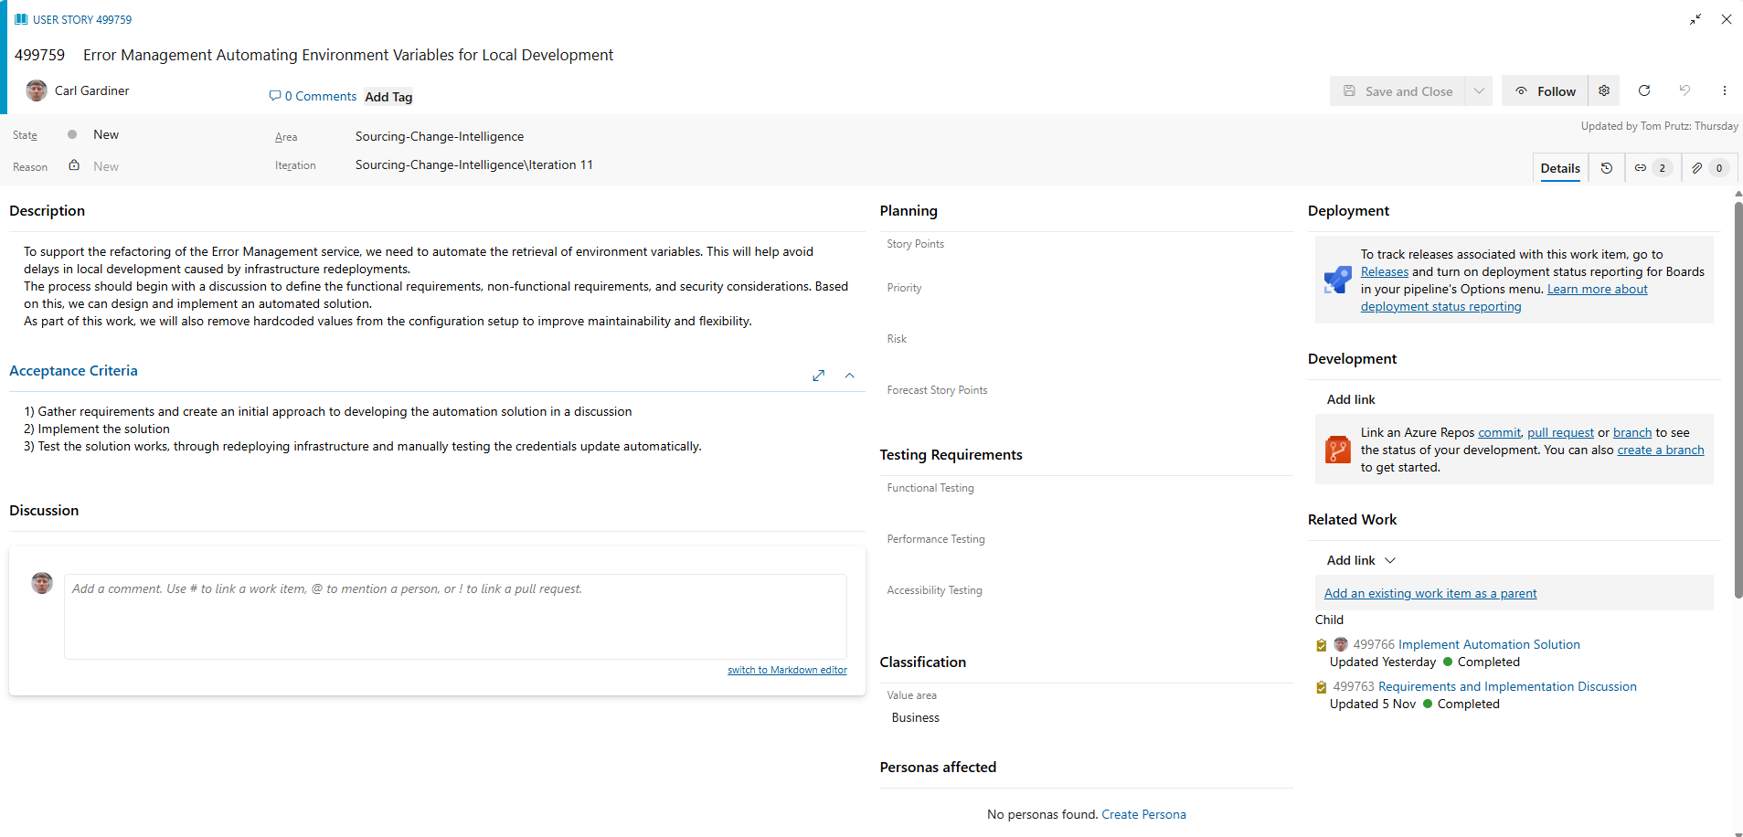
User Story
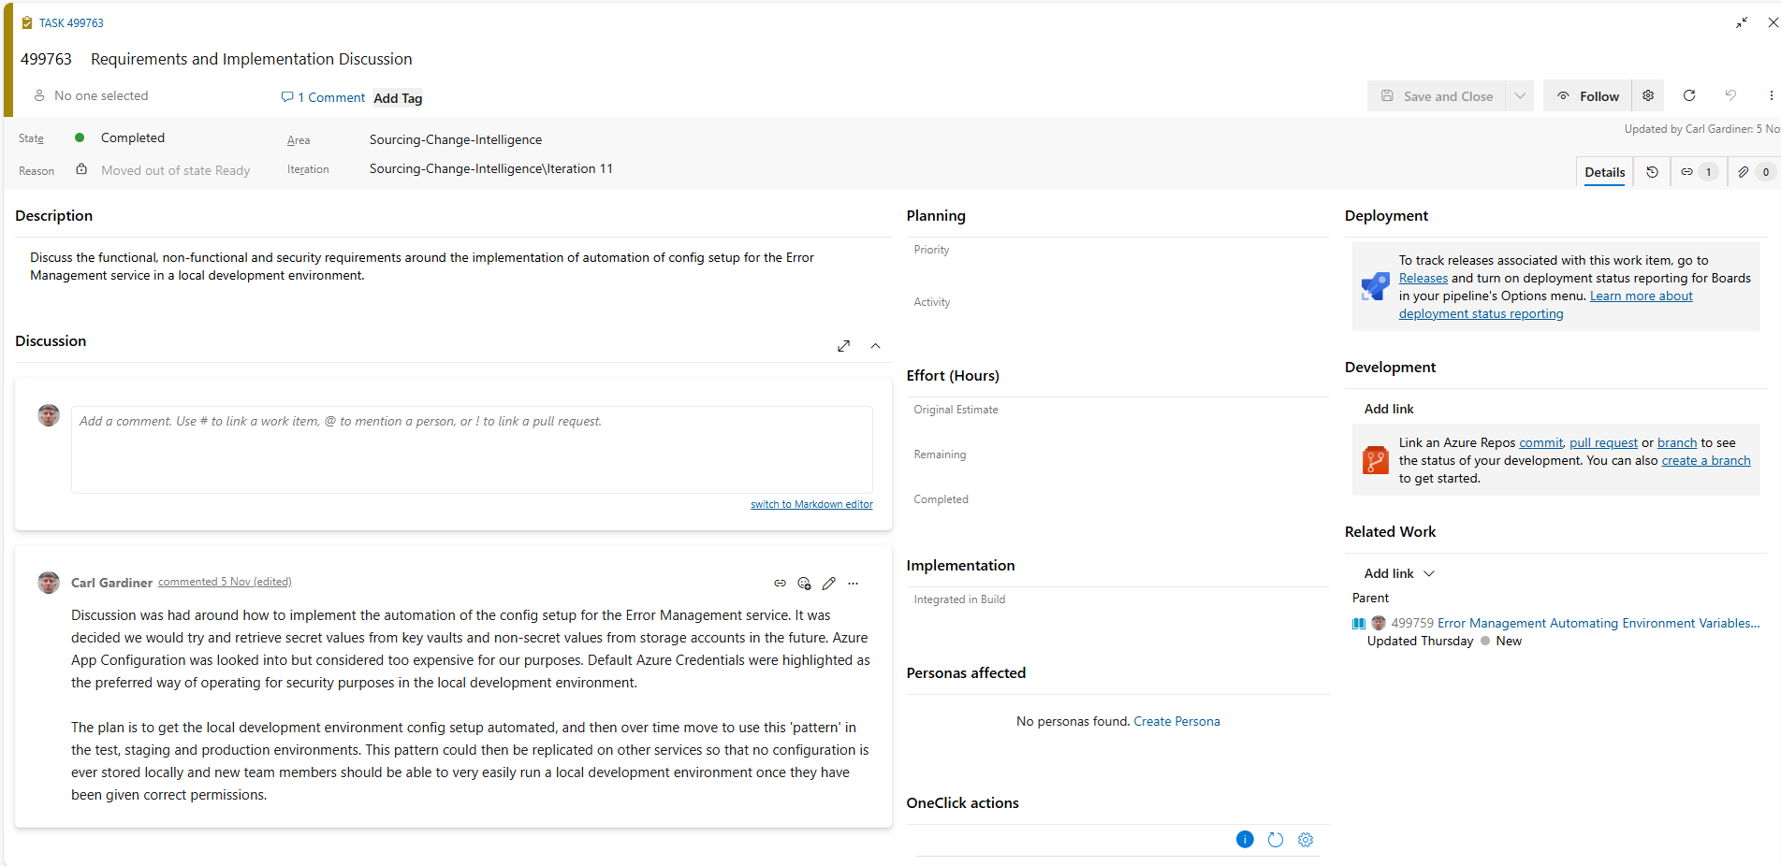
Discussion Task
The team, consisting of three software engineers, a test engineer and a product owner came together to discuss the problem during the Skills Session. From the Skills Session, we concluded that, ideally, all our configuration would be moved out of environment variables, with secret values being stored and retrieved in an Azure Key Vault, and non-secret values being stored elsewhere on Azure. The retrieving of secrets would be made possible by using RBAC combined with Azure Default Credentials. The reasons for this were that it would allow our secrets to be secure, whilst allowing for consistency across development, testing and production environments. It was decided that, as a Minimum Viable Product, I would not handle automation of the non-secret values but would focus on automating the retrieval of secret values from an Azure Key Vault.
As part of this Skills Session, I led the team through a spike development to see if our ideas were possible. I created a React application locally and managed to use the azure/identity and azure/keyvault-secrets packages from Microsoft to retrieve secrets from one of our Azure Key Vaults and displayed them to a local development frontend.
There was discussion of whether an Azure App Configuration Store (another Azure offering) would be one possible solution to this problem. However, after the team spent some time reviewing the pricing of the offering, it was realised it would cost between £300-£400 per environment per year, which seemed too costly compared to the almost negligible price of an Azure Key Vault.
The team also expressed a desire to have good documentation in a README.md file that would allow a new developer to set up the local development environment easily if they were to join the team.
Through this, a task was created on a sprint board, with me being responsible for writing the code that would allow this to be carried out as well as writing the documentation.
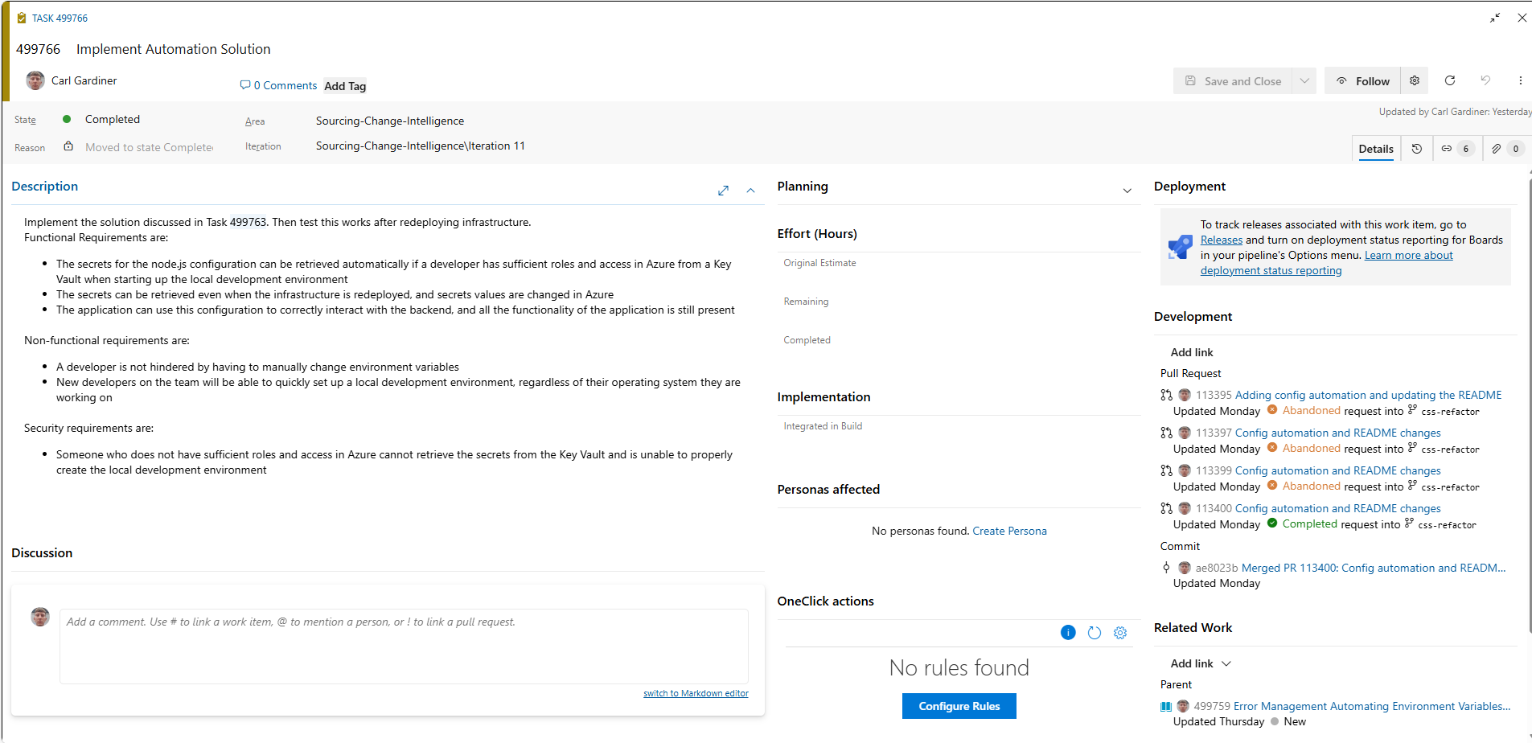
Implementation Task

Functional Requirements
The functional requirements of the development task were:
- The secrets for the node.js configuration can be retrieved automatically if a developer has sufficient roles and access in Azure from a Key Vault when starting up the local development environment
- The secrets can be retrieved even when the infrastructure is redeployed, and secrets values are changed in Azure
- The application can use this configuration to correctly interact with the backend, and all the functionality of the application is still present

Non-functional Requirements
The non-functional requirements of the development task were:
- A developer is not hindered by having to manually change environment variables
- New developers on the team will be able to quickly set up a local development environment, regardless of their operating system they are working on

Security Requirements
The security requirements of the development task were:
- Someone who does not have sufficient roles and access in Azure cannot retrieve the secrets from the Key Vault and is unable to properly create the local development environment

Design Phase
As mentioned before, a spike was done in the Skills Session to evaluate the validity of the work. Diagrams were also created by me to contrast the current configuration implementation and identify the intended end goal of all this work (beyond the initial retrieving of secrets for configuration and including non-secret configurations as well).
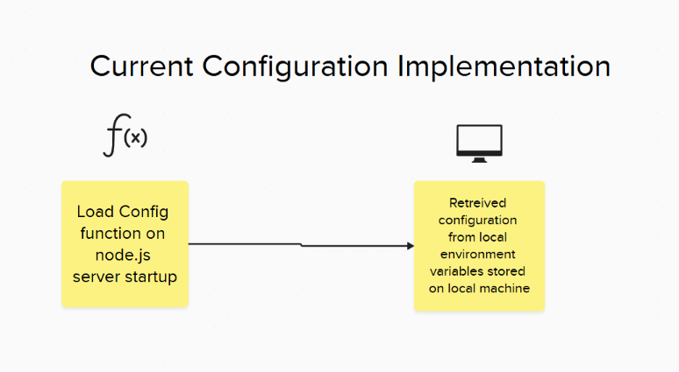
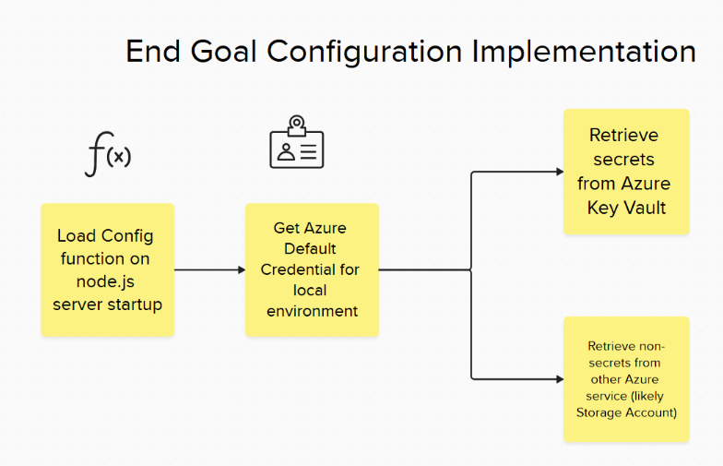

Development Phase
I started by creating a branch off the current development branch in the git repository to carry out this work without affecting other team members potentially working on the code in this repository.
When developing the automation solution, because, as part of the refactor, the team are converting all JavaScript files to TypeScript files, I started by changing the file extension of the configuration loading file from .js to .ts. The conversion from JavaScript to TypeScript is to allow for more strict type-checking, boundary access and good practice in the codebase.
This required me to change many file paths elsewhere, to allow for the importing of various packages and files from other parts of the codebase. I also changed the node.js server to run using ts-node, a tool that allows for TypeScript to be run without transpiling to JavaScript, allowing for faster development times by skipping the build step usually associated with TypeScript.
Server Script Changes
It also meant that I had to change the way that the code was functioning to avoid TypeScript errors and warnings. One problem was that the configuration was being initialised as an empty JavaScript object, so TypeScript flagged any additional properties being added when calling the load config function as something that is not present on the configuration object. To get around this, I created an AppConfig TypeScript interface with nullable properties that would allow me to add configuration at runtime without showing errors or warnings and instantiated an object that implements that interface. A benefit of this is that, should I need to add configuration properties to the code in the future, I will need to explicitly create new properties on the interface, or my code will show errors and warnings about adding properties that don’t exist to the configuration object.
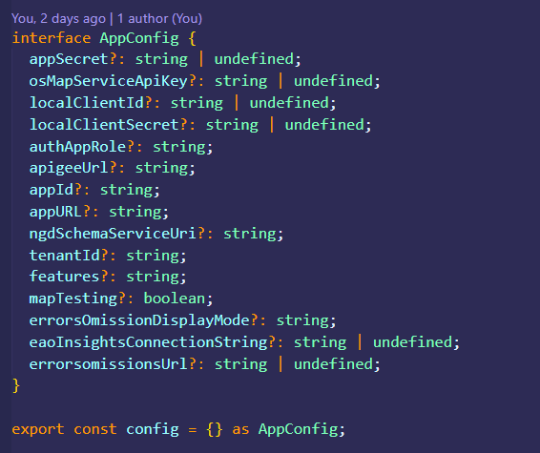
Interface Code
I also wrote a README, detailing how to set up the local development environment for a new developer.

Requirements Changing and Refactoring
During the development of the automation solution, I discovered that there were two different Azure Key Vaults that keys would have to be pulled from to make the automation solution work. I made the decision to create two different secret clients in the code rather than try to merge the two Key Vaults together in Azure by changing how the infrastructure pipelines worked. This is because merging the two Key Vaults would potentially break other systems’ dev environments (as they are not only used for this service) and the memory used for each secret client is quite negligible and performance impact is not noticeable. Here is the code creating the two secret clients:
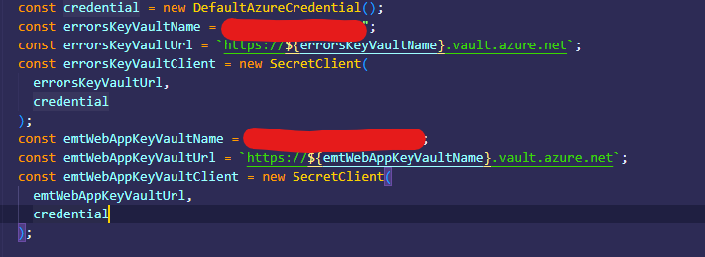
Secret Client code
Arguably, when the infrastructure changes in the future to allow for non-secrets to be part of the automation solution, this change should be reviewed and potentially a more performant solution involving only a single client could be arranged, but currently this is the most efficient solution regarding external infrastructure requirements.
The following code shows how I used secret clients to retrieve secrets from the Key Vaults:
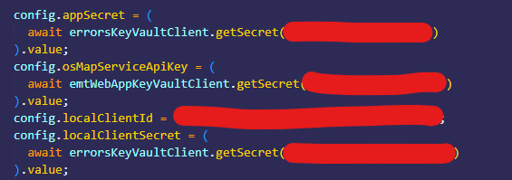
Getting Secrets code
Of particular note is the fact that the localClientId (a non-secret value) is hardcoded currently. This is something that will be further refined when non-secret values are placed in Azure, but for local development during the refactor this is something that was considered beyond the scope of the requirements for the automation tool.

Testing and Debugging Phase
Because of the use of Azure Default Credentials, it was quite difficult to know whether this code would work on other people’s machines. Initially, I had created the README by including the steps I had taken to create the local development environment on my machine from a newly cloned git repository. This was done on my Windows machine.
However, when asking a team member who uses a Mac machine to implement the README, it became apparent that, due to authorisation issues not linked to this work, they would have to set up the local development environment differently. For this reason, I amended the README to include steps fort those not on Windows machines, and they managed to follow the README and get the local development environment working after this.
I then asked a team member on Windows to try and set up the local development environment, and they also were able to, following the README instructions.
I then redeployed the cloud infrastructure using deployment pipelines, to force secrets change in the Azure Key Vault and test the reliability of the automation solution. The automation solution worked, with me simply having to restart the server to get the correct configuration speaking to the backend.

Deployment and Maintenance Phase
For deployment of this code, I created a pull request in Azure DevOps, to merge this code into the development branch of the code repository. My code was then reviewed by a senior engineer, who approved it after recommending minor improvements involving the moving of code around.

Pull Request in Azure DevOps
Because the service being refactored is not currently production-ready, the maintenance and improvement of this code will continue, with future improvements planned (see below). Otherwise, the team plans to continue to maintain and improve this automation solution in the future, and this method of retrieving configuration is a pattern we plan to use in other services under our control.

Potential Future Improvements
As mentioned, the future goal for configuration automation in this service is to also have all non-secret values stored somewhere in Azure, and for our node.js server to retrieve the configuration values at startup time. This would allow for changing of values in the future without changing the system’s code and could allow for easy reprovisioning in a disaster recovery scenario.
Another future improvement is to allow this sort of retrieving of credentials for all environments, including testing and production environments, and to have the code act the same way across multiple environments, so we can have more confidence that the system will act the same when deploying to a production environment.
Although currently, commented out code is in this format:
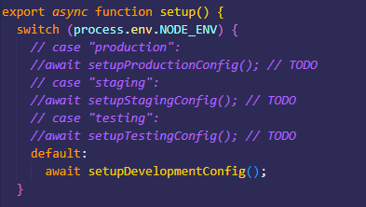
Commented out future code
This code will probably be redeveloped so that a single function takes an argument of the type of environment in use. Although this may not be the case, if there are significant discrepancies between the environments (for example, the development environment will likely not use deployment slots, whereas production will in order to reduce downtime and allow for pre-release testing).

