Project: Refactoring a React Front-End for Improved Testability
Contents
Project: Refactoring a React Front-End for Improved Testability 1
Introduction 2
Analysis and Requirements Gathering Phase 4
Functional Requirements 4
Non-Functional Requirements 4
Security Considerations 4
Design Phase 6
Development Phase 8
Testing and Debugging Phase 11
Deployment and Maintenance Phase 13

Introduction
This portfolio entry focuses on applying software development techniques to refactor a React front-end component, improving its testability and modularity in order to implement a series of functional, non-functional and security requirements. The project involved restructuring the code and implementing dependency injection to then allow for the implementation of the new code and testing of this new code.
The specification for the project was given during a two-week agile sprint, in the form of a User Story (311811) and a child Task (416811). These user stories were produced by business analysts in conjunction with customers and engineers on our team and were finalised during an estimation session during the sprint where timeframes and criteria were agreed. Here are images of the aforementioned User Story and child Task, which were stored in Azure DevOps to allow for agile development:
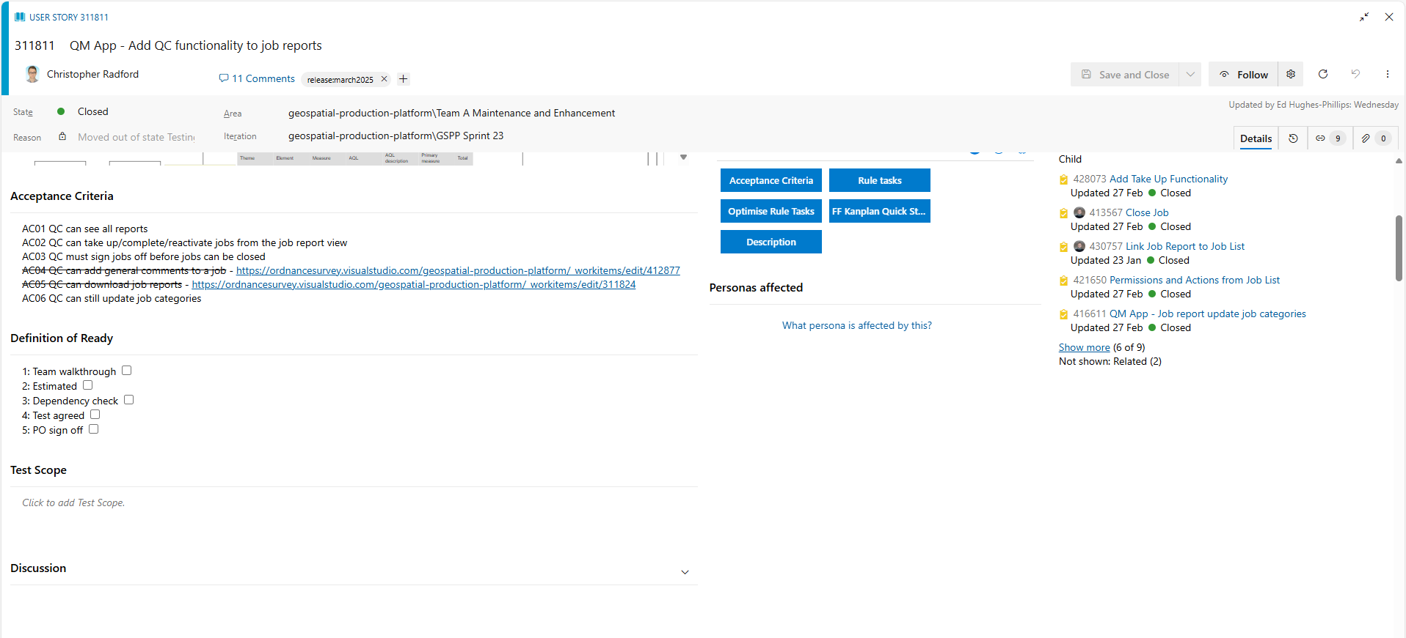

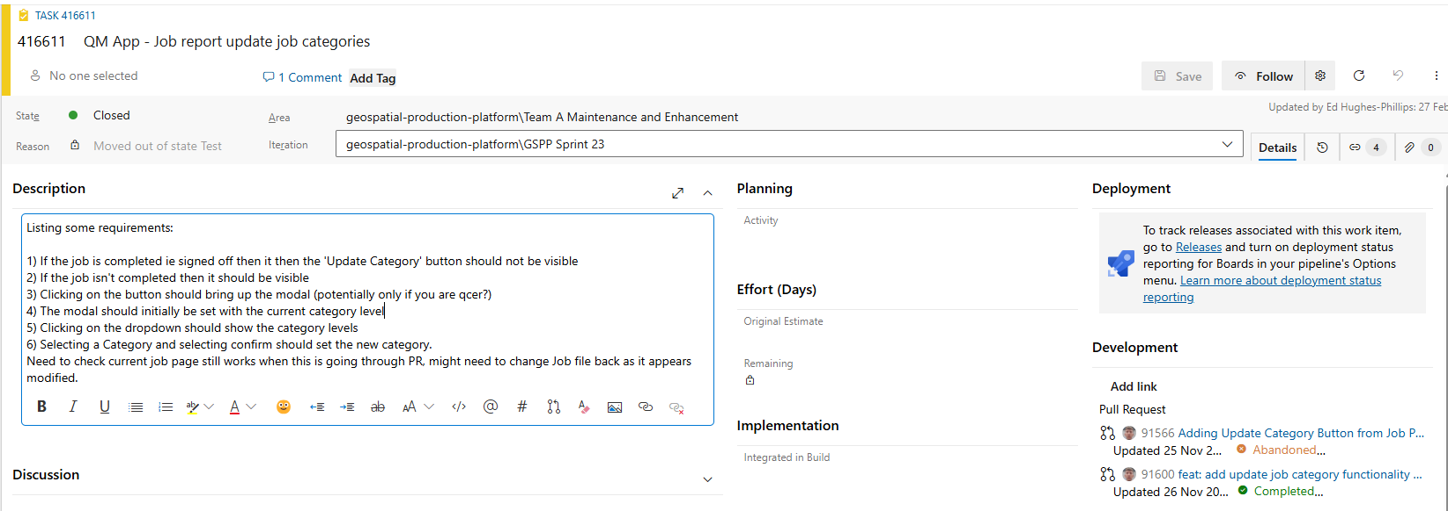
The task 416611 specifically refers to the AC06 Acceptance Criteria, which was a requirement agreed upon after consideration by both developers and business analysts during a meeting at the start of the sprint. The initial impetus for the requirement was obtained from the business analysts speaking to customers directly.
The task involved adding new functionality to a Job Report Page on our Quality Management App, the requirements for this were as follows:
1) If the job is completed i.e. signed off then the ‘Update Category’ button should not be visible.
2) If the job isn’t completed then the ‘Update Category’ button should be visible.
3) Clicking on the button should bring up the Update Category modal (there was some discussion around whether this should be restricted to certain categories of user).
4) The Update Category modal should initially be set with the job’s current category level.
5) Clicking on a dropdown on the Update Category modal should show the category levels available to select.
6) Selecting a category and selecting Confirm should set the new category.
7) This needed to not break existing functionality.

Analysis and Requirements Gathering Phase
I began the project by analysing the existing implementation and working out how to implement the new functionality. The React component for the page was initially monolithic and therefore required significant mocking of unrelated functionality to create unit tests for new functionality.

Functional Requirements
For functional requirements of the task, I realised the following was needed:
- The refactored component needed to allow for an Update Category button which allowed changes to other components based on user input.
- The component had to integrate seamlessly with the existing React-based system while ensuring all user actions triggered expected behaviours.

Non-Functional Requirements
For non-functional requirements, I realised that the three following categories needed to be accounted for:
- Scalability: The new modular design needed to allow for easier expansion without affecting unrelated components.
- Maintainability: The improved structure needed to simplify debugging and future feature additions.
- Performance: By reducing unnecessary re-renders and improving state management, the new structure needed to enhance application responsiveness.

Security Considerations
Despite adding new features, they had to be done in line with existing security practices:
- While security risks were minimal due to internal user access restrictions, I made sure the following best practices were to be followed:
  - Using a well-maintained frontend CSS framework (Material UI) to reduce vulnerabilities and bugs. The usage of Material UI ensures cross-browser compatibility as it is tested across most major browsers and devices. Material UI is an open-source framework and therefore contains code vetted by a large community and comes with components which automatically sanitise inputs (to prevent cross-site scripting or SQL injection attacks) and secure default practices which mean that less work is needed by developer to ensure best practice.
  - Validating and sanitising input data on the backend.
  - Ensuring secure authentication through the company’s existing authentication systems, allowing only authorised personnel to interact with the application and only in ways they are authorised to.
I realised the initial design lacked clear modularity of components, making it difficult to test individual functionality effectively. This was because of the requirements listed in Task 416611. This was compounded by the fact that some of the larger component made API calls, meaning that if you were testing functionality that did not involve those API calls, you would still have to mock out the API call functionality to test it, which was completely unnecessary. From research, I discovered that, to enhance code reuse and allow for testability, it would be good to split up the components that made up the page so they could be tested individually. From researching, breaking the page down into smaller components also would improve the performance as React would only re-render the smaller components that needed to be re-rendered rather than a whole page.
User stories and acceptance criteria were documented in Azure DevOps (see above User Story (311811) and a child Task (416811)) to guide the refactoring process. This was done at the task level but the wireframe that I had to follow was included at the user story level. The identification of the need to refactor the code was done by me, and this was seconded whilst communicating with another engineer on my team, as we both agreed the current implementation was too unwieldy to allow for new features to be added easily, and continuing in the same vein would affect maintainability in the future.

Design Phase
I reviewed a wireframe diagram to help identify logical component groupings. This is the wireframe that had to be followed (the wireframe below is split into two images, showing the top and bottom of the page, as smaller images became blurry and unreadable):
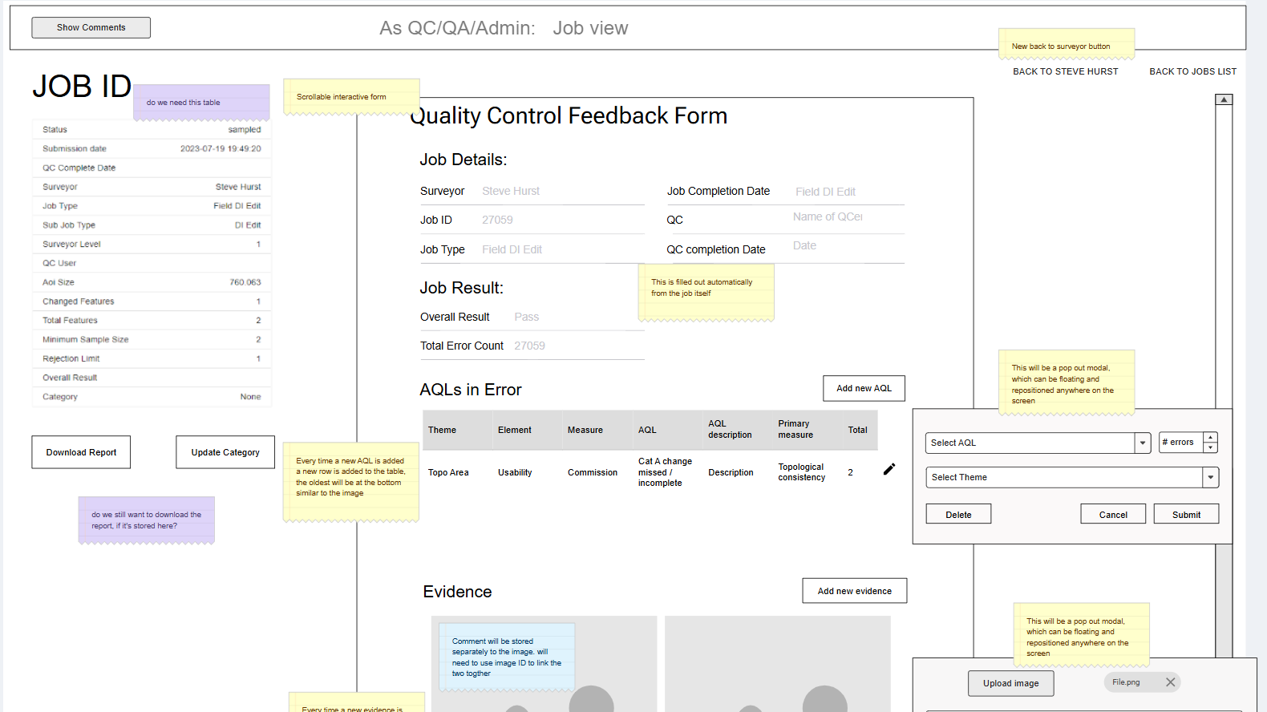

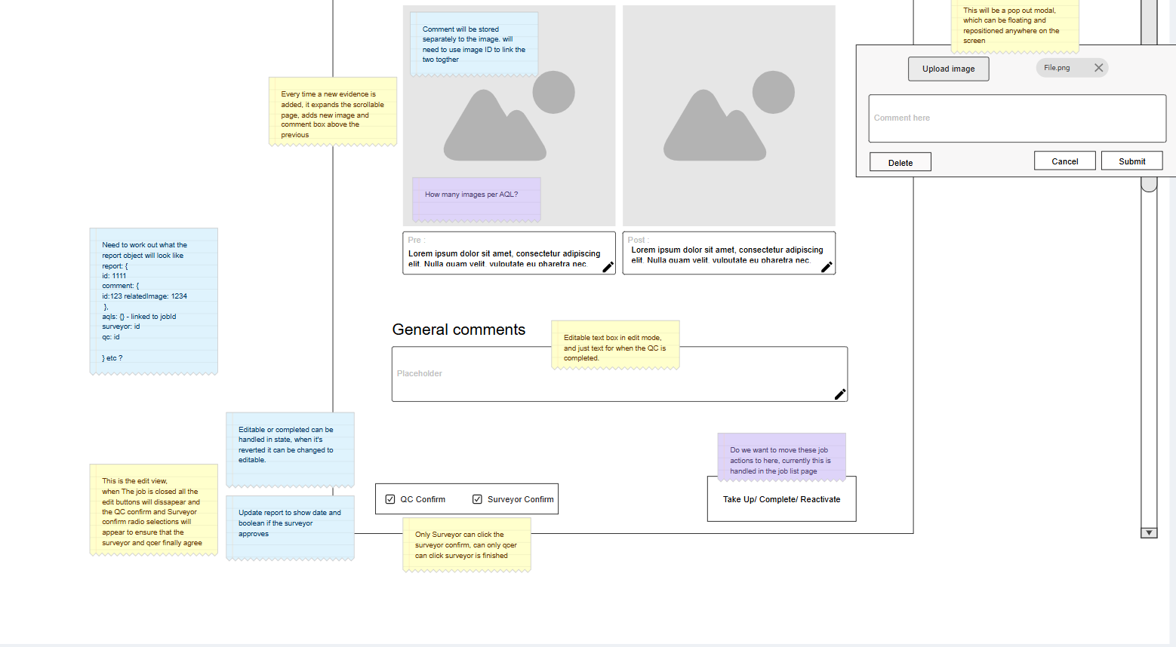

The wireframe was produced by a senior engineer, after consultation with the UI/UX team, a lead engineer and some customers who wanted to make known their ideas for the page.
I restructured the React front-end by separating large files into smaller, reusable parts. From the wireframe, there is a clear separation between the left-hand column and the rest of the page, so I decided to start there with reimplementing the job report page component. There already was a separate component for the left-hand side information, but it did not include buttons (which is what I had to introduce for the Update Category Ticket), so I decided to encapsulate the whole left-hand side into a ‘JobInfoColumn’ component, with the current job info component.
I was then able to introduce dependency injection to enable easier unit testing of individual parts instead of mocking out functionality in a large, monolithic component.
This diagram explains how this works:
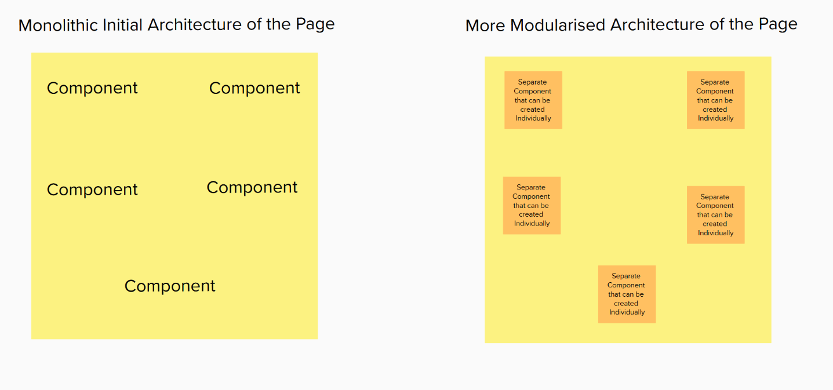
The Monolithic Architecture shows a page component in React where all the Components are at the same level and cannot be instantiated individually. Due to how functional components work in React, such a model means that to unit test one Component of the page, the rest of the page needs to be mocked out as well. This leads to unwieldy tests that are difficult to refactor. The Modularised Architecture changes this, instead composing the page of Components which can be instantiated individually, which makes testing far easier and allows for component reuse as well which reduces development time.

Development Phase
I refactored monolithic components into modular units.
Here was the TSX code for the Job Report Page before:
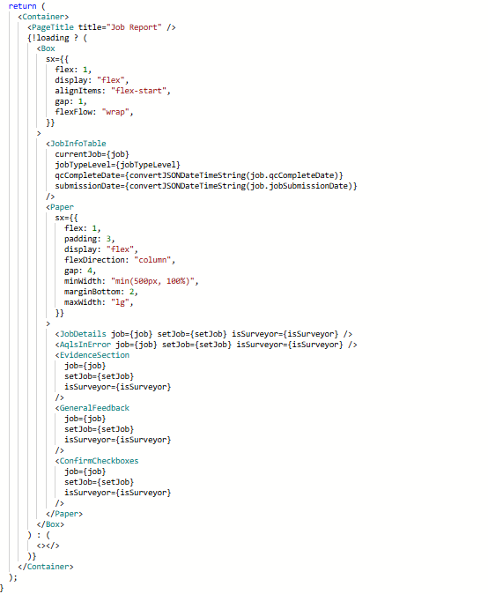
And here was the TSX code for the Job Report Page afterwards:
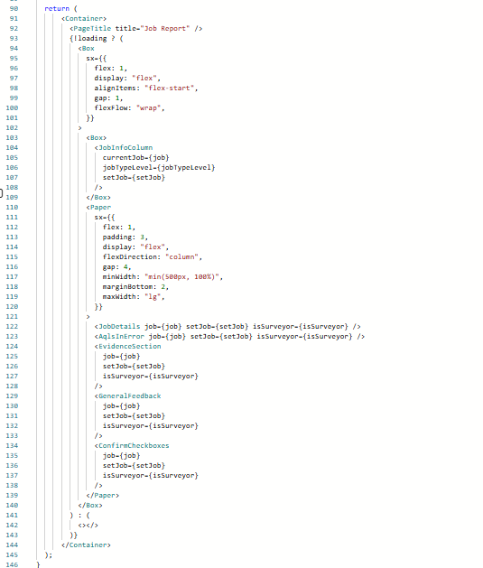
The Job Info Column looked like this:
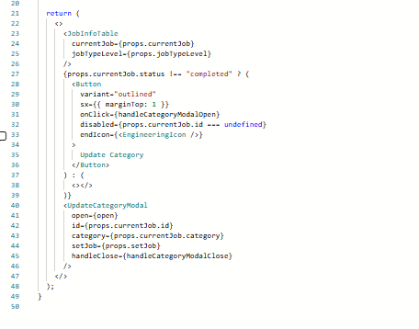
I did this because it allowed me to nest the JobInfoTable component at this level, allowing for it to be tested and dependency injected. It also allowed me to test the update category functionality separately
I injected and extracted Functions as props, improving reusability and isolating logic for better testability. This is considered good practice for testing, as it also separates the concerns of logic, rendering and user interaction and allows for easier mocking for components such as modals where mocking is unavoidable.
Material UI components were used for UI consistency and efficiency, this is because the Material UI framework is tested across multiple different browsers as it has a large, open-source community supporting it.
The development I did was done on a git branch in source control derived from the main branch. When merging back into main after the work was complete, the branch was squashed into as few commits as possible, and a pull request was not allowed to be merged into main until automated tests and a code review sent out to the development team was approved. The code review process was fairly democratic, with other team members making comments. Although most team members could approve a pull request, senior engineers had the authority to veto if they thought the pull request did not meet a high enough standard.

Testing and Debugging Phase
I debugged by running tests locally and running tests in the automated deployment pipeline when the code was undergoing code review and being deployed. Because there were already unit tests for parts of the page, failing tests were useful in indicating when a breaking change had been made during the refactor. Breaking changes involving infrastructure were highlighted during the code review process with the automated pipelines which made sure they worked in a non-local environment.
I also debugged by carrying out manual checks to make sure the front end displayed correctly. This was done by running a local development environment to check that things looked and worked correctly from a user’s point of view.
I implemented new unit tests to verify component functionality without requiring interaction with the backend.
Here you can see the number of added files, which previously didn’t exist (Azure DevOps adds a ‘+’ sign next to entirely new files in the git history):
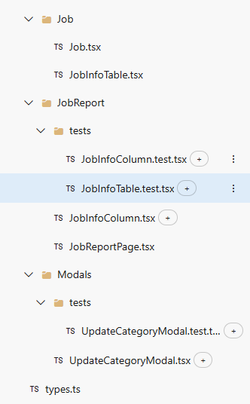
I used a test-driven development (TDD) approach initially, creating test cases before implementing the changes. This, combined with existing tests in the codebase, ensured that new features firstly worked as intended, and secondly that new features did not break existing features. Occasionally, due to the refactoring, I needed to refactor certain tests that already existed, but this led to simpler tests, instead of adding complexity, thus making the codebase more easily maintainable.
Automated testing pipelines in Azure DevOps ensured that any new changes met predefined acceptance criteria before being merged. Combined with the TDD approach discussed before, the probability of breaking changes or errors making it to our cloud estate and working software is significantly reduced (though not entirely eliminated). Azure DevOps Pipelines were used for the automated testing and deployment of software after having during and after the Pull Request process. The benefit of using an Azure DevOps pipeline is that code that does not pass unit and acceptance tests can be prevented from making it to development/ testing environments which can prevent problems from occurring in our cloud estate ahead of time. It ensures that software works and is reliable and makes it so that this is not dependent on manual processes, which are inherently more prone to failure due to human error.

Deployment and Maintenance Phase
I integrated the refactored code into the existing repository and tested across different environments.
I resolved dependency issues caused by varying versions in Node Package Manager (NPM).
Future improvements were identified, including further enhancements to the system’s architecture. The improvements I identified included making sure that NPM packages were consistent across different environments, as during debugging I had noticed discrepancies between my local environment and the pipeline environment, but this was outside the scope of the task given to me at the time.
Here is some evidence that the Azure DevOps pipeline passed, along with the unit tests that were added to the project. The stages of the pipeline are shown in the first diagram and the tests passing are shown in the second diagram. This shows how the pipeline prevents broken code from making it to production.
