Business Analysis and Modelling
Module Code: COMP40043
Module Name: Data and Business Analysis
Title of Assignment: Business Analysis and Modelling
Assignment 1
Student Name: Carl Gardiner
Student ID: 24030180

Contents
Part 1: System As is 1
1.1 Nature of the Problem and Business Impact 1
1.2 Business Impact Table 2
Table 1 2
1.3 PESTLE analysis 4
Table 2 4
1.4 SWOT analysis 6
Table 3 6
1.5 UML Use Case Diagram 7
Figure 1 7
1.6 Use Case Script 8
Table 4 8
1.7 UML Activity Diagram 9
Figure 2 9
Part 2: System To Be 10
2.1 - Justification for Change 10
2.1a - Where would the ELS store be located? 10
2.1b - Who would govern access to the ELS storeroom? 10
2.1c - How are items of equipment checked in/ out of the ELS? 10
2.1d - Who would have access to the ELS? 10
2.1e - How would employees gain access to the ELS? 10
2.1f - How would the ELS be used by employees? 10
2.1g – What other benefits would an ELS provide? 11
2.1h - Proposed change 11
Figure 3 11
2.2 Functional and Non-functional requirements 12
Table 5 12
2.3 Data flow diagram 15
Figure 4 15
2.4 Data Requirements 16
2.4a - Requirement 1.0 and 4.0 16
Table 6 16
2.4b - Requirement 2.0, 5.0, 7.0 16
Table 7 16
2.4c - Requirement 3.0 17
Table 8 17
2.4d - Requirement 6.0 17
Table 9 17
Table 10 17
2.4e - Requirement 8.0 and 9.0 17
Conclusion 19
References 20

Word Count with Tables - 3595
Word Count without Tables - 1645

Part 1: System As is

1.1 Nature of the Problem and Business Impact
This case study is regarding the feasibility of an Equipment Loan System (hereafter referred to as an ELS) at Ordnance Survey (hereafter OS). OS is a business that makes revenue by providing geospatial data and maps to its customers. Whilst this case study cannot use actual figures for business and legal reasons, geospatial data makes up the most significant portion of the two revenue streams. Most of the revenue from the geospatial data is from a contract with the UK government, called the Public Sector Geospatial Agreement (hereafter PSGA), which states (Ordnance Survey, 2024):
The Public Sector Geospatial Agreement (PSGA) sets out how Ordnance Survey (OS) provides world-leading location data and expertise to the public sector across Britain. It supports the delivery of critical infrastructure and services, as well as working to help protect our environment.
Other customers, such as energy companies, make up the rest of the geospatial data revenue. In reference to what OS does, their website (Ordnance Survey, 2024) states that:
… we show businesses how to gain a location data edge and we help everyone experience the benefits of the world outside
OS has lots of additional ‘floating equipment’, including whiteboards, display screens, flip charts, extension cables, laptops etc which are free to be transported around the building. Whilst having this additional equipment is incredibly useful for employees in the office, OS does not currently have an ELS.
OS employs between 1000-2000 employees at any one time. For the purposes of this case study and to make calculations easier, it is assumed the number is 1500.

1.2 Business Impact Table
Table 1 is a Business Impact Table highlighting problems that exist because of the lack of a formal ELS. The IDs of the problems will be used elsewhere in this case study.

Table 1
Problem ID | Problem | Narrative | Business Impact
A | Difficulty Searching for Equipment | When an employee wishes to use additional equipment, it is often difficult to find what they are looking for. This is because they either don’t know where to look for it, or it has moved from where they saw it previously. | An employee spending time looking for equipment is an employee not performing their primary role. Because equipment is not stored in a central space, it is not unreasonable to suppose an employee may spend an hour per week looking for equipment. Given a 37-hour working week, this would represent almost a week-and-a-half of wasted time per year. Given a £36000 mean average yearly salary in the UK (including bonuses) (Thornhill, Jo (Forbes), 2024) and given a 1924-hour working-year this could cost the business £1000 per employee. If spread across all employees, this could amount to £1,500,000 lost per year by employees looking for equipment. Whilst time looking for equipment can never be removed entirely, more efficient methods could reduce money lost.
B | Loss of Equipment | Smaller pieces of additional equipment could be taken from HQ by employees, either intentionally or unintentionally. Additionally, OS allows many external personnel into HQ for various reasons, and the National Health Service (NHS) rents some office space inside HQ. As such, theft of additional equipment is likely. | Missing or stolen equipment would lead to replacement equipment having to be bought. If every employee managed to lose just £25 of equipment per year, that would represent at least £25,000 of equipment that needs to be replaced per year. UK business lose more than £183m per year as a result of theft, with 14% losing laptops, which average at £249 per item (Secton, 2022). This would cost OS roughly £52.290 per year if it follows the national average.
C | Difficulty Accounting for Equipment | Due to the widespread distribution of equipment throughout the building, it is currently unfeasible to keep track of it all. | Without a central database for the additional equipment, it would be impossible to figure out how much equipment is currently available or being used. This means it is currently impossible for OS to budget for equipment accurately. OS could potentially have thousands of pieces of equipment in use that is untracked.
D | Difficulty Maintaining Current Equipment | Due to the widespread distribution of equipment throughout the building, it is currently very difficult to organise maintenance schedules for those pieces of equipment that require it. | Without being able to organise maintenance schedules, unmaintained equipment may become unusable over time. Regarding Health and Safety compliance, failure to correctly schedule maintenance could lead to fines, negativity publicity and injury or loss of life. For example, minor breaches of Health and Safety law (such as not Portable Appliance Testing) carries a fine of up to £20000 (PAT, 2024). Where non-compliance puts an employee in danger of life and limb, “The maximum penalty in the Crown Court is an unlimited fine or imprisonment not exceeding two years or both.” (Health and Safety Executive, 2024)

1.3 PESTLE analysis
This PESTLE analysis identifies “six key areas that should be considered when attempting to identify the sources of change” (Cadle et al. 2021, 1: External Environment Analysis). These are external factors related to the problems in the Table 1. Where there is more than one issue in a single category, external issues are ranked, starting with the most impactful.

Table 2
External Factor | Issue
Political | - PSGA contract runs out in 1 April 2030 (Ordnance Survey, 2024), changes in government (from the results of national elections) or Problems B, C and D could cause the government to award the contractor to geospatial competitors, such as Google Maps (Google, 2024) or Apple Maps (Apple Maps, 2024), which would have a devastating affect on Ordnance Survey because of the UK government’s procurement policy (gov.uk, 2025).  - OS’s shares are 100% owned by the Secretary of State for Science (Ordnance Survey, 2024) and a majority of revenue comes from the PSGA. Problems B and C could lead to accusations of misuse of public funds as external audits could cause the public to question government misspend.
Economic | - Economic downturn could lead to a need for OS to reduce spending. Problems A, B, C and D would each impact OS’s ability to do that.
Social | - Since the Covid-19 pandemic, OS has operated as a ‘hybrid’ company (with no mandate to come in to office, but looking upon it favourably). To maintain a positive work culture, OS hosts ‘in-person days’ for mostly remote teams. Problem A is likely to affect these employees who do not know the HQ that well, as they would struggle to find equipment they needed.  - Because of the ‘hybrid’ environment, employees working from home might need equipment temporarily, leading to an increased likelihood of Problem B.
Technical | - Due to the ‘hybrid’ work environment, equipment is often needed in the office for meetings. Problem A means it can be an issue for employees to set up meetings correctly.  - Technologically, multiple pieces of equipment might be needed by an employee at one time, Problem C means additional equipment might be ordered without needing to be.
Legal | - Legally, Problem D could lead to fines (for example, a broken extension lead could give an employee an electric shock), ranging from small to business-ending for OS because of Health and Safety Legislation.  - If theft occurred as in Problem B, it is more difficult for OS to find the culprit and press charges or be compensated.
Environmental | - Problem C could mean that OS is ordering equipment they don’t need, meaning resources are being wasted building those products and shipping to OS.  - OS tries to maintain an environmentally conscious image (Ordnance Survey, 2024), Problems A, B, C and D could cause money to be diverted away from environmental efforts.

1.4 SWOT analysis
This SWOT analysis is slightly altered, as usually the Opportunities is in reference to external factors (James Cadle et al. 2021, : 1: Strategy Analysis), but because of the nature of this case study it has been modified to reflect internal opportunities

Table 3
Strengths | Weaknesses
- OS has significant amounts of surplus equipment at HQ. Although the exact number is impossible to ascertain, it is likely in the thousands. This equipment can be used to enhance capability and productivity | - Problem A reduces productivity  - Problem C means OS doesn’t have a firm grasp of how much equipment of various types it has, leading to potential overspend  - Problem D could lead to broken or faulty equipment, which represents a financial risk from either employees not being productive or someone being harmed and OS being fined
Opportunities | Threats
- An ELS could allow for placing all equipment in a store, alleviating Problem A through ease-of-access for employees wanted to use equipment  - An ELS would reduce the chances of Problem B occurring  - An ELS tracking equipment could allow for remediation of Problems C and D, allowing for better budgeting and better maintained equipment  - An ELS system could allow for Online Analytical Processing through comparisons of prices of equipment with equipment on the internet, leading to more cost effective procurement policies. | - External personnel stealing equipment as in Problem B  - Legal issues resulting from Problem D  - Other geospatial companies overtaking OS through good internal policies such as an ELS allowing for more productive employees, leading to OS losing government contracts (gov.uk, 2025)

1.5 UML Use Case Diagram
Figure 1 shows a UML Use Case Diagram of how procuring equipment works at OS with a non-existent ELS:

Figure 1
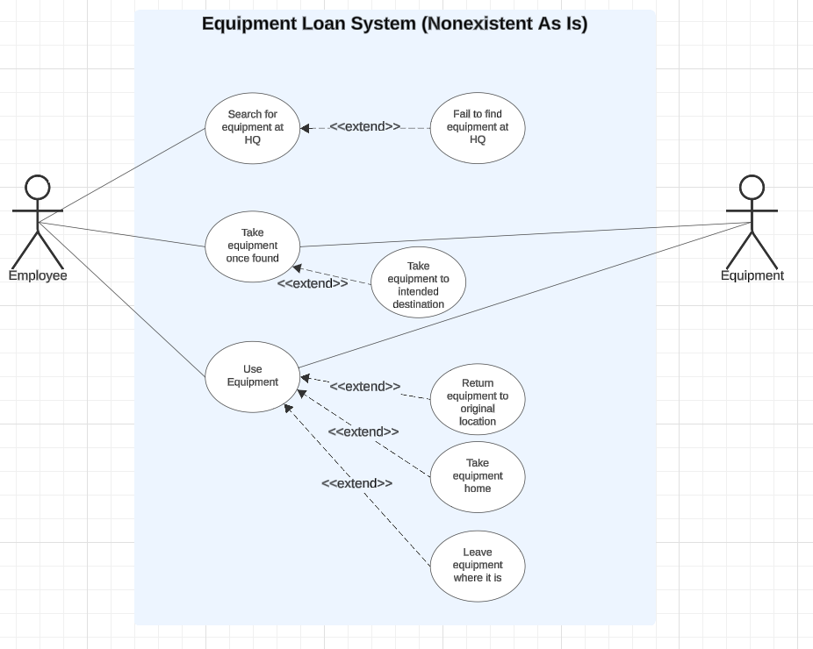

In relation to Table 1, the current system lacks procedure and clearly highlights how Problem A would prevent all other activity, it also shows how easily Problem B would occur in the extensions of the Use Equipment Use Case. From this diagram, Problem C and Problem D can be clearly deduced as consequences of the lack of an ELS.

1.6 Use Case Script

Table 4
Main Success Path
Actor Actions | System Response
Customer searches for equipment at HQ | Equipment is found; however this may have been a long process, highlighting Problem A
Customer takes equipment once found | Equipment is taken
Customer uses equipment once found | Equipment is used for intended purpose
Alternate Paths
Actor Actions | System Response
Customer fails to find equipment at HQ | There is no current system response, showing how Problem A may waste an employee’s time
Customer takes the equipment to its intended destination after taking the equipment | Equipment is taken to the intended destination
Customer returns the equipment to its original location after use | This could be useful or not for other employees looking for the equipment, highlighting Problem A.
Customer takes equipment home after use | This highlights Problem B and could lead to the equipment being stolen or never returned. This would lead to Problems C and D.
Customer leaves the equipment where it is after use | This could be useful or not for other employees looking for the equipment, highlighting Problem A. This could also lead to Problems C and D due to losing track of where equipment is kept.

1.7 UML Activity Diagram
Figure 2 shows a UML Activity Diagram created using UML 2.5 conventions (Fakhroutdinov, 2024) showing the flow of activity that an employee would go through when procuring equipment at OS currently without an ELS in place:

Figure 2
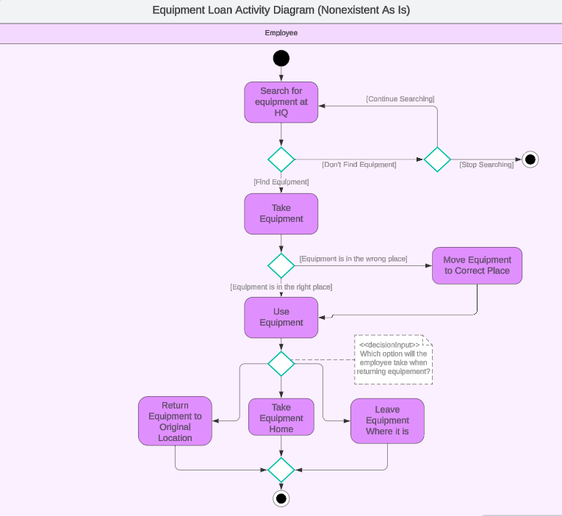
Similarly to the Use Case Diagram in Figure 1, Figure 2 shows how multiple of the problems in Table 1 would affect an employee currently when trying to procure and use equipment. It also makes it more obvious how Problem A can lead to an undesired end state (signified by the Activity Final Node after the [Stop Searching] flow), and how Problem B, C, and D can occur through the options before the Merge Node before the bottom Activity Final Node).

Part 2: System To Be

2.1 - Justification for Change
Given the As Is System defined in Part 1, it is clear OS requires some sort of ELS to enable problems in Table 1 to be mitigated or controlled outright. How this might be done relies on answering these questions:

2.1a - Where would the ELS store be located?
To combat Problems A and B, an ELS store would have to be secure against open access, whilst still being accessible to employees. Many storerooms are not used as much as before the Covid-19 pandemic, making this an obvious choice because of the availability and lack of cost.

2.1b - Who would govern access to the ELS storeroom?
This could be done by an Inventory Manager, or an automated access control system linked to employee security passes, both would suffice to combat Problem B. An Inventory Manager would cost more in terms of employee wages but would be more flexible and could fill other roles needed in the ELS. Whereas an automated system would be initially more expensive but would reduce cost over time (Jensen, 2023). Overall, an Inventory Manager would be preferable due to their flexibility.

2.1c - How are items of equipment checked in/ out of the ELS?
If there is an Inventory Manager, a barcode scanner linked to a database would suffice, but in an automated system it is hard to prevent the potential of stealing outlined in Problem B for smaller pieces of equipment and would rely on the employee scanning the equipment themselves. A paper system would not suffice, as it would be difficult to maintain to combat Problem C and D and has more potential for error. Overall, an Inventory Manager scanning equipment for employees is preferable.

2.1d - Who would have access to the ELS?
OS employees would have to be the only ones that have access to the ELS, to prevent Problem B.

2.1e - How would employees gain access to the ELS?
Access to the ELS would have to be governed by an administrator, which could be the Inventory Manager or, in the case of an automated system, a member of security.

2.1f - How would the ELS be used by employees?
Employees could book a reservation on the ELS and could then use the equipment during the reserved. An email could be sent to an employee if they do not return the equipment on time, thus helping to ensure that Problem B becomes less frequent.

2.1g – What other benefits would an ELS provide?
An ELS could allow for business analytics gathered from data in the ELS databases, which would allow for better forecasting and provision of equipment.

2.1h - Proposed change
Because sections 2.1a – 2.1g identified the need for an Inventory Manager, an Inventory Manager could help by solving problems B, C and D and preventing the need to hire contractors to maintain equipment. Figure 3 shows a UML Activity Diagram for the proposed system in which an employee would use the ELS:

Figure 3
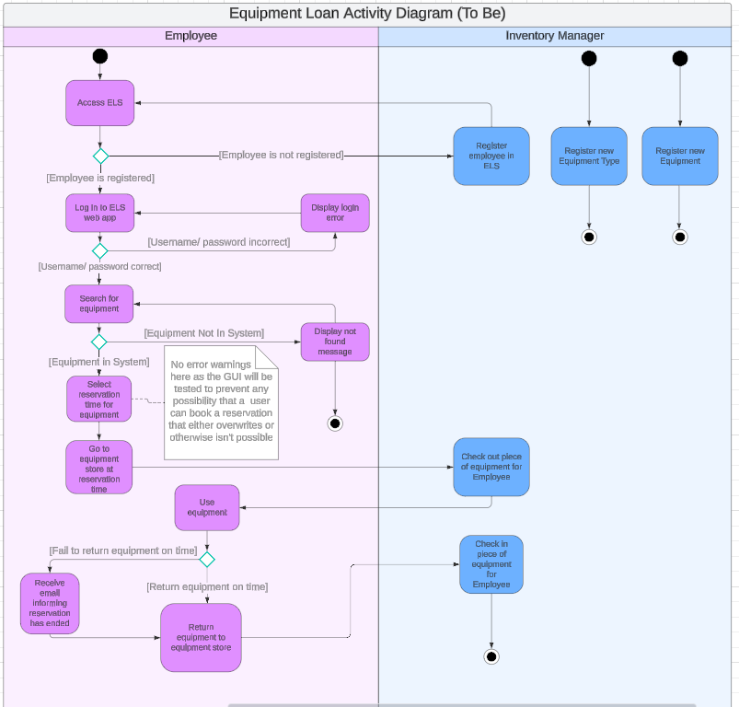

2.2 Functional and Non-functional requirements
Table 3 shows the functional and non-functional requirements for specific functionalities in the proposed ELS system. The Requirement IDs will be used elsewhere in this case study.

Table 5
Requirement ID | Functional Requirements | Non-functional Requirements
1.0 | Inventory Manager can register employees to the ELS (helps alleviate Problem A) | Security: Admin-only area of web app where users can be registered  Username and password: Username must be employee’s work email address. Password to be given to employee securely.  First name and second name: These will be useful for identifying employees easily and for greetings in the ELS system itself.
2.0 | Inventory Manager can register new pieces of equipment to the ELS (helps alleviate Problems A, B, C and D) | Must: Exact equipment must not already exist
3.0 | Inventory Manager can register new equipment types to the ELS (helps alleviate Problem C) | Must: Type must not already exist
4.0 | Employee can log into system (helps alleviate Problem A) | Username: Must be a valid email address  Password: Must be valid and secure  Speed: Must be almost instant from the employee’s view
5.0 | Employee can search for equipment they want to use (helps alleviate Problem A) | Speed: Database retrieval should be within a few seconds and should show a loading symbol to inform employee retrieval is ongoing.  Information: Employee should be informed if there is no equipment that they have searched for.
6.0 | Employee can reserve equipment/ inventory manager can reserve maintenance window for equipment by using the GUI to choose the time they want (helps alleviate Problem A) | Conflict: The user shouldn’t be able to select times where the equipment has already been reserved  Conflict: The user should not be able to select times that the equipment is under maintenance.  Conflict: The user should not be able to select impossible times (i.e. in the past)  Conflict: The user should not be able to book out the equipment for longer than its max time  Visual: This should be done in a format that is user friendly in terms of clear colours and indicators on a calendar differentiating between dates that are booked and ones that are not
7.0 | Inventory Manager can check out/ in equipment for employee (helps alleviate problem B and C) | Must: Update database to allow for checking out/in
8.0 | Information can be taken from databases and transformed to allow for business intelligence analytics. (helps alleviate Problem C) | Must: Be done on a regular, but not immediate, basis
9.0 | Inventory Manager has access to business intelligence reports, (helps alleviate Problems C and D) | Must: This overview must only be available to the Inventory Manager, as only they should have this high-level view of the effect on the business
9.0 | Automated System sends email when employee has not returned equipment (helps alleviate Problem B) | Must: email must be sent quickly, in order to inform an employee that they have not returned the equipment as soon as possible

2.3 Data flow diagram
Figure 4 displays a data flow diagram showing how the functional requirements identified in Table 3 would work as processes and how they would link to processes and data stores. Uses the Gane and Sarson notation (Visual Paradigm Online, 2024)

Figure 4
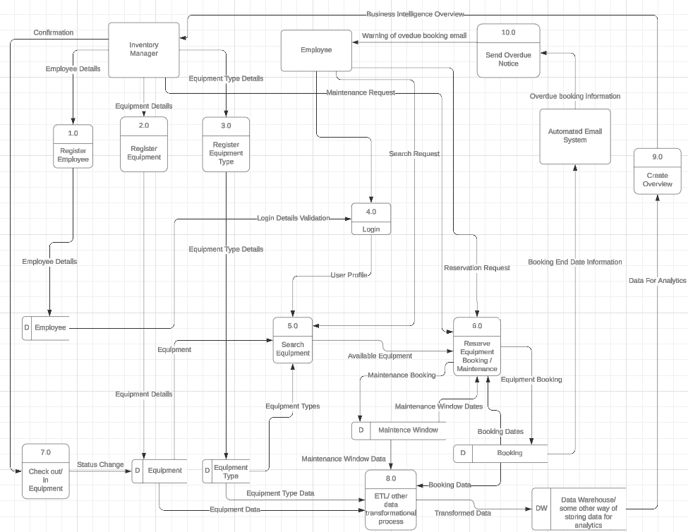

2.4 Data Requirements
Tables 4,5,6,7 and 8 identify what data requirements are needed for the tables in the data stores identified in Figure 4 to fulfil the requirements identified in Table 3.
No IDs are included in this data, they are assumed to be part of the data or would be replaced with a composite key of the data requirements identified in these tables.
All data types are references to SQL Server data types (Microsoft Contributors, 2024)

2.4a - Requirement 1.0 and 4.0
Requirements 1.0 and 4.0 require that an Employee table (Table 4) be created in the database to handle employees being registered and logged on, and this table will be used by other requirements for reference.

Table 6
ID | Field Name | Data Type | Constraint
1 | First Name | NVARCHAR(50) | 2 or more characters
2 | Second Name | NVARCHAR(50) | 2 or more characters
3 | Email | NVARCHAR(120) | Conforms to regex in line with OS email address
4 | Password | NVARCHAR(50) | 10 or more characters. Unique

2.4b - Requirement 2.0, 5.0, 7.0
Requirements 2.0, 5.0 and 7.0 require that an Equipment table (Table 5) be created in the database to handle equipment registration, searching for equipment and the checking in/ out of equipment.

Table 7
ID | Field Name | Data Type | Constraint
1 | Equipment Type ID | SMALLINT | Not null. FK
2 | Max Hours Available | TINYINT | Between 0 and 168 (a week)
3 | Checked In | BIT | Not null

2.4c - Requirement 3.0
Requirement 3.0 requires that an Equipment Type table (Table 6) be created.

Table 8
ID | Field Name | Data Type | Constraints
1 | Type Name | NVARCHAR(100) | Not null. Unique

2.4d - Requirement 6.0
Requirement 6.0 requires that a Booking table (Table 7) and a Maintenance window table (Table 8) be created. The primary difference is that the Booking table requires use of DATETIME because multiple bookings could be made on the same day, and the Maintenance Window table doesn’t require a reference to an employee.

Table 9
ID | Field Name | Data Type | Constraints
1 | Equipment ID | SMALLINT | Not null. FK
2 | Employee ID | SMALLINT | Not null. FK
3 | Start Time | DATETIME | Not null.  Must be after current datetime.
4 | End Time | DATETIME | Not null. End time must be after Start Time

Table 10
ID | Field Name | Data Type | Constraints
1 | Equipment ID | SMALLINT | Not null. FK
2 | Start Date | DATE | Not null. Must be after current date.
3 | End Date | DATE | Not null. Must be after Start Date.

2.4e - Requirement 8.0 and 9.0
Requirements 8.0 and 9.0 are outside the scope of this case study, but some form of data transformation would be needed to allow for analysis of patterns in the data which would allow for Problems C and D to be addressed by planning for the future using data analysis. On a small scale this could be done directly from database queries, but if the analysis grew in complexity, started requiring historical data or started using outside sources, an ETL process with a Data Warehouse would be required (Holistics, 2024).

Conclusion
By implementing an ELS as described throughout this case study, OS could drastically lower time wasted by employees. It could also reduce cost from lost time or missing or stolen equipment. The buying of new equipment could also be better informed due to the data available through the ELS, leading to reduced expenditure. Fines associated with lack of maintenance could be avoided. The government would be more likely to view OS as less wasteful, increasing the probability of maintaining profitable contracts with them. Employees would be less frustrated by the lack of an efficient system for loaning equipment.

References
Apple Maps, 2024. Homepage. [Online]
Available at: https://www.apple.com/uk/maps/
[Accessed 15th December 2024].
Fakhroutdinov, K., 2024. UML 2.5 Diagrams Overview. [Online]
Available at: https://www.uml-diagrams.org/uml-25-diagrams.html
[Accessed 15th December 2024].
Google, 2024. Explore and navigate your world. [Online]
Available at: https://maps.google.co.uk/maps/about/#!/
[Accessed 15th December 2024].
gov.uk, 2025. Public Procurement Policy. [Online]
Available at: https://www.gov.uk/guidance/public-sector-procurement-policy
[Accessed 14th January 2025].
Health and Safety Executive, 2024. Penalties. [Online]
Available at: https://www.hse.gov.uk/enforce/enforcementguide/court/sentencing-penalties.htm
[Accessed 15th December 2024].
Holistics, 2024. Understanding the Data Warehouse. [Online]
Available at: https://www.holistics.io/books/setup-analytics/understanding-the-data-warehouse/
[Accessed 15th December 2024].
James Cadle, D. P. J. H. A. R. D. B. P. T., 2021. Business Analysis Techniques. 3rd ed. Swindon: BCS, The Chartered Institute for IT.
Jensen, S., 2023. Workflow Automation Statistics You Need to Know. [Online]
Available at: https://www.formstack.com/blog/workflow-automation-statistics#:~:text=Formstack%E2%80%99s%202022%20State%20of%20Digital%20Maturity%20report%20found,per%20year.%20The%20average%20company%20saves%20%2446%2C000%20annually.
[Accessed 15th December 2024].
Microsoft Contributors, 2024. Data Types (Transact-SQL). [Online]
Available at: https://learn.microsoft.com/en-us/sql/t-sql/data-types/data-types-transact-sql?view=sql-server-ver16
[Accessed 15th December 2024].
Ordnance Survey, 2024. Government and Public Sector. [Online]
Available at: https://www.ordnancesurvey.co.uk/customers/public-sector#:~:text=The%20PSGA%20replaced%20the%20PSMA%20for%20England%20and,access%20to%20OS%20OpenData%20and%20Premium%20data%20APIs
[Accessed 15th December 2024].
Ordnance Survey, 2024. Ordnance Survey Homepage. [Online]
Available at: https://www.ordnancesurvey.co.uk/
[Accessed 15th December 2024].
Ordnance Survey, 2024. Ordnance Survey policies and corporate information. [Online]
Available at: https://www.ordnancesurvey.co.uk/governance
[Accessed 15th December 2024].
Ordnance Survey, 2024. The Public Sector Geospatial Agreement. [Online]
Available at: https://www.ordnancesurvey.co.uk/customers/public-sector/public-sector-geospatial-agreement
[Accessed 15th December 2024].
Ordnance Survey, 2024. What we're doign to help environmental sustainability. [Online]
Available at: https://www.ordnancesurvey.co.uk/governance/policies/environment/os-environmental-sustainability
[Accessed 15th December 2024].
PAT, 2024. Is PAT Testing A Legal Requirement?. [Online]
Available at: https://www.pat.org.uk/is-pat-testing-a-legal-requirement/
[Accessed 15th December 2024].
Secton, 2022. The real cost of lost and stolen assets. [Online]
Available at: https://www.seton.co.uk/legislationwatch/article/the-real-cost-of-lost-and-stolen-assets/
[Accessed 14th January 2025].
Thornhill, Jo (Forbes), 2024. Forbes Advisor. [Online]
Available at: https://www.forbes.com/uk/advisor/business/average-uk-salary-by-age/
[Accessed 15th December 2024].
Visual Paradigm Online, 2024. Gane-Sarson Data Flow Diagram Tutorial. [Online]
Available at: https://online.visual-paradigm.com/id/knowledge/software-design/gane-sarson-dfd-tutorial
[Accessed 15th December 2024].

