Database Implementation Report
Module Code: COMP40043
Module Name: Data and Business Analysis
Title of Assignment: Business Analysis and Modelling
Assignment 2
Student Name: Carl Gardiner
Student ID: 24030180

Contents
Part 1: Database Design 1
1.1 Business Rules and Assumptions 1
1.2 Entity Relationship Diagram of ELS Database 3
Part 2: Database Creation and Queries 4
2.1a Database Creation Script 4
2.1b Creating the Employee Table 4
2.1c Employee Constraint Tests 5
2.1d Creating the Employee-Manager-Tenure Table 7
2.1e Employee-Manager-Tenure Constraint Tests 8
2.1f Creating the Equipment-Type Table 9
2.1g Creating the Equipment Table 10
2.1h Equipment Constraint Tests 11
2.1j Creating the Booking Table 12
2.1k Booking Constraint Tests 13
2.1l Creating the Maintenance-Window Table 14
2.1m Maintenance-Table Constraint Tests 15
2.1n Populating Employee Table 16
2.1o Populating Employee-Manager-Tenure Table 16
2.1p Populating Equipment-Type Table 17
2.1q Populating Equipment Table 17
2.1r Populating Booking Table 18
2.1s Populating Maintenance-Window Table 18
2.2 Six Required Queries 19
2.2a Query 1 19
2.2b Query 2 20
2.2c Query 3 21
2.2d Query 4 23
2.2e Query 5 24
2.2f Query 6 25
2.2g Query 7 26
2.2h Query 8 28
Part 3: Data Mining and Business Intelligence 29
3.1 Data Mining and Business Intelligence 29
3.2 OLTP and OLAP 29
3.3 Data Mining and Using k-means clustering 29
References 31
Word Count with tables - 2675
Word Count without tables - 1648

Part 1: Database Design

Business Rules and Assumptions
This case study is about designing and developing an Equipment Loan System (hereafter referred to as an ELS) at Ordnance Survey (hereafter referred to as OS), and how data mining and business intelligence would be useful to the business. It follows on from a previous case study, which identified problems surrounding the lack of an ELS at OS, and suggested ways that an ELS might be implemented, and how that would impact the business.
There are some key assumptions which are useful to know for the purpose of designing the database.
Table 1
Assumption ID | Assumption
1 | An employee can log on to the ELS, they can do this with their work email address and their password, once they have been registered by an Inventory Manager
2 | An employee can make bookings from the ELS for specific pieces of equipment, they are only prevented from doing so if the piece of equipment is currently booked out for the time the employee wants, the piece of equipment is under maintenance during that time, or the employee has tried to book longer than the max time in hours allowed for that piece of equipment
3 | An Inventory Manager can book in maintenance windows for individual pieces of equipment, they are only prevented from doing so because the equipment is booked out during that time, or the equipment is under maintenance during that period
4 | Each piece of equipment has a particular unique ‘type’ associated with it, as there may be for example, multiple laptops (although in the real world, these types might be more specific, for this case study generic terms are used for item types)
5 | Each piece of equipment can be checked in or out by the Inventory Manager, allowing them to know which pieces of equipment are currently available, and to allow for emails to be sent out to employees that have not returned equipment on time.
6 | An employee can count as a manager in the ELS and a manager can be an employee, so all employees of OS will be counted as employees in the ELS
7 | A piece of equipment can only be booked out for a certain amount of time. With the upper limit of this value being 168 hours (a week) but potentially being less depending on how frequently the equipment might be used

Although not identified in the previous case study, the queries in Part 2 of this case study require a way of identifying relationships between managers and employees, so that functionality will also need to be added to the database.

Entity Relationship Diagram of ELS Database
Figure 1
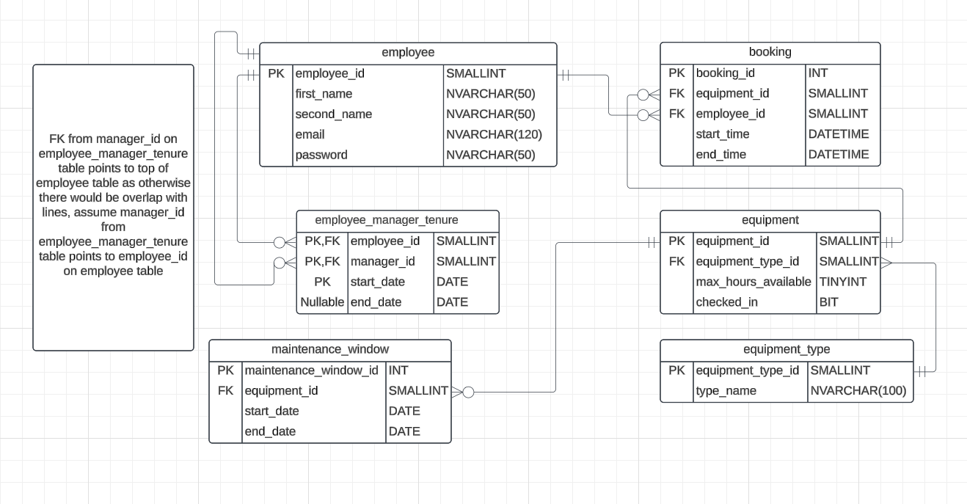
This ERD is normalised to Third Normal Form (hereafter referred to as 3NF).
(Wikipedia Contributors, 2020) describes 3NF as a:
database schema design approach for relational databases which uses normalizing principles to reduce the duplication of data, avoid data anomalies, ensure referential integrity, and simplify data management.

Part 2: Database Creation and Queries

2.1a Database Creation Script
Figure 2
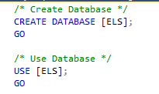
This script in Figure 2 creates the ELS database and starts using it

2.1b Creating the Employee Table
Figure 3
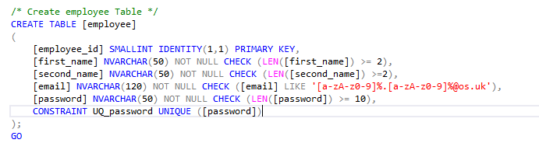
Figure 4
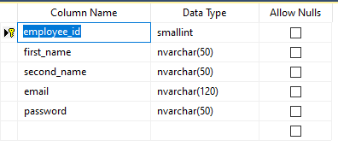
Table 2
The employee_id is of type SMALLINT which ranges from -32,768 to 32,767 (Microsoft Contributors, 2024). Given that OS has 1000-2000 employees at any one time, this type makes sense
The IDENTITY(1,1) command auto-increments the employee_id field (Microsoft Contributors, 2024)
NVARCHAR is used for the rest of the types, as the Unicode allows for characters in other languages

Reasonable constraints are applied to the first_name, second_name and password fields. This allows Assumption 1 to be implemented.

The email field must conform to the specified regex in line with the OS email format. This makes the email look like ‘<first part>.<second part>@os.uk’. It is not reliant on first name or second name as transitive dependencies (thus maintaining 3NF), as the email can include nicknames, or be different in the case of multiple employees with the same first name and second names. This allows Assumption 1 to be implemented.

2.1c Employee Constraint Tests
Figure 4 shows the commands used to test the Employee Table. Them failing proved there was sufficient constraint on the table. All constraint tests after this follows this format.
Figure 5
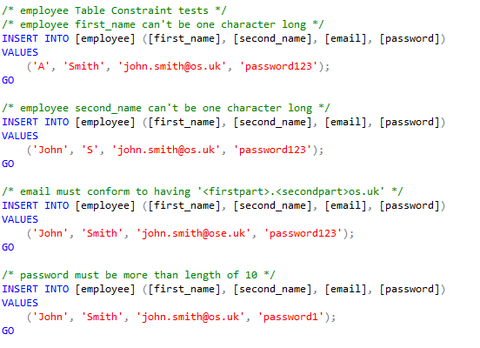

2.1d Creating the Employee-Manager-Tenure Table
Figure 6
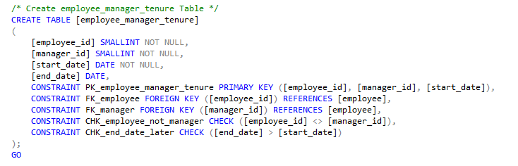
Figure 7
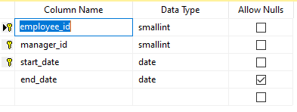
Table 3
This table identifies the start and end dates that a particular employee was managed by a manager
The employee_id and manager_id fields refer to an instance of the employee table as a foreign key
The start_date is a date that cannot be null, as it is part of the composite primary key, and is crucial to the table
The end_date is nullable, as this is only changed once the tenure is over, and is useful to identify current tenures
The primary key is a composite key which ‘uses the contents of two or more fields from a table’. (BBC Bitesize, 2024)The primary key up of employee_id, manager_id and start_date, to ensure uniqueness and no transitive dependencies, as otherwise end_date would be partly dependent on a non-key property. This also allows the Employee-Manager-Tenure Table to be used as a link table to allow for handling of Assumption 6, and prevents any duplicate records from being possible, which would be possible with a standard id field. Overall, a composite key is good because it ‘the data naturally contains multiple attributes that together form a unique identifier’ (restack, 2024)
Reasonable constraints are placed on dates and IDs in the table
Theoretically this would prevent the CEO from being put in this table, however a workaround could easily be made for the CEO, and it is unlikely they would be denied, therefore it is not worth changing the nature of the primary key

2.1e Employee-Manager-Tenure Constraint Tests
Figure 8
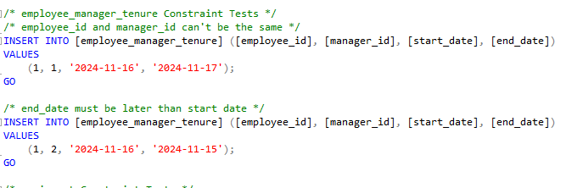

2.1f Creating the Equipment-Type Table
Figure 9
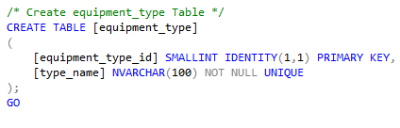
Figure 10
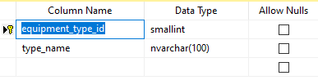
Table 4
The Equipment-Type Table describes a type of equipment, rather than a particular instance of it. This allows Assumption 4 to be implemented
Whilst it is unlikely there would be more than 32,767 types for the equipment_type_id , making it a TINYINT could potentially run out of values with only 255 values (Microsoft Contributors, 2024). This allows Assumption 4 to be implemented
The type_name field uses NVARCHAR(100), because it possibly could have complicated names in a real world scenario This allows Assumption 4 to be implemented. This allows Assumption 4 to be implemented
The type_name field is unique. This allows Assumption 4 to be implemented

2.1g Creating the Equipment Table
Figure 11
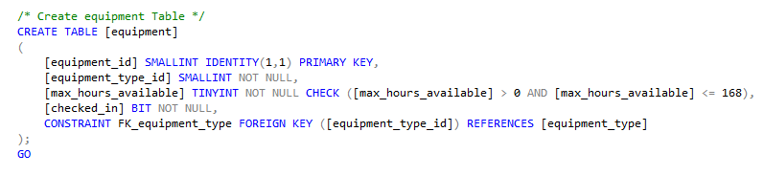
Figure 12
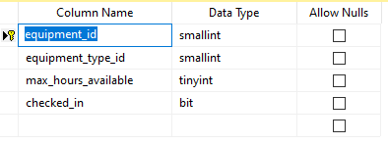
Table 5
The equipment_id field is a SMALLINT due to unlikely to be more than 32,767 at one time
The equipment_type_id foreign key references the equipment_type table
The max_hours_available field is a TINYINT due to having a constraint between 0 and 168 (a week’s worth of hours). This allows Assumption 7 to be implemented
The checked_in field is a BIT for binary true/false (Microsoft Contributors, 2024). This allows Assumption 5 to be implemented

2.1h Equipment Constraint Tests
Figure 13
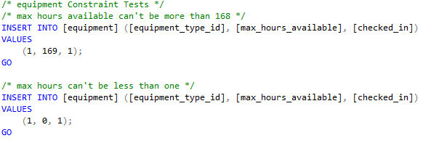

2.1j Creating the Booking Table
Figure 14
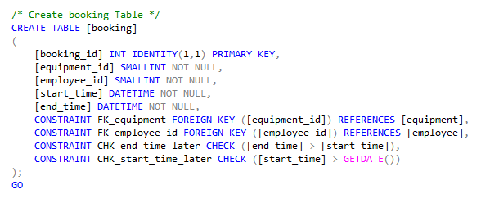
Figure 15
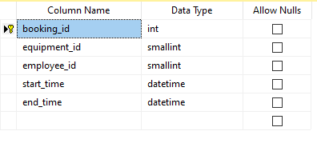
Table 6
The booking_id field uses INT because up to 2,147,483,647 bookings could be made (Microsoft Contributors, 2024)
The equipment_id and employee_id are foreign keys to those respective tables
The start_time and end_time fields are DATETIME due to being able to place bookings within a day

The end_time must be after start_time. This allows for Assumption 2 to be implemented
The start_date must be after current DATETIME (GETDATE() function returns a DATETIME (Microsoft Contributors, 2024)). This allows for Assumption 2 to be implemented

2.1k Booking Constraint Tests
Figure 16
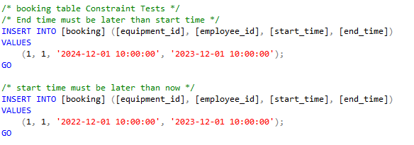

2.1l Creating the Maintenance-Window Table
Figure 17
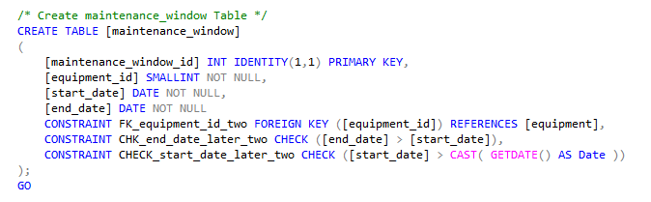
Figure 18
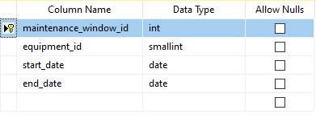
Table 7
The maintenance_window_id field is an INT to allow 2,147,483,647 feasible maintenance windows
The equipment_id foreign key referencing the Equipment Table
The start_date and end_date are DATE types, as maintenance windows should last a minimum of a day
The start_date and end_date are DATE types, as maintenance windows should last a minimum of a day. This allows Assumption 3 to be implemented
The end_date must be after start_date. This allows Assumption 3 to be implemented
The start_date must be after the current date, this value is retrieved by casting the result of the GETDATE() function into a DATE type. This allows Assumption 3 to be implemented

2.1m Maintenance-Table Constraint Tests
Figure 19
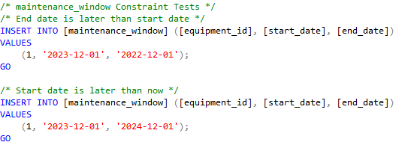

2.1n Populating Employee Table
Figure 20
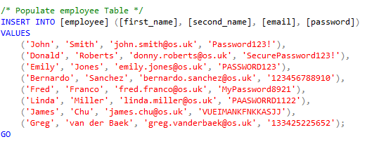

2.1o Populating Employee-Manager-Tenure Table
Figure 21
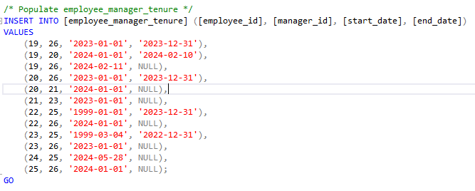
No employee is not null during the current date in this table, although they could be (this would represent an employee having left).

2.1p Populating Equipment-Type Table
Figure 22
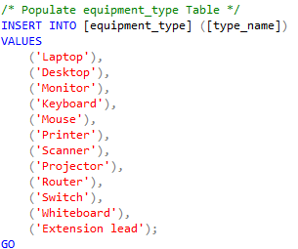

2.1q Populating Equipment Table
Figure 23
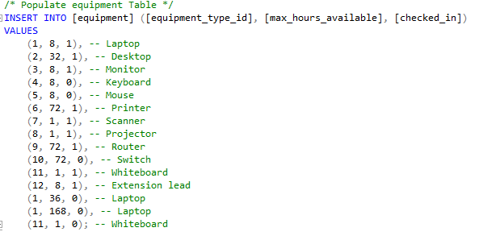

2.1r Populating Booking Table
Figure 24
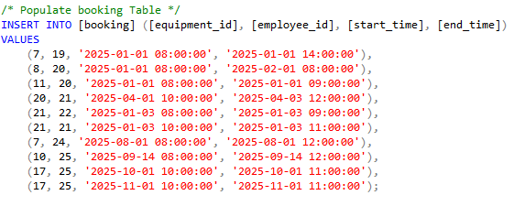

2.1s Populating Maintenance-Window Table
Figure 25
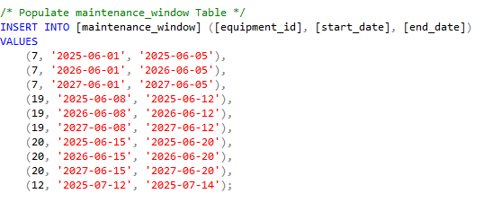

2.2 Six Required Queries

2.2a Query 1

Query Script
Figure 26
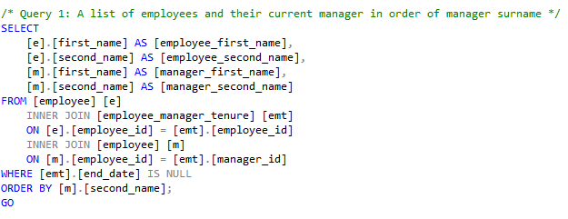

Output for Query
Figure 27
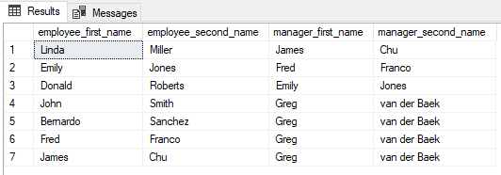

Comments on Query
Query 1 returns a result set of names and uses aliases to be clearer and differentiate between employees and managers. Two inner joins, which’ selects records that have matching values in both tables.” (Gonzalez & Stubberfield, 2024) are used to join two instances of the Employee Table to the Employee-Manager-Tenure Table by either employee_id or manager_id field. Any rows in the result set that have an end_date that are not NULL are removed because they would represent previous tenures. The rows are ordered by manager_second_name.

2.2b Query 2

Query Script
Figure 28
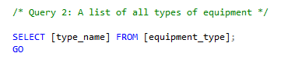

Output for Query
Figure 29
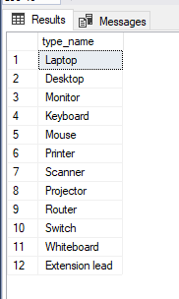

Comments on Query
Query 2 is only a SELECT statement on type_name in the Equipment-Type Table. This query also helps implement Assumption 4.

2.2c Query 3

Query Script
Figure 30
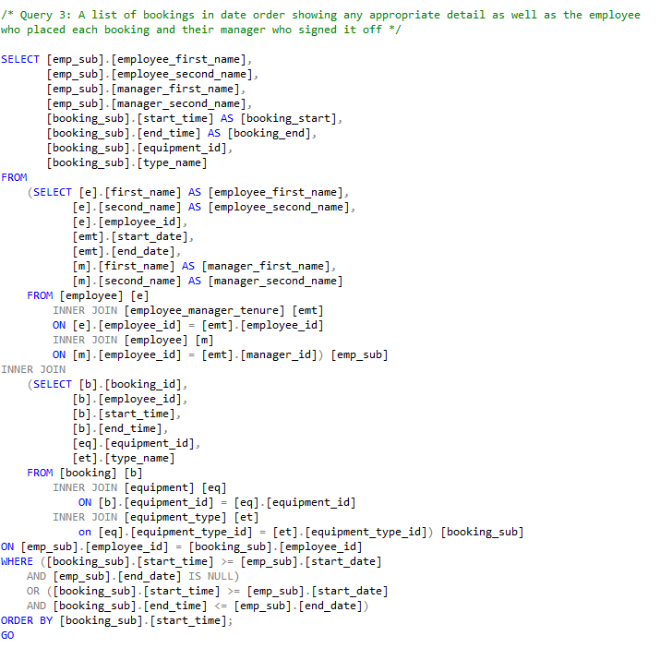

Output for Query
Figure 31
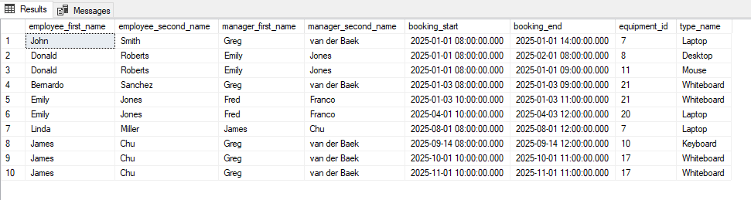

Comments on Query
Because the query required a lot of information to be retrieved in the result set, the query was a multistage process, so multiple subqueries were used (O'Hearn, 2017). The emp_sub subquery retrieved the employee details, manager details and start times and end times for each tenure by inner joining the Employee-Manager-Tenure Table onto two separate instances of the Employee table (one joined by employee_id and one joined by manager_id). The booking_sub subquery inner joined the Booking Table onto the Equipment Table and Equipment-Type Table to return details about each booking. Both these subqueries returned the employee_id in the result set, allowing for both subqueries to be inner joined on this field and returning lots of detail about each booking. After that, a WHERE clause checks that the result set only accounts for rows where the tenure matches the booking time. Finally, the result set was ordered by the booking start_time field.

2.2d Query 4

Query Script
Figure 32
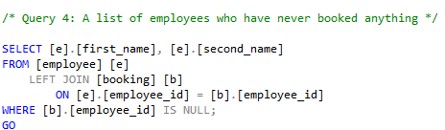

Output for Query
Figure 33
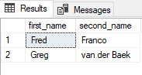

Comments on Query
This query performs a left join to return all records from the Employee Table (w3schools, 2024). From there, the WHERE clause returns only the records where the booking part of the result set has a NULL value in the employee_id field, which would represent an employee never having booked anything.

2.2e Query 5

Query Script
Figure 28 shows the query script for Query 5:
Figure 34
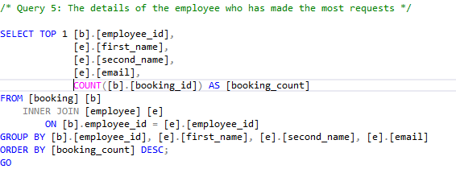

Output for Query
Figure 35
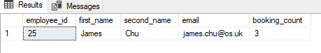

Comments on Query
Query 5 inner joins the Booking Table on the Employee Table. The GROUP BY aggregates any rows which have the same employee_id, first_name, second_name and email fields (Beaulieu, 2020).After that, the COUNT function counts all the different booking_ids associated with that grouping (Beaulieu, 2020). After that, the result set is ordered by descending value and the TOP 1 in the select statement returns the employee with the most bookings.

2.2f Query 6

Query Script
Figure 36
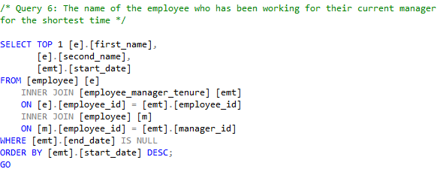

Output for Query
Figure 37
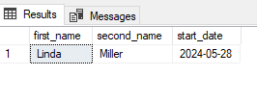

Comments on Query
This query inner joins the Employee-Manager-Tenure Table onto two separate instances of the Employee table (one joined by employee_id and one joined by manager_id). The result set is narrowed by the end_date being NULL (representing the employee currently having a tenure under that manager) and then ordered by descending value. Finally, the TOP 1 in the SELECT statement means only the employee who has been working for their manager for the shortest time is returned.

2.2g Query 7

Query Script
Figure 38
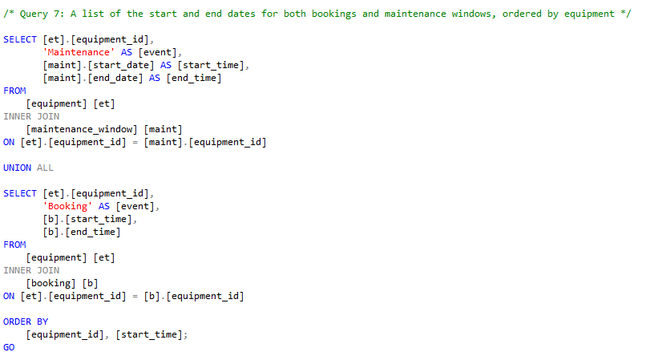

Output for Query
Figure 39
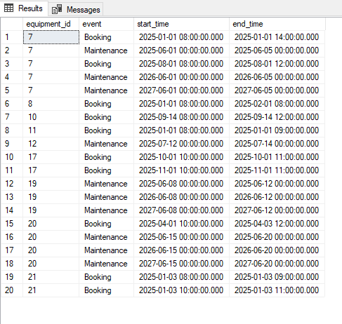

Comments on Query
Query 7 returns a result set where two different tables have been unioned (through the UNION ALL operator). UNION ALL was used because ‘With union all, the number of rows in the final data set will always equal the sum of the number of data sets being combined’. (Beaulieu, 2020) For the data sets being combined, those that are maintenance windows and those that are bookings on equipment are signalled by the ‘AS event’ in the SELECT statements. The union works because there are the same number of columns, and the columns are of similar data types (DATE and DATETIME for the start_times/ start_dates and end_times/ end_dates are considered similar). This query combines Assumption 2 and 3 and could be used to prevent incorrect bookings/ maintenance windows being created in the ELS.

2.2h Query 8

Query Script
Figure 40
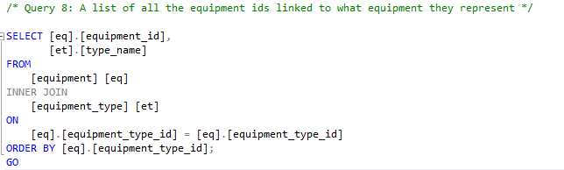

Output for Query
Figure 41
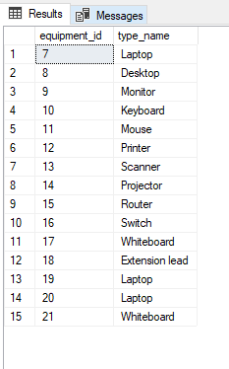

Comments on Query
Query 8 returns a result set where the Equipment Table is inner joined by equipment_type_id onto the Equipment-Type Table. In the result set, the equipment_id and type_name are shown together in ascending order. This query would be useful for the ELS frontend, combining Assumptions 2 and 4.

Part 3: Data Mining and Business Intelligence

3.1 Data Mining and Business Intelligence
Data Mining is:
the automated or convenient extraction of patterns representing knowledge implicitly stored or captured in large databases, data warehouses, the Web, other massive information repositories, or data streams.
(Han, et al., 2011).
Vitt, et al. (2008) state:
The primary goal of business intelligence is to help people make decisions that improve a company's performance and promote its competitive advantage
Data mining is used to inform business intelligence, with the quality of data and data mining being proportional to its ability to make quality decisions.

3.2 OLTP and OLAP
Online Transactional Processing is ‘the real-time execution of large numbers of database transactions by large numbers of people, typically over the internet.’ (IBM, 2024) whereas Online Analytical Processing is ‘technology for performing high-speed complex queries or multidimensional analysis on large volumes of data in a data warehouse, data lake or other data repository’ (IBM, 2024).
OLTP usually involves quick, atomic operations like bank account transactions), whereas OLAP usually involves much larger datasets but allows for analysis to support data mining and business intelligence.
OLAP involves Extract, Transform and Load operations. An example of an extraction process would be taking data from the ELS database tables. An example of a transform operation would be summarising the number of bookings for a given month or the number of times a piece of equipment has been booked out over a year and storing that particular data in a data warehouse.

3.3 Data Mining and Using k-means clustering
‘In directed data mining, the goal is to construct a model that explains or predicts one or more particular target variables. In undirected data mining, the goal is to find overall patterns that are not tied to a particular target.’ (Linoff & Berry, 2011)
Directed data mining could be used to explain why certain employees were likely to not return equipment on time (overdue booked equipment being the variable). Undirected data mining could be used for any patterns but might for example find a correlation between types of equipment and how often they are booked.
k-means clustering could be used to cluster bookings based on the length of time a piece of equipment is booked for and the maximum amount of time it is available. Three centroids could be initialised randomly on a graph with the bookings being points, and each booking could be assigned to a centroid based on its closeness to a centroid, before the centroid locations are updated to be the centre of the mean of their associated bookings. After repeating these steps for multiple iterations or until the centroids do not change significantly, you would probably see three groups of bookings appear: those that have long bookings/ long maximum times, short bookings/ long maximum times and short bookings/ short maximum times. You could compare this data to repeat bookings to adjust maximum booking times for equipment.

References
BBC Bitesize, 2024. Design Types of Keys. [Online]
Available at: https://www.bbc.co.uk/bitesize/guides/z4wf8xs/revision/4
[Accessed 29th November 2024].
Beaulieu, A., 2020. Learning SQL Chapter 3: Query Primer Page 60. 3rd ed. Sebastopol: O'Reilly.
Beaulieu, A., 2020. Learning SQL, Chapter 6: Working with Sets, Page 106. 3rd ed. Sebastopol: O'Reilly.
Beaulieu, A., 2020. Learning SQL, Chapter 8: Grouping and Aggregrates, Page 149. 3rd ed. Sebastopol: O'Reilly.
Gonzalez, L. R. & Stubberfield, A., 2024. Cracking the Data Science Interview, Chapter 5. 1st ed. s.l.:Packt Publishing .
Han, J., Kamber, M. & Pei, J., 2011. Data Mining: Concepts and Techniques, Preface. 3rd ed. s.l.:Morgan Kaufmann.
IBM, 2024. What is OLAP?. [Online]
Available at: https://www.ibm.com/think/topics/olap
[Accessed 26th December 2024].
IBM, 2024. What is OLTP?. [Online]
Available at: https://www.ibm.com/think/topics/oltp
[Accessed 26th December 2024].
Linoff, G. S. & Berry, M. J. A., 2011. Data Mining Techniques: For Marketing, Sales, and Customer Relationship Management. 3rd ed. s.l.:Wiley.
Microsoft Contributors, 2024. bit (Transact-SQL). [Online]
Available at: https://learn.microsoft.com/en-us/sql/t-sql/data-types/bit-transact-sql?view=sql-server-ver16
[Accessed 29th November 2024].
Microsoft Contributors, 2024. CREATE TABLE (Transact-SQL) IDENTITY (Property). [Online]
Available at: https://learn.microsoft.com/en-us/sql/t-sql/statements/create-table-transact-sql-identity-property?view=sql-server-ver16
[Accessed 26th November 2024].
Microsoft Contributors, 2024. GETDATE (Transact-SQL). [Online]
Available at: https://learn.microsoft.com/en-us/sql/t-sql/functions/getdate-transact-sql?view=sql-server-ver16
[Accessed 29th November 2024].
Microsoft Contributors, 2024. int, bigint, smallint and tinyint (Transact-SQL). [Online]
Available at: https://learn.microsoft.com/en-us/sql/t-sql/data-types/int-bigint-smallint-and-tinyint-transact-sql?view=sql-server-ver16
[Accessed 26th November 2024].
O'Hearn, S., 2017. OCA Oracle Database SQL Exam Guide (Exam 1ZO-071). s.l.:McGraw Hill Computing.
restack, 2024. Should I Implement Composite Keys. [Online]
Available at: https://www.restack.io/p/ai-implementation-considerations-answer-composite-keys
[Accessed 24th December 2024].
Vitt, E., Luckevich, M. & Misner, S., 2008. Business Intelligence. s.l.:Microsoft Press.
w3schools, 2024. SQL LEFT JOIN Keyword. [Online]
Available at: https://www.w3schools.com/sql/sql_join_left.asp
[Accessed 24th December 2024].
Wikipedia Contributors, 2020. Third Normal Form. [Online]
Available at: https://en.wikipedia.org/wiki/Third_normal_form
[Accessed 26th November 2024].

