Work Based Project

The Problem
At Ordnance Survey, there is a team called Sensed Data Management Services. They process geospatial data taken from remote sensing equipment (utilised by aircraft, UAV etc) as blocks. They begin by ingesting (also known as preprocessing) the blocks and then enrich the data to be consumed by other departments and external supply chain. For the blocks, there is a database which tracks many features of them, including where they along the ingestion to enrichment ‘pipeline’ in a series of fields.
Currently, finding out information from this table requires the use of SQL queries to get what is wanted. I have been tasked with producing a dashboard that would be much more intuitive, whilst still allowing for filtering of data, but in a more visually pleasing and apparent way, and as a jumping off point for future automation.

Scope
Three contracts:
As a user, I am able to view blocks that are currently being processed
As a user, I am able to view blocks processed during a given time frame
As a user, I am able to see which stage of processing the block is currently at

Computer Language, IDE and Methodology Choice

Programming Language
C# for programming.

IDE
Visual Studio, for ease of use with C# and to allow for easy templating of the Blazor Project.

Framework
Blazor, with server-side rendering (for security reasons), this is how the GSPP dashboard has been made so am using this for reference.

Methodology
Iterative Development, with sprints being used to iterate on the development of the dashboard
Git being used for the initial project, with branching on top of branching, and the main branch being blocked except through pull requests
Set up some cards and show them being signed off here.

Activity Flow Diagram

Code

Unit Testing
What would be some good tests that would prove that this project works?

Backend Testing

Frontend Testing
Unit testing can be split between the ‘backend’ tests using xUnit functionality, and frontend tests using the bUnit framework.

Debugging
Had write access problems
Had datetimes coming back as the same
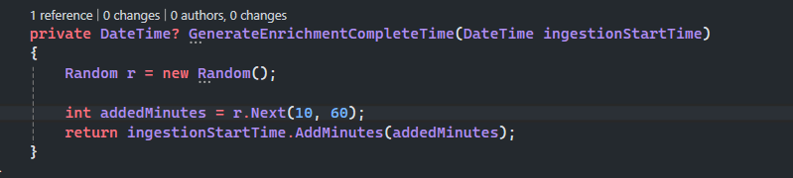
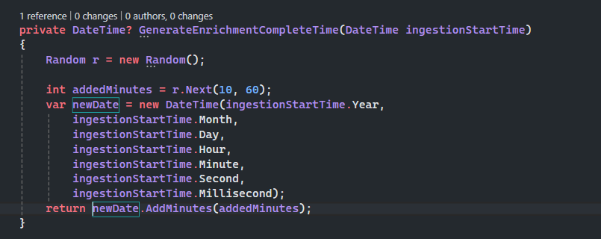

Reflection

Using a Green Computing Approach

