**ShowChatWindow for ConnectWise Control**

# Installation Guide

1. Download the ShowChatWindow.exe and ShowChatWindow.txt files from here:  
   <https://drive.google.com/drive/folders/1K6GXHx64G7N2SasLEJgr4Vf4U3jYrLhd>  
   There is also a **Winrar SFX Example** folder containing **ShowChatWindow.sfx.exe** if you decide to use Winrar SFX to package up the files at step 5.
2. Open **ConnectWise Control Web Interface** and select **Admin \ Appearance** and scroll down to the **Client Resources** and make a note of the **ApplicationTitle** value:  
   
3. You will need a SFX extractor such as **Winrar** as the files need to be packaged up into a self-extracting zip file (aka sfx).
4. Open the ShowChatWindow.txt file and edit it with the values obtained from Step 1:

|  |  |
| --- | --- |
| **Default Value:** | %COMPUTERNAME% - ConnectWise Control - Waiting for your host...  %COMPUTERNAME% - ConnectWise Control – Connected |
|  |  |
| **Custom Value:** | %COMPUTERNAME% - XYZ Remote Control - Waiting for your host...  %COMPUTERNAME% - XYZ Remote Control – Connected |

1. Package up the ShowChatWindow.exe and ShowChatWindow.txt into a SFX file. The SFX file should be a self-extracting file and all prompts are hidden from user when executed.
2. Upload the ShowChatWindow.sfx.exe file into the ConnectWise Control Shared Toolbox  
     
   
3. Right click on a PC and choose Run Tool  
   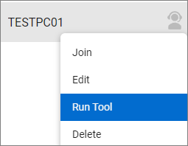
4. Double click on the **ShowChatWindow.sfx.exe** file which will copy the file down to the user’s session and execute the file which should then bring the Chat Window into focus:  
   

# Release Notes

## v1.0.0 -15/11/2022

-First public release.