Intro


GEARHEAD STRUCT
Code Documentation

Development Setup
PREREQUISITES

- Setup-Standalone App
  - CalculiX Code Repository <LINK>
  - PrePoMax Code Repository <LINK>
  - Launcher Repository <LINK>
  - Inno Script
    - For Linux development, use Wine then install Inno Script Studio
  - Detailed Development <LINK>

- Setup-Software as a Service (Web App) - <TBA>
  - On-premise
    - On-premise server specifications
    - On-premise credentials
  - Cloud
    - AWS Cloud Resource

Setup-Standalone App
Setup-Standalone App

- Folder Structure (update the picture below if there are any updates)
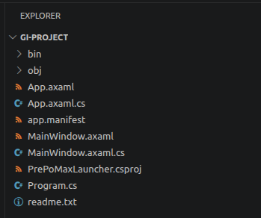

- Details
  - Folders
    - bin - contains all the files related to the C# project for testing and release. Includes the two folders:
      - Debug
        - Contains the runtime environment and other packages. Sometimes contains the exported exe file and its bloatware.
      - Release
        - Contains the exported exe file (after building and release). For production deployment purposes

    - obj - also contains Debug and Release folders (not the same as those found in bin folder). Contains metadata of the elements used in the front end of the application

<<remaining file details will be added later>>

DEVELOPMENT PROPER
- To test the application, run the following commands:

dotnet clean
dotnet run

- To publish the GI Launcher exe file, run the following commands:

dotnet publish -c Release -r win-x64 --self-contained true

The exe file is located at bin/publish/Release/publish

- To export the GI Launcher bundle file, modify and publish the Inno Script

[Setup]
AppName=GI Launcher Suite
AppVersion=1.0
DefaultDirName={pf}\GI_Suite
OutputBaseFilename=GI_Launcher_Installer

[Files]
Source: "Launcher\bin\Release\net8.0\win-x64\publish\*"; DestDir: "{app}\Launcher"; Flags: recursesubdirs

Source: "PrePoMax\*"; DestDir: "{app}\PrePoMax"; Flags: recursesubdirs
Source: "CalculiX\*"; DestDir: "{app}\CalculiX"; Flags: recursesubdirs

[Icons]
Name: "{commondesktop}\FEA Launcher"; Filename: "{app}\Launcher\GI-Launcher.exe"

Since Inno Script is not compatible with Linux, use Wine. Do the following commands on the terminal, on the same file directory of the iss file.

wine ~/.wine/drive_c/Program\ Files\ \(x86\)/Inno\ Setup\ 6/ISCC.exe setup.iss

Tab 4

