Guilas JovenCarl C. 2185-6BlockTech
NW-301 02/12/2025

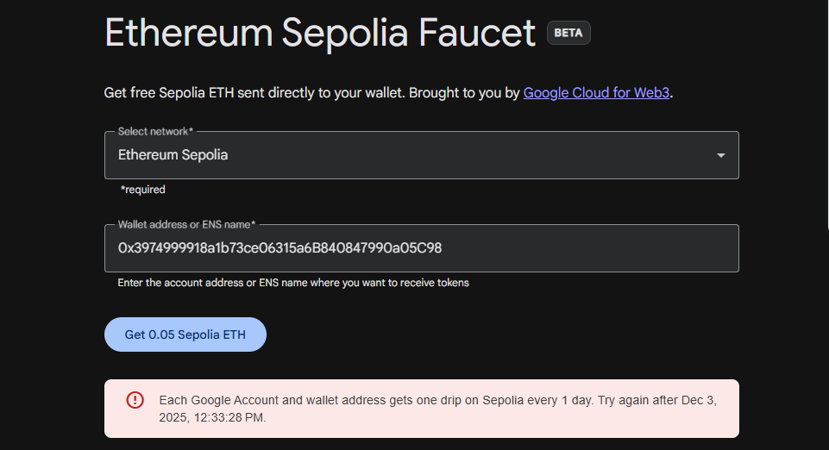
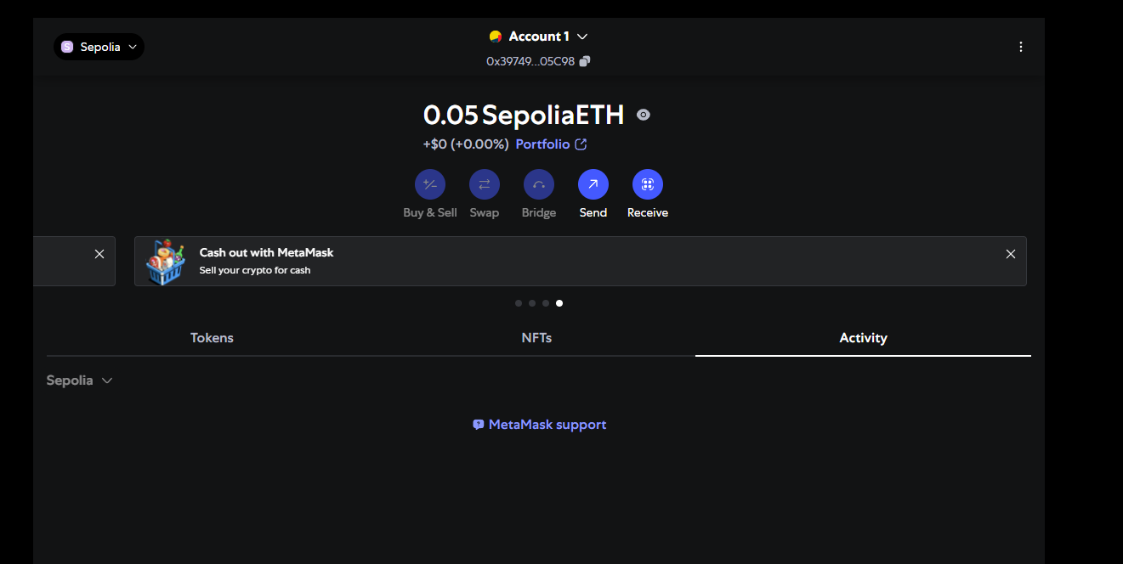
Reflection:
These instructions for getting test Ether from the Alchemy Sepolia Faucet reminded me that using blockchain tools isn’t just about following technical steps you also have to pay attention to how you set up your accounts. The guide stresses using a real name, a trustworthy email, and even switching browsers or networks if something doesn’t work.

