

**CSIS 3003**

**PROJECT I**

**Activities Management System**

**(Stage 1)**

**Foong Chin Wei(D170274B)**

**Lee Yi Sheng (D170286B)**

**Lew Zhan Fai (D170360B)**

**Lecturer: Mr. So Yong Quay**

**26th April 2018**

**Department of Computer Science**

**Faculty of Engineering and Information Technology**

**Table of Contents**

Introduction …………………………………………………………………… 3

Objective …………………………………………………………………….... 4

Background Research ………………………………………………………… 5

Literature Review ………………………………………………………..... 6 - 8

Research ………………………………………………………………….. 9 - 10

A financial justification for project ………………………………………….. 11

Curriculum Vitae ……………………………………………………….... 12-14

An outline of duties of each member for each stage ………………….... 15 - 16

Project Scope …………………………………………………………..…..... 17

Methodology ………………………………………………………..……….. 18

Project Plan …………………………………………………………..…….... 19

References …………………………………………………………..……….. 20

**Introduction**

Nowadays ICT has been developed into high technology era, the rapid development of social network, even if people do not meet each other also can become friends.Social networks have become quite common, most people use Facebook, Twitter, Google+, and so on to making friends and take part in some activities.

People can take part in activities by informed of school or friends, but we decided to use the rapid development of social network to make a website.

Our project title is Activities Management System, which creates a platform in website to let the organizer to upload their activities such as competition, seminar , camp and etc.So that the participant can also browse to our website to look up what activities are holding and take part in the activities on the spot on the website. The participant also can click on the organizer page to look up what activities there had held.

Project Objective

By developing this project we can achieve the objective below:

* When the participant take part in an event there can communicate with other participant and increase people’s social network
* The website provide a platform to let the organizer spread out the information of activities and which increase the speed of information flow
* The participant can keep in touch of the activities that organize from some company and improve the reputation of company or organizer
* The website provide a platform to let the participant easier to find their favourite activities

Personal Objective

We choose the topic because we would like to try to develop a website system. This is big challenge to us, because website with system is our first project. Of cause,we also hope through this project to enhanced our HTML and PHP skills.

**Background Research**

**Bizzabo**



**Bizzabo** does everything aside from serving you tea. This is a fully fledged platform that allows you to manage every aspect, at every stage of the event planning: Create a landing page, sell tickets, email attendees and run reports at the end of it all. (BIZZABO, 2018)

**Bizzabo** is the world's fastest growing event tech company. Our holistic Events Cloud empowers marketers and planners to manage, grow and maximize events. (BIZZABO, 2018)

Bizzabo is a customer relationship management platform in the United States, which is committed to simplifying the process of marketing activities by promoting automation in all aspects. Users can create their own marketing messages, schedules, and registration sites to track user interactions, ticket receipts, and attendance.

One of the problems, email integration is not as extensive as it could be and some users have experienced problems at the time of sending messages. We will try to improve this problem.

Literature Review

In this part, I am going to explore the research related to my project that have been conducted by other academic previously. Activities management system is web system which comprises PHP, MySQL and Web service. Web system is a kind of website with a system.

In a typical organization, there's always plenty that to do such as: pay vendors, invoice customers, answer customer inquiries, and fix bugs in hardware or software. You need to know who wants what and keep track of what is left to do.

A ticketing system allows you to check the status of various tasks: when they were requested, who requested them and why, when they were completed, and etc. A ticketing system need to include register an event or a ticket, assign an organizer and participant to the ticket, track change to the ticket, launch activity based on ticket status , and lastly close the ticket.Besides that,the system have to add on the function of deletions , customer service , network security.

In the deletions,Deletion may be primarily a manual process, so that people will use it rarely. The prime intention here is to maintain a history of events and the current status, and never to lose it.In the function of customer service, Tracking the request ensures the company has a record of what types of queries are most common. This also can give the company instant feedback on whether or not their users find the published documentation or processes hard to understand, merely sufficient, or easy to follow.Lastly with the network security, if a system is compromised by a security breach, this event can be entered and tracked as a ticket, and an alert can be sent to the appropriate parties. People responsible for the hardware, the software, the administration, the firewall, the proxy, or the Internet access can be assigned as interested parties to the ticket.

This is importance to make sure that the website is accessibility, ease of use, access control ,ability to track history, immutable history and flexible views.(RT Essential)

The core function of an IT ticketing system is to manage all incoming requests from other departments in a company. Because IT departments tend to have a high volume of requests, they need a system to manage the life cycle of every individual request, from submission to resolution. There are several online programs that provide services to accomplish this, from simple intake software to more sophisticated tools that triage and track issues. We’ll take a look at the variety of these functions later on.

Sometimes, the IT department also doubles as a customer support center or help desk, and may be staffed by technicians who help people outside the company - typically customers or other product users - to resolve their technical issues. Regardless of whether the ticketing system will manage external or internal requests, the program should perform similarly.

Same as the RT Essential,ticketing system have to add on the function of self service portal, ticket log, assigning tickets, secure of the system and live support.Self service portal means that A one-stop shop where workers and customers can quickly and easily submit their tickets to our system.Beside that, ticket log means that once a ticket is received, the next step is to log it. This could be as simple as a spreadsheet that lists incoming tickets by timestamp, but the important thing is that IT has an organizational system in place so that no ticket gets overlooked.Assigning tickets means to maximize the IT team’s bandwidth, tickets should be assigned to a single “owner” who will work on the ticket from start to finish. You can choose to manually assign tickets to team members, or find a product that automatically assigns tickets based on worker availability or appropriate knowledge base.About the secure system, security should be a top priority when choosing an IT ticketing system, even if tickets do not contain sensitive information.Regardless of the level of security necessitated by our techniques, we will look for a secure system to ensure that information does not get leaked to the public.Lastly,with the live support, having a 24/7-staffed help desk or chat service can also help increase transparency and drive customer engagement with the IT department. We can use this assistance tool to troubleshoot technical issues before formally submitting a ticket, as to cut down the volume of tickets IT must process.

There are some points of company growth that might naturally lend themselves to an IT ticketing system change. Shifts in management, new product features, or high team turnover all may present opportunities to make a switch that does not disrupt the rest of business. Of course, we will make sure that our ticketing system shift responds to the specific demands of us - features can lose their utility if they aren’t tailored to our needs.  (RT Essentials,2005)

**Research**

**HTML**

HTML is known as Hypertext Markup Language. HTML is a set of markup symbols and codes in a file intended to display on a World Wide Web browser page. The markup is duty on tells the Web browser display a Web page’s words and images. Each markup code is referred to as an element. Some of the elements come in pairs that indicate when some display effect is to begin and when it is to end.( HTML)

**PHP**

PHP stands for Hypertext Preprocessor. Before that, PHP originally derived from Personal Home Page Tools. PHP is a script language and interpreter that is used to create Web pages. PHP is an open source program and used primarily on Linux Web servers. PHP executes on the server, while a comparable alternative, JavaScript, executes on the client. The Web server calls PHP to interpret and perform the operations in the PHP script before the page is sent to a user that has requested it. (PHP)

**MySQL**

MySQL is an open source relational database management system (RDBMS) based on Structured Query Language (SQL). A database is a structured collection of data, it may be anything from a simple shopping list to a picture gallery of the large amount of information in a corporate network. A database management system is needed to add, access, and process data stored in a computer database. MySQL runs on virtually all platforms, such as Linux, UNIX, and Windows. (MySQL)

**Web Service**

Web services also called application services are services that made available from a business Web server for Web users or other Web-connected programs. Web services usually combine with programming of data, and also human resources as well. Providers of Web service s are generally known as application service providers. Web service range from such major services as storage management and customer relationship management (CRM) down to much more limited services such as the furnishing of a stock quote and the checking of bids of an auction item. The accelerating creation and availability of these services is a major Web trend. (Web Service**)**

**A financial justification for project**

The estimated net cash flow for our design of the Activities Management

System is approximately RM2,000. We will use this money to purchase software for

designing the Activities Management System. Example, Domain Name (website

domain name is the unique name that appears in the URL for our website), Website

Hosting (Hosting is simply the service that allows your website to be accessed by other Internet users), PHP, Web Service, Copywriting.

|  |  |
| --- | --- |
| **Software** | **cost** |
| Domain Name | RM40 |
| Website Hosting | RM800 |
| PHP | RM0 |
| Web service | RM400 |
| Copywriting | RM200 |
| **Total Cost =** | RM1440 |

**Curriculum Vitae**

****Name: Foong Chin Wei

Age: 19

Nationality: Malaysian

Gender: Male

I/C: 990414-08-9611

Address: No21, Jalan Harmonium 22/17,  
 Tamen Desa

Tebrau, Johor Bahru, Johor.

H/P number: 018-6625420

Student ID: D170274B

Batch: IT17-B

Email: [Chinwei9611@gmail.com](mailto:Chinwei9611@gmail.com)

Education Qualifications :

|  |  |  |
| --- | --- | --- |
| **Name of Institution** | **From - To** | **Highest qualification Attained** |
| SJK (C) Tampoi | 2006 - 2011 | UPSR |
| SMK Dato’Usman Awang | 2012 - 2016 | SPM |

Ability Skill : HTML

Java Programming

Adobe Photoshop  
 PHP

Language : (Proficiency : Best = 10 ~ Worst = 1)

|  |  |
| --- | --- |
| **Language** | **Proficiency** |
| English | 7 |
| Bahasa Melayu | 7 |
| Mandarin | 9 |
| Hakka | 9 |

Possess own transport : No

****Name: Lee Yi Sheng

Age: 19

Nationality: Malaysian

Gender: Male

I/C: 990613-01-5017

Address: No21, Jalan Harmonium 22/17,  
 Tamen Desa

Tebrau, Johor Bahru, Johor.

H/P number: 019-719 1889

Student ID: D170286B

Batch : IT17-B

Email: [leonlionko@gmail.com](mailto:leonlionko@gmail.com)

Education Qualifications :

|  |  |  |
| --- | --- | --- |
| **Name of Institution** | **From - To** | **Highest qualification Attained** |
| SJK (C) Foon Yew 5 | 2006 - 2011 | UPSR |
| SMK Taman Desa Tebrau | 2012 - 2016 | SPM |

Ability Skill : HTML

Java Programming

Adobe Photoshop  
 PHP

Language : (Proficiency : Best = 10 ~ Worst = 1)

|  |  |
| --- | --- |
| **Language** | **Proficiency** |
| English | 5 |
| Bahasa Melayu | 4 |
| Mandarin | 6 |
| Japanese | 2 |

Possess own transport : No

Name: Lew Zhan Fai

 Age: 19

Nationality: Malaysian

Gender: Male

I/C No: 991130-01-5551

Address: No 10, Jalan Tombak 4,  
 Taman Sri Tebrau,80050,  
 Johor Bahru, Johor

H/P No: 018-9553792

Student ID: D170360B

Class : IT-17B

E-mail: faifai_1130@hotmail.com

Educational Qualification :

|  |  |  |
| --- | --- | --- |
| **Name of Institution** | **From - To** | **Highest Qualification Attained** |
| SJK(C) Foon Yew 1 | 2006 - 2011 | UPSR |
| SMK Taman Sri Tebrau | 2012 - 2016 | SPM |

Ability skills : HTML

Java Programming

Adobe Photoshop  
 PHP

Language : (Proficiency: Best = 10, Worst = 1)

|  |  |
| --- | --- |
| **Language** | **Proficiency** |
| Bahasa Malaysia | 6 |
| English | 5 |
| Mandarin | 7 |
| Japanese | 3 |

Process Own Transport : No

|  |  |  |
| --- | --- | --- |
| **Foong Chin Wei** | **Lew Zhan Fai** | **Lee Yi Sheng** |
| **Project topic and title**  **-**According the content of our project, we decided the project name as ‘Activity Management System’. | **Background research**  -We search some of the website as research such as concert website, seminar website, competition website because we want to combine all of these ideas inside our website. | **Research**  -We will build a website with the web-based system, internet application, JavaScript, PHP. |
| **Rationale for project choice**  **-**First of all, we discuss to design a apps about sleeping but reject by supervisor because of the apps have no marketing value. For example, the apps inside HUAWEI and SAMSUNG have better function such as sleeping rate, exercise rate and else.  -After that, we discuss a new idea about managing the activity in website. The system is more about organizer can post their activity or event in the website and participant can browse the website and choose the activity to attend | **A financial justification for project**  **-** I wrote about the cost and the price of the software we needed to run this project. I still have a table to see where we're going to spend our money. | **Project Scope**  -draw a use case diagram for activity management system and explain how the system works and every statement for each character. |
| **Literature review**  **--** I read two books in which I learned how to plan our project and strengthen our project. Also write my opinion on these two books. | **Project Plan**  **-** I made a Gantt chart set us a time to finish our final project 1 before due date. | **Methodology**  **-**I draw a iterative life cycle model and explain the meaning for each phases in sequence. |
| **Curriculum Vitae**  **--**Fill in my information | **Curriculum Vitae**  **-**Fill in my information | **Curriculum Vitae**  **-**Fill in my information |

**An outline of the duties of each member for each stage.**

**Project Scope**

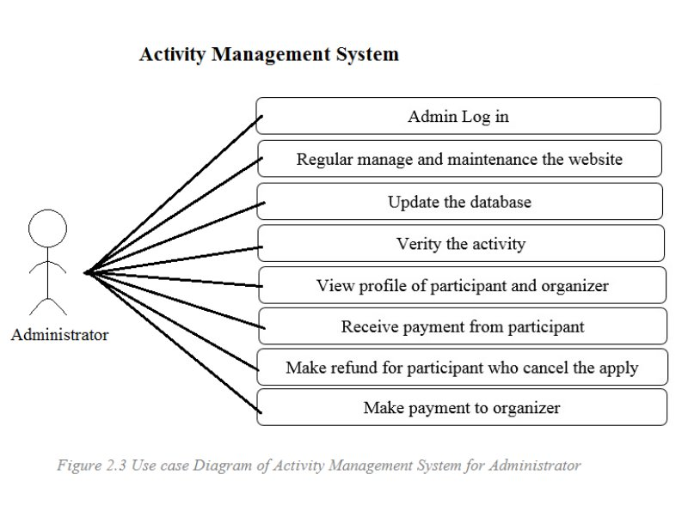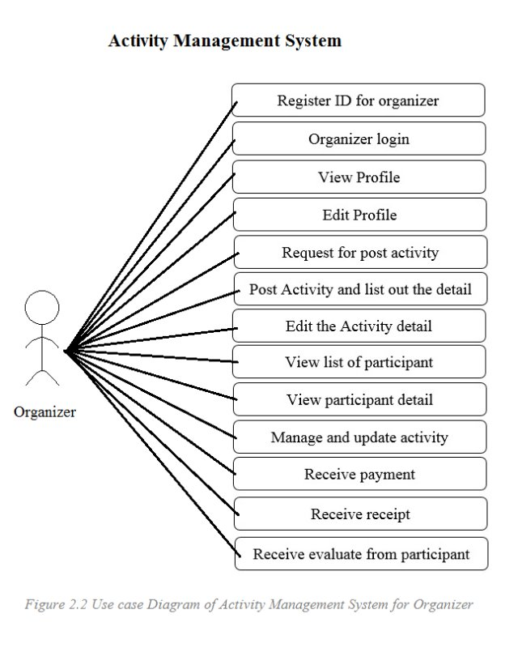

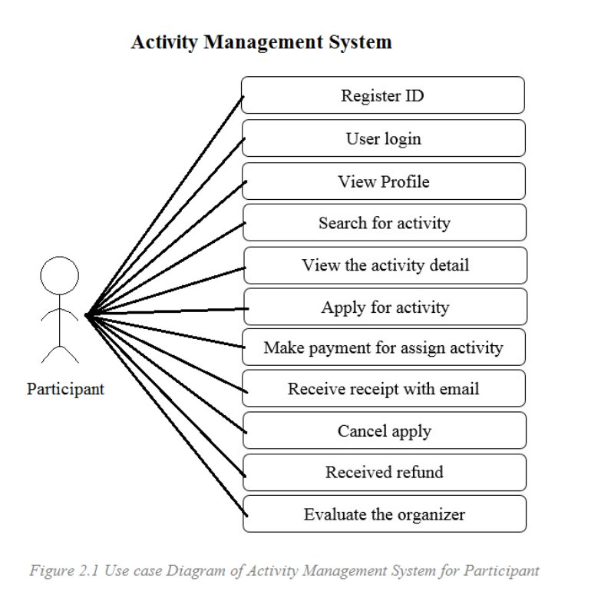

Activity Management System is designed on website due to base on the user requirement, website is included on almost all devices in the market. Based on the statistics and the analysis in the market, we found that it is a norm that users were difficult on searching for activities and organizer have difficult on publicize the activities. These problems cause that activities had obviously decrease on statistical table. Thus, Activity Management System provides help on solving these problems.

First of all, organizers need to log in for post their activities or events on our website. They can edit or update the detail after posting. Users also require to log in before searching for activities or events that posted by organizers. If the users found the activities they want, users can apply for that activities and make payment. Users can also cancel the apply they make and take back the payment before the apply deadline. The organizers will take their payment after the apply deadline.

**Methodology**

In the iterative model does not begin with completely requirements for software developed. The development specifying and implementing with just a part of software as a begin, and complete the system with feedback for determining the final requirements. With repeated this process to produce a new version of the software. Programmer can demonstrate results of the process early and receive feedback from users to improve the efficiency. (Iterative Model,2017)

The Iterative model is show in Figure 1 below.

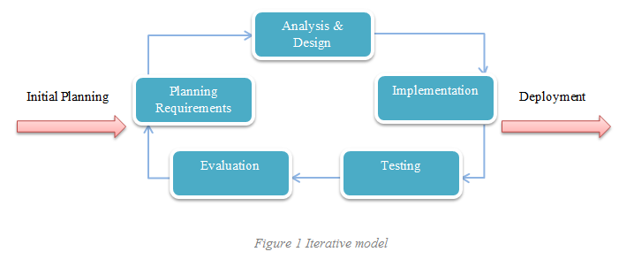

Consider an iterative life cycle model which consists of repeating the following four phases in sequence:

1. **Requirements –** The requirements for the software are gathered and analysed. Iteration should final result in requirements phase that produces a complete specification of requirements.
2. **Design –** A software solution to meet the requirements is designed. The design may contain previous design or new design to match the software development.
3. **Implementation and Test –** For implementation phase, the researcher performed the actual coding, integrate the software, and testing phase start from the scratch.
4. **Review –** After the software is evaluated, the current requirements are reviewed, and changes and additions to requirements proposed.

**Project Plan**

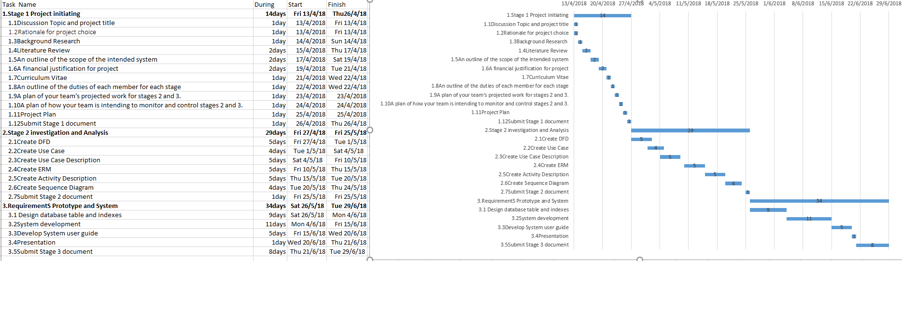

References

(Iterative Model,2017)  
-<https://www.testingexcellence.com/iterative-model/>

(BIZZABO, 2018)-[www.bizzabo.com/](http://www.bizzabo.com/)

(HTML)- <https://searchmicroservices.techtarget.com/definition/HTML-Hypertext-Markup-Language>

(PHP) – <https://whatis.techtarget.com/definition/PHP-Hypertext-Preprocessor>

(MySQL) - <https://searchoracle.techtarget.com/definition/MySQL>

(Web service) - <https://searchmicroservices.techtarget.com/definition/Web-services-application-services>

# (RT Essentials,2005)-[https://www.smartsheet.com/how-use-smartsheet-it-ticketing-system](https://web.wechat.com/cgi-bin/mmwebwx-bin/webwxcheckurl?requrl=https%3A%2F%2Fwww.smartsheet.com%2Fhow-use-smartsheet-it-ticketing-system&skey=%40crypt_3666a7c3_d2d19170183d27315be94935b4989b6b&deviceid=e201808916894162&pass_ticket=3sw1kHFAjtu7s7o56Z5c5Lwoal7muKz3m%252BW3pWbhb9WM1%252F88C%252BwM44sPO7%252FxWy5F&opcode=2&scene=1&username=@e12365b9cbe236c65c9b7811d4756cc1400bc7b45802002efcdc50a8d8124e12) https://www.safaribooksonline.com/library/view/rt-essentials/0596006683/ch01.html https://www.safaribooksonline.com/library/view/rt-essentials/0596006683/[https://www.smartsheet.com/how-use-smartsheet-it-ticketing-system](https://web.wechat.com/cgi-bin/mmwebwx-bin/webwxcheckurl?requrl=https%3A%2F%2Fwww.smartsheet.com%2Fhow-use-smartsheet-it-ticketing-system&skey=%40crypt_3666a7c3_d2d19170183d27315be94935b4989b6b&deviceid=e201808916894162&pass_ticket=3sw1kHFAjtu7s7o56Z5c5Lwoal7muKz3m%252BW3pWbhb9WM1%252F88C%252BwM44sPO7%252FxWy5F&opcode=2&scene=1&username=@e12365b9cbe236c65c9b7811d4756cc1400bc7b45802002efcdc50a8d8124e12) https://www.safaribooksonline.com/library/view/rt-essentials/0596006683/ch01.html https://www.safaribooksonline.com/library/view/rt-essentials/0596006683/[https://www.smartsheet.com/how-use-smartsheet-it-ticketing-system](https://web.wechat.com/cgi-bin/mmwebwx-bin/webwxcheckurl?requrl=https%3A%2F%2Fwww.smartsheet.com%2Fhow-use-smartsheet-it-ticketing-system&skey=%40crypt_3666a7c3_d2d19170183d27315be94935b4989b6b&deviceid=e201808916894162&pass_ticket=3sw1kHFAjtu7s7o56Z5c5Lwoal7muKz3m%252BW3pWbhb9WM1%252F88C%252BwM44sPO7%252FxWy5F&opcode=2&scene=1&username=@e12365b9cbe236c65c9b7811d4756cc1400bc7b45802002efcdc50a8d8124e12) https://www.safaribooksonline.com/library/view/rt-essentials/0596006683/ch01.html https://www.safaribooksonline.com/library/view/rt-essentials/0596006683[https://www.smartsheet.com/how-use-smartsheet-it-ticketing-system](https://web.wechat.com/cgi-bin/mmwebwx-bin/webwxcheckurl?requrl=https%3A%2F%2Fwww.smartsheet.com%2Fhow-use-smartsheet-it-ticketing-system&skey=%40crypt_3666a7c3_d2d19170183d27315be94935b4989b6b&deviceid=e201808916894162&pass_ticket=3sw1kHFAjtu7s7o56Z5c5Lwoal7muKz3m%252BW3pWbhb9WM1%252F88C%252BwM44sPO7%252FxWy5F&opcode=2&scene=1&username=@e12365b9cbe236c65c9b7811d4756cc1400bc7b45802002efcdc50a8d8124e12) https://www.safaribooksonline.com/library/view/rt-essentials/0596006683/ch01.html https://www.safaribooksonline.com/library/view/rt-essentials/0596006683[https://www.smartsheet.com/how-use-smartsheet-it-ticketing-system](https://web.wechat.com/cgi-bin/mmwebwx-bin/webwxcheckurl?requrl=https%3A%2F%2Fwww.smartsheet.com%2Fhow-use-smartsheet-it-ticketing-system&skey=%40crypt_3666a7c3_d2d19170183d27315be94935b4989b6b&deviceid=e201808916894162&pass_ticket=3sw1kHFAjtu7s7o56Z5c5Lwoal7muKz3m%252BW3pWbhb9WM1%252F88C%252BwM44sPO7%252FxWy5F&opcode=2&scene=1&username=@e12365b9cbe236c65c9b7811d4756cc1400bc7b45802002efcdc50a8d8124e12) https://www.safaribooksonline.com/library/view/rt-essentials/0596006683/ch01.html https://www.safaribooksonline.com/library/view/rt-essentials/0596006683[https://www.smartsheet.com/how-use-smartsheet-it-ticketing-system](https://web.wechat.com/cgi-bin/mmwebwx-bin/webwxcheckurl?requrl=https%3A%2F%2Fwww.smartsheet.com%2Fhow-use-smartsheet-it-ticketing-system&skey=%40crypt_3666a7c3_d2d19170183d27315be94935b4989b6b&deviceid=e201808916894162&pass_ticket=3sw1kHFAjtu7s7o56Z5c5Lwoal7muKz3m%252BW3pWbhb9WM1%252F88C%252BwM44sPO7%252FxWy5F&opcode=2&scene=1&username=@e12365b9cbe236c65c9b7811d4756cc1400bc7b45802002efcdc50a8d8124e12) https://www.safaribooksonline.com/library/view/rt-essentials/0596006683/ch01.html [https://www.safaribooksonline.com/library/view/rt-essentials/0596006683https://www.smartsheet.com/how-use-smartsheet-it-ticketing-systemhttps://www.safaribooksonline.com/library/view/rt-essentials/0596006683/ch01.html](https://www.smartsheet.com/how-use-smartsheet-it-ticketing-system) -[https://www.safaribooksonline.com/library/view/rt-essentials/0596006683/ch01.htmlhttps://www.safaribooksonline.com/library/view/rt-essentials/0596006683/ch01.htmlhttps://www.safaribooksonline.com/library/view/rt-essentials/0596006683/ch01.htmlhttps://www.safaribooksonline.com/library/view/rt-essentials/0596006683/ch01.htmlhttps://www.safaribooksonline.com/library/view/rt-essentials/0596006683/ch01.htmlhttps://www.safaribooksonline.com/library/view/rt-essentials/0596006683/ch01.htmlhttps://www.safaribooksonline.com/library/view/rt-essentials/0596006683/ch01.htmlhttps://www.safaribooksonline.com/library/view/rt-essentials/0596006683/ch01.html](https://www.safaribooksonline.com/library/view/rt-essentials/0596006683/ch01.html) -https://www.safaribooksonline.com/library/view/rt-essentials/0596006683/