

**CSIS 3003**

**PROJECT I**

**Activities Management System**

**(Stage 2)**

**Foong Chin Wei(D170274B)**

**Lee Yi Sheng (D170286B)**

**Lew Zhan Fai (D170360B)**

**Lecturer: Mr. So Yong Quay**

**25th May 2018**

**Department of Computer Science**

**Faculty of Engineering and Information Technology**

**Table of Contents**

1.0 Data Flow Diagram 2

* 1. Context Level Diagram 2
  2. DFD Diagram 0 3

2.0 Entity Relationship Diagram 7

3.0 Class Diagram 8

4.0 Use Case Diagram 6

4.1 Login System 6

4.2 Organizer System 6

4.3 Activity System 7

4.4 Payment system 7

5.0 Use Case Description 8

5.1 Login System 8,9

5.2 Organizer System 10,11,12

5.3 Activity System 13,14,15,16,17,18

5.4 Payment System 19,20,21

6.0 Activity diagram 22

6.1 Login System 22

6.2 Organizer system 23

6.4 Activity System 24

6.5 Payment System 25

7.0 Sequence diagram 26

7.1 Login System 26,27

7.2 Organizer System 28,29

7.3 Activity System 30,31

7.4 Payment System 32

**1.0 Data Flow Diagram**

**1.1 Context Level Diagram**

**Activity Management System**

**Context**

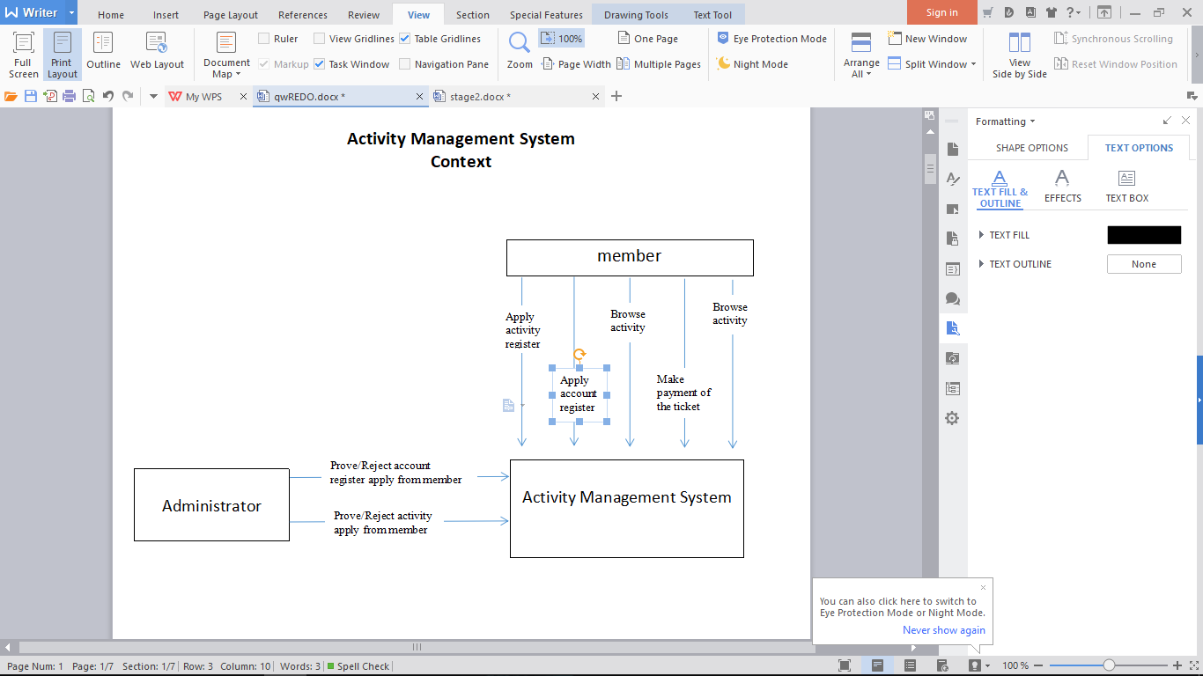

**1.2** Diagram 0 DFD for Activity Management System

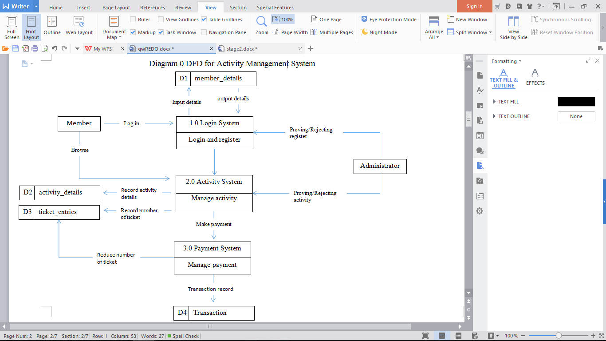

**1.3 DFD Diagram 1**

**Diagram 1 DFD Login System**

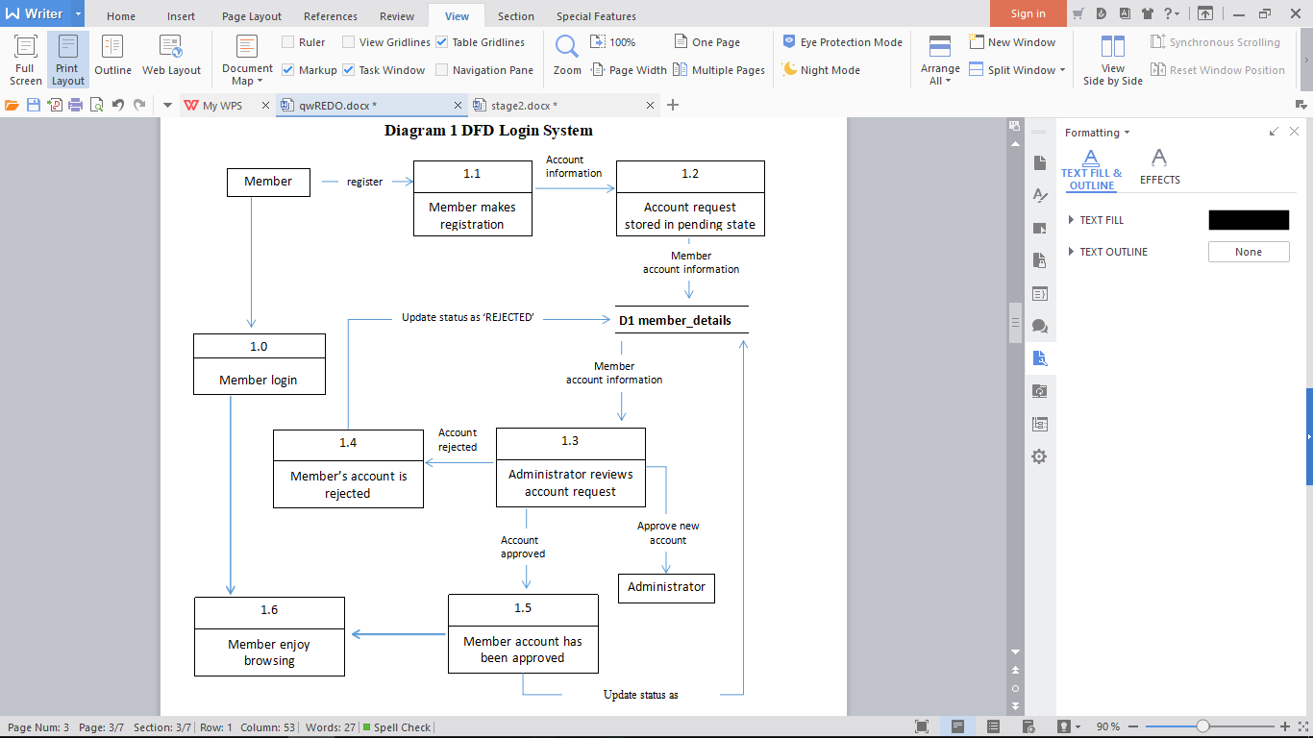

**Diagram 1 DFD Activity System**

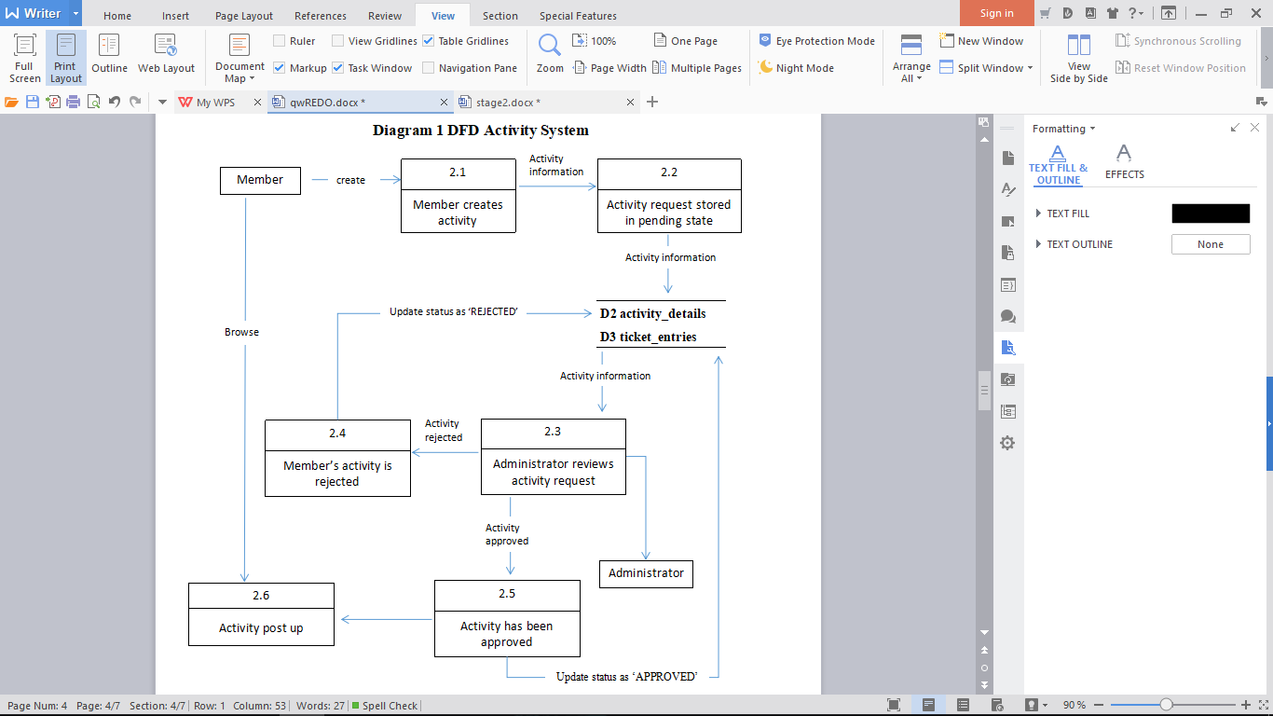

**Diagram 1 DFD Payment System**

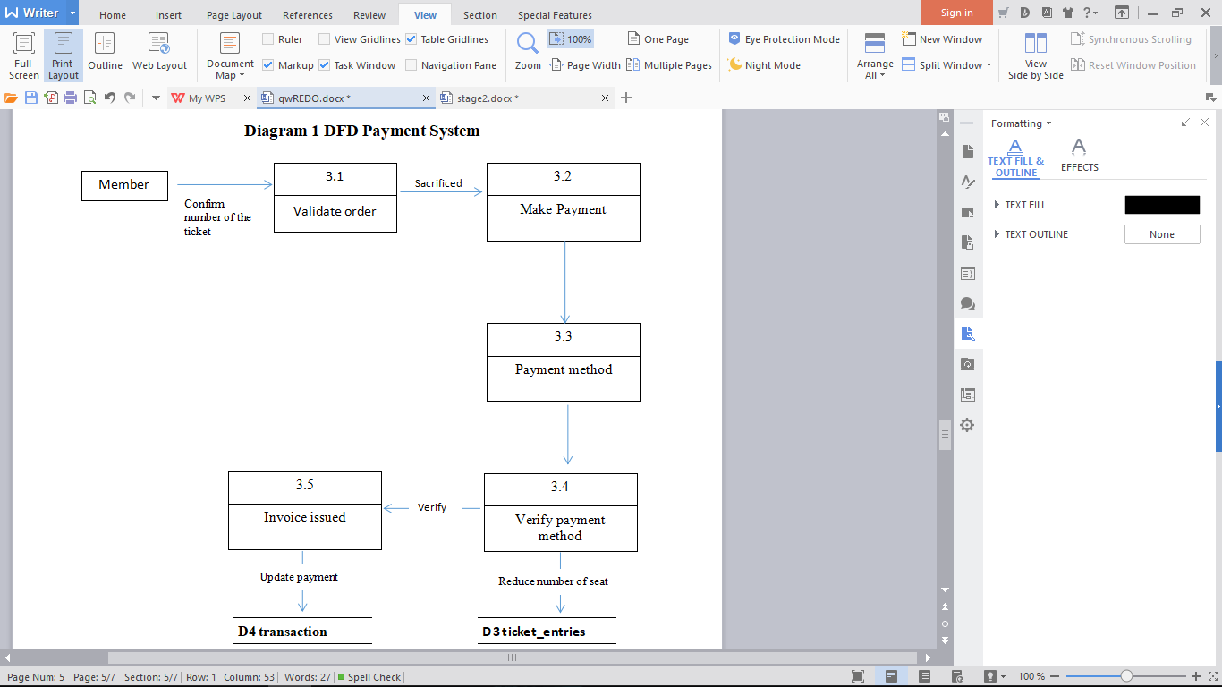

**2. Entity Relationship Diagram**

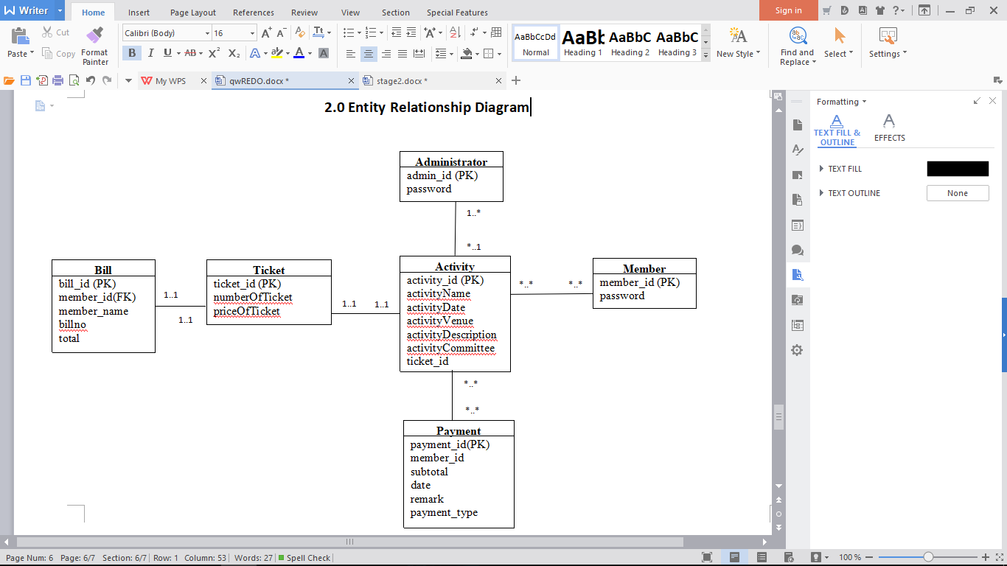

**3.** **Class Diagram**

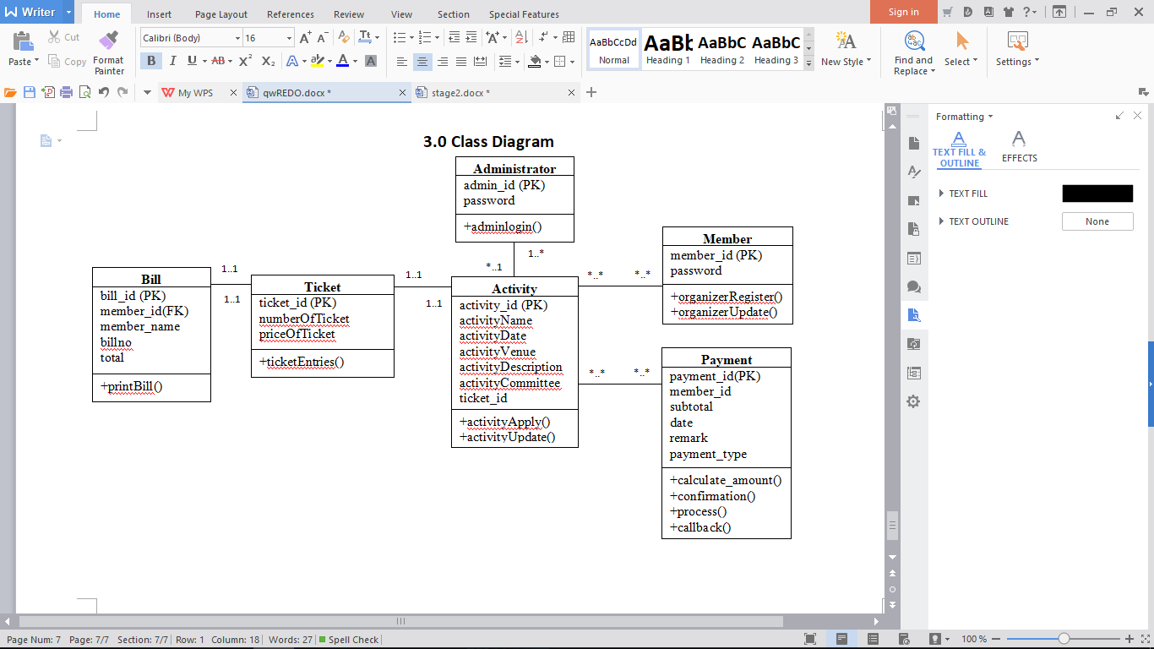

**4.0 Use case diagram**

**4.1 Login System**

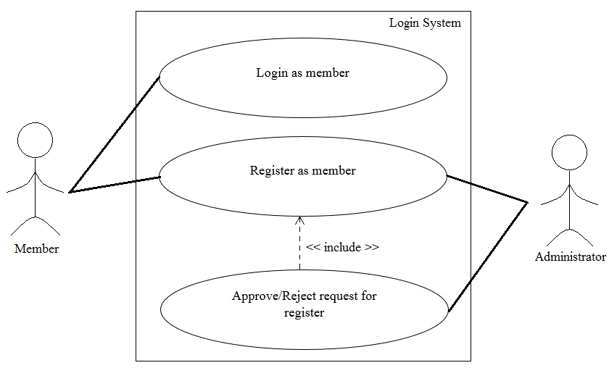

**4.2 Activity System**

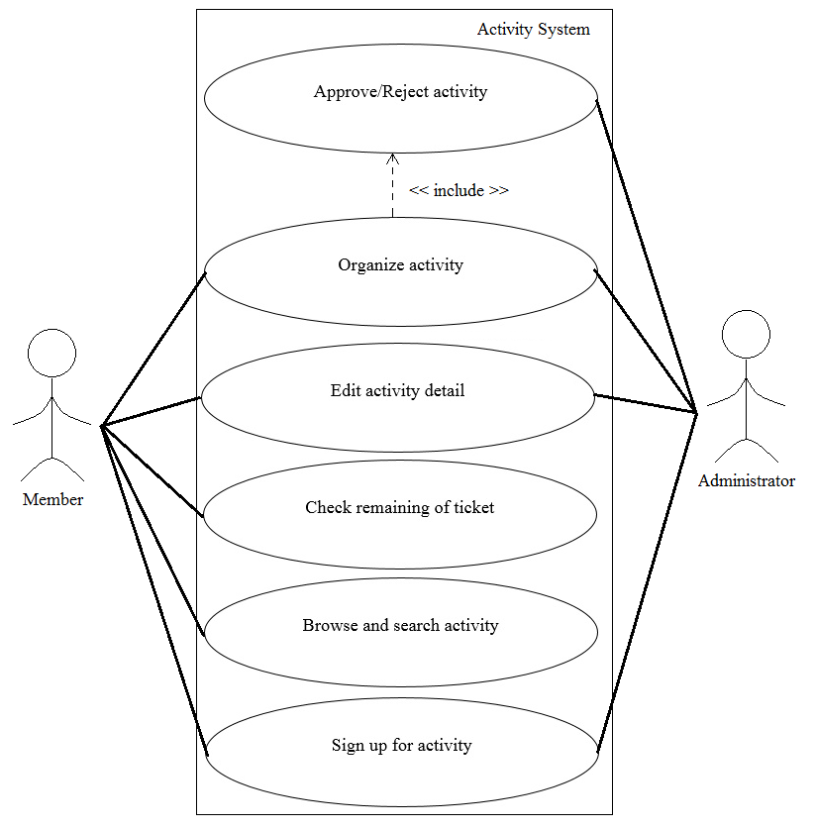

**4.3Payment System**

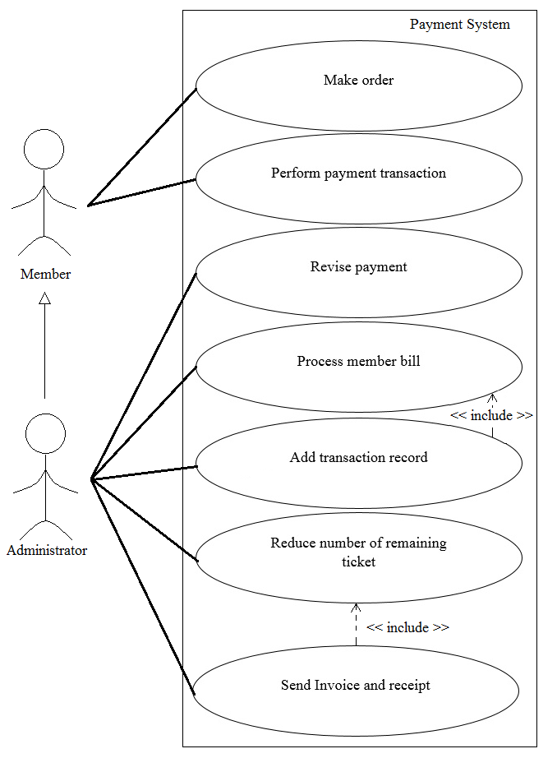

**5.0 Use case description**

**5.1 Login System**

|  |  |  |
| --- | --- | --- |
| **Use case: Login as member (Login System)** | | |
|
| Overview: This case describes how the member log in. | | |
|
| Pre-conditions:   1. Network connection with server required. | | |
|
| Post conditions:   1. Successful condition  * Member log in successfully. | | |
|
|
| Event | | Response |
| 1 | User browse the webpage system. | * + - * Display main page UI. |
| 2 | User select Login. | * + - * Display log in page UI. |
| 3 | User insert username and password required. | - |
| 4 | User select Login button. | * + - * Perform information validation.       * Display message “<Username> log in successfully.”       * Display member UI. |
| 5 | User login success. | * + - * User login as member. |
| Extensions | | |
| 4 | Invalid username and password. | * + - * Reject the request.       * Display error message.       * Re-enter information required. |

|  |  |  |
| --- | --- | --- |
| **Use case: Register as member (Login System)** | | |
|
| Overview: This case describes how the user register as member. | | |
|
| Pre-conditions:   1. Network connection with server required. | | |
|
| Post conditions:   1. Successful condition  * Member register had successfully. | | |
|
|
| Event | | Response |
| 1 | User browse the webpage system. | * + - * Display main page UI. |
| 2 | User select register. | * + - * Display register UI. |
| 3 | User insert username and password. | - |
| 4 | User select confirm button. | * + - * Checking contain same information with database.       * Display message “Thank you for register, please wait for administrator to approve this registration. |
| 5 | Administrator select view register. | * + - * Display register request list. |
| 6 | Administrator select approve registration | * + - * Insert member register information into member database.       * Display message registration approve had successfully. |
| 7 | User select check registration process. | * + - * Display message “Register successfully.” |
| 8 | User register success. | * + - * User register as member successfully. |
| Extensions | | |
| 4 | Same information detected. | * + - * Reject the request.       * Display error message.       * Re-enter information required. |
| 7 | Administrator select reject. | * + - * Display message “Register rejected.” |

**5.2 Activity System**

|  |  |  |
| --- | --- | --- |
| **Use case: Organize activity (Activity System)** | | |
|
| Overview: This case describes how the member organize activity. | | |
|
| Pre-conditions:   1. Network connection with server required. 2. Member login required. | | |
|
| Post conditions:   1. Successful condition  * Member organize activity successfully. | | |
|
|
| Event | | Response |
| 1 | Member login to webpage. | * + - * Perform account validation.       * Display main page UI. |
| 2 | Member select activity. | * + - * Display activity page with many options. |
| 3 | Member select organize activity. | * + - * Display organize activity UI and required insert activity detail. |
| 4 | Member insert activity detail. | - |
| 5 | Member select confirm. | * + - * Sending information to administrator.       * Display message “Please wait for admin to approve this request.” |
| 5 | Administrator select activity organize list. | * + - * Display request of activity organize list. |
| 6 | Administrator select approve. | * + - * Insert activity information into Activity and ticket entries database.       * Display message “Activity approved” |
| 7 | Member select view request status. | * + - * Display request list and status. |
| 8 | Member select activity. | * + - * Display message “Request approved.” |
| Extensions | | |
| 1 | Invalid account. | * + - * Display message “Please enter correct user Username/Password.”       * Clear the password text field. |
| 8 | Administrator select reject. | * + - * Display message “Request rejected.” |

|  |  |  |
| --- | --- | --- |
| **Use case: Edit activity (Activity System)** | | |
|
| Overview: This case describes how the member edit activity. | | |
|
| Pre-conditions:   1. Network connection with server required. 2. Member login required. 3. Activity had been organized. | | |
|
| Post conditions:   1. Successful condition  * Member edit activity successfully. | | |
|
|
| Event | | Response |
| 1 | Member login to webpage. | * + - * Perform account validation.       * Display main page UI. |
| 2 | Member select activity. | * + - * Display activity page with many options. |
| 3 | Member select activity from list. | * + - * Display the list of activity that organized. |
| 4 | Member select edit activity. | * + - * Receive activity detail from activity and ticket entries database.       * Display activity detail in text field. |
| 5 | Member edit the activity detail. | - |
| 6 | Member select confirm. | * + - * Update activity detail to activity and ticket entries database.       * Display message “Edit successfully.” |
| 7 | Member edit activity success. | - |
| Extensions | | |
| 1 | Invalid account. | * + - * Display message “Incorrect user ID/Password, please enter correct user ID/Password.”       * Clear the password text field. |

|  |  |  |
| --- | --- | --- |
| **Use case: Check remaining of ticket (Activity System)** | | |
|
| Overview: This case describes how the member check the remaining of ticket. | | |
|
| Pre-conditions:   1. Network connection with server required. 2. Member login required. 3. Activity had been organized. | | |
|
| Post conditions:   1. Successful condition  * Member check remaining of ticket successfully. | | |
|
|
| Event | | Response |
| 1 | Member login to webpage. | * + - * Perform account validation.       * Display main page UI. |
| 2 | Member select activity. | * + - * Display activity page with many options. |
| 3 | Member select activity from list. | * + - * Display the list of activity that had organized. |
| 4 | Member select ticket. | * + - * Display the remaining of ticket and other option. |
| 5 | Member check remaining of ticket successfully. | - |
| Extensions | | |
| 1 | Invalid account. | * + - * Display message “Incorrect user ID/Password, please enter correct user ID/Password.”       * Clear the password text field. |

|  |  |  |
| --- | --- | --- |
| **Use case: Browse and search activity (Activity System)** | | |
|
| Overview: This case describes how the member browse and search for activity. | | |
|
| Pre-conditions:   1. Network connection with server required. 2. Member login required. | | |
|
| Post conditions:   1. Successful condition  * Member browse and search activity successfully. | | |
|
|
| Event | | Response |
| 1 | Member login to webpage. | * + - * Perform account validation.       * Display main page UI. |
| 2 | Member insert activity name or type. | * + - * Display some similar activity under search bar. |
| 3 | Member select search. | * + - * Display all similar activity list. |
| 4 | Member browse and search activity had successfully. | - |
| Extensions | | |
| 1 | Invalid account. | * + - * Display message “Incorrect user ID/Password, please enter correct user ID/Password.”       * Clear the password text field. |
| 3 | Member insert name or type that not related at all. | * + - * Display message “The related activity is not found.” |

|  |  |  |
| --- | --- | --- |
| **Use case: Sign up for activity (Activity System)** | | |
|
| Overview: This case describes how the member sign up for activity. | | |
|
| Pre-conditions:   1. Network connection with server required. 2. Member login required. | | |
|
| Post conditions:   1. Successful condition  * Display make order page. | | |
|
|
| Event | | Response |
| 1 | Member login to webpage. | * + - * Perform account validation.       * Display main page UI. |
| 2 | Member select activity. | * + - * Display activity detail page and some option. |
| 3 | Member select sign up. | * + - * Display text field required insert personal information. |
| 4 | Member insert information. | - |
| 5 | Member select confirm. | * + - * Checking information missing.       * Display payment page. |
| Extensions | | |
| 1 | Invalid account. | * + - * Display message “Incorrect user ID/Password, please enter correct user ID/Password.”       * Clear the password text field. |
| 5 | User information missing | * Reject request * Display error message * Display message “Some information is missing, please fill the information.” |

**5.3 Payment System**

|  |  |  |
| --- | --- | --- |
| **Use case: Make order (Payment System)** | | |
|
| Overview: This case describes how the member make order to continue sign up progress. | | |
|
| Pre-conditions:   1. Network connection with server required. 2. Member login required. 3. Member had insert information and accepted by system. | | |
|
| Post conditions:   1. Successful condition  * Display perform payment transaction page. | | |
|
|
| Event | | Response |
| 1 | Member select confirm in sign up page. | * + - * Display make order UI. |
| 2 | Member select number of ticket for purchase. | * + - * Checking the amount of remaining ticket is more than ordering ticket.       * Display confirm button. |
| 3 | Member select confirm. | * + - * Display perform payment transaction page. |
| Extensions | | |
| 2 | Amount of remaining ticket is less than ordering ticket. | * Reject request * Display message “The remaining ticket is <amount of remaining ticket> which is not enough for your order, please re-select the number of ticket you want to purchase.” * Re-select required. |

|  |  |  |
| --- | --- | --- |
| **Use case: Perform payment transaction (Payment System)** | | |
|
| Overview: This case describes how the member perform payment transaction to complete sign up. | | |
|
| Pre-conditions:   1. Network connection with server required. 2. Member login required. 3. Member had make order successfully. | | |
|
| Post conditions:   1. Successful condition  * Member payment successfully. * Member sign up for activity successfully. | | |
|
|
| Event | | Response |
| 1 | Member select confirm in make order page. | * + - * Display payment UI. |
| 2 | Member select payment method. | * + - * Display text field for require insert payment information. |
| 3 | Member insert payment information. | - |
| 4 | Member select confirm. | * + - * Checking payment transaction.       * Payment transaction accepted.       * Send transaction into transaction database. |
| 5 | Member payment transaction successfully. | - |
| 6 | Member sign up for activity successfully. | - |
| Extensions | | |
| 4 | Invalidate payment information detected. | * Reject request * Display error message * Display message “Please re-enter the information to continue the payment.” |

|  |  |  |
| --- | --- | --- |
| **Use case: Revise payment (Payment System)** | | |
|
| Overview: This case describes how the administrator revise the payment. | | |
|
| Pre-conditions:   1. Network connection with server required. 2. Administrator login required. | | |
|
| Post conditions:   1. Successful condition  * Order revised successfully. | | |
|
|
| Event | | Response |
| 1 | Administrator login to webpage. | * + - * Perform account validation.       * Display administrator page UI. |
| 2 | Administrator select payment system. | * + - * Display payment system UI. |
| 3 | Administrator select view sales order. | * + - * Receive data from transaction database.       * Display sales order list. |
| 4 | Administrator select an order. | * + - * Display order detail. |
| 5 | Administrator edit the sales order information. | - |
| 6 | Administrator select confirm | * + - * Perform details validation.       * Update sales order information into transaction database.       * Display message “Sales order revise successfully”. |
| 7 | Administrator revise the order successfully. | - |
| Extensions | | |
| 1 | Invalid account. | * + - * Display message “Incorrect user ID/Password, please enter correct user ID/Password.”       * Clear the password text field. |
| 6 | Validation failed | * + - * Reject request.       * Display error message. |

|  |  |  |
| --- | --- | --- |
| **Use case: Process member bill (Payment System)** | | |
|
| Overview: This case describes how the administrator process member bill. | | |
|
| Pre-conditions:   1. Network connection with server required. 2. Administrator login required. | | |
|
| Post conditions:   1. Successful condition  * Administrator process member bill successfully. | | |
|
|
| Event | | Response |
| 1 | Administrator login to webpage. | * + - * Perform account validation.       * Display administrator page UI. |
| 2 | Administrator select payment system. | * + - * Display payment system UI. |
| 3 | Administrator select view sales order. | * + - * Receive data from transaction database.       * Display sales order list. |
| 4 | Administrator select an order. | * + - * Display order detail. |
| 5 | Administrator select process member order. | * + - * Process member bill.       * Add transaction record.       * Insert into transaction database.       * Display message “Process member bill successfully.” |
| 6 | Administrator process member bill successfully. | - |
| Extensions | | |
| 1 | Invalid account. | * + - * Display message “Incorrect user ID/Password, please enter correct user ID/Password.”       * Clear the password text field. |

|  |  |  |
| --- | --- | --- |
| **Use case: Send Invoice and receipt (Payment System)** | | |
|
| Overview: This case describes how the invoice and recipe work. | | |
|
| Pre-conditions:   1. Network connection with server required. 2. Administrator had process member bill. | | |
|
| Post conditions:   1. Successful condition  * Reduce seat from ticket entries database had successfully. * Invoice and receipt has successfully send. | | |
|
|
| Event | | Response |
| 1 | Transaction record complete detected. | * Reduce seat from ticket entries database. * Receive bill from database. * Send Invoice to member. * Send receipt to member. |
| 2 | Reduce seat from ticket entries database successfully. | - |
| 3 | Invoice successfully send to user. | - |
| 4 | Receipt successfully send to user. | - |
| Extensions | | |
| - | - | - |

**6.0** [**Activity**](https://r.search.yahoo.com/_ylt=Awr9LvCacwZbE_QAuMYPQgx.;_ylu=X3oDMTByb2lvbXVuBGNvbG8DZ3ExBHBvcwMxBHZ0aWQDBHNlYwNzcg--/RV=2/RE=1527178266/RO=10/RU=https%3a%2f%2fen.wikipedia.org%2fwiki%2fActivity_diagram/RK=2/RS=DKVTDHKbDpfRuEevHar9A.wJHmo-) **Diagram**

**6.1 Login System**

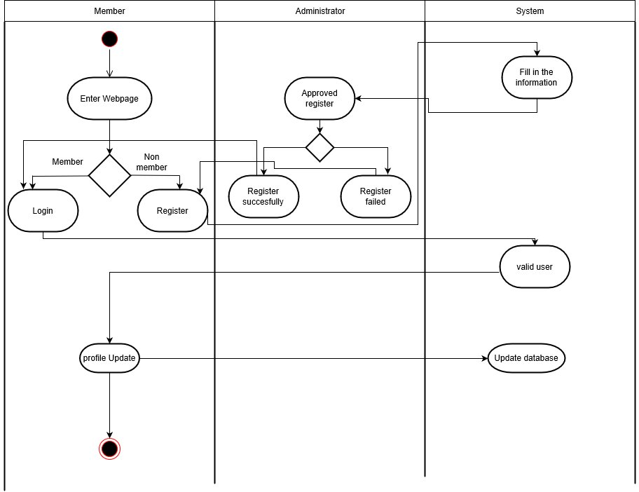

**6.2 Activity System**

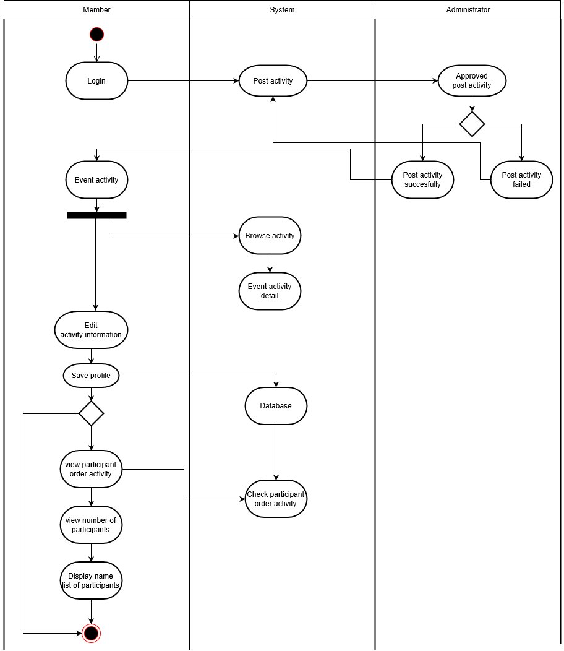

**6.3 Payment System**

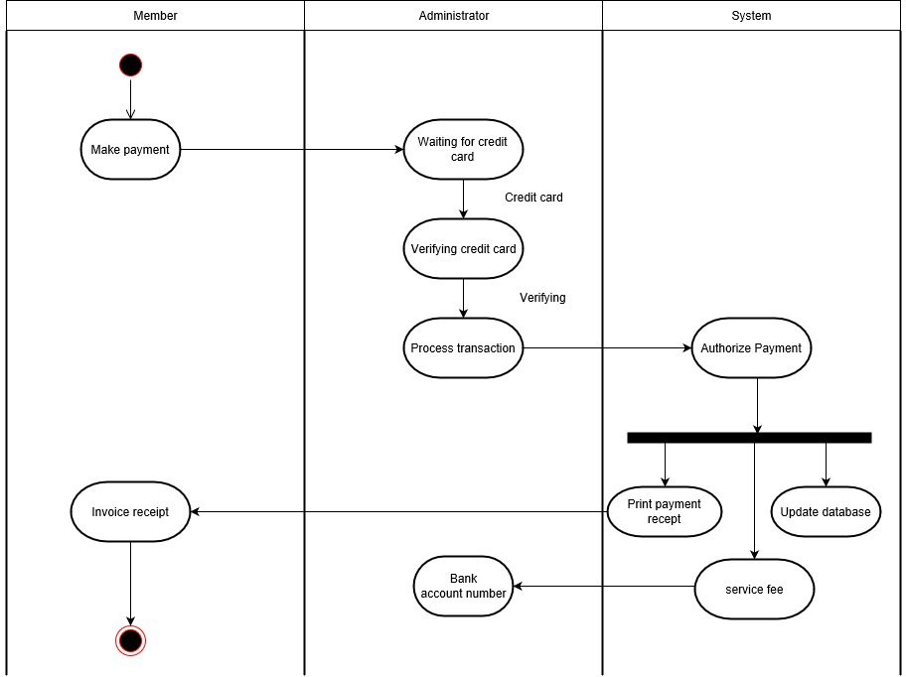

**7.0 Sequence diagram**

**7.1 Login System**

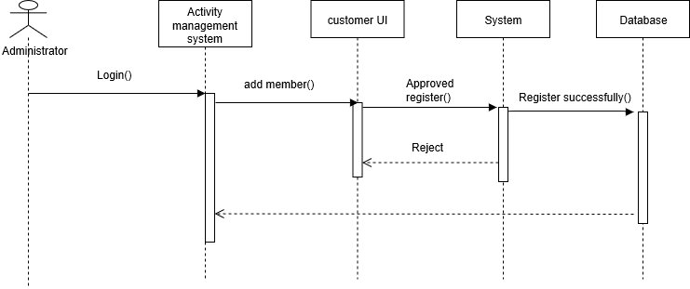

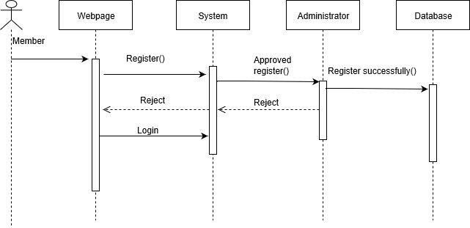

**7.2 Activity System**

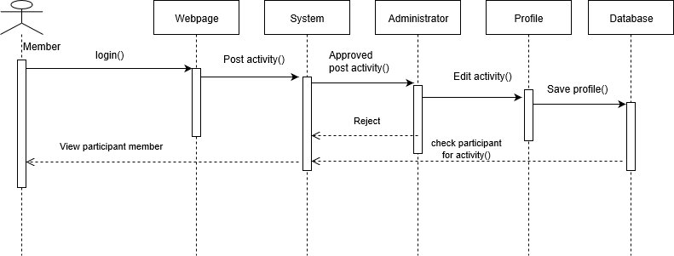

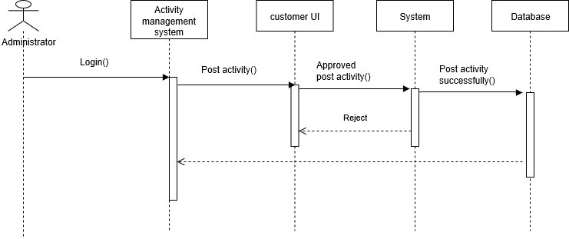

**7.3 Payment System**



