Digital Cookbook & Recipe Archive Manager Draft

Dominic Hatcher-Thomassen, Carl Luidee Lim, Tatiana Arias
https://github.com/CarlLuidee03/SPU_CSC3220_W26_Team_Cyan
Engineering and Computer Science Department, Seattle Pacific University
CSC 3220: Applications Programming
Dr. Andrew Cameron
January 29, 2026
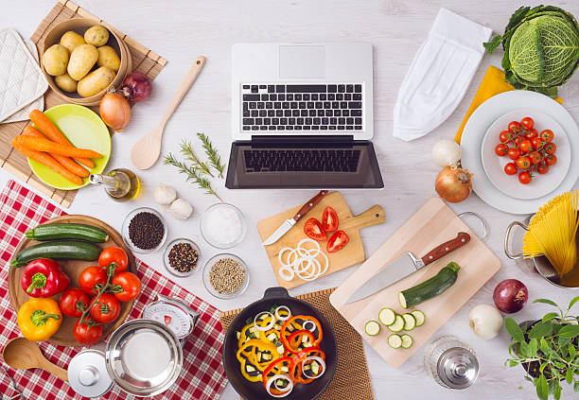
Personal recipe manager, single-user, and beginner-friendly application that lets users manage their recipes in a simple and organized environment. The app allows users to access their recipes offline and stores the recipe data in a local relational database. Users won’t have to worry about losing or finding their recipes.
Users will be able to easily create, view, update, and delete recipes. Recipes will include a title, description, instructions, and a list of ingredients with the quantities. Serving sizes will also be configurable, and the recipe will adjust accordingly. The app will also allow managing ingredients and their quantity units. Recipe tag filtering is a prominent feature. Users will be able to view and filter recipes based on tags, including difficulty, dietary, cuisine type, meal type, and allergens.

