Assignment Part A (Logisim) – Semester 1, 2017

Name: Carl Humphries

Student Number: 5084150

Email Address: carl.humphries@griffithuni.edu.au

# Circuit Functions

## 3:8 Decoder Both (Top to Bottom and Bottom to Top)

This circuit works by using three input; C1, C2 and C3. These signals then go through a series of eight sets of two AND gates using NOT gates to distinguish the outputs. This is to get around not using three input AND gate. The way the logic works for the inputs follows a three-input truth table. This is done with repeating patterns in the inputs;   
C1 goes off a pattern where first four inputs are C1(bar) and the next four are C1.  
C2 does off a pattern where first two inputs are C2(bar) and the next two are C2 then repeat.  
C3 goes off a pattern where every second input it is C3 and every first is C3(bar).

For each extra input it increases the pattern by 2X  where every time the input is inverted. I created two decoders just for logical layout when making Part A. One is just the other one flipped upside down. All outputs represents a number from 0-7 from the AND gates.

## Card Logic

Now that I can assume that the inputs are cards from 0-7 and each line represents those numbers. I used a system of OR gates to make smaller inputs light up if the input is greater than it. I did this for one of the cards C2 and from there ran it into a wall of blockers that determine if Card1 is X that Card2 is not greater than (6-X) this allowed me to see if the cards lost. From here I inverted the signal to show on if the game has been won Because if a signal passes through then you have lost.

## Part A

Using the decoders and the card logic I could easily connect the circuit to have the cards C1 and C2 inputted into the card logic as 6 inputs two 3-bit octal digits. And then the output showing if they won. Part A used the templates from the decoders and the template of the card logic where the top to bottom decoder was on top and the bottom to top was on the bottom this was to make it look symmetric and to save complexity.

## Part B

Part B is a lot more complex than previous parts so I will split it into the input and the win/lose circuits.

### Input Circuit

In this part I used N as a three-bit input to set the number of games to either win or lose for the game to be over. It then compares to a constant 000 input to make sure the game cannot start if the number of games is equal to 0. It also compares to the counter for wins and the counter for losses. This is done by using comparators that are provided. The output a true if the inputs are equal.

Start input is to begin the game and is run through an AND gate that is also connected to the inverted signal of the number of games and 0 comparator. This completely stops the signal if that games are equal to 0. Start then runs into “Start Block” AND gates that allow the clock to go through to update the counters and the comparator output of the counters for both wins and losses to the number of games (this stops It saying you win and lose before the game has started). If the Start is off ie game has not started and the clock is pulsed it resets the counters instead of updating them this allows for a quick reset.

### Win/Lose

Using Part A the two cards are inputted as C1-(1,2,3) and C2-(1,2,3) and the output is True if that game is won. This then goes into the part of a lose counter that if it is on it will decrease the counter and the inverted signal goes into the win counter at the same part. If this is off and the clock is updated, then the counter increases. So, by doing this I can increase one counter and decrease the other depending if you win or lose. The output of the counters are three-bit and then compared to the number of games. If the game has started (Start = TRUE) and the number of wins or losses are equal to the number of games. The OVERALL_WINNER or OVERALL_LOSER LED’s are light and then the signal passes through an OR gate that locks the system out. It does this by inverting this signal and running it though a main “Lockout Block” so that now the clock cannot update anything until the game is reset.

# Circuit diagrams

## 3:8 Decoder Both (Top to Bottom and Bottom to Top)

### Top to Bottom

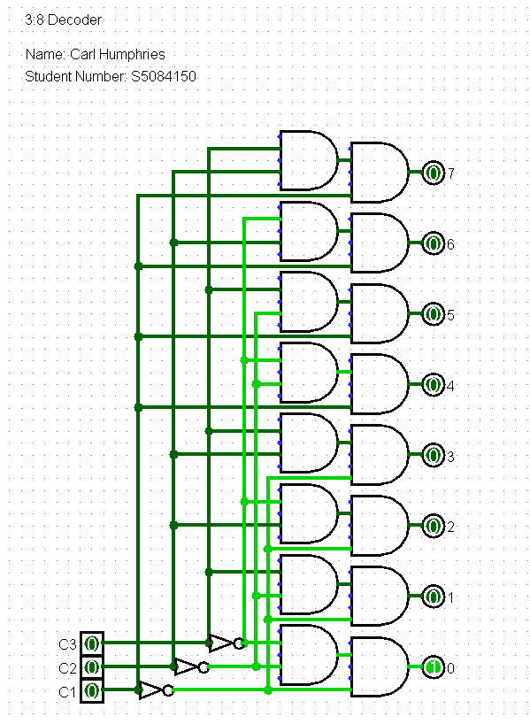

### Bottom to Top

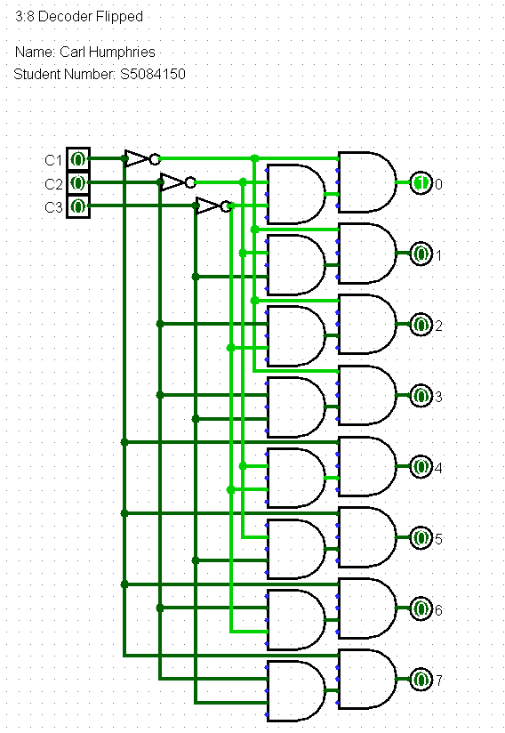

## Card Logic

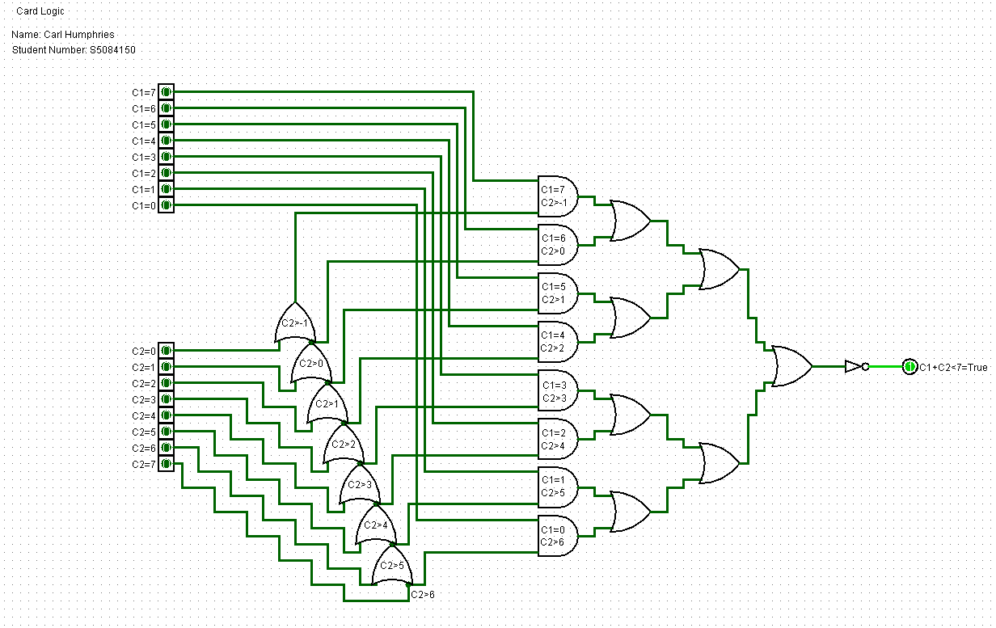

## Part A

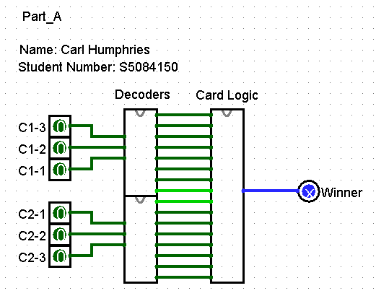

## Part B

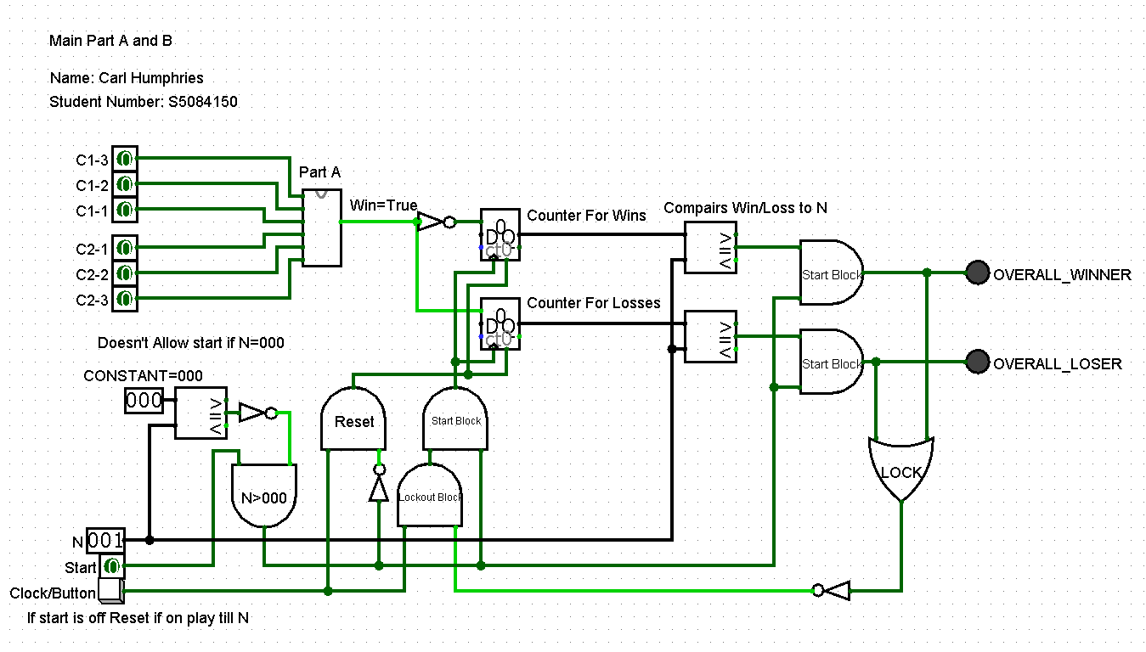

# Truth table

## Truth table taken from Logisim:

