The HelpChek Engine is designed to assist Developers, Testers and Help Authors in “Checking Help” works and finding/fixing topic and context strings.

When Help is opened (F1 pressed) the HLP Topic Context-String is send to DebugView(). If the Clarion HLP() topic is not in the CHM file then no page opens in the help viewer and there is no way to tell what Topic was attempted. This debug info can be used to change the CHM file topic and not have to change the source code.

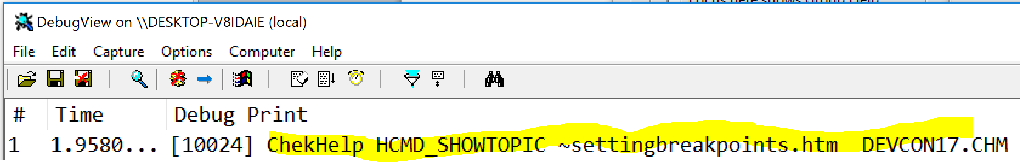

If Ctrl+Shift is held down while Help is opened the HelpChek Window is opened showing all Controls with HLP() on the window. Each row can be double-clicked on to open that Help and verify it works. This will also let a Help Author see what HLP has been assigned by the Developer.

In the below example Window each TAB has Help with a #Bookmark

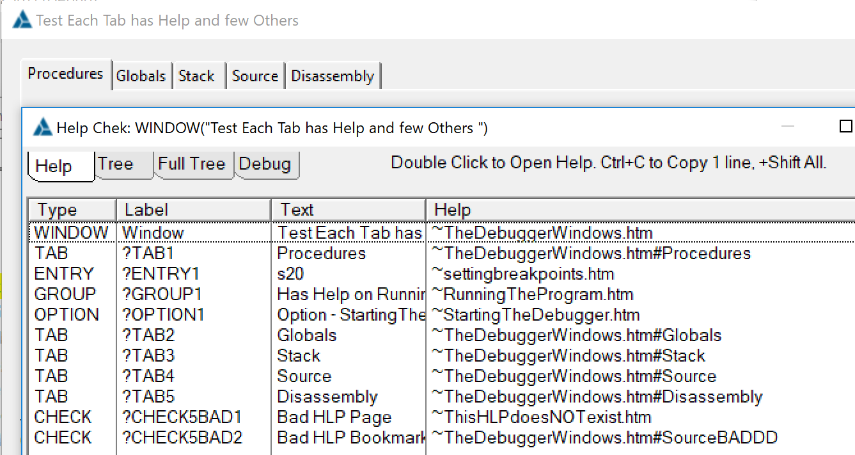

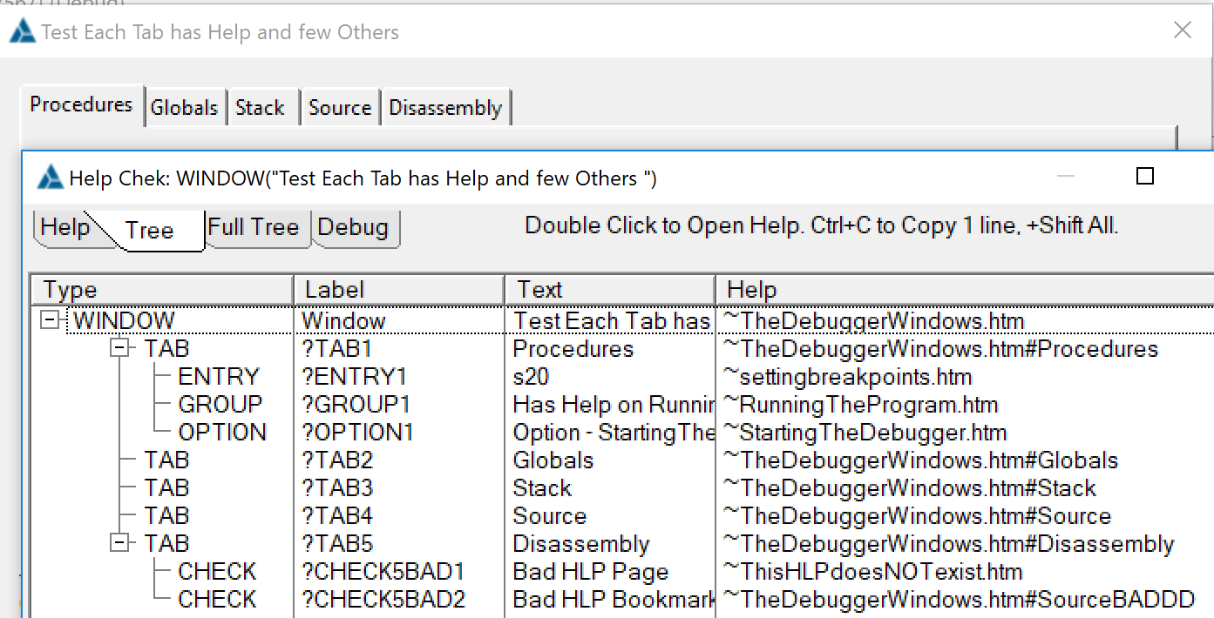

**Adding to an APP is simple.**

You need the CbHelpEngChek.INC and .CLW files in the project folder or Libsrc

In the Global Embeds add the INC and Define an Object:

!"Help Chek" shows HLP topic in DebugView plus Ctrl+Shift+F1 opens Chek Window

**INCLUDE**(**'CbHelpEngChek.inc'**),**ONCE**

**HelpChekCls** CbHelpChekClass

In an early CODE embed use code like below. It is suggested to only run this internally so find a file, folder, registry or something. Below example assumes the file HELPCHEK.TXT will be present to use this:

**IF EXISTS**(**'HelpChek.TXT'**) **THEN**

HR# = HelpChekCls.**Init**(**'YourHelp.CHM'**, **True** )

**IF** HR# **THEN Message**(**'HelpChekCls.Init failed Result = '** & HR# &**'||File='**& HelpChekCls.ChmFileName ).

**ELSE**

**HELP**(**'YourHelp.CHM'**) !Not needed if Templates set HELP()

**END**

You must do the above after the templates set the HELP() or it will override the above. Appgen has a bug that you cannot leave the APP Help File name blank, it will change blank to “.HLP”.