Lib Maker Plus - aka - Lib Maker *Minus*

This LibMaker was made for CIDC 2019 by Carl Barnes for the presentation Good Bye XP. If you are going to move to Windows 7+ you will likely need to create LIBs for new API functions. This new lib maker makes it easy to do and avoid duplicates with Clarion’s Win32.LIB. This is based on Mark Goldberg’s LibMaker. I added LIB Subtraction (hence “*minus*”), tagging, more..

Here’s an example of what it can do … Say you want the new Slim Reader Write locks and any new Critical Section functions in the Kernel.

1. To add Kernel Right click on the Add button and a Popup drops down. Click Windows DLLs…, then Kernel. You will see it loaded into the list.

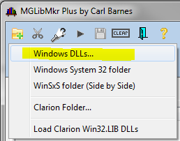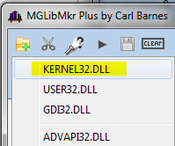

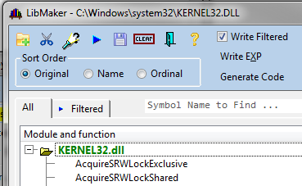

2. Click the third button  to search and tag by name. Enter “SRW” and you’ll see the below. Note there are several methods to search including Regular Expressions using Clarion Match().

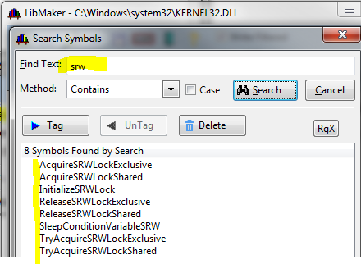

3. Now in the List you see SRW Tagged. The Filter tab shows just Tagged. You could save a LIB now and due to “Write Filtered” being checked it would save only the 8 tagged symbols.

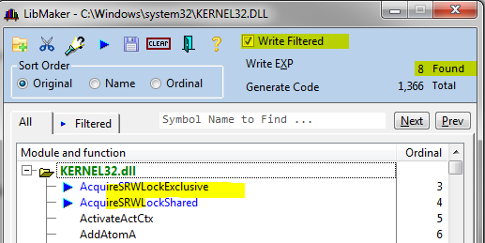 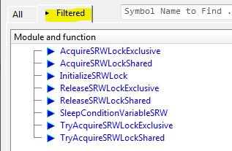

4. Next Search and Tag the Critical Section exports.

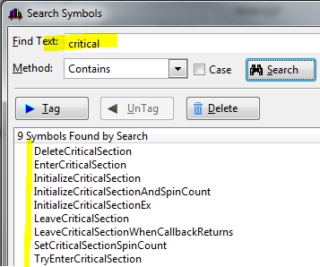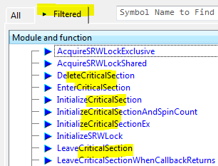

5. You can use the Tag button to remove all the UnTagged from the All list for less clutter:

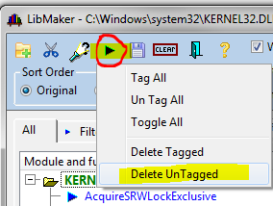 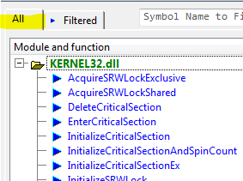

6. Most of the Critical Section exports are already in Clarion’s Win32.LIB so if they are in this LIB then you’ll get duplicate symbol errors from the Linker. It is easy to remove them using the Subtract button which is the second button the scissors. Right-click on it and a popup offers common choices. Select Clarion Folder… and on the next popup pick Win32.LIB

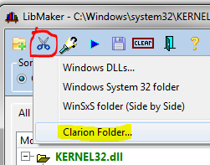 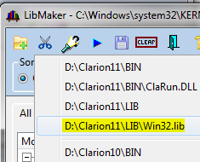

7. The Subtract Window opens with a list of all duplicates found. Normally I would click the Delete button, in this case I’ll click UnTag to visually see the dups in the All list

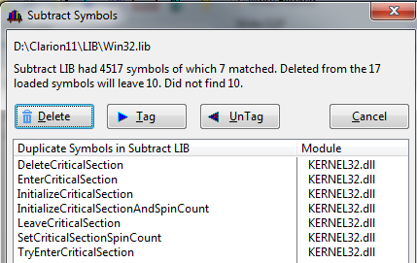 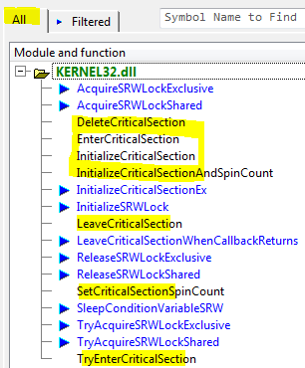

If I save the LIB (with the  button) then because  is checked the only exports will be those tagged. You could also use the Tag button to delete Untagged.

One other thing you can do with Subtract is to see the new symbols in a new release of a DLL. Import the new one, then subtract the old one, what is left are new exports.

One other new feature is warning you about Export symbols you do NOT want. If you import Shellre.DLL you’ll see the a few messages like below. DllGetVersion is exported by many DLLs. It is intended to be used with LoadLibary and GetProcAddress. If you have it in your LIB you will likely get a Duplicate Symbol error from the Linker because SV incorrectly included it in Win32.LIB. You want to “Omit ALL”.

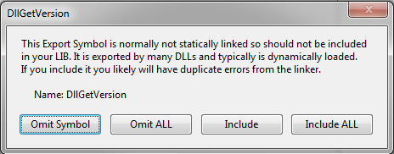

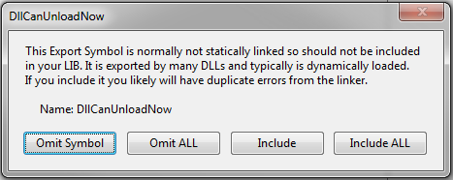

**WinSxS - Windows Side by Side**

WinSxS folder holds Version specific copies of DLLs that Windows loads based on a Manifest. (The Windows\WinSxS folder can has 1000’s of folders, most with just 1 DLL.) The most common need is to get Version 6 of ComCtl32.DLL that is used for Visual Styles and has all the new features. In the System32 folder you will find the older version 5. Below I show the screen captures of loading version 6, then subtracting version 5 to see what’s new:

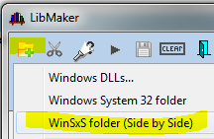

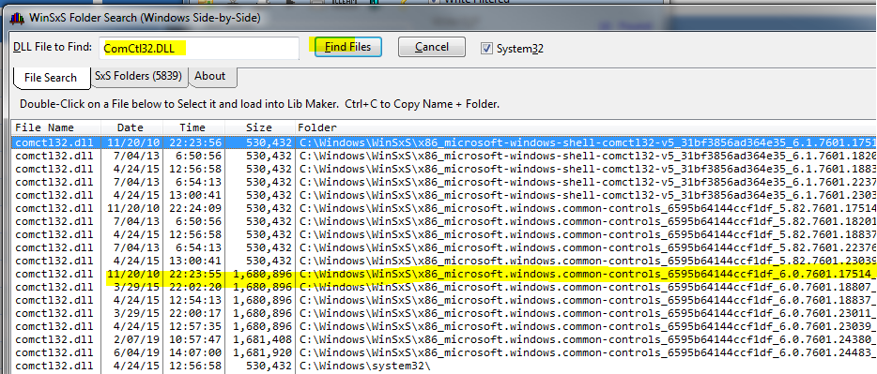

Then Subtract the ComCtl32.DLL from System32 and find there are 28 new symbols:

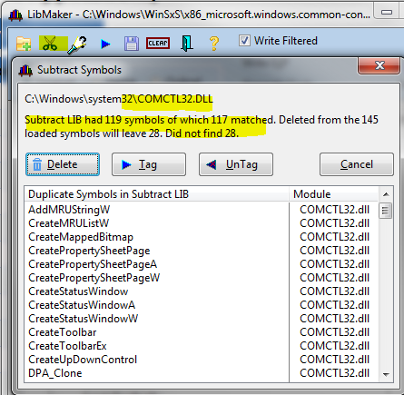

After Delete the 29 Symbols are just the new ones, e.g. you’ll see TaskDialog.

