PPT on Window Previewer

1. Checkbox in LIST using Style not Icons
   1. Same code as a Text “X” check
   2. Style uses Wingdings for “□☒☑” checks
   3. Class does not require Icons to ship
   4. Limited to one color per “icon”
   5. Check/Uncheck Code same as Icon
2. Wingdings for Check Boxes
   1. Example project includes list checks

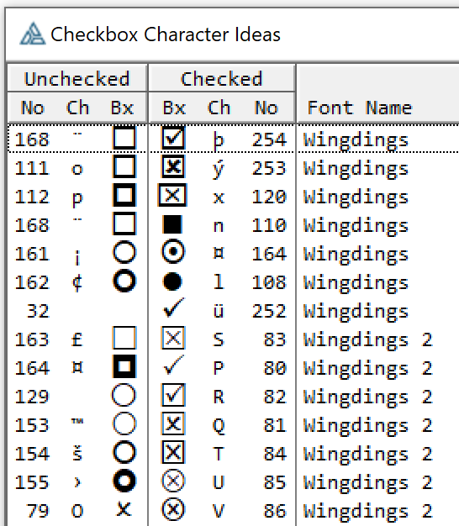 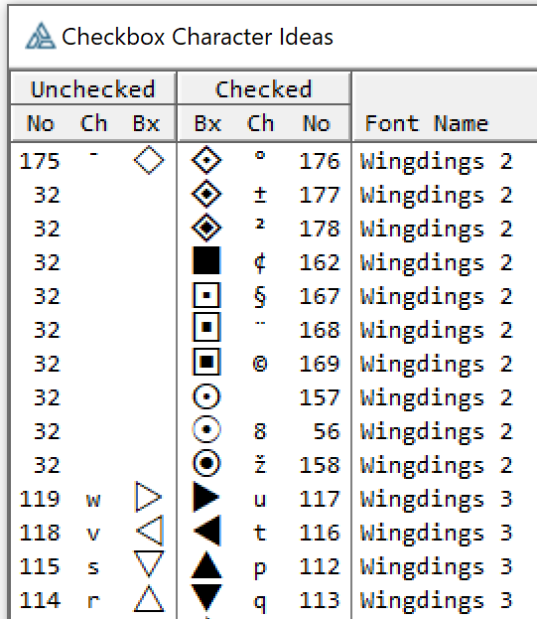

1. Method 1 – Column Style Z(#)
   1. Code just like a Text “X” check
   2. Wingding Font for Column
   3. Style Z(#) in Format not in Queue
   4. Limited to 1 Wingding Font and 1 Color
   5. Queue has STRING(1) with Check Character
   6. See Code
2. Method 2 – Cell Style Y
   1. Code similar to Icons
   2. Queue with STRING(1) and LONG Style
   3. Style Number is Checked Status and Symbol
   4. Multiple Fonts and Colors
   5. Style has Picture @PxP with Check Character “x”

|  |
| --- |
| **CheckFnt STRING**(**'Wingdings 2'**)  **Check0 STRING**(**'<163>'**) !I like these Wingding 2's for best looking  **Check1 STRING**(**'<83>'**)  **CheckQ QUEUE**,PRE(ChkQ)  **ChkBox STRING**(**1**) !ChkQ:ChkBox  **Name STRING**(**20**) !ChkQ:Name  **END**  **Window WINDOW**(**'Style Checkbox Z(1)'**),AT(,,**169**,**195**),GRAY,SYSTEM,FONT(**'Segoe UI'**,**9**)  **LIST**,USE(?ListCB),FROM(CheckQ),**FORMAT**(**'15C|~Tag~C@s1@Z(1)91L(2)|M~Name~@s32@'**)  ?ListCB{PROPSTYLE:FontName,**1**}=**'Wingdings 2'**  ?ListCB{PROPSTYLE:FontSize,**1**}=**12**  ?ListCB{PROPSTYLE:TextSelected,**1**} = COLOR:WindowText !COLOR:Black  ?ListCB{PROPSTYLE:BackSelected,**1**} = COLOR:Window !COLOR:White  !Setup so Selecting row does not change colors else they invert and will not appear correctly    **OF** EVENT:NewSelection !Checkbox toggle code  **IF** ?ListCB{PROPLIST:MouseDownField}=**1** |  **AND** ?ListCB{PROPLIST:MouseDownZone} = LISTZONE:field **THEN**  **GET**(CheckQ,**CHOICE**(?ListCB))  ChkQ:ChkBox = **CHOOSE**(ChkQ:ChkBox<>Check0,Check0,Check1)  **PUT**(CheckQ)  **END** |
| **CheckQ QUEUE**,PRE(ChkQ)  **CBChar STRING**(**1**) ! blank  **CBStyle LONG** ! 1=Unchecked 2=Checked  **Name STRING**(**20**)  **END**  **LIST**,USE(?ListCB),FROM(CheckQ),**FORMAT**(**'16C|Y~Tag~@s1@91L(2)|M~Name~@s32@50L(2)|M~**  **LOOP** SNo=**1 TO 2** !Config 2 Styles: 1=Checked, 2=UnChecked  ?ListCB{PROPSTYLE:Picture,SNo} =**CHOOSE**(SNo,**'@P'** & Check1 &**'P'**,**'@P'** & Check0 &**'P'**)  ?ListCB{PROPSTYLE:FontName,SNo} =**'Wingdings'**  ?ListCB{PROPSTYLE:FontSize,SNo} =**12**  ?ListCB{PROPSTYLE:TextColor,SNo} = **CHOOSE**(SNo,Color1,Color0)  ?ListCB{PROPSTYLE:BackColor,SNo} = COLOR:White  ?ListCB{PROPSTYLE:TextSelected,SNo} = **CHOOSE**(SNo,Color1,Color0)  ?ListCB{PROPSTYLE:BackSelected,SNo} = COLOR:White  **END**  **OF** EVENT:NewSelection  **IF** ?ListCB{PROPLIST:MouseDownField}=**1** |  **AND** ?ListCB{PROPLIST:MouseDownZone} = LISTZONE:field **THEN**  **GET**(CheckQ,**CHOICE**(?ListCB))  ChkQ:CBStyle = **3** - ChkQ:CBStyle  **PUT**(CheckQ)  **END**  **END** |
|  |
|  |
|  |
|  |
|  |