Parallel Remote Access Server Version 3.0 Documentation Script ReadMe

NOTE: This script requires PowerShell V3 or later.

Support for non-English Versions of Microsoft Word
The script supports the following languages:
- Catalan
- Chinese
- Danish
- Dutch
- English
- Finnish
- French
- German
- Norwegian
- Portuguese
- Spanish
- Swedish

What the Script Documents
The script documents the following items:

- Farm Settings
  - Site
    - Properties
- Site
  - RD Session Hosts
    - Hosts
      - General
      - User profile
      - Application Packages
      - Optimization
      - Desktop access
      - Settings
      - RDP printer
    - Host pools
      - General
      - Hosts
      - User profile
      - Application Packages
      - Desktop access
      - Settings
      - RDP printer
      - Auto-upgrade
    - Templates
      - General
      - Advanced
      - Preparation
      - Optimization
      - License Keys
      - Summary (Nothing here worth documenting)
    - Sessions (Nothing here worth documenting)
    - Scheduler
      - General
      - Trigger
      - Options
  - VDI
    - Host Pools
      - General
      - Members
      - Action
      - User profile
      - Application packages
      - Optimization
      - Settings
      - RDP printer
      - Security
      - Auto-upgrade
    - Templates
      - General
      - Advanced
      - Preparation
      - User profile
      - Optimization
      - License Keys
      - Settings
      - Security
      - Summary (Nothing here worth documenting)
    - Hosts (Not documented yet)
    - Sessions (Nothing here worth documenting)
    - Scheduler (Not documented yet)
  - Azure Virtual Desktops
    - Workspaces
      - General
    - Host pools
      - General
      - Hosts
      - Configuration
      - Template
      - Provisioning
      - Assignment
      - User profile
      - Application Packages
      - Settings
      - RDP printer
      - Auto-upgrade
      - AVD Agent
    - Templates
      - General
      - Hosts
      - Preparation
      - Optimization
    - Hosts
    - Sessions (Nothing here worth documenting)
    - Scheduler
  - Remote PCs (Not implemented in PoSH yet)
  - Providers
    - General
    - Credentials
    - Advanced
  - Secure Gateways
    - Secure Gateways
      - General
      - Mode
      - Network
      - SSL/TLS
      - User Portal
      - WYSE
      - Security
      - Web
    - Tunneling Policies (Not implemented in PoSH)
  - Connection Brokers
    - Connection Brokers
      - Properties
    - Auto-promotion
  - Enrollment Servers
    - Enrollment Servers
      - Properties
    - AD Integration
  - HALB
    - Virtual Servers
      - Properties
      - General
      - LB gateway payload
      - LB SSL payload
      - Device Manager (Not implemented in PoSH yet)
      - Devices
      - Advanced
    - Devices (Not fully implemented in PoSH yet)
  - Themes
    - General
    - Access
    - Messages
    - User Portal (Web client)
      - URLs
      - Branding
      - Colors
      - Language
      - Messages
      - Input prompt
      - Secure Gateway
      - Legal policies
    - Windows client
      - Branding
      - Messages
      - Custom menu
  - Certificates
    - Certificates
      - General
  - Application Packages
    - Application Packages
      - General
      - Certificate
  - Settings
    - Auditing (Not implemented in PoSH)
    - Global logging (Not implemented in PoSH yet)
    - URL redirection
    - Notifications
    - Client settings
    - Template Versions
    - Features
    - Application Packages
- Sessions (Nothing here worth documenting)
- Load Balancing
  - Load Balancing
  - CPU Optimization
- Publishing
- Type = Folder
  - Information
  - Folder
  - Filtering
  - Routing
- Type = PCDesktop
  - Information
  - Publish from
  - Desktop
  - Filtering
  - Routing
  - Shortcuts
- Type = RDSDesktop
  - Information
  - Publish from
  - Desktop
  - Filtering
  - Routing
  - Shortcuts
  - Type = VDIDesktop
  - Information
  - Sites
  - Publish from
  - Desktop
  - Filtering
  - Routing
  - Shortcuts
- Type = PCApp
  - Information
  - Publish from
  - Application
  - Filtering
  - Routing
  - Shortcuts
- Type = RDSApp
  - Information
  - Publish from
  - Application
  - Filtering
  - Routing
  - Shortcuts
  - File extensions
  - License
  - Display
  - Quick Keypad (Not documented)
  - Type = VDIApp
  - Information
  - Sites
  - Publish from
  - Application
  - Filtering
  - Routing
  - Shortcuts
- Type = AVDApp or WVDApp
  - Information
  - Publish from
  - Application
  - Filtering
  - Shortcuts
  - File extensions
  - License
  - Display
- Type = AVDDesktop or WVDDesktop
  - Information
  - Publish from
  - Desktop
  - Filtering
  - Shortcuts
- Type = LocalApp
  - Information
  - Application
  - Filtering
  - Shortcuts
- Quick Keypad (Not implemented in PoSH)
- Universal Printing
  - Universal Printing
  - Printer drivers
  - Fonts
- Universal Scanning
  - WIA
  - TWAIN
  - Connection
  - Authentication
  - Settings
  - Logon hours
  - Multi-factor authentication
    - Azure RADIUS
      - Connection
      - Attributes
      - Automation
    - Duo RADIUS
      - General (Not documented yet)
      - Connection
      - Attributes
      - Automation
      - Advanced (Not documented yet)
      - Restrictions (Not documented yet)
    - FortiAuthenticator RADIUS
      - Connection
      - Attributes
      - Automation
    - TekRADIUS
      - Connection
      - Attributes
      - Automation
    - RADIUS
      - General
      - Connection
      - Attributes
      - Automation
      - Advanced (Not documented yet)
      - Restrictions (Not documented yet)
    - Google Authenticator
      - General
      - Settings (Not documented yet)
      - User Enrollment (Not documented yet)
      - User management (Not documented yet)
      - Restrictions (Not documented yet)
    - Microsoft Authenticator (Not documented yet)
      - General
      - Settings
      - User Enrollment
      - User management
      - Restrictions
    - Other TOTP (Not documented yet)
      - General
      - Settings
      - User Enrollment
      - User Management
      - Restrictions
    - Email OTP (Not documented yet)
      - General
      - Settings
      - User Enrollment
      - User management
      - Restrictions
    - DeepNet DualShield
      - Connection
      - Application
      - Authentication
    - SafeNet
      - Connection
      - Authentication
  - SAML
    - Properties
    - General
    - IdP
    - SP
    - Attributes
  - Allowed devices
- Device Manager (Not implemented in PoSH)
  - Device Manager
  - Windows device groups
  - Options
  - Scheduler
- Policies
- Policy
  - Criteria
    - User, group, or computer
    - Gateway
    - Client device operating system
    - IP Address
    - Hardware ID
- Session
  - Session/Connection
    - Session/Connection/Primary connection
    - Session/Connection/Secondary connections
    - Session/Connection/Reconnection
    - Session/Connection/Computer name
    - Session/Connection/Advanced settings
    - Session/Connection/Web authentication
    - Session/Connection/Multifactor authentication
    - Session/Connection/Session prelaunch
    - Session/Connection/Local proxy address
  - Session/Display
    - Session/Display/Settings
    - Session/Display/Multi-monitor
    - Session/Display/Published applications
    - Session/Display/Desktop options
    - Session/Display/Browser
  - Session/Printing
  - Session/Scanning
  - Session/Audio
  - Session/Keyboard
  - Session/Local devices and resources
    - Session/Local devices and resources/Clipboard
    - Session/Local devices and resources/Disk drives and folders
    - Session/Local devices and resources/Devices
    - Session/Local devices and resources/Video capture devices
    - Session/Local devices and resources/Ports
    - Session/Local devices and resources/Smart cards
    - Session/Local devices and resources/Pen and touch input
    - Session/Local devices and resources/Multimedia redirection for AVD
    - Session/Local devices and resources/File transfer
  - Session/Experience
    - Session/Experience/Performance
    - Session/Experience/Compression
  - Session/Network
  - Session/Server authentication
  - Session/Advanced settings
- Client options
  - Client options/Appearance
  - Client options/Connection
  - Client options/Logging
  - Client options/Update
  - Client options/PC keyboard
  - Client options/Single Sign-On
  - Client options/Advanced
    - Client options/Advanced/Global
    - Client options/Advanced/Language
    - Client options/Advanced/Printing
    - Client options/Advanced/Windows client
    - Client options/Advanced/RemoteFX USB redirection
    - Client options/Advanced/Customer Experience Program
- Control settings
  - Control settings/Connections
  - Control settings/Credentials
  - Control settings/Import and export
- Redirection
- Administration
  - Accounts
    - Account Properties
  - Features
  - Settings
  - Mailbox
  - Reporting
  - Audit (Nothing here worth documenting)
  - Chat history (Nothing here worth documenting)
- Information (Nothing here worth documenting)
- Monitoring (Nothing here worth documenting)
- Reporting (Nothing here worth documenting)
- License
  - License details

Prerequisites
Before using PowerShell to document anything in the Remote Application Server (RAS), ensure we have the requirements.
- At least one Windows Server is running a fully configured Parallels RAS server.
- Select the Server or Desktop OS computer/VM for running this script.
- Install the RAS PowerShell module.
- Download the RAS installer from https://www.parallels.com/products/ras/download/links/, as shown in Figure 1.
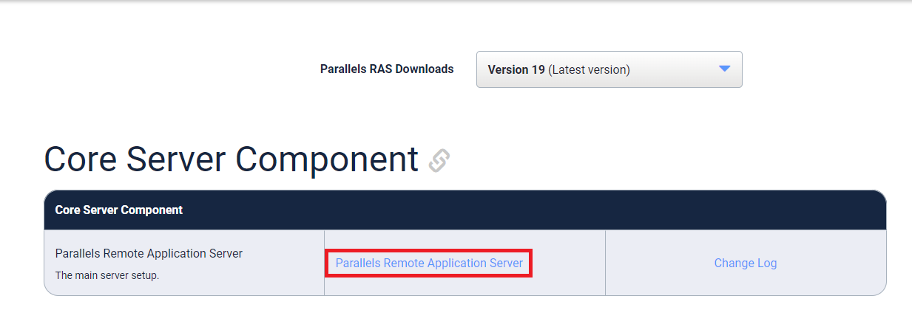
Figure 1
- There are two ways to install just the PowerShell module.
  - Run RASInstaller-x.y.z.msi, where x.y.z is the download's version number.
    - In the Install Wizard, deselect every option except Parallels RAS PowerShell, as shown in Figure 2.
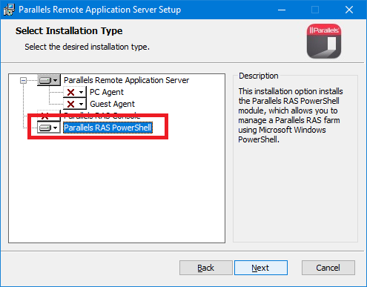
Figure 2
  - Open an elevated command prompt.
    - Change to the folder containing the RAS installer.
    - As shown in Figure 3, type in the following command: msiexec /i RASInstaller-x.y.z.msi /qn ADDLOCAL=F_PowerShell where x.y.z is the download's version number. Note: The installation takes only a few seconds.
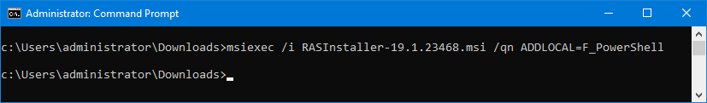
Figure 3
- The installation is verified by opening Control Panel/Programs and Features, as shown in Figure 4.
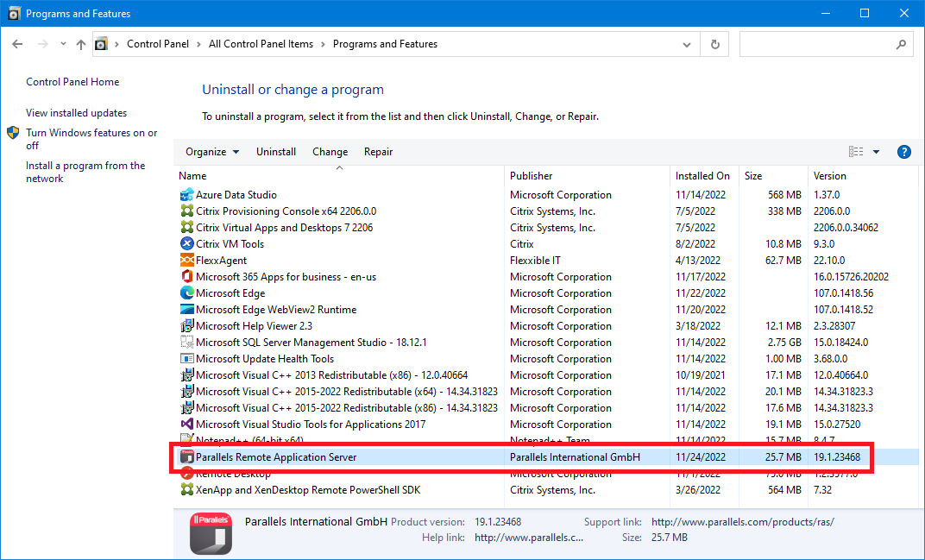
Figure 4

I developed the script using RAS 19.1.22368, 19.2.23906, and 19.2.23975 on Windows 10 22H2 and Word 365.

Script Usage
How to use this script?
- Save the script as RAS_Inventory_V4_0.ps1 in your PowerShell scripts folder.
- From the PowerShell prompt, change to your PowerShell scripts folder.
- From the PowerShell prompt, type in:
  - .\RAS_Inventory_V4_0.ps1 and press Enter.
- By default, the script creates an HTML file named Parallels_RAS.html.
- If you use the –PDF option, the script creates a PDF file named Parallels_RAS.PDF.
- If you use the –MSWord option, the script creates a Word document named Parallels_RAS.docx.
- If you use the –Text option, the script creates a text file named Parallels_RAS.txt.

Full help text is available.

Get-Help .\RAS_Inventory_V4_0.ps1 –full

The help text explains all the parameters the script accepts.

Help Text

NAME
C:\PSScripts\RAS_Inventory_V4_0.ps1

SYNOPSIS
Creates a complete inventory of a V19.3/4, 20, or 21 Parallels Remote Application Server.

SYNTAX
C:\PSScripts\RAS_Inventory_V4_0.ps1 [-ServerName <String>] [-User <String>] [-RASSite
<String>] [-HTML] [-Text] [-Folder <String>] [-Section <String[]>] [-AddDateTime]
[-Dev] [-Log] [-ScriptInfo] [-ReportFooter] [-MSWord] [-PDF] [-CompanyAddress
<String>] [-CompanyEmail <String>] [-CompanyFax <String>] [-CompanyName <String>]
[-CompanyPhone <String>] [-CoverPage <String>] [-UserName <String>] [-SmtpPort
<Int32>] [-SmtpServer <String>] [-From <String>] [-To <String>] [-UseSSL]
[<CommonParameters>]

DESCRIPTION
Creates a complete inventory of a V19.3/4, 20, or 21 Parallels Remote Application Server
(RAS) using Microsoft PowerShell, Word, plain text, or HTML.

The script requires at least PowerShell version 3, but runs best in version 5.

The Word application is not required to run the script. This script outputs in both Text and HTML formats.

The default output format is HTML.

Creates an output file named Parallels_RAS.<fileextension>.

You do NOT have to run this script on a server running RAS. This script was developed
and run from a Windows 11 VM.

Word and PDF documents include a Cover Page, Table of Contents, and Footer.
Includes support for the following language versions of Microsoft Word:
Catalan
Chinese
Danish
Dutch
English
Finnish
French
German
Norwegian
Portuguese
Spanish
Swedish

PARAMETERS
-ServerName <String>
Specifies which RAS server to use to run the script against.

ServerName can be entered as the NetBIOS name, FQDN, localhost, or IP Address.

If entered as localhost, the actual computer name is determined and used.

If entered as an IP address, an attempt is made to determine and use the actual
computer name.

Default value is LocalHost

Required? false
Position? named
Default value LocalHost
Accept pipeline input? false
Accept wildcard characters? false

-User <String>
Username to use for the connection to the RAS server.

Default value is contained in $env:username

Required? false
Position? named
Default value $env:username
Accept pipeline input? false
Accept wildcard characters? false

-RASSite <String>
Limit report to one RAS Site.

Default value is all RAS Sites in the RAS Farm.

Required? false
Position? named
Default value All
Accept pipeline input? false
Accept wildcard characters? false

-HTML [<SwitchParameter>]
Creates an HTML file with an .html extension.

HTML is now the default report format.

This parameter is set True if no other output format is selected.

Required? false
Position? named
Default value False
Accept pipeline input? false
Accept wildcard characters? false

-Text [<SwitchParameter>]
Creates a formatted text file with a .txt extension.

This parameter is disabled by default.

Required? false
Position? named
Default value False
Accept pipeline input? false
Accept wildcard characters? false

-Folder <String>
Specifies the optional output folder to save the output report.

Required? false
Position? named
Default value
Accept pipeline input? false
Accept wildcard characters? false

-Section <String[]>
Processes one or more sections of the report.
Valid options are:
Site
LB (LoadBalancing)
Publishing
Printing (Universal Printing)
Scanning (Universal Scanning)
Connection
Policies
Admin (Administration)
Licensing
All

This parameter defaults to All sections.

A comma separates multiple sections. -Section admin, licensing

Required? false
Position? named
Default value All
Accept pipeline input? false
Accept wildcard characters? false

-AddDateTime [<SwitchParameter>]
Adds a date timestamp to the end of the file name.

The timestamp is in the format of yyyy-MM-dd_HHmm.
June 1, 2026 at 6PM is 2026-06-01_1800.

Output filename will be ReportName_2026-06-01_1800.<ext>.

This parameter is disabled by default.
This parameter has an alias of ADT.

Required? false
Position? named
Default value False
Accept pipeline input? false
Accept wildcard characters? false

-Dev [<SwitchParameter>]
Clears errors at the beginning of the script.
Outputs all errors to a text file at the end of the script.

This is used when the script developer requests more troubleshooting data.
The text file is placed in the same folder from where the script is run.

This parameter is disabled by default.

Required? false
Position? named
Default value False
Accept pipeline input? false
Accept wildcard characters? false

-Log [<SwitchParameter>]
Generates a log file for troubleshooting.

Required? false
Position? named
Default value False
Accept pipeline input? false
Accept wildcard characters? false

-ScriptInfo [<SwitchParameter>]
Outputs information about the script to a text file.
The text file is placed in the same folder from where the script is run.

This parameter is disabled by default.
This parameter has an alias of SI.

Required? false
Position? named
Default value False
Accept pipeline input? false
Accept wildcard characters? false

-ReportFooter [<SwitchParameter>]
Outputs a footer section at the end of the report.

This parameter has an alias of RF.

Report Footer
Report information:
Created with: <Script Name> - Release Date: <Script Release Date>
Script version: <Script Version>
Started on <Date Time in Local Format>
Elapsed time: nn days, nn hours, nn minutes, nn.nn seconds
Ran from domain <Domain Name> by user <Username>
Ran from the folder <Folder Name>

Script Name and Script Release date are script-specific variables.
Start Date Time in Local Format is a script variable.
Elapsed time is a calculated value.
Domain Name is $env:USERDNSDOMAIN.
Username is $env:USERNAME.
Folder Name is a script variable.

Required? false
Position? named
Default value False
Accept pipeline input? false
Accept wildcard characters? false

-MSWord [<SwitchParameter>]
SaveAs DOCX file

Microsoft Word is no longer the default report format.
This parameter is disabled by default.

Required? false
Position? named
Default value False
Accept pipeline input? false
Accept wildcard characters? false

-PDF [<SwitchParameter>]
SaveAs PDF file instead of DOCX file.

The PDF file is roughly 5 to 10 times larger than the DOCX file.

This parameter requires Microsoft Word to be installed.
This parameter uses Word's SaveAs PDF capability.

This parameter is disabled by default.

Required? false
Position? named
Default value False
Accept pipeline input? false
Accept wildcard characters? false

-CompanyAddress <String>
Company Address to use for the Cover Page if the Cover Page has the Address field.

The following Cover Pages have an Address field:
Banded (Word 2013/2016)
Contrast (Word 2010)
Exposure (Word 2010)
Filigree (Word 2013/2016)
Ion (Dark) (Word 2013/2016)
Retrospect (Word 2013/2016)
Semaphore (Word 2013/2016)
Tiles (Word 2010)
ViewMaster (Word 2013/2016)

This parameter is only valid with the MSWORD and PDF output parameters.
This parameter has an alias of CA.

Required? false
Position? named
Default value
Accept pipeline input? false
Accept wildcard characters? false

-CompanyEmail <String>
Company Email to use for the Cover Page if the Cover Page has the Email field.

The following Cover Pages have an Email field:
Facet (Word 2013/2016)

This parameter is only valid with the MSWORD and PDF output parameters.
This parameter has an alias of CE.

Required? false
Position? named
Default value
Accept pipeline input? false
Accept wildcard characters? false

-CompanyFax <String>
Company Fax to use for the Cover Page if the Cover Page has the Fax field.

The following Cover Pages have a Fax field:
Contrast (Word 2010)
Exposure (Word 2010)

This parameter is only valid with the MSWORD and PDF output parameters.
This parameter has an alias of CF.

Required? false
Position? named
Default value
Accept pipeline input? false
Accept wildcard characters? false

-CompanyName <String>
Company Name to use for the Cover Page.
The default value is contained in
HKCU:\Software\Microsoft\Office\Common\UserInfo\CompanyName or
HKCU:\Software\Microsoft\Office\Common\UserInfo\Company, whichever is populated
on the computer running the script.

This parameter is only valid with the MSWORD and PDF output parameters.
This parameter has an alias of CN.

Required? false
Position? named
Default value
Accept pipeline input? false
Accept wildcard characters? false

-CompanyPhone <String>
Company Phone to use for the Cover Page if the Cover Page has the Phone field.

The following Cover Pages have a Phone field:
Contrast (Word 2010)
Exposure (Word 2010)

This parameter is only valid with the MSWORD and PDF output parameters.
This parameter has an alias of CPh.

Required? false
Position? named
Default value
Accept pipeline input? false
Accept wildcard characters? false

-CoverPage <String>
What Microsoft Word Cover Page to use.
Only Word 2010, 2013, and 2016 are supported.
(default cover pages in Word en-US)

Valid input is:
Alphabet (Word 2010. Works)
Annual (Word 2010. Doesn't work well for this report)
Austere (Word 2010. Works)
Austin (Word 2010/2013/2016. Doesn't work in 2013 or 2016, mostly
works in 2010, but Subtitle/Subject & Author fields need moving
after the title box is moved up)
Banded (Word 2013/2016. Works)
Conservative (Word 2010. Works)
Contrast (Word 2010. Works)
Cubicles (Word 2010. Works)
Exposure (Word 2010. Works if you like looking sideways)
Facet (Word 2013/2016. Works)
Filigree (Word 2013/2016. Works)
Grid (Word 2010/2013/2016. Works in 2010)
Integral (Word 2013/2016. Works)
Ion (Dark) (Word 2013/2016. Top date doesn't fit; box needs to be
manually resized or font changed to 8 point)
Ion (Light) (Word 2013/2016. Top date doesn't fit; box needs to be
manually resized or font changed to 8 point)
Mod (Word 2010. Works)
Motion (Word 2010/2013/2016. Works if the top date is manually changed to
36 point)
Newsprint (Word 2010. Works but the date is not populated)
Perspective (Word 2010. Works)
Pinstripes (Word 2010. Works)
Puzzle (Word 2010. Top date doesn't fit; box needs to be manually
resized or font changed to 14 point)
Retrospect (Word 2013/2016. Works)
Semaphore (Word 2013/2016. Works)
Sideline (Word 2010/2013/2016. Doesn't work in 2013 or 2016. Works in
2010)
Slice (Dark) (Word 2013/2016. Doesn't work)
Slice (Light) (Word 2013/2016. Doesn't work)
Stacks (Word 2010. Works)
Tiles (Word 2010. Date doesn't fit unless changed to 26 point)
Transcend (Word 2010. Works)
ViewMaster (Word 2013/2016. Works)
Whisp (Word 2013/2016. Works)

The default value is Sideline.
This parameter has an alias of CP.
This parameter is only valid with the MSWORD and PDF output parameters.

Required? false
Position? named
Default value Sideline
Accept pipeline input? false
Accept wildcard characters? false

-UserName <String>
Username to use for the Cover Page and Footer.
The default value is contained in $env:username
This parameter has an alias of UN.
This parameter is only valid with the MSWORD and PDF output parameters.

Required? false
Position? named
Default value $env:username
Accept pipeline input? false
Accept wildcard characters? false

-SmtpPort <Int32>
Specifies the SMTP port for the SmtpServer.
The default is 25.

Required? false
Position? named
Default value 25
Accept pipeline input? false
Accept wildcard characters? false

-SmtpServer <String>
Specifies the optional email server to send the output report(s).

If From or To are used, this is a required parameter.

Required? false
Position? named
Default value
Accept pipeline input? false
Accept wildcard characters? false

-From <String>
Specifies the username for the From email address.

If SmtpServer or To are used, this is a required parameter.

Required? false
Position? named
Default value
Accept pipeline input? false
Accept wildcard characters? false

-To <String>
Specifies the username for the To email address.

If SmtpServer or From are used, this is a required parameter.

Required? false
Position? named
Default value
Accept pipeline input? false
Accept wildcard characters? false

-UseSSL [<SwitchParameter>]
Specifies whether to use SSL for the SmtpServer.
The default is False.

Required? false
Position? named
Default value False
Accept pipeline input? false
Accept wildcard characters? false

<CommonParameters>
This cmdlet supports the common parameters: Verbose, Debug,
ErrorAction, ErrorVariable, WarningAction, WarningVariable,
OutBuffer, PipelineVariable, and OutVariable. For more information, see
about_CommonParameters (https:/go.microsoft.com/fwlink/?LinkID=113216).

INPUTS
None. You cannot pipe objects to this script.

OUTPUTS
No objects are output from this script. This script creates a Word, PDF, HTML, or plain
text document.

NOTES

NAME: RAS_Inventory_V4_0.ps1
VERSION: 4.00 Beta 39
AUTHOR: Carl Webster
LASTEDIT: January 6, 2026

-------------------------- EXAMPLE 1 --------------------------

PS C:\PSScript >.\RAS_Inventory_V4_0.ps1

Outputs, by default, to HTML.
Prompts for credentials for the LocalHost RAS Server.

-------------------------- EXAMPLE 2 --------------------------

PS C:\PSScript >.\RAS_Inventory_V4_0.ps1 -RASSite EMEASite

Includes only data for the EMEASite.
Outputs, by default, to HTML.
Prompts for credentials for the LocalHost RAS Server.

-------------------------- EXAMPLE 3 --------------------------

PS C:\>PS C:\PSScript .\RAS_Inventory_V4_0.ps1 -MSWord -CompanyName "Carl Webster
Consulting" -CoverPage "Mod" -UserName "Carl Webster" -ComputerName RAS01

Will use:
Carl Webster Consulting for the Company Name.
Mod for the Cover Page format.
Carl Webster for the User Name.
RAS server named RAS01 for the ComputerName.

Outputs to Microsoft Word.
Prompts for credentials for the RAS Server RAS01.

-------------------------- EXAMPLE 4 --------------------------

PS C:\>PS C:\PSScript .\RAS_Inventory_V4_0.ps1 -PDF -CN "Carl Webster Consulting" -CP
"Mod" -UN "Carl Webster"

Will use:
Carl Webster Consulting for the Company Name (alias CN).
Mod for the Cover Page format (alias CP).
Carl Webster for the User Name (alias UN).

Outputs to PDF.
Prompts for credentials for the LocalHost RAS Server.

-------------------------- EXAMPLE 5 --------------------------

PS C:\>PS C:\PSScript .\RAS_Inventory_V4_0.ps1 -CompanyName "Sherlock Holmes
Consulting" -CoverPage Exposure -UserName "Dr. Watson" -CompanyAddress "221B Baker
Street, London, England" -CompanyFax "+44 1753 276600" -CompanyPhone "+44 1753 276200"
-MSWord

Will use:
Sherlock Holmes Consulting for the Company Name.
Exposure for the Cover Page format.
Dr. Watson for the User Name.
221B Baker Street, London, England for the Company Address.
+44 1753 276600 for the Company Fax.
+44 1753 276200 for the Company Phone.

Outputs to Microsoft Word.
Prompts for credentials for the LocalHost RAS Server.

-------------------------- EXAMPLE 6 --------------------------

PS C:\>PS C:\PSScript .\RAS_Inventory_V4_0.ps1 -CompanyName "Sherlock Holmes
Consulting" -CoverPage Facet -UserName "Dr. Watson" -CompanyEmail
SuperSleuth@SherlockHolmes.com
-PDF

Will use:
Sherlock Holmes Consulting for the Company Name.
Facet for the Cover Page format.
Dr. Watson for the User Name.
SuperSleuth@SherlockHolmes.com for the Company Email.

Outputs to PDF.
Prompts for credentials for the LocalHost RAS Server.

-------------------------- EXAMPLE 7 --------------------------

PS C:\PSScript >.\RAS_Inventory_V4_0.ps1 -Dev -ScriptInfo -Log

Creates an HTML report.

Creates a text file named RASInventoryScriptErrors_yyyyMMddTHHmmssffff.txt that
contains up to the last 250 errors reported by the script.

Creates a text file named RASInventoryScriptInfo_yyyy-MM-dd_HHmm.txt that
contains all the script parameters and other basic information.

Creates a text file for transcript logging named
RASDocScriptTranscript_yyyyMMddTHHmmssffff.txt.

-------------------------- EXAMPLE 8 --------------------------

PS C:\PSScript >.\RAS_Inventory_V4_0.ps1 -Section Policies

Creates an HTML report that contains only policy information.
Processes only the Policies section of the report.

-------------------------- EXAMPLE 9 --------------------------

PS C:\PSScript >.\RAS_Inventory_V4_0.ps1 -Section Admin, Licensing

Creates an HTML report.

The report includes only the Administration and Licensing sections.

-------------------------- EXAMPLE 10 --------------------------

PS C:\PSScript >.\RAS_Inventory_V4_0.ps1 -SmtpServer mail.domain.tld -From
RASAdmin@domain.tld -To ITGroup@domain.tld -Text

The script uses the email server mail.domain.tld, sending from RASAdmin@domain.tld
and sending to ITGroup@domain.tld.

The script uses the default SMTP port 25 and does not use SSL.

If the current user's credentials are not valid to send an email, the script prompts
the user to enter valid credentials.

Outputs to a text file.
Prompts for credentials for the LocalHost RAS Server.

-------------------------- EXAMPLE 11 --------------------------

PS C:\PSScript >.\RAS_Inventory_V4_0.ps1 -SmtpServer mailrelay.domain.tld -From
Anonymous@domain.tld -To ITGroup@domain.tld

***SENDING UNAUTHENTICATED EMAIL***

The script uses the email server mailrelay.domain.tld, sending from
anonymous@domain.tld and sending to ITGroup@domain.tld.

To send an unauthenticated email using an email relay server requires the From email
account to use the name Anonymous.

The script uses the default SMTP port 25 and does not use SSL.

***GMAIL/G SUITE SMTP RELAY***
https://support.google.com/a/answer/2956491?hl=en
https://support.google.com/a/answer/176600?hl=en

To send an email using a Gmail or g-suite account, you may have to turn ON the "Less
secure app access" option on your account.
***GMAIL/G SUITE SMTP RELAY***

The script generates an anonymous, secure password for the anonymous@domain.tld
account.

Outputs, by default, to HTML.
Prompts for credentials for the LocalHost RAS Server.

-------------------------- EXAMPLE 12 --------------------------

PS C:\PSScript >.\RAS_Inventory_V4_0.ps1 -SmtpServer
labaddomain-com.mail.protection.outlook.com -UseSSL -From
SomeEmailAddress@labaddomain.com -To ITGroupDL@labaddomain.com

***OFFICE 365 Example***

https://docs.microsoft.com/en-us/exchange/mail-flow-best-practices/how-to-set-up-a-multifunction-device-or-application-to-send-email-using-office-3

This uses Option 2 from the above link.

***OFFICE 365 Example***

The script uses the email server labaddomain-com.mail.protection.outlook.com, sending
from SomeEmailAddress@labaddomain.com and sending to ITGroupDL@labaddomain.com.

The script uses the default SMTP port 25 and SSL.

Outputs, by default, to HTML.
Prompts for credentials for the LocalHost RAS Server.

-------------------------- EXAMPLE 13 --------------------------

PS C:\PSScript >.\RAS_Inventory_V4_0.ps1 -SmtpServer smtp.office365.com -SmtpPort 587
-UseSSL -From Webster@CarlWebster.com -To ITGroup@CarlWebster.com

The script uses the email server smtp.office365.com on port 587 using SSL, sending from
webster@carlwebster.com and sending to ITGroup@carlwebster.com.

If the current user's credentials are not valid to send an email, the script prompts
the user to enter valid credentials.

Outputs, by default, to HTML.
Prompts for credentials for the LocalHost RAS Server.

-------------------------- EXAMPLE 14 --------------------------

PS C:\PSScript >.\RAS_Inventory_V4_0.ps1 -SmtpServer smtp.gmail.com -SmtpPort 587
-UseSSL -From Webster@CarlWebster.com -To ITGroup@CarlWebster.com

*** NOTE ***
To send an email using a Gmail or g-suite account, you may have to turn ON the "Less
secure app access" option on your account.
*** NOTE ***

The script uses the email server smtp.gmail.com on port 587 using SSL, sending from
webster@gmail.com and sending to ITGroup@carlwebster.com.

If the current user's credentials are not valid to send an email, the script prompts
the user to enter valid credentials.

Outputs, by default, to HTML.
Prompts for credentials for the LocalHost RAS Server.

RELATED LINKS

