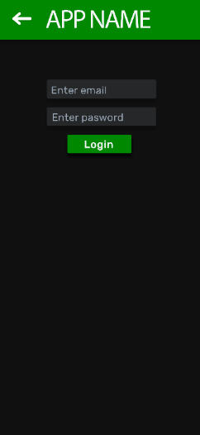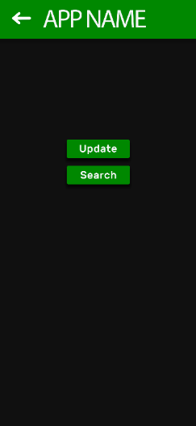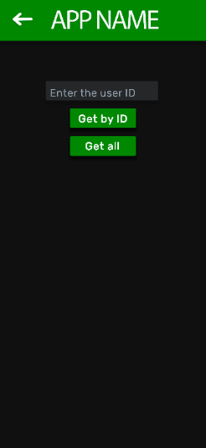

Logo is a scroll (just in case)

Green bar is a navbar

Font type:

* //Font word “APP”: Rubik Bold, 148 pt
* Enter text: Roboto Regular, 58 pt
* Buttons text: Roboto Bold, 60 pt (contained button)

Distances:

* Margins from grey squares to edges: 252 px
* Margin text-grey squares: 27 px
* Distance between all squares (buttons and input text): 46 px
* “APP”/logo and all the squares are centered
* Green square: 200 px
* Button squares: 360 x 106 px
* Text input squares: 615 x 106 px
* “Register” and “Login” are centered

Radius and stuff:

* Radius of every square: 8 px

Colors (RGB):

* Green: (0, 135, 0)
* Black/Dark grey: (23, 23, 23)
* Grey: (42, 43, 44)
* Input text: (153, 162, 175)
* Buttons: (255, 255, 255)

Animations and etc:

* While waiting the logo has a white brightness
* When the user enters the datum the previous words (name, surname, password, email, pone) dissapear to introduce the new text.

1. Start/Charging screen. The logo centered
2. Register or login. If you don’t register/identify you can’t acces to anything.
3. Login.
4. Update or search. Once you are registered/identified you can update/change your datum or search someone.
5. Search by ID or get all. You can search someone if you know its ID or get a listo f all the users. // Instead of asking if get all or search by ID, show all and give the option to write the ID and search automatically, like whatsapp.