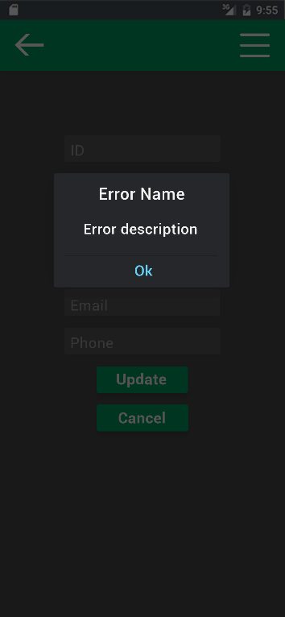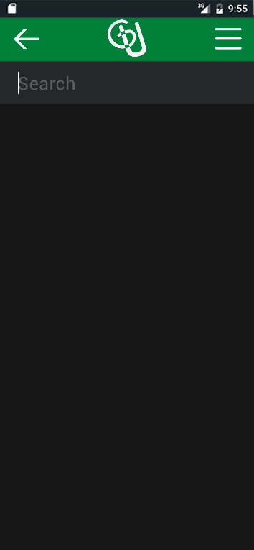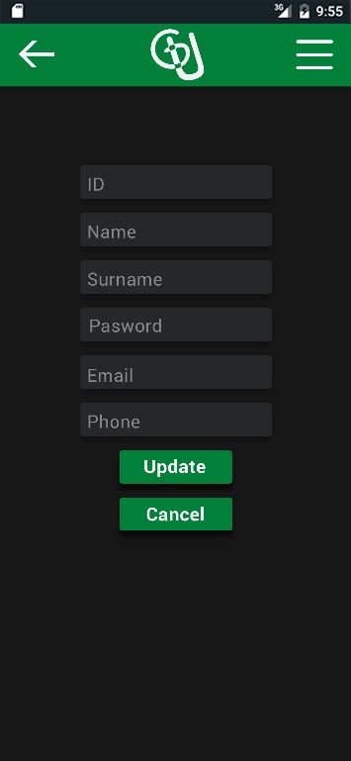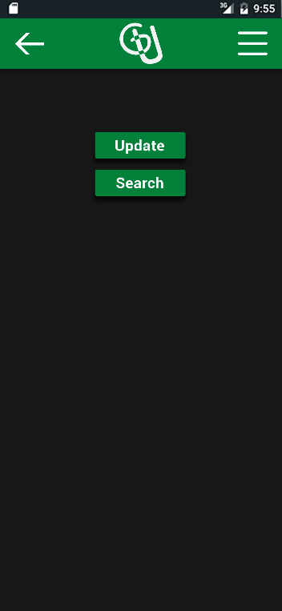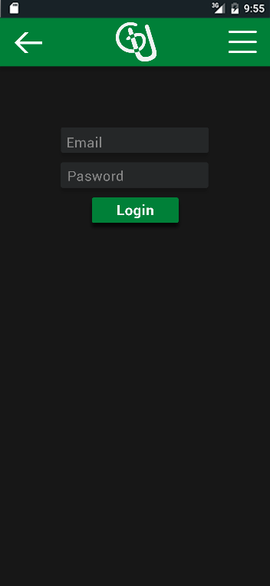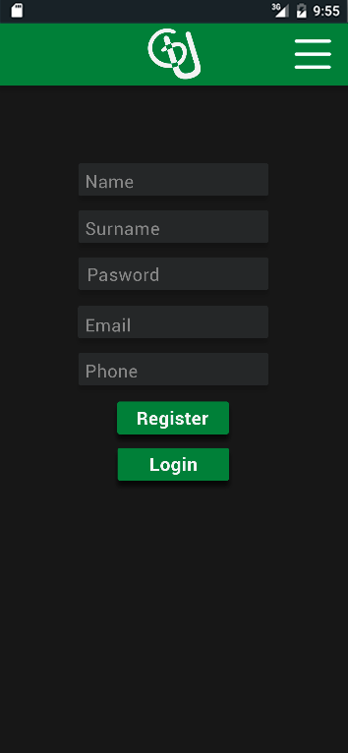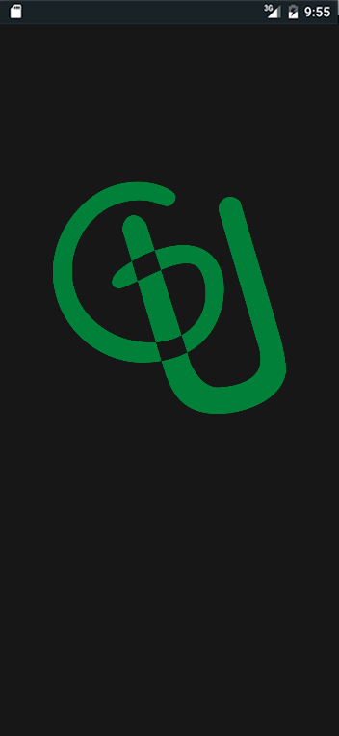

Sizes: width x height (unit)

Logo is a scroll (just in case)

Green bar is a navbar

Font type:

* Enter text: Roboto Regular, 58 pt
* Buttons text: Roboto Bold, 60 pt
* Error advice: Roboto Medium,

Distances:

* Margins from grey squares to edges: 252 px
* Margin from text (inside) to grey squares: 27 px
* Distance between all squares (buttons and input text): 46 px
* Logo and all the squares are centered
* Green square: 200 px
* Button squares: 360 x 106 px
* Text input squares (grey): 615 x 106 px

Back arrow:

* Horizontally centered in the Navbar (62 px up and down).
* Left margin: 60 px

Hamburguer button:

* Horizontally centered in the navbar (54 px)
* Right margin: 60 px

Radius and stuff:

* Radius of every square (except navbar): 8 px

Colors (RGB):

* Green: (19, 127, 63)
* Black/Dark grey: (29, 29, 29)
* Grey: (42, 43, 44)
* Input text (example: name, surname, phone, email: (134, 134, 134)
* Buttons text: (255, 255, 255)

Animations and etc:

* While waiting the logo has a white brightness at the edges
* When the user enters the datum, the previous words (ex: name, surname, password, email, pone) dissapear to introduce the new text.
* To search, the white stick flicks and when the text is introduced the word “Search” dissapears.
* The backgruond dims when the error appears.

1. **Start/Charging screen**.

* The logo centered

1. **Register or login**. If you don’t register/identify you can’t acces to anything.

* “Register” and “Login” are centered

1. **Login**.
2. **Update or search**. Once you are registered/identified you can update/change your datum or search someone.
3. **Update**
4. **Search by ID or get all**. You can search someone if you know its ID or get a listo f all the users. //
5. Instead of asking if get all or search by ID, show all and give the option to write the ID and search automatically, like whatsapp.

* Grey bar: 1125 x 190 px
* Vertical stick: White (255, 255, 255), 3 x 100

1. **Error for any screen**.

* Distance from the top of the error square to the highest letter: 58 px
* Distance from “Error Name” to error description: 92 px
* “Error Name”: White (255, 255, 255), Roboto Regular, 65 pt
* “Error description”: White (255, 255, 255), Roboto Medium, 58 pt
* “Ok”: Blue (144, 211, 245), Roboto Medium, 58 pt
* Same radius (8 px)
* “Error square”: Grey (42, 43, 46), 695 x 450 px