**BENEFIT FUNCTIONS**

**Omni-directional Services**

We assume that the rate of production of a potential ecosystem service, *Pi*, at a supply node is

,

where *Ai* is the area of focal node *i*, α ≥ 0 is the rate of production of the potential ecosystem service per unit area for a single, completely isolated, supply node, β ≥ 0 is amount that rate of production of the potential ecosystem service increases per unit area of supply nodes that the focal node is connected to (i.e., the effect of connectivity on ecosystem service production), *Iij* is an indicator where *Iij* = 1 if there is an ecological-ecological link between supply node *i* and supply node *j* and *Iij* = 0 otherwise, and **S** is the set of all supply nodes.

We then assume that the aggregate utility of the use of the potential ecosystem services produced at supply nodes depends on the social-ecological connections between supply and demand nodes and whether the service is rival or non-rival.

In the non-rival case, the aggregate utility at a demand node, *Ui*, is assumed to be

,

where λ > 0 is the utility per unit of ecosystem service utilised and η > 0 is the density of beneficiaries per unit area. Here we assume that the number of people benefiting is proportional to area, each beneficiary at a demand node utilise all the potential services produced at the supply nodes they are connected to, and that utility is a linear function of the rate at which the service is utilised. Note, that we could consider a non-linear utility function rather than the linear utility function in Eq. 2, but for simplicity we assume a linear function here. Not also that η could be node specific, but for simplicity we assume that each demand node has the same density of beneficiaries.

In the rival case, beneficiaries share ecosystem service benefits and we assume that these are shared in proportion to the number of beneficiaries in each demand node. In this case, the utility is

,

where **D** is the set of all demand nodes. In this case, the summation on the right hand side ensures that ecosystem services are allocated proportional to the number of beneficiaries in each demand node. Note again that η could be node specific.

**PREVIOUS STUFF BY RALF AT THE FIRST WORKSHOP – THE ABOVE IS A SPECIAL CASE OF THE BELOW**

Supply

The overall supply in a node I is given by the overall area of the cell and possible other site characteristics (such as land use intensity, habit suitability) as well as service supply through the connectedness of adjacent nodes.

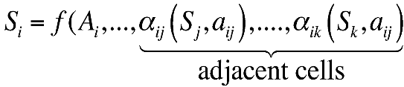

Examples: Consider *S* is be species richness, depending on the area A. A network of more habitat might bring other species in, but these could be the same species, which https://lh5.googleusercontent.com/VMWrOiJw3hBvFOrz20ySvonTvETwYbiQspdd64VGzHSHHa_CHfMlTFuFM2q7nt-Mjpe4kT349ptpjo3pjjoAwa-HmEk0hROqr5UOec3wQRJGAPEdeHRuZ6thu-mOdaCZJZKQA9GN has to correct for.

https://lh5.googleusercontent.com/VMWrOiJw3hBvFOrz20ySvonTvETwYbiQspdd64VGzHSHHa_CHfMlTFuFM2q7nt-Mjpe4kT349ptpjo3pjjoAwa-HmEk0hROqr5UOec3wQRJGAPEdeHRuZ6thu-mOdaCZJZKQA9GNdenotes the (material) flow of a service, while *aij* denote the strength of the link.

Demand

Similarly we define demand in a node *i* by

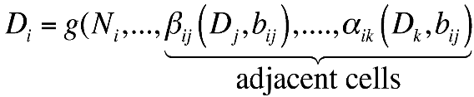

Demand might be mostly driven by population *N* but can change given communication with nodes either increasing or diminishing demands.

**Benefit**

Benefit *Bi* generated in a node is given by a utility function *h*, which relates demand *D* in a node with available resources.

The latter is calculated by the total resources available through the links to adjacent nodes corrected for certain conflict due to other demanding nodes taking away resources. All this is captured by the function https://lh5.googleusercontent.com/35gd3KW6M2Upz0veKG5rAHsuBJIYaZ2PaPq9iQF-QOd5aqZ1NT2BukRb1K9gxP6X1qP4BzAElgoQb8iX_8hrHEYPKY2yh_zm1gmk9lbk3mluMBDMO-XnsNpDjQof1INxft1s-Czj

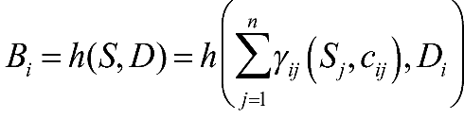

In case of non-rival resources, possible conflicting uses can be ignored. If *S* denotes the supply of a rival service we either follow a simple approach and correcting the flow from all *Sj* to *Si* just estimating the fraction of resources available giving the number of other conflicting demands

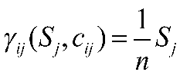 where *n* is the number of demanding nodes. The more precise estimation however, results from the exact estimation how much resource are taken from that node, which require and iterative calculation estimating an equilibrium of resource distribution (mostly likely depending on the relationships of the *Nj*, *cij*, of the adjacent nodes.

Benefit functions

There are in general three options to estimate the benefit. In the 1st case if demand is met by supply, we assume a maximum Benefit. In all other cases, benefit equals supply.

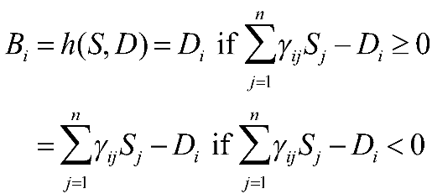

Second we can calculate a ratio estimation the relation between supply and demand, which equals 1 if supply and demand is met.

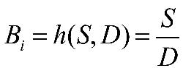

In this case B could be increased even beyond demand (economic point of view) and would stimulate people using/demanding more. On the contrary, one could study what has the more impact: fulfilling benefit by either increase supply or by changing demand through introducing more connections between demand patches (more or less communication). Finally, we see, that if *D* decreased to zero this leads to infinite benefit, what was originally proposed by Siddharta Gautama (Buddha, 600 B.C.).

A third option of the utility function *h* is estimate the product of supply and demand at maximization the use

