

**TASK**

**Exploratory Data Analysis on the Penguins Dataset**

[](http://www.hyperiondev.com/portal/)

**Introduction**

The dataset for the penguin_iter.cvs document has 17 columns of information and 344 penguins in the study. The study was conducted from 10 November to 3 December 2007 during which time it was observed how the eggs were laid by the penguins.

Three separate studies (PAL0708, PAL0809 and PAL0910) were conducted in this time on three islands (Torgersen, Biscoe and Dream) where the penguin waddles were observed. A group of penguins on land are called a waddle (Penguins International, 2020).

There were three species of penguins that were studied (Adelie, Chinstrap and Gentoo) of which it was confirmed that 168 were males and 165 were females.

In this study we will be looking at the sizes of the different species of penguins and the diet of the penguins on the different islands.

**Adélie Penguin (*Pygoscelis adeliae*)**

The Adélie penguin (Image 1.1) is known for the white circle around their eyes and the males and females tend to have a similar size and are difficult to tell apart (Australian Antarctic Program, 2022a).

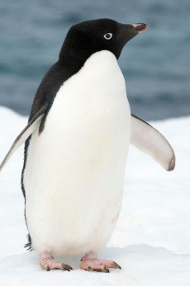

**Image 1.1**: The Adélie penguin (Hume, 2019).

Though the Adélie penguins are increasing in Antarctica, they have fallen by 65% in the last 25 years in areas where climate change has been established (WWF-UK, 2023).

**Chinstrap Penguin (*Pygoscelis antarctica*)**

The Chinstrap penguin (Image 1.2) is known for its fine black plumage at the top of the head and a thin black strip of feathers that spans from one side of the face to the other under the cheek and can be found on the Antarctic islands (Rafferty, 2020a).

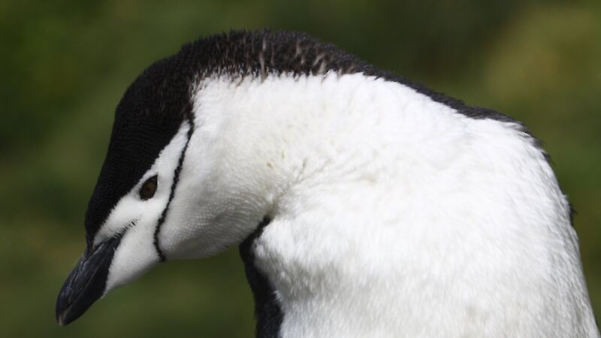

**Image 1.2:** The Chinstrap Penguin (Australian Antarctic Program, 2022b).

**Gentoo Penguin (*Pygoscelis papua*)**

Though the Gentoo penguin (Image 1.3) lives in cold climate, they tend to live on flat, rocky beaches with no ice. These penguins are known as strong swimmers and can swim up to 22 miles per hour and 600 feet deep, making them the fastest diving birds (Oceana, 2023).

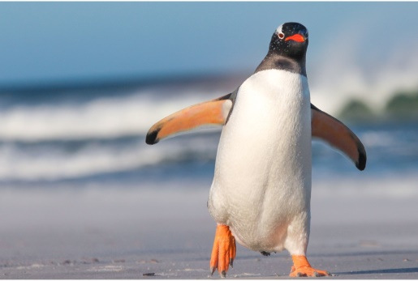

**Image 1.3:** The Gentoo Penguin (Wild Republic, 2023).

**DATA CLEANING**

Because all of the penguins were adults in the first egg stage, the Stage column was removed, as well as the Region column, because all of the penguins were from Anvers.

The Sex column had ‘.’ in which had to be converted to nan values to be able to remove those values and get a count on the males and females of which there could be certainty.

**MISSING DATA**

When counting the missing values, 318 of the values in the Comment column were missing, the comments were not needed in the analysis and thus the column was removed.

Culmen depth, culmen length, flipper length and body mass all had a missing percentage of 0.58%, which is a negligible value and those missing values were dropped. Delta 15 N had a missing percentage of 4.07% and Delta 13 C had a missing percentage value of 3.78%. These two columns could not be dropped, because it is necessary to test the health of the penguins, so the rows with the missing values had to be dropped.

**PENGUINS USED IN THE STUDY**

In Graph 1.1 we can see that the amount of penguins used in each of the three studies were similar with PAL0706 at 31.98%, PAL0809 at 33.14% and PAL0910 at 34.88%, which gives us a good spread of data.  
  
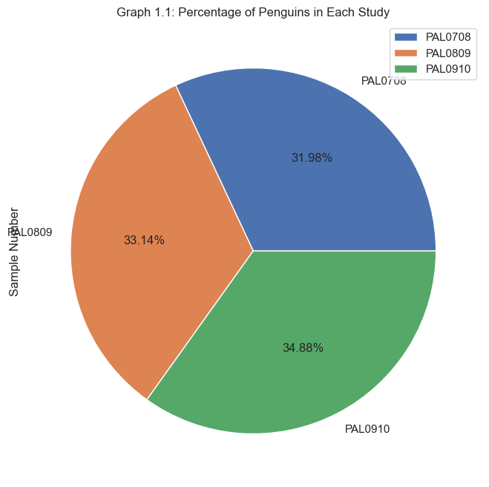

**PENGUINS WEIGHTS AND OTHER ATTRIBUTES**

The Gentoo penguins can be seen (Graph 1.2) with the highest average weight in the species with an average over 5kg when compared with the other two. This is a normal average weight for Gentoo penguins at 5kg where some of the males can even reach 8,5kg (Rafferty, 2020b).

The Adélie penguins received the lowest average weight just below the Chinstrap penguins and Adélie penguins are known to be the smallest species in the Antarctic (WWF-UK, 2023).

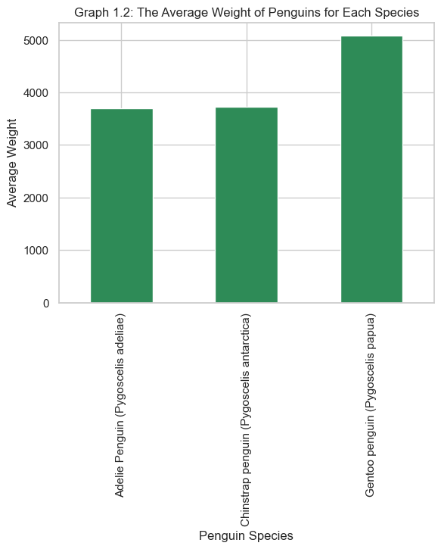

The top five heaviest penguins (Graph 1.3) in the study are all from the Gentoo species and male. The heaviest penguin is N39A2 and considering as mentioned above that the Gentoo penguin can reach up to 8,5kg, this is low for the highest value. The females tend to like the heavier males, because their weight indicates how good they are with catching fish (Horvath, 2015).

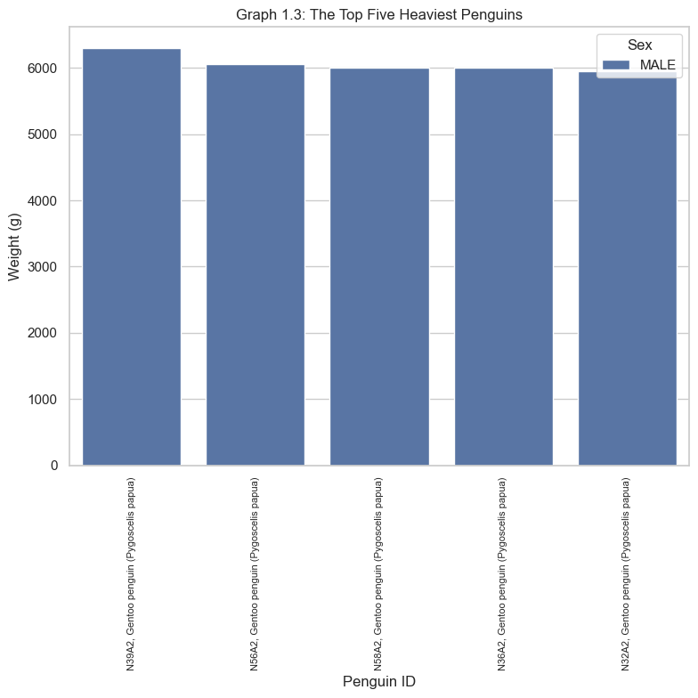

The culmen is the upper ridge of the penguin’s bill. When looking at Graph 1.4, we can see that in each species, the bill is longer and wider for the male compared to the female. This is accurate, because although males and female penguins look alike, the males have broader and longer beaks than the females (Horvath, 2015).

The Adélie penguins tend to have short and wide bills which will give their bills a stubby appearance. The Chinstrap penguins have the biggest bills in both length and width whereas the Gentoo penguins have long narrow bills.

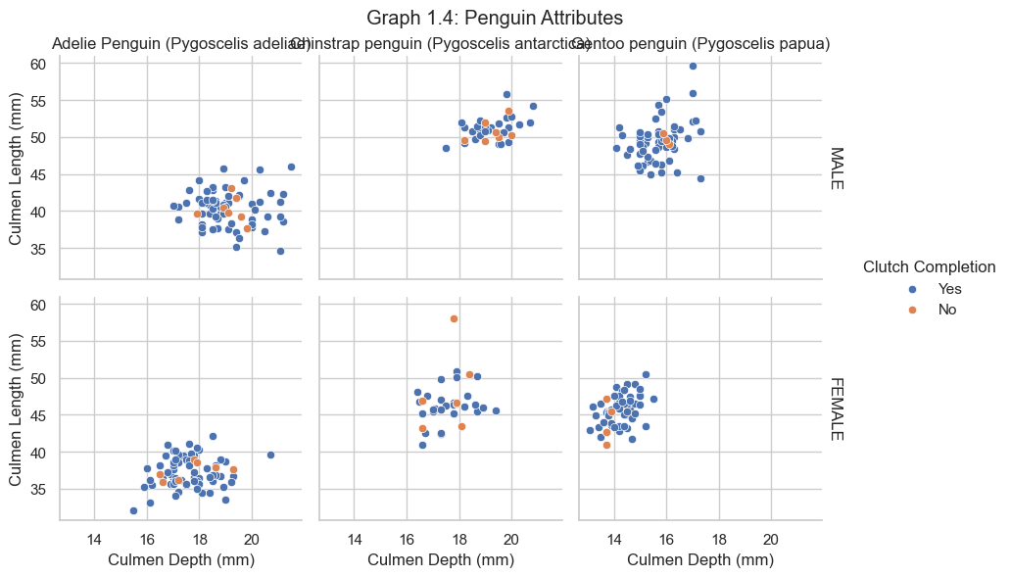

In Graph 1.5 we can see that the Adélie penguins are the most commonly found species in the Antarctic islands and can be seen in all three islands, Torgersen (100%), Biscoe (26.2%) and Dream (45.2%). In warmer months the Adélies can be found in various of the breeding colonies over the Antarctic, which is why they are the inspiration for World Penguin Day (Rafferty, 2020c).

The Gentoo penguins are only on the Biscoe island (73.8%) and the Chinstrap penguins on Dream (54.8%). The island, Dream, has been named an Important Bird Area due to the breeding colonies of the Adélie and Chinstrap penguins, making this a restricted area. This is important due to the dwindling numbers in Chinstrap penguins due to competition with humans for squid (Rafferty, 2020a).

Biscoe island was originally inhabited by only Adélie penguins, in 1993, there were only 14 Gentoo nests starting out, which soon surpassed the Adélie penguins in numbers (Powell, 2016).

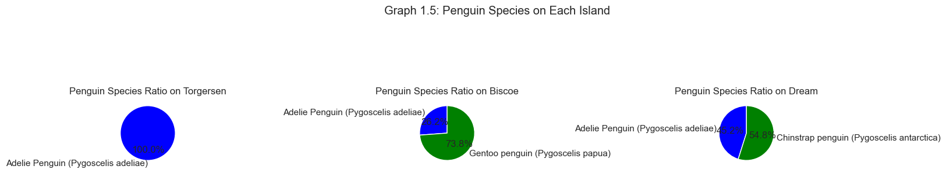

Graph 1.6 indicates the average isotope value of Nitrogen found in the blood, feathers, eggshells and bones of penguins of each island. Because N is a key nutrient of life, the cycle has been studied the last few years due to the rise in human population and pollution. Penguins that live in Antarctica can better represent the cycle for study because they are relatively isolated (Wu, 2023). Thus we will get information on the diet of penguins.

Delta 15N is indicated in percentage and Dream island has the highest average value for Delta 15N at 9.18%, meaning that the diet there is higher in krill, a favourite of the Adélie penguin, which has a high colony ratio in the Dream and Torgersen islands which is why those two have higher delta 15N values (Emslie and Patterson, 2007).

Delta 15N is the lowest in the Biscoe island which has a high colony ratio of Gentoo penguins, penguins that prefer fish and squid in their diet (Australian Antarctic Program, 2022c).

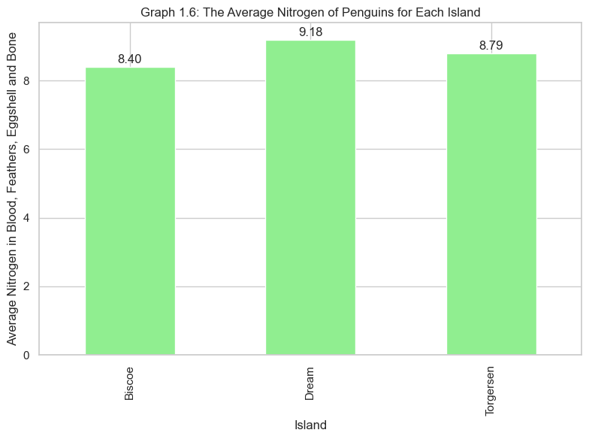

In Graph 1.7 we can see the delta 13C value average in % for the different islands and this will give us a concept of the flaura in the diet of the different penguin colonies. Biscoe, at -26.11% indicates that the penguins from that island has benthic seaweeds in their diet, which means that it will be a prominent item in the Gentoo penguin’s diet (Dunton, 2015).

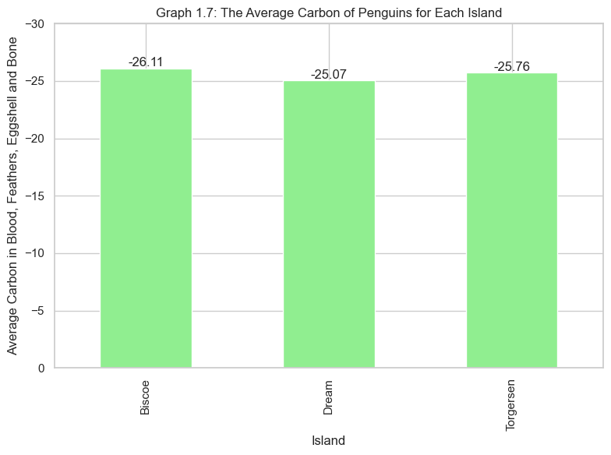

**CONCLUSION**

To have a more thorough idea of the diet of penguin colonies, more data is needed over varouis years to see if we can see a pattern in the changes in diet due to global warming. Adélie penguins are the smallest of the three and is the most widely found in the Antarctic. They also prefer krill in their diet and less seaweed.

The Gentoo penguins are the largest penguins of the three species and eat more fish and benthic seaweed while being found on the Biscoe island. The Chinstrap penguins can be found on the Dream island and have the largest beaks of the penguins.

**THIS REPORT WAS WRITTEN BY : CARLA HILLS**



**REFERENCES**

* Australian Antarctic Program. (2022a). Adélie Penguin. Reviewed on 26 July 2023. https://www.antarctica.gov.au/about-antarctica/animals/penguins/adelie-penguin/
* Australian Antarctic Program. (2022b). Chinstrap Penguin. Reviewed on 26 July 2023. https://www.antarctica.gov.au/about-antarctica/animals/penguins/chinstrap-penguin/
* Australian Antarctic Program. (2022c). Gentoo Penguin. Reviewed on 27 July 2023. https://www.antarctica.gov.au/about-antarctica/animals/penguins/gentoo-penguin/#:~:text=Diet%20and%20feeding&text=They%20usually%20eat%20a%20mix,the%20eggs%20of%20gentoo%20penguins.
* Dunton, K.H. (2015). Measurements of Antarctic Peninsula Fauna. Reviewed on 27 July 2023. https://academic.oup.com/icb/article/41/1/99/99017
* Emslie, S., Patterson, W.P. (2007). Abrupt recent shift in delta 13C and delta 15N values. Reviewed on 27 July 2023. https://pubmed.ncbi.nlm.nih.gov/17620620/
* Horvath, A. (2015). How do penguins find their mate in a sea of tuxedos? Reviewed on 27 July 2023. https://pursuit.unimelb.edu.au/articles/how-do-penguins-find-their-mate-in-a-sea-of-tuxedos#:~:text=Although%20males%20and%20females%20look,suggests%20they're%20good%20fishers.
* Hume, I. (2019). Adelie Penguin. Reviewed on 26 July 2023. https://australian.museum/learn/animals/birds/adelie-penguin/
* Oceana. (2023). Gentoo Penguin. Reviewed on 26 July 2023. https://oceana.org/marine-life/gentoo-penguin/
* Penguins International. (2020). What do you call a group of penguins? Reviewed on 26 July 2023. https://www.penguinsinternational.org/2020/11/17/what-do-you-call-a-group-of-penguins/WWF-UK. (2023).
* Powell, H. (2016). On the Arctic Peninsula, Scientists witness a Penguin Revolution. Reviewed on 27 July 2023. https://www.allaboutbirds.org/news/on-the-antarctic-peninsula-scientists-witness-a-penguin-revolution/#
* Rafferty, J.P. (2020a). Chinstrap Penguin. Reviewed on 26 July 2023. https://www.britannica.com/animal/gentoo-penguin
* Rafferty, J.P. (2020b). Gentoo Penguin. Reviewed on 26 July 2023. https://www.britannica.com/animal/gentoo-penguin
* Rafferty, J.P. (2020c). Adélie Penguin. Reviewed on 27 July 2023. https://www.britannica.com/animal/Adelie-penguin
* Wild Republic. (2023). Gentoo Penguin. Reviewed on 26 July 2023. https://www.wildrepublic.com/product/gentoo-penguin/
* Wu, L. (2023). Molecular transformation of organic nitrogen in Arctic penguin guano-affected-soil. Reviewed on 27 July 2023. https://www.sciencedirect.com/science/article/pii/S0160412023000697
* WWF-UK. (2023). Adélie Penguin- Antarctic Birds with Attitude. Reviewed on 26 July 2023. https://www.wwf.org.uk/learn/wildlife/adelie-penguins#:~:text=Ad%C3%A9lie%20penguins%20are%20increasing%20in,better%20adapted%20to%20warmer%20climates).