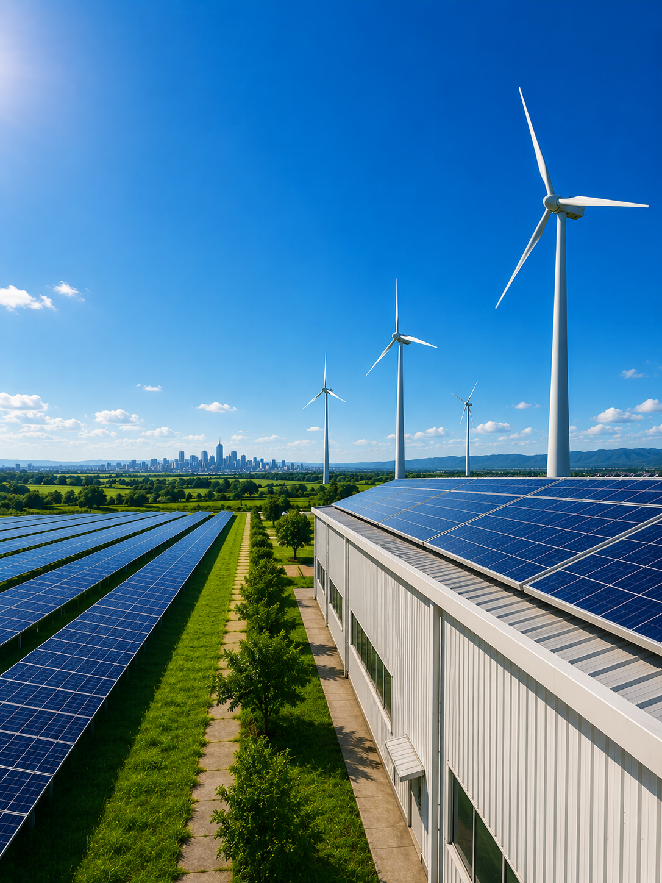

600 kWp
Solar Capex Proposal
IFGL Refractories, Kandla, Gujarat
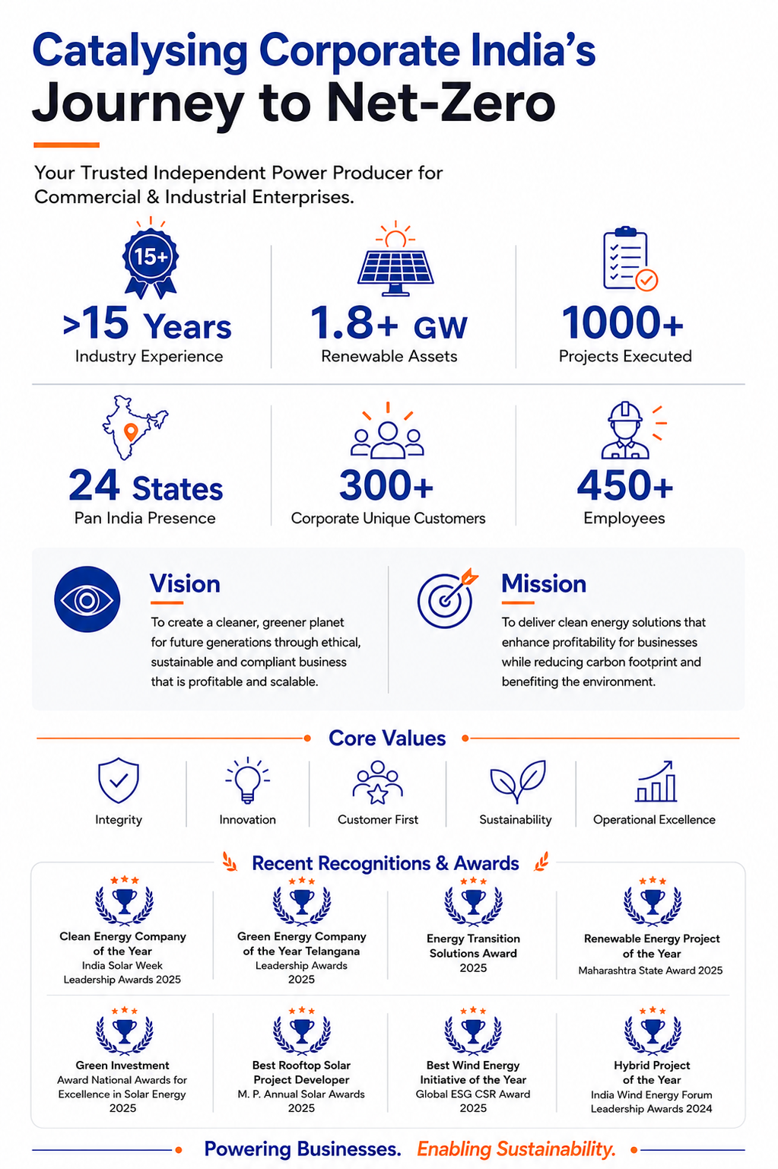
600 kWp
Solar Capex Proposal

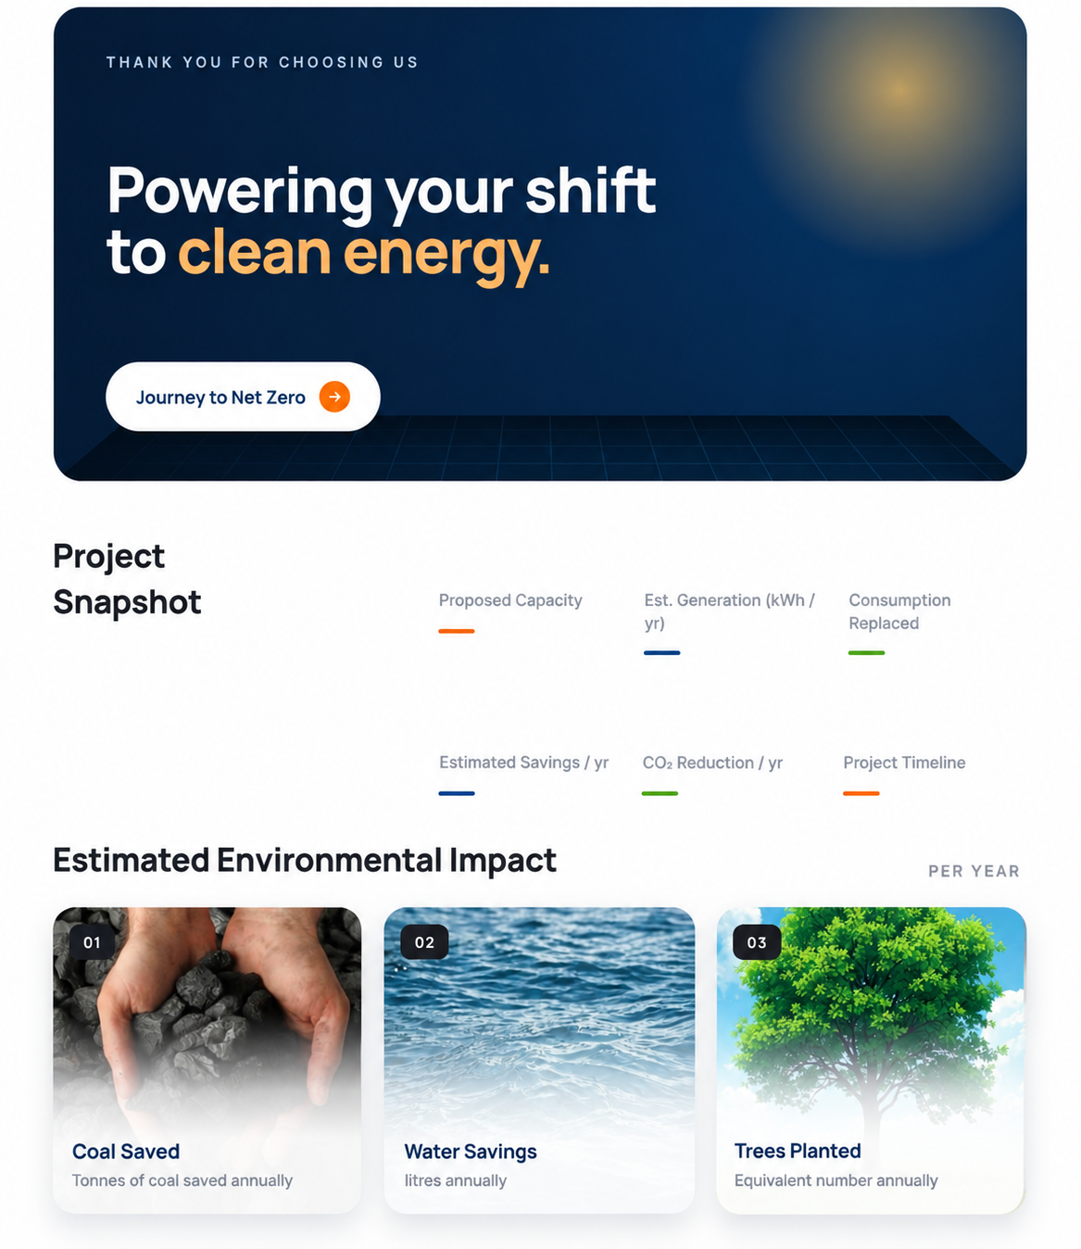

{7} months
₹{5}

{2} kWp
{3}
{4}%
{6}

{10}

A future ready solar solution designed to reduce energy costs and carbon emissions.
{8}

{9}

Table of Contents
Executive Summary
Site Details 6
1.1 Customer Details 6
1.2 Site Details 6
Technical Offer 7
2.1 Capacity Assessment 7
2.2 Plant Layout 7
2.3 Estimated Generation 9
2.4 Bill of Material 9
2.5 Scope of Work 10
2.6 Tentative Project Schedule 12
Commercial Offer 13
3.1 Project Cost 13
3.2 Financial Analysis 13
3.3 Terms & Conditions 14
Legal Provisions 15
Environmental Impact 16
Illustrative list of our projects 18

Executive Summary

IFGL Refractories Ltd.
Kandla, Gujarat
Technical Snapshot
Proposed Capacity (kWp) | { } kWp
Installation Technology | { }
Estimated Generation | { } kWh/year
% Consumption Replaced | { }
Net Metering | Yes / No
Key Components | Modules –  Inverters –
Project Timeline | { }
Exclusions | { }

Commercial Snapshot
Investment (Rs. Crs) | { }
Payment Terms | - 30% Advance along with PO  - The following payment would be through a bank guarantee/ irrevocable Letter of Credit equivalent of 70% of the project cost  - 60% after receipt of material at site of work on pro rata basis;  - 7.5% after plant commissioning of the plant i.e. “Commissioning Date”  - 2.5 % after receipt of CEIG approval but no later than 60 days from the “Commissioning Date”
AMC Cost | { }
Payback Period | { }
Net Savings over 25 Years | { }

Proposal Details
Submitted by | { }
Submitted on | { }
Validity | { }

1.0 | Site Details

1.1 Customer Details
Name | { }
Corporate Address | { }
Contact Person | { }
Mobile | { }
Email | { }

1.2 Site Details
Site Address | { }
Latitude | { }
Longitude | { }
Type of Installation | { }
Type of Roofs | { }
Availability of Water | { }
Shading | { }

Insert site Google Map view snapshot

2.0 | Technical Offer

2.1 Capacity Assessment
Parameters | Estimated Capacity (kWp) | Notes
Based on shadow-free area | { } | { }
Based on electricity consumption | { } | { }
Based on state regulatory limit | { } | { }
Proposed Capacity | { } | { }

2.2 Plant Layout
Type of Installation | { }
Type of Mounting | { }
Power Evacuation | { }

Installation Types
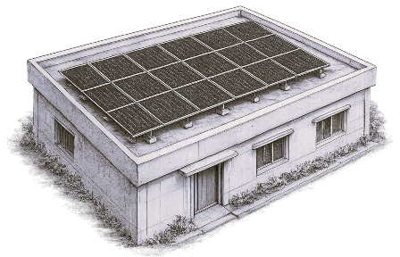  RCC | 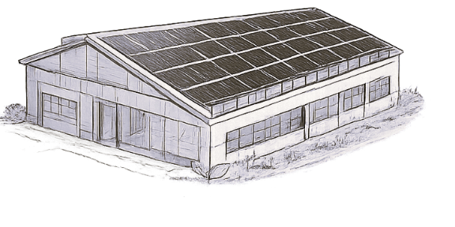  Shed | 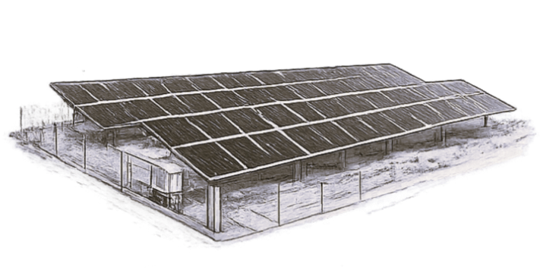  Ground Mount | 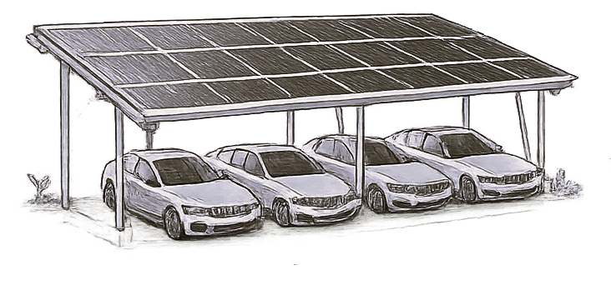  Carport
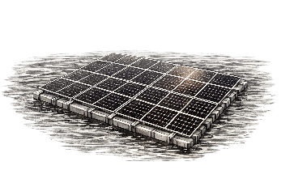
Floating

For Rooftop
Shed / Building | Capacity (kWp) | Tilt | Azimuth | Walkways / Lifeline
{ } | { } | { } | { } | { }
{ } | { } | { } | { } | { }
Total | { }

For Shed
Shed / Building | Capacity (kWp) | Tilt | Azimuth | Walkways / Lifeline
{ } | { } | { } | { } | { }
{ } | { } | { } | { } | { }
Total | { }

For Ground Mounted
Type of Installation | { }
Azimuth (deg) | { }
Tilt (deg) | { }
Type of Mounting | { }
Power Evacuation | { }
Fencing | { }
Plant Lighting | { }

For Carport / For Floating

Type of Installation | { }
Azimuth (deg) | { }
Tilt (deg) | { }
Type of Mounting | { }
Power Evacuation | { }
Fencing | { }
Plant Lighting | { }

Top View of Plant | ISO View of Plant
Insert design layout | Insert design layout

2.3 Estimated Generation
Type of System | { }
Estimated Generation (kWh/year)* | { }
Degradation | { }
Guaranteed Generation (kWh/year)* | { }
Plant Life (Years) | { }
*Subject to { } kWh/m²/yr irradiation, 75% PR, 100% grid availability and shadow-free conditions.

2.4 Bill of Material
Sr. | Equipment | Description | Specifications | Qty (max)
1 | Solar PV Module | Type | { } | xx kWp
 |  | Make / Model | { }
 |  | Efficiency | { }
2 | Inverter | Type | { } | xx nos.
 |  | Env. Class / Location | { }
 |  | Make / Model | { }
3 | Module Mounting Structure | Type | { } | Equiv. to SPP kWp
 |  | Make | { }
Cable & Cable Tray
1 | DC Cable | Make / Size | { } | xx m
2 | AC Cable | Make / Size | { } | xx m
3 | Cable Tray | Type / Size | { } | xx m
LT Panel & Energy Meter
1 | LT Switchgear | Type / Make / Rating | { } | xx sets
2 | Spare Feeder (if any) | Type / Make / Rating | { } | xx sets
3 | Energy Meter + ACCB | Make / Class | { } | xx nos.

Safety Equipment
Safety remains a key priority, with best-in-class safety equipment provided in accordance with applicable industry standards.
1 | Lightning Arrestor | Type / Make | { } | xx nos.
2 | Earthing Kit | Make / Specs | { } | xx nos.
3 | Lifeline | Make | { } | xx m
4 | Walkways | Type / Size | { } | xx m
5 | Mesh over Skylights | Make / Specs | { } | xx m
6 | Railings over Roof | Make / Specs | { } | xx m
7 | Ladder | Make / Specs | { } | xx m

Monitoring & Cleaning
Sr. | Equipment | Description | Specifications | Qty (max)
1 | Remote Monitoring System | Make / Specs | { } | xx nos.
2 | Irradiation Sensor | Make / Specs | { } | xx nos.
3 | Ambient Temp. Sensor | Make / Specs | { } | xx nos.
4 | Module Cleaning (Manual) | Make | { } | xx m
5 | Water Pump / Tank / Meter | Make | { } | xx nos.
HT Equipment (if applicable)
1 | HT / VCB Panel | Type / Make / Rating | { } | xx nos.
2 | Transformer | Type / Make / Rating | { } | xx nos.
3 | Transmission / Termination | Type / Length | { } | xx m
4 | Auxiliary Power | Transformer / LT / UPS | { } | xx nos.
5 | MCR Room / SCADA | Standard / Make | { } | xx nos.
6 | Boundary / Lighting / CCTV | Standard / Make | { } | xx nos.
7 | Fire Fighting Equipment | Make | { } | xx nos.
Net Metering (Customer Scope)
1 | Net Metering Hardware | Make / Class | { } | xx nos.
2 | Net Metering Cubicle | Make | { } | —
*Quantities are indicative; may vary at detailed design stage.

2.5 Scope of Work

Sr. | Description | FPEL Scope | Client Scope
EPC
1 | Finalization of site location |  | 
2 | Approach road for heavy vehicles, trailers & road permit |  | 
3 | Safe permanent ladder access per safety requirement |  | 
4 | Clearing of site for installation |  | 
5 | Basic engineering, overall layout & general arrangement | 
6 | Submission of BOM with makes, SLD & PVSyst report | 
7 | Detailed project execution schedule | 
8 | Equipment specifications, drawings & data sheets | 
9 | System sizing | 
10 | Supply of PV modules, inverters & BOS materials | 
11 | Space / provision for storage of materials |  | 
12 | Civil works for mounting structures, earthing etc. | 
13 | Erection of module mounting structure & equipment | 
14 | Laying & termination of AC/DC, communication, earthing & LA | 
15 | Construction / upgradation of main metering cubicle |  | 
16 | Installation of PV modules, inverters & BOS material | 
17 | Commissioning of monitoring & grid synchronisation | 
18 | DG protection | 
19 | Security, watch & ward |  | 
20 | Water & power for construction |  | 
21 | As-built drawings & O&M manuals | 
22 | Pre-commissioning checks, testing, training & handover | 
23 | Insurance during construction till handover | 
24 | Project handover documentation | 
25 | Liaisoning with Govt for CEIG approval & safety certificate | 
26 | Net metering approval from authority | 
27 | Issuance of documents for approvals & Statutory fees |  | 
AMC
1 | Daily monitoring of plant performance & generation | 
2 | Routine maintenance of plant & equipment | 
3 | Emergency breakdown maintenance (response ≤48 hrs) | 
4 | Coordination with OEMs for warranty & breakdown support | 
5 | Water & auxiliary power for maintenance |  | 
6 | Cleaning of modules |  | 

2.6 Tentative Project Schedule

Sr. | Item Description | Aug-26 | Sep-26 | Oct-26 | Nov-26
1 | Receipt of PO and Advance Order
2 | Customer Kick-Off Meeting
3 | Design Approval / Site Handover (whichever later)
4 | Submission & Approval of Design
5 | Placement of Orders on Vendors (Material Wise)
6 | Manufacturing & Dispatch of Materials
7 | Mobilization of Team at Site
8 | Installation & Test Charge
9 | Approvals
10 | Commercial Operation Date (COD)
11 | Site and Documentation Handover
 | Start Date = | Jul-26 |  | Project End Date = | Nov-26

Delivery & Installation | { } months from receipt of advance or handover of clear site (whichever is later).
Commissioning Date | 3 days of successful plant running. Downtime due to grid / load issues not attributable to supplier treated as successful.
Handover Documents | As-built drawings, data sheets (STAAD report of MMS, lifeline, LA), authority approvals, test reports, GA drawings for LT/HT panels, pre-commissioning checklist, PDI & dispatch clearance, warranty certificate, O&M manual, PR data (optional), training records.

3.0 | Commercial Offer

3.1 Project Cost
System Description | Investment per Wp (Rs.) | Total Investment (Rs.)
Turnkey EPC of 910 kWp solar power plant | { } | { }
Net metering material & installation – ABT meters (2 nos.) | { } | { }
Generation panel with TVM unidirectional solar meter | { } | { }
TOTAL | { } | { }
In words: Rupees { }

AMC Cost (Optional):

System Description | Investment per Wp (Rs.)
AMC Cost for Solar Power Plant 1st year | ₹ 650 /-  with 5% y-o-y escalation

Note:
- 8.9% GST is additional to the Project cost.
- Any changes in the Govt. duty structures and price impact due to Anti-dumping duty/Safe-guard duty/Basic Custom Duty shall be charged extra at actual and any cost benefits due to policy reason shall be passed on to consumer
- The cost of imported components is based on exchange rate of 1 USD = INR 95.55. In case of fluctuations in USD beyond ± 1 % the same will be applicable to the above price

3.2 Financial Analysis
Item | Unit | Value
System Size | kWp | { }
System Cost (incl. GST) | Rs. Lacs | { }
GST Input Credit (8.9% of basic) | Rs. Lacs | { }
Net Cost to Client | Rs. Lacs | { }
AMC Cost | Rs. Lacs/year | { }
Solar Units Generated (Year 1) | Units/year | { }
Present Power Tariff | Rs./unit | { }
Avg. EB Tariff Increase | % p.a. | { }
Savings in Year 1 (post-tax) | Rs. Lacs | { }
Payback Period | Years | { }
Project Life | Years | { }
Inverter Life | Years | { }
Net Savings over Project Life | Rs. Lacs | { }
Total Units over Project Life | Lac Units | { }
Project IRR – Post Tax | % | { }
Equity IRR – Post Tax | % | { }
Levelised Cost of Generation | Rs./kWh | { }

3.3 Terms & Conditions
Validity of Offer | This quotation shall remain valid for { } days from the date of this proposal.
Payment Milestone | 30% advance with PO against BG. Balance 70% via BG / irrevocable LC: 60% on material receipt at site (pro-rata); 7.5% after commissioning; 2.5% after CEIG approval (≤60 days from commissioning). Net-metering approvals not linked to payment terms.
TDS Deduction | 70% of invoice = goods – TDS u/s 194Q / TCS 0.1%. 30% = services – TDS u/s 194C / TCS 2%.
Title Transfer | Title remains with FPEL until full payment and No Dues Certificate is issued.
Late Payment | Due within 15 days of invoice. Delayed payments attract 2% p.m. simple penal interest (calculated daily).
Product & Performance Warranty | 10-yr SPV product warranty; 25-yr output warranty (2.5% Year-1 degradation, 0.7% p.a. thereafter); 5-yr inverter warranty; BOS 1 yr / OEM terms.
Force Majeure | FPEL not liable for delay due to acts of God, war, strikes, embargoes, govt. orders or statutory processing delays.
AMC (non-comprehensive) | Rs. { } lakhs in Year 1 with 5% p.a. escalation.
Placement of Order | Binding only on written order acceptance by FPEL. Orders cannot be cancelled once placed.
FPEL Payment Details | RBL Bank Limited, Ameerpet Branch, Hyderabad | A/c: 609000467653 | IFSC: RATN0000112
FPEL GST No. | 36AABCF6092M2Z7

Exclusions | - { }

4.0 | Legal Provisions
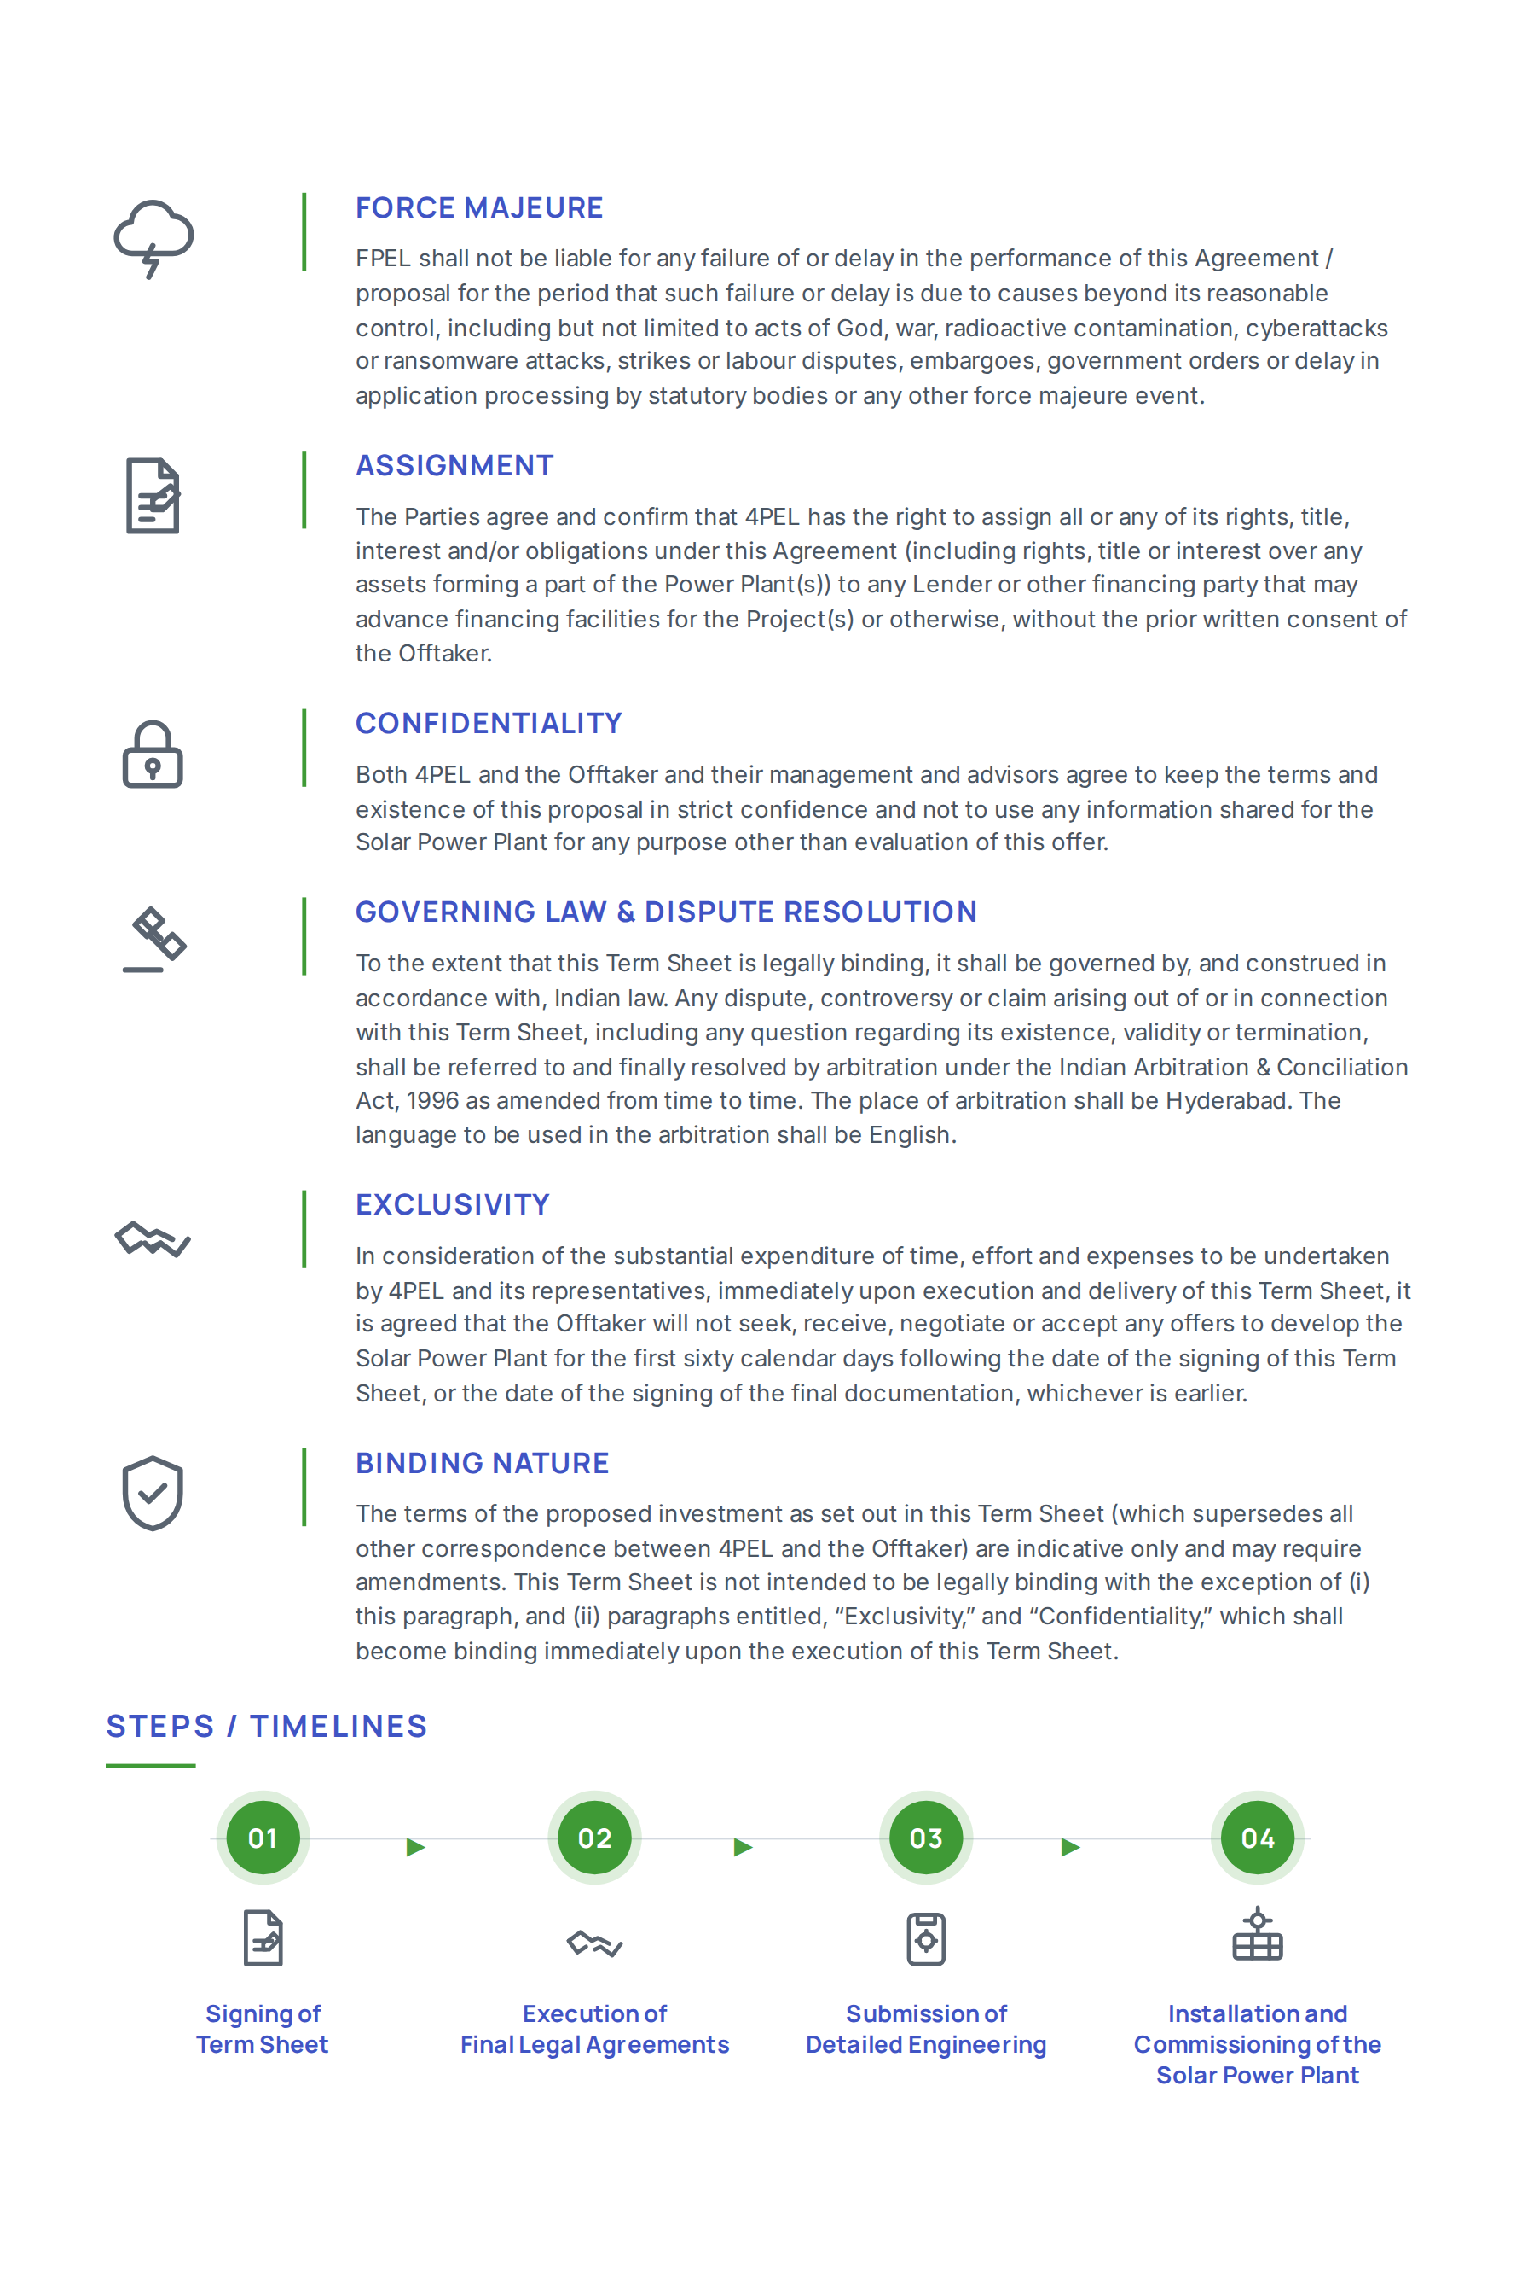

5.0 | Environmental Impact

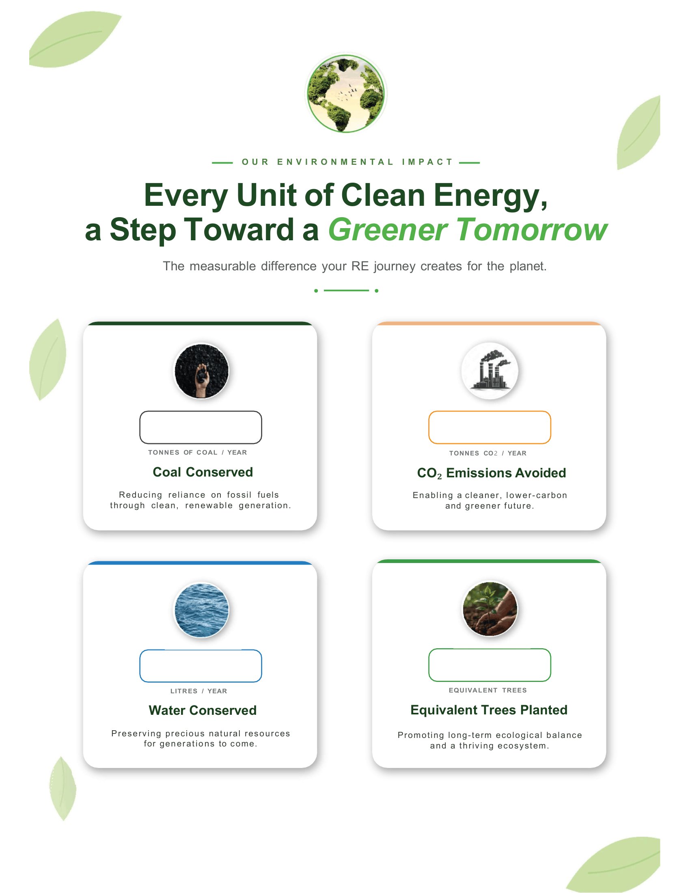
{14}

{13}

{11}

{12}

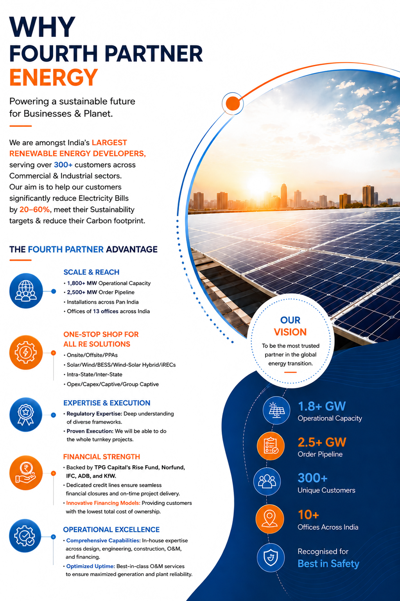

Illustrative list of our projects
Delivering reliable renewable energy solutions across diverse industries.

Company | Industry | Location | Capacity (MWp)
RSWM Textiles | Textiles | Rajasthan | 27.00 MWp
UltraTech Cements | Cements | Pan India | 12.00 MWp
Jindal India Limited | Iron & Steel | Pan India | 10.32 MWp
Bharathi Cements | Cements | Kadapa, AP | 10.00 MWp
Hyundai Motors | Auto | Chennai, TN | 10.00 MWp
Kalburgi Cements | Cements | Gulbarga, KA | 8.50 MWp
D-Mart | Retail | Pan India | 8.60 MWp
Sintex Industries | Plastics | Pan India | 6.25 MWp
Bridgestone India | Tyres | Pan India | 5.72 MWp
Hindustan Unilever | FMCG | Pan India | 5.35 MWp
Dr. Reddy's Laboratories | Pharma | Pan India | 5.30 MWp
Chettinad Cements | Cements | Solapur | 3.915 MWp
Tata Consultancy Services (TCS) | IT | Pan India | 3.84 MWp
Nilkamal Plastics | Plastics | Pan India | 3.60 MWp
Walmart India | Retails | Pan India | 3.56 MWp
Total |  |  | 500+ MWp




FOURTH PARTNER ENERGY PRIVATE LIMITED
No. N46, Fourth Partner House, HMT Nagar, Nacharam,
Hyderabad, Telangana 500076

1800 3000 1345 | www.fourthpartner.co | marketing@fourthpartner.co





