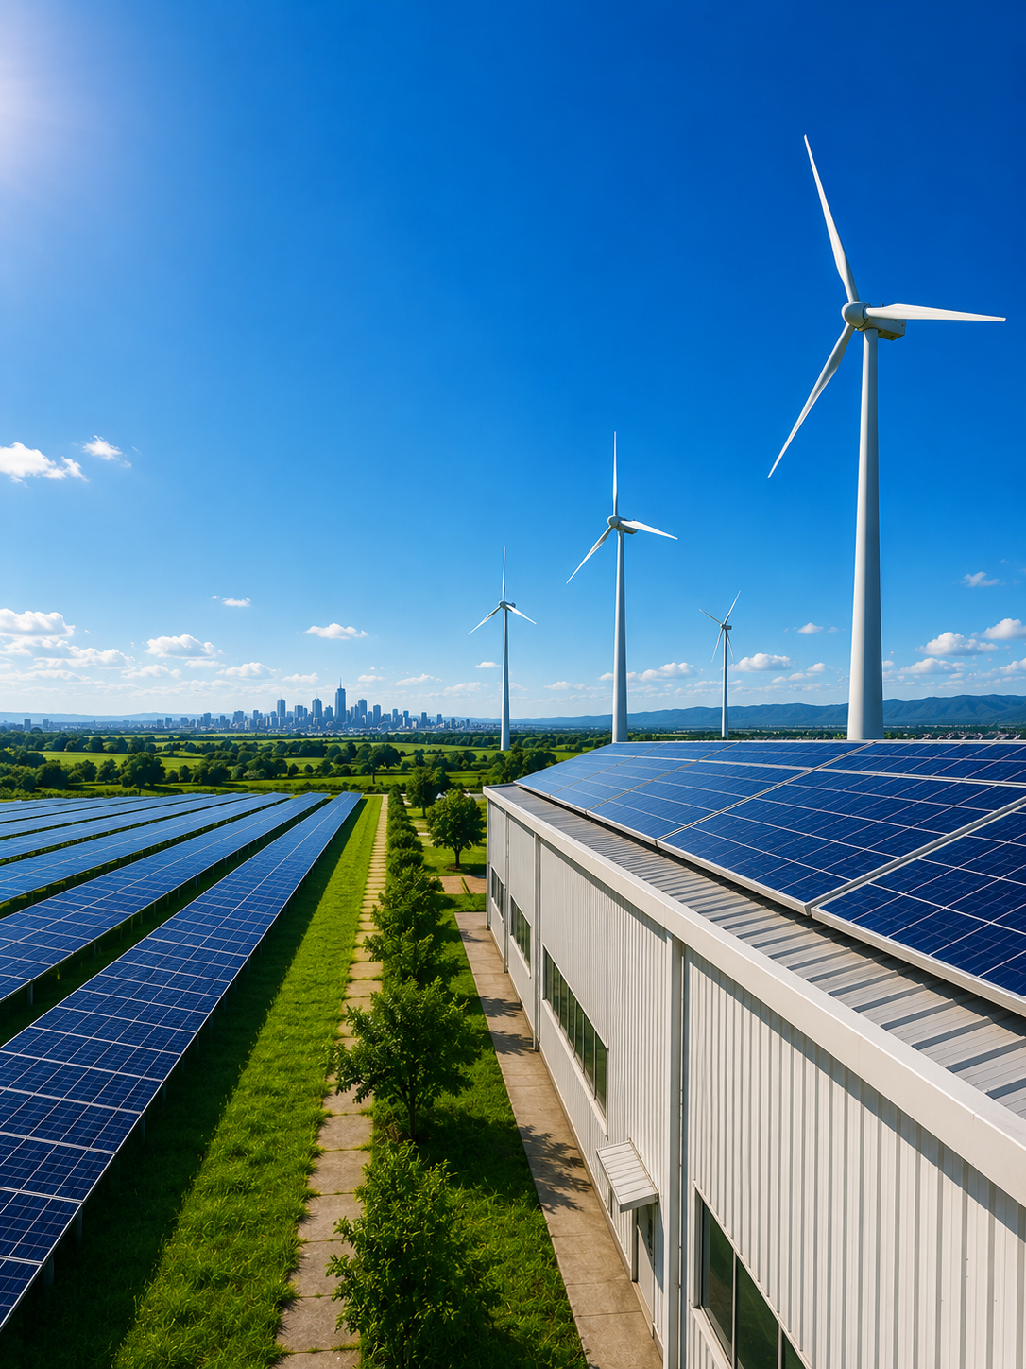

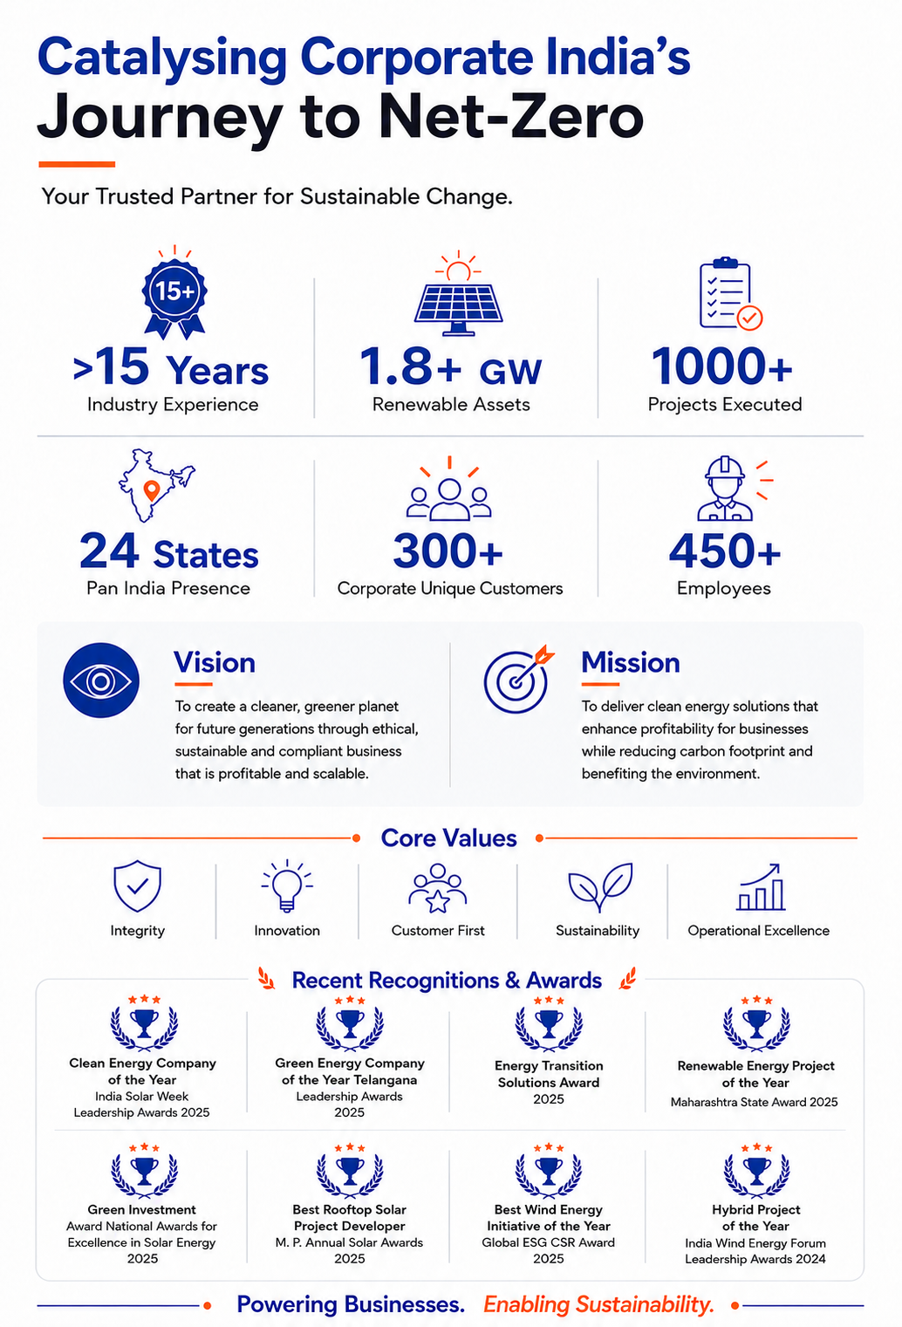
XXX Company, Tamil Nadu
1200 kWp
Solar Opex Proposal

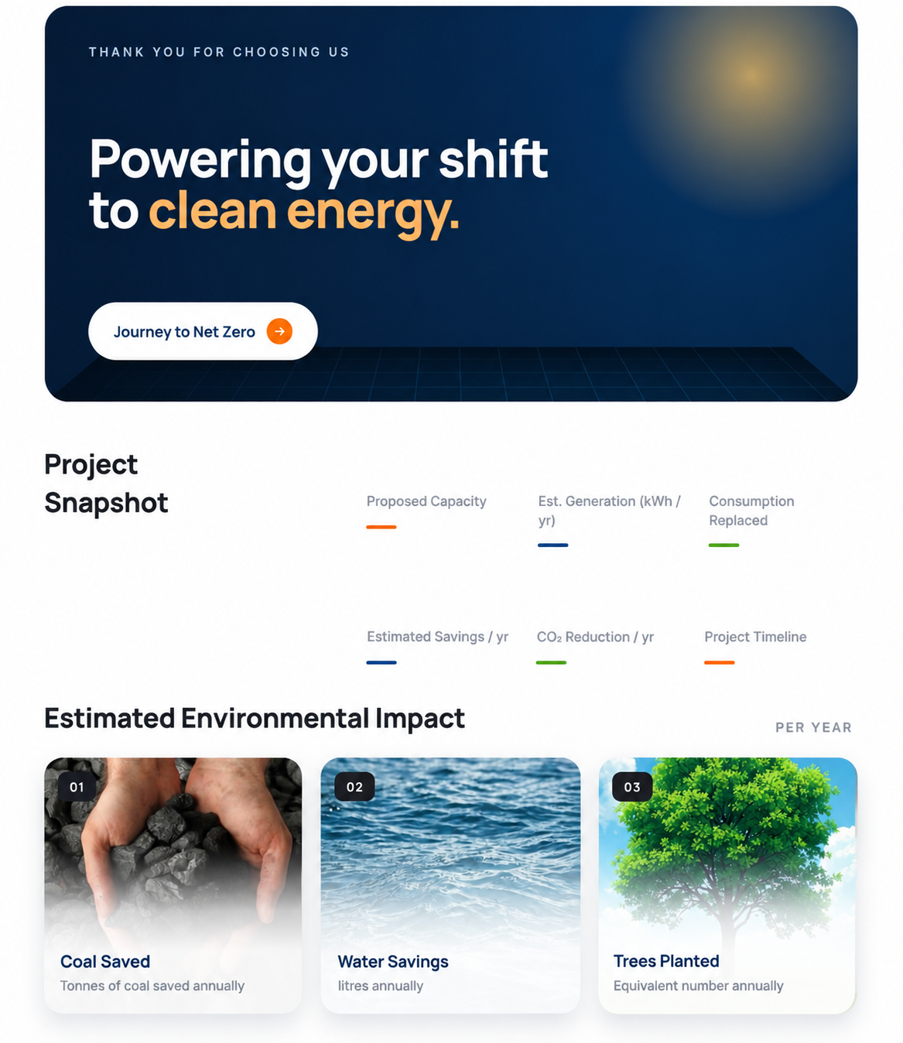

37.7 L
₹45 L
3 + 1 Months
1593 t
42%
17.52 L
A future ready solar solution designed to reduce energy costs and carbon emissions.
1200 kWp
772
73,176

Table of Contents

Executive Summary 5
Site Details 6
1.1 Customer Details 6
1.2 Site Details 6
Technical Offer 7
2.1 Capacity Assessment 7
2.2 Plant Layout 7
2.3 Estimated Generation 10
2.4 Bill of Material 10
2.5 Scope of Work 11
2.6 Tentative Project Schedule 13
Commercial Offer 14
3.1 Proposed Solar Tariff: 14
3.2 Estimated Cost Savings: 15
3.2 Terms & Conditions: 15
3.3 Defaults & Termination Rights: 17
3.4 Termination charges 17
Standard Terms & Conditions 18
Environmental Impact 19
Illustrative list of our projects 21

Executive Summary

Bimbo bakeri
Tamil Nadu
Technical Snapshot
Proposed Capacity (kWp)
Installation Technology
Estimated Generation
Guaranteed Generation
Metering
Key Components
Project Timeline
Exclusions

Commercial Snapshot
Variable Grid Rate (₹/kWh)
Proposed Solar Tariff (₹/kWh)
% Savings (1st Year) based on Estimated Generation
% grid consumption replaced
Reduction in CO2 emissions
(In Tons)

Proposal Details
Submitted by
Submitted on
Validity

1.0 | Site Details

1.1 Customer Details
Name
Address
Contact Person
Mobile
Email

1.2 Site Details
Address
Latitude
Longitude
Type of Installation
Type of Roofs
Availability of Water | Yes
Shading | Shadow-free

Insert site Google Map view snapshot

2.0 | Technical Offer

2.1 Capacity Assessment
Parameters | Estimated Capacity (kWp) | Notes
Based on shadow-free area
Based on electricity consumption
Based on state regulatory limit
Proposed Capacity

2.2 Plant Layout
Type of Installation
Type of Mounting
Power Evacuation

Installation Types
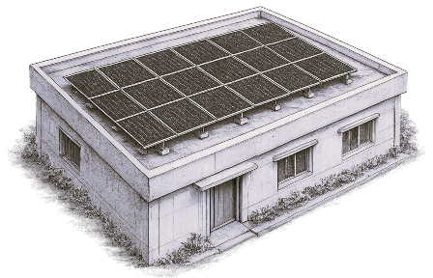  RCC | 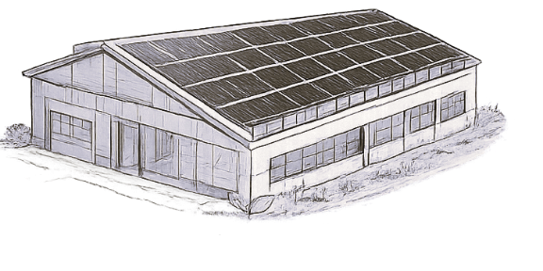  Shed | 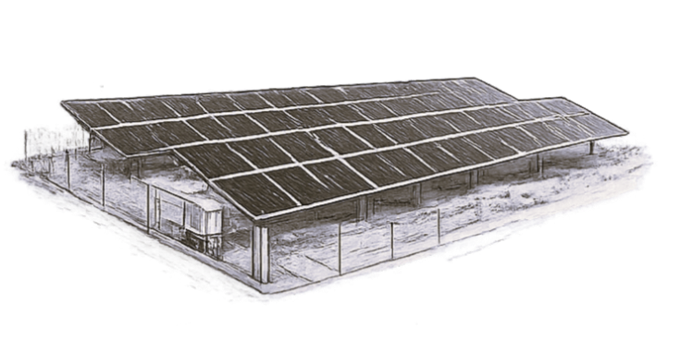  Ground Mount | 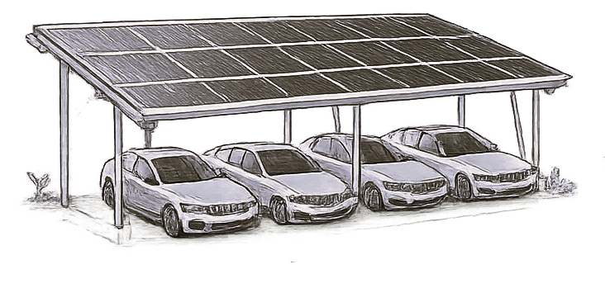  Carport
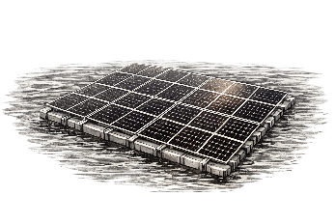
Floating

For Rooftop
Shed / Building | Capacity (kWp) | Tilt | Azimuth | Walkways / Lifeline
Total

For Shed
Shed / Building | Capacity (kWp) | Tilt | Azimuth | Walkways / Lifeline/ Railings
Total

For Ground Mounted
Type of Installation
Azimuth (deg)
Tilt (deg)
Type of Mounting
Power Evacuation
Fencing
Plant Lighting

For Carport
Type of Installation
Azimuth (deg)
Tilt (deg)
Type of Mounting
Power Evacuation
Fencing
Plant Lighting

For Floating
Type of Installation
Azimuth (deg)
Tilt (deg)
Type of Mounting
Power Evacuation
Anchoring System
Plant Lighting
Ground Clearance (Min)

Top View of Plant

Top View of Plant
Insert design layout

ISO View of Plant

ISO View of Plant
Insert design layout

2.3 Estimated Generation
Type of System
Estimated Generation (kWh/year)*
Degradation | 2.5% Yr-1, 0.7% p.a. thereafter
Guaranteed Generation (kWh/year)*
Plant Life (Years)
*Subject to 1,850 kWh/m²/yr irradiation, 75% PR, 100% grid availability and shadow-free conditions.

2.4 Bill of Material
Sr. | Equipment | Description | Specifications | Qty (max)
1 | Solar PV Module | Type |  | xx kWp
 |  | Make / Model
 |  | Efficiency
2 | Inverter | Type |  | xx nos.
 |  | Env. Class / Location
 |  | Make / Model
3 | Module Mounting Structure | Type |  | Equiv. to SPP kWp
 |  | Make
Cable & Cable Tray
1 | DC Cable | Make / Size |  | xx m
2 | AC Cable | Make / Size |  | xx m
3 | Cable Tray | Type / Size |  | xx m
LT Panel & Energy Meter
1 | LT Switchgear | Type / Make / Rating |  | xx sets
2 | Spare Feeder (if any) | Type / Make / Rating |  | xx sets
3 | Energy Meter + ACCB | Make / Class |  | xx nos.

Safety Equipment
Safety remains a key priority, with best-in-class safety equipment provided in accordance with applicable industry standards.
1 | Lightning Arrestor | Type / Make |  | xx nos.
2 | Earthing Kit | Make / Specs |  | xx nos.
3 | Lifeline | Make |  | xx m
4 | Walkways | Type / Size |  | xx m
5 | Mesh over Skylights | Make / Specs |  | xx m
6 | Railings over Roof | Make / Specs |  | xx m
7 | Ladder | Make / Specs |  | xx m

Sr. | Equipment | Description | Specifications | Qty (max)
Monitoring & Cleaning
1 | Remote Monitoring System | Make / Specs |  | xx nos.
2 | Irradiation Sensor | Make / Specs |  | xx nos.
3 | Ambient Temp. Sensor | Make / Specs |  | xx nos.
4 | Module Cleaning (Manual) | Make |  | xx m
5 | Water Pump / Tank / Meter | Make |  | xx nos.
HT Equipment (if applicable)
1 | HT / VCB Panel | Type / Make / Rating |  | xx nos.
2 | Transformer | Type / Make / Rating |  | xx nos.
3 | Transmission / Termination | Type / Length |  | xx m
4 | Auxiliary Power | Transformer / LT / UPS |  | xx nos.
5 | MCR Room / SCADA | Standard / Make |  | xx nos.
6 | Boundary / Lighting / CCTV | Standard / Make |  | xx nos.
7 | Fire Fighting Equipment | Make |  | xx nos.
Net Metering (Customer Scope)
1 | Net Metering Hardware | Make / Class |  | xx nos.
2 | Net Metering Cubicle | Make |  | —
Behind the Meter
1 | Zero Feed in Device | Make / Class | As per design | xx nos.
2 | DG Synchronization | Make / Class | As per design | xx nos.

*Above mentioned capacities are indicative and may vary at the time of detailed designing.
Exclusions | - Spare feeder / Bus-Bar of suitable rating  - Net meter & metering infra upgradation  - Internet connectivity for monitoring

2.5 Scope of Work
Sr. | Description | FPEL Scope | Client Scope
EPC
1 | Finalization of Site location | 
2 | Proper approach road to site for movement of heavy vehicles, trailers, Road permit. |  | 
3 | Ensuring safe permanent ladder access to the site as per safety requirement |  | 
4 | Clearing of site for installation |  | 
5 | Basic Engineering of Plant including overall Layout and General Arrangement | 
6 | Submission of BOM with offered makes, SLD and PV Syst Report | 
7 | Detailed Project Execution Schedule | 
8 | Equipment Specifications, Drawings, Technical Data Sheets | 
9 | System Sizing | 
10 | Supply of Solar PV Modules, Inverters and BOS Materials | 
11 | Space and construction/ provision for Storage of Materials |  | 
12 | Civil works for Mounting structures, Earthing etc. | 
13 | Erection of Module Mounding Structure and mounting of other equipment | 
14 | Laying and Termination of AC Side, DC Side Cables, Communication cables, earthing and lightning protection. | 
15 | Construction or Upgradation of existing main metering cubicle as per statutory requirement |  | 
16 | Installation of Solar PV Modules, Inverters and supplied BOS Material | 
17 | Commissioning of Remote monitoring and Synchronization with Grid | 
18 | DG Protection | 
19 | Security, watch and ward |  | 
20 | Water and power availability for construction work |  | 
21 | As built drawings and O&M manuals | 
22 | Pre-commissioning Checks and Testing with training and handover | 
23 | Insurance of Plant and Equipment during Construction till Project Handover | 
24 | Project Handover Documentation | 
25 | Liasioning with Govt Dept for CEIG approval of SLD and obtaining Safety Certificate after installation Project Construction approval | 
26 | Statutory Fees for CEIG & Other |  | 
27 | Issuance of required documents for Statutory approvals |  | 
28 | Generation Panel with Meter (If applicable) |  | 
AMC
1 | Daily monitoring of plant performance & generation | 
2 | Routine maintenance of plant & equipment | 
3 | Emergency breakdown maintenance (response ≤ 48 hrs) | 
4 | Coordination with OEMs for warranty & breakdown support | 
5 | Water & auxiliary power for maintenance |  | 
6 | Cleaning of modules | 
7 | Insurance of Plant and Equipment during O&M till PPA term | 

2.6 Tentative Project Schedule

Sr. | Item Description | Sep-26 | Oct-26 | Nov-26 | Dec-26
1 | PPA Signing
2 | Customer Kick-Off Meeting
3 | Site Handover / Design Approval (whichever later)
4 | Mobilization of team at site
5 | Procurement
6 | Civil Work, Installation & Cabling
7 | Pre Commissioning & Test Charge
8 | Liasoning
9 | Site Acceptance Test
10 | Handover
11 | Project Closure
 | Start Date = | Aug-26 |  | Project End Date = | Dec-26

Delivery & Installation | 3 + 1 Months months from receipt of advance or handover of clear site
Commissioning Date | 3 days of successful plant running. Downtime due to grid / load issues not attributable to supplier treated as successful.
Handover Documents | As-built drawings, data sheets (STAAD report of MMS, lifeline, LA), authority approvals, test reports, GA drawings for LT/HT panels, pre-commissioning checklist, PDI & dispatch clearance, warranty certificate, O&M manual, PR data (optional), training records.

3.0 | Commercial Offer

Offtaker | Bimbo bakeri (hereinafter referred to as “Offtaker”) having its registered office at Tamil Nadu.
Power Producer | Fourth Partner Energy Private Limited and its financial partners/subsidiary company (hereinafter referred to as “4PEL” or “Power Producer”) having its registered office at Fourth Partner House, Plot No N46, House No. 4-9-10, HMT Nagar, Hyderabad 500076, India
Nature of Contract | The Solar Power Plant will be developed, built, owned, financed, operated and maintained by 4PEL on a turnkey BOOT (Build, Own, Operate and Transfer) basis  The Offtaker will only pay the 4PEL for the power generated or deemed to be generated  The onus of system uptime and maintenance is entirely on the 4PEL.  The Offtaker agrees to buy all the power generated by this solar power plant.
Title & Tenure | 4PEL shall always be the absolute, legal and beneficial owner of the Power Plant(s) including environmental incentives/attributes.  The Term of the Contract would be for a period of 25 years from the Commissioning Date.  On the completion of the Term of the Contract, the Offtaker will have the Option to buy the asset at Nil Value. Please note that the life of the solar power plant is expected to be 25 years.

3.1 Proposed Solar Tariff:

For every unit (kWh) of power generated or deemed to be generated by the Solar Power Plant, the Offtaker can avail followings tariff options:

Period | Tariff Rs/kWh | Tariff Type  (Flat/Escalated)
25 Years | 4.64 | FLAT

*Tariff is determined based on 100% power offtake by the Offtaker.

- Duty, Taxes & any Surcharges, including electricity duty and/or any other taxes (including GST, cross subsidy charges, ASC charges, grid support charges, network charges, reactive energy charges, standby charges, and other indirect taxes), as and when applicable will be charged by 4PEL on actual basis and will be paid by the Offtaker.
- Any changes in the Govt. duty structures and price impact due to Anti-dumping duty/Safe-guard duty shall be charged extra as actual and any cost benefits due to policy reason shall be passed on to consumer
- The cost of imported components is based on exchange rate of 1 USD = INR 96.55. In case of fluctuations in USD beyond ± 1 % the same will be applicable to the above price
- We shall use the Solar Price | Energy Trend as the benchmark to calculate the variation in module cost.

3.2 Estimated Cost Savings:
Parameter | Period / Unit | Value
Variable Grid Rate | ₹/kWh | XXX
Proposed Solar Tariff | ₹/kWh | XXX
Landed Cost of Solar Power | ₹/kWh | XXX
Per Unit Savings | ₹/kWh | XXX
Estimated Annual Generation (kWh) | (1st year) | XXX
1st Yr Savings (₹) | (1st year) | XXX
Total Savings over PPA Term (₹) |  | XXX
In words: xxx

3.2 Terms & Conditions:
Payment Terms | - 4PEL will bill the Offtaker monthly based on actual & deemed generation  - The Offtaker shall make payment of the amounts due to 4PEL within 15 (Fifteen) days from the date of monthly invoice.  - The Offtaker shall make payments by electronic funds transfer/RTGS to the account designated by 4PEL.  - Delayed payment will attract penal interest of 2% simple interest per month calculated daily.
Payment Security | - The Offtaker shall provide Bank Guarantee from a reputed bank for an amount equivalent to 6 months energy charges as a payment security to 4PEL.  - Bank Guarantee shall be returned at the end of the Tenure of the contract.  - Bank Guarantee shall be provided by the Offtaker immediately after signing of the PPA.
Power Producer’s Responsibilities | - Design, procure, install, operate and maintain the solar power plant on a turnkey BOOT (Build, Own, Operate and Transfer)  - All regulatory and statutory approvals required to install and operate the plant mostly state regulatory or nodal agency, CEIG approvals.  - Supply electricity at the point identified & assessed by the 4PEL.  - Making provision for insurance payments in relation to the Power Plant(s).  - Monthly metering and billing based on the terms of the agreement.  - Provide the Offtaker online monitoring access to the plant.
Offtaker’s Responsibilities | - Evacuating Electricity from the Delivery Point, and paying all Invoices raised by the 4PEL by the Due Date  - The Offtaker will off-take 100% (one hundred percent) of the Electricity generated, or incur costs as per Deemed Generation  - The Offtaker will undertake payment of all applicable statutory taxes, duties, levies and cess, assessed/ levied on the Offtaker  - The Offtaker undertakes to grant the authorized representatives of 4PEL unhindered access to the solar plant premises on a day-to-day basis.  - Offtaker to provide safe access to the roof with the help of permanent ladder suitable for Solar Power Plant installation, operation and maintenance during the period of agreement  - Offtaker shall provide suitable rating spare feeders, for connecting Solar Power Plant under the same roof where power plant will get installed.  - Offtaker shall provide (State Industrial Development Corporation) permits required to install and operate solar power plant.  - The Offtaker shall provide round the clock security for the premises and hence the solar power plant to prevent any unauthorized access to the premises  - For constructing the plant, all requisite access and utilities (power and water for construction- will be provided by the Offtaker.  - Offtaker to ensure that the roof has sufficient load bearing capacity for the solar power plant and provide structural stability report if needed.  - Supply of water (TDS < 500 ppm) equivalent to 35-40 litres per kWp per month for cleaning of modules Internet connection for remote monitoring of the solar power plant.  - Offtaker to provide space for the solar power plant at zero lease rental throughout the PPA term. Lease Agreement to be entered into for the same.  - Offtaker to ensure that the solar power plant remains shadow free from nearby trees and buildings throughout the PPA duration.  - The Offtaker will bear statutory costs towards obtaining and renewing the relevant approvals including CEIG and Net Metering/Net Billing/Gross Metering (including metering infrastructure upgradation costs)
Deemed Generation | - If any capacity of Solar Power Plant is not operational on account of events which are not solely attributable to the 4PEL, including but not limited to non-availability of load, deviation in Power Quality Parameter, curtailment of solar generation with DG running, power outage, relocation of Solar Power Plant shall be levied Deemed Generation  - Deemed Generation shall be calculated based on power generated during the previous seven days.  - In case the Offtaker does not pay the Tariff Invoices till the Due Date, 4PEL reserves the right to turn off the Solar Power Plant and apply Deemed Generation charges
Relocation | - The Offtaker shall provide a notice of 6 months to 4PEL and shall bear the costs arising from moving, disassembling and re-installing/ commissioning the Solar Power Plant, including Deemed Generation during relocation period.  - In case generation at the new site is lower than the original Site, 4PEL shall be entitled to revise the Tariff to account for such shortfall in generation.

3.3 Defaults & Termination Rights:
Off-taker Defaults | - Failure to pay amounts by due date  - Failure to maintain bank guarantee /deposit  - Breach of other obligations mentioned in the contract
Termination | - There shall be a lock-in for 5 years from the date of commissioning with in which the Agreement cannot be terminated  - The Agreement can be terminated:  - In case of Off-taker’s default, that is unresolved within 30 (thirty) days, the Off-taker shall be required to pay 4PEL, Termination Charges as shown in table below. In these cases, the asset ownership continues to rest entirely with 4PEL and will be repossessed and transported out by 4PEL no later than 90 days from receipt of the final payment from the Offtaker.  - In case of 4PEL’s Default, that is unresolved within 30 (thirty) days, without paying any Termination Charges.

3.4 Termination charges
Year | Termination value/ kWp (end year)
1 | 43,873
2 | 42,310
3 | 40,702
4 | 39,047
5 | 37,345
6 | 35,592
7 | 33,788
8 | 31,929
9 | 30,014
10 | 28,041
11 | 26,461
12 | 24,844
13 | 23,188
14 | 21,492
15 | 19,756
16 | 17,979
17 | 16,159
18 | 14,297
19 | 12,391
20 | 10,441
21 | 8,445
22 | 6,404
23 | 4,316
24 | 2,182
25 | 0

4.0 | Standard Terms & Conditions
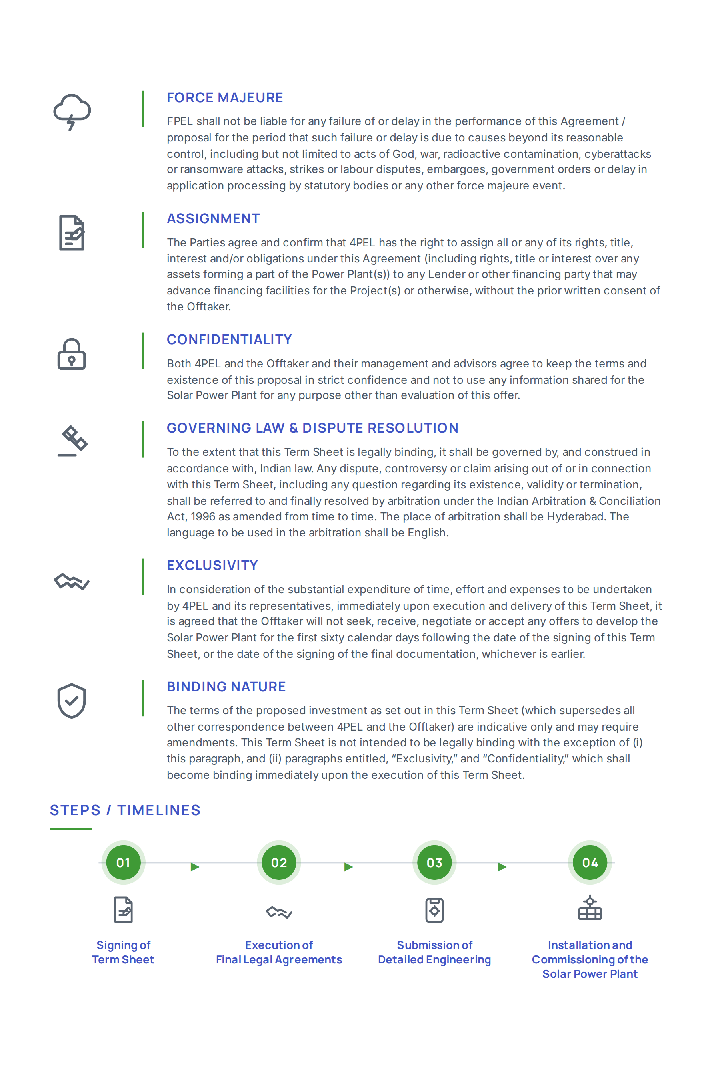

5.0 | Environmental Impact
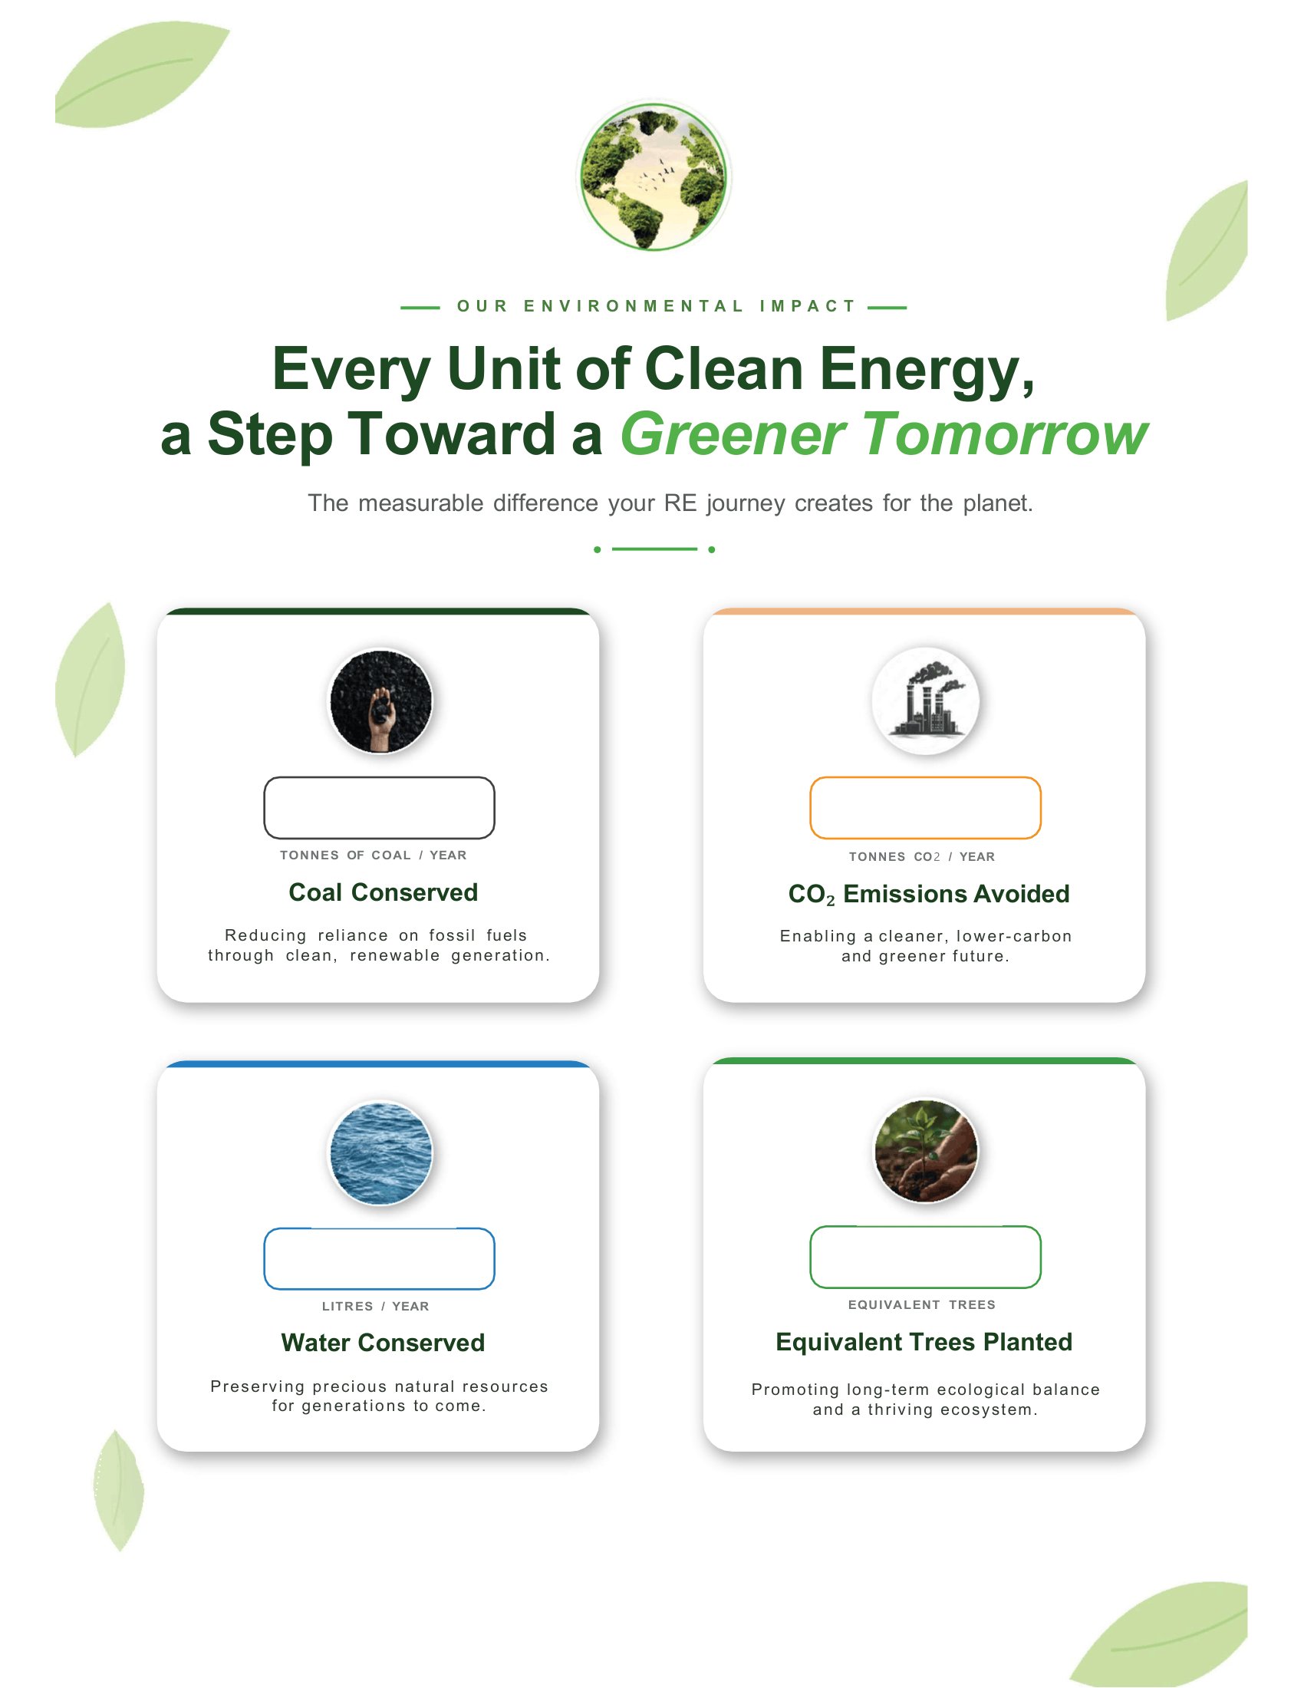

37,77,750
1,593
73,176
772

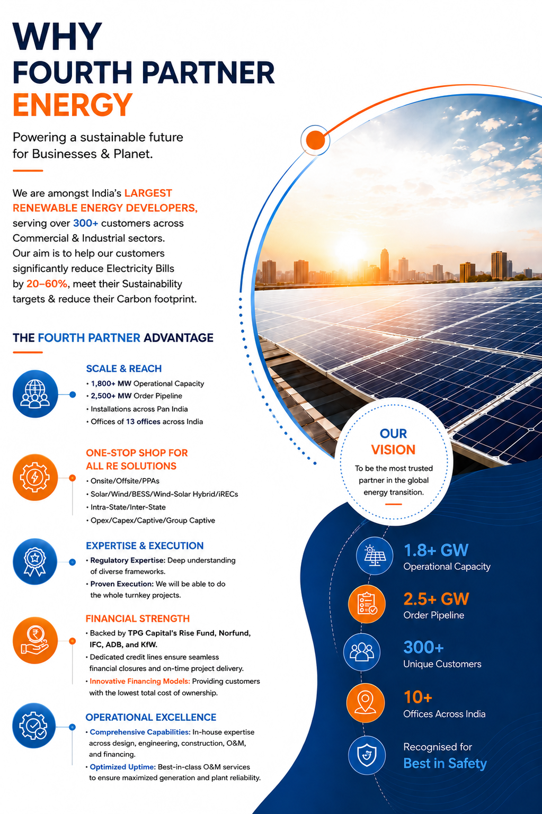

Illustrative list of our projects
Delivering reliable renewable energy solutions across diverse industries.

Company | Industry | Location | Capacity (MWp)
RSWM Textiles | Textiles | Rajasthan | 27.00 MWp
UltraTech Cements | Cements | Pan India | 12.00 MWp
Jindal India Limited | Iron & Steel | Pan India | 10.32 MWp
Bharathi Cements | Cements | Kadapa, AP | 10.00 MWp
Hyundai Motors | Auto | Chennai, TN | 10.00 MWp
Kalburgi Cements | Cements | Gulbarga, KA | 8.50 MWp
D-Mart | Retail | Pan India | 8.60 MWp
Sintex Industries | Plastics | Pan India | 6.25 MWp
Bridgestone India | Tyres | Pan India | 5.72 MWp
Hindustan Unilever | FMCG | Pan India | 5.35 MWp
Dr. Reddy's Laboratories | Pharma | Pan India | 5.30 MWp
Chettinad Cements | Cements | Solapur | 3.915 MWp
Tata Consultancy Services (TCS) | IT | Pan India | 3.84 MWp
Nilkamal Plastics | Plastics | Pan India | 3.60 MWp
Walmart India | Retails | Pan India | 3.56 MWp
Total |  |  | 500+ MWp

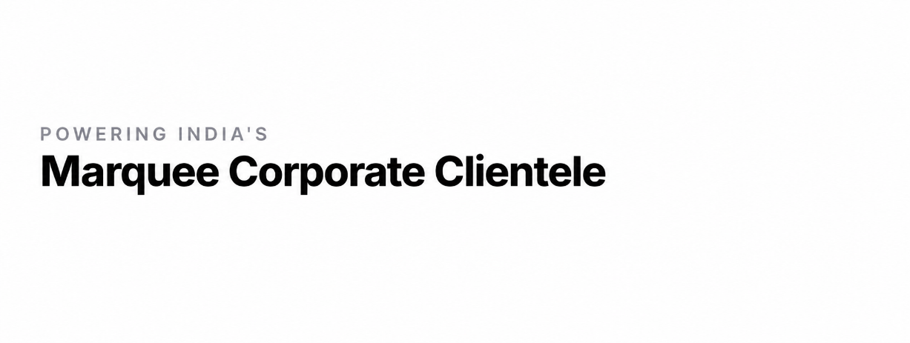


FOURTH PARTNER ENERGY PRIVATE LIMITED
No. N46, Fourth Partner House, HMT Nagar, Nacharam,
Hyderabad, Telangana 500076

Regional Offices: Hyderabad (Head Office) | Chennai | Bengaluru | Mumbai | Gurugram
1800 3000 1345 | www.fourthpartner.co | marketing@fourthpartner.co


