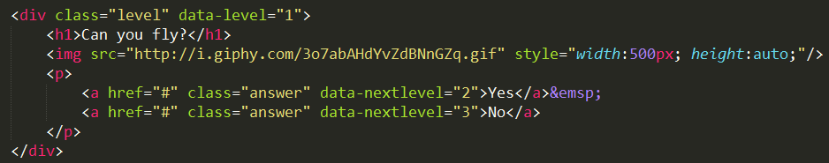

Yes

level 1

level 3

level 2

level 4

level 6

level 5

level 7

No

No

No

Yes

Yes