Object Oriented Programming Project

Production Organisation in a Warehouse

The purpose of this project is to organise the storage in a warehouse. We have 3 different kind of pieces: round, square and cylindrical pieces. Depending on their shape they need to be stored in a different storage position of the warehouse.

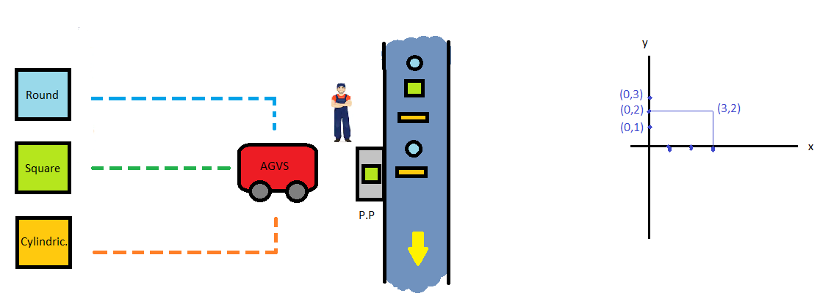
In the following image we have a map of the warehouse:

As we can see, we have 3 different storage bins where the production pieces need to be classified and stored. Their coordinates are: (0,1), (0,2) and (0,3).

Each piece has a sale price: round shape costs 10€, square shape costs 5€ whereas cylindrical shape costs 20€. Pieces can also be painted with a combination of colors and each color used increments the cost of the piece. Available colors are red (5€), green (5€), blue (5€) and gold (10€).

Several vehicles called Automated Guided Vehicle System (AGVS) are applied concurrently as a transport of the production to the different storage bins. Every AGVS moves one coordinate at a time, vertically or horizontally, and can transport at most one piece at a time. All available AGVS are stored initially in a vehicle storage with coordinates (3,3).

We have a Conveyor that brings each piece to the picking point (P.P) located at the coordinate (3,2) where it gives to the AGVS the position every piece needs to be stored depending on its shape. The conveyor moves forward when there is no piece in the P.P. because we have installed a presence detector, so the first piece in the conveyor always stays in the picking point.

When the position of the AGVS coincides with the picking point position then the AGVS takes the piece from the picking point. The AGVS receive the position the conveyor provides and then brings the piece to its corresponding storage bin. After storing the piece the AGVS returns back to the picking point.

AGVS vehicles have a limited amount of battery, so if an AGVS moves many times its battery runs out and its execution is stopped.

The entry point of the program (main) is at the Warehouse.java file. The program creates the initial state of the warehouse with three storage bins in their positions for each kind of piece, a conveyor with its picking point, some pieces randomly created added to the conveyor and some AGVS located in the vehicle storage. Then each available AGVS starts to move each piece from the picking point to its corresponding storage bin asynchronously (each AGVS with a different thread), moving from the picking point to the storage position and returning back to the picking point for each piece.

The final state of the program is every piece stored in its corresponding storage bin and all AGVS located at the picking point. However, some vehicles can be stopped halfway because they do not have enough battery to move, so in this case, some pieces may not be stored.

Object Diagram

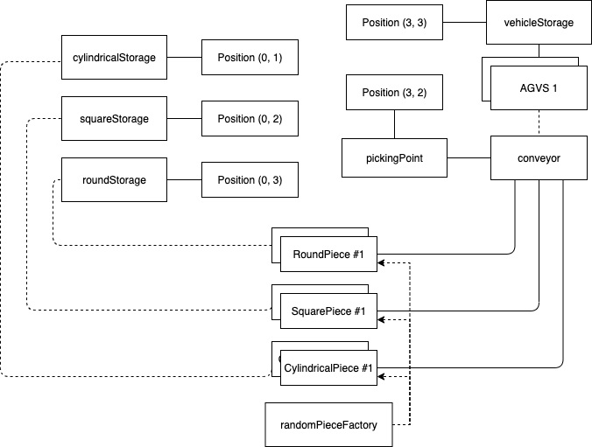

Class Diagram

Core model
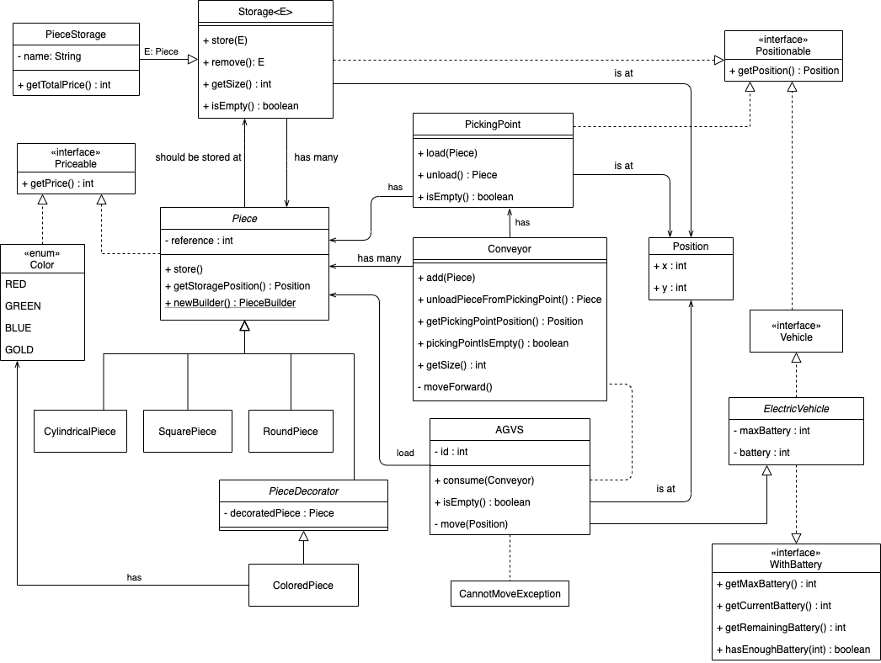
Utility classes

