AHU Anomaly - Analysis Report

The AHU anomaly detection function inputs AHU- and zone-level HVAC network trendlog data and **detects hard and soft faults related to AHUs.** This function is intended to help the user identify potential causes for anomalous AHU operations which may cause energy use inefficiencies. The accompanying visualizations are intended to aid understanding of the detected faults. These depict supply air temperature, and the coolest/warmest/average return air temperatures as a function of outdoor air temperature, and damper and valve actuator positions as a function of outdoor air temperature. Additionaly, a number of diagrams are generated which depict damper and valve actuator positions and temperature readings at characteristic AHU operational periods. More informations is available at the respective sections.

# Visualizations - Split-range controller

A set of two charts are generated for each AHU inputted. The top chart depicts supply air temperature, and the coolest/warmest/average return air temperatures as a function of outdoor air temperature. For reference, the "ideal" supply air temperature is depicted.  
  
The bottom chart is a Split-range controller diagram, which plots damper and valve actuator positons and average fraction of active perimeter heaters per zone as a function of outdoor air temperature. The four underlaying color zones represent the four distinct operating mode: Heating (red zone) , economizer (yellow zone), economizer with cooling (grey zone), and cooling (blue zone). For reference, the below Split-range controller diagram is a typical example of normal AHU operations.

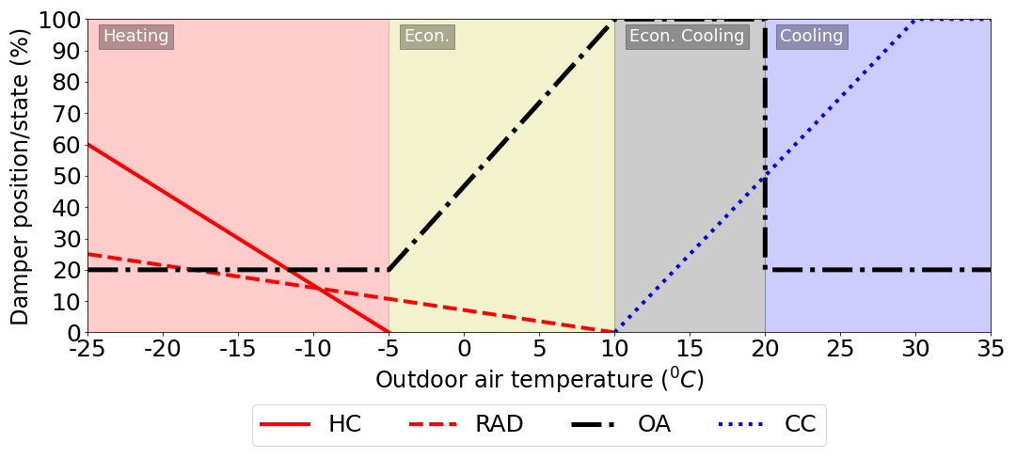

## AHU: ahu1.csv



## AHU: ahu2.csv



# Visualizations - Snapshots of AHU operating periods

A set of four to six visuals per AHU are generated which depict characteristic operating periods of the AHU and the average damper/valve positions and temperatures at those periods. The fraction of time of operation is the percentage of the total time of the AHU's operation which exhibit the following damper/valve positions and temperatures.

## AHU: ahu1.csv

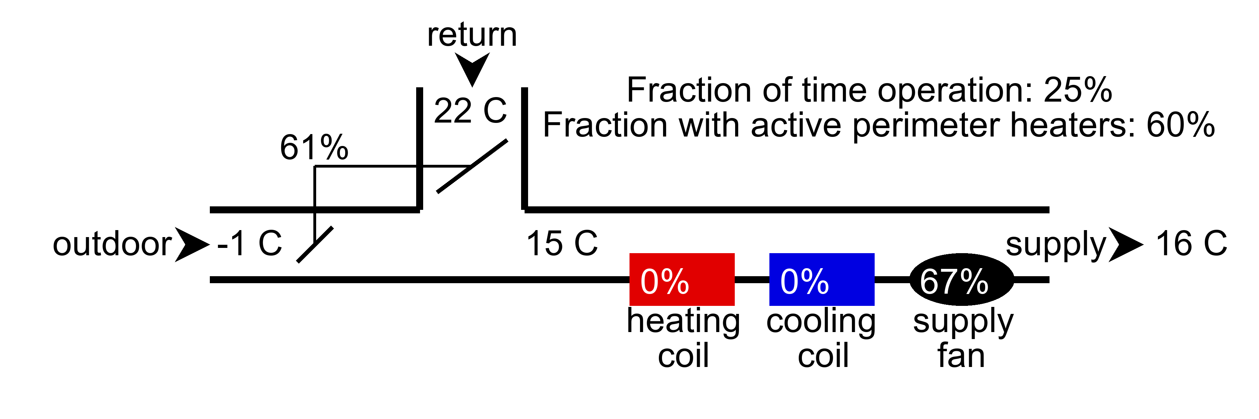

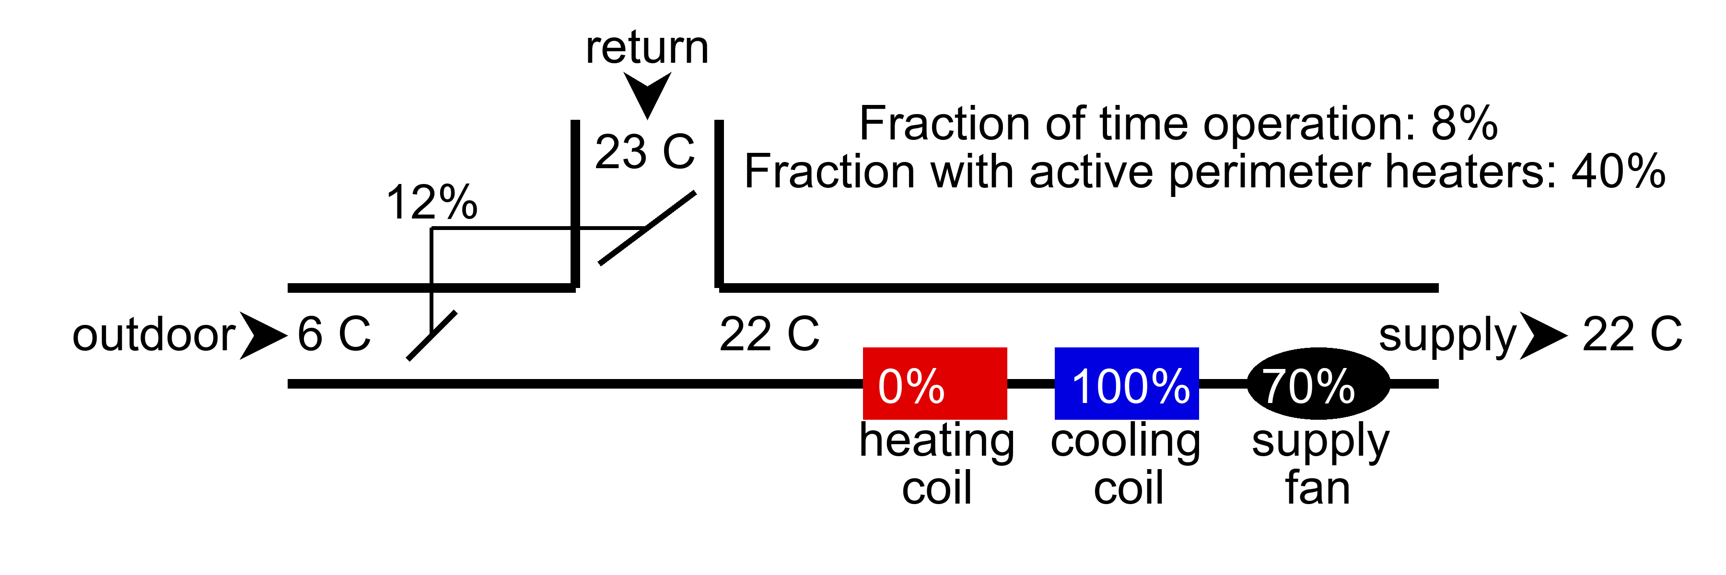

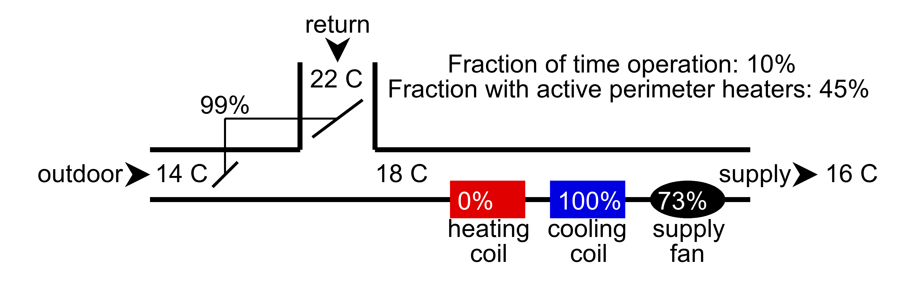

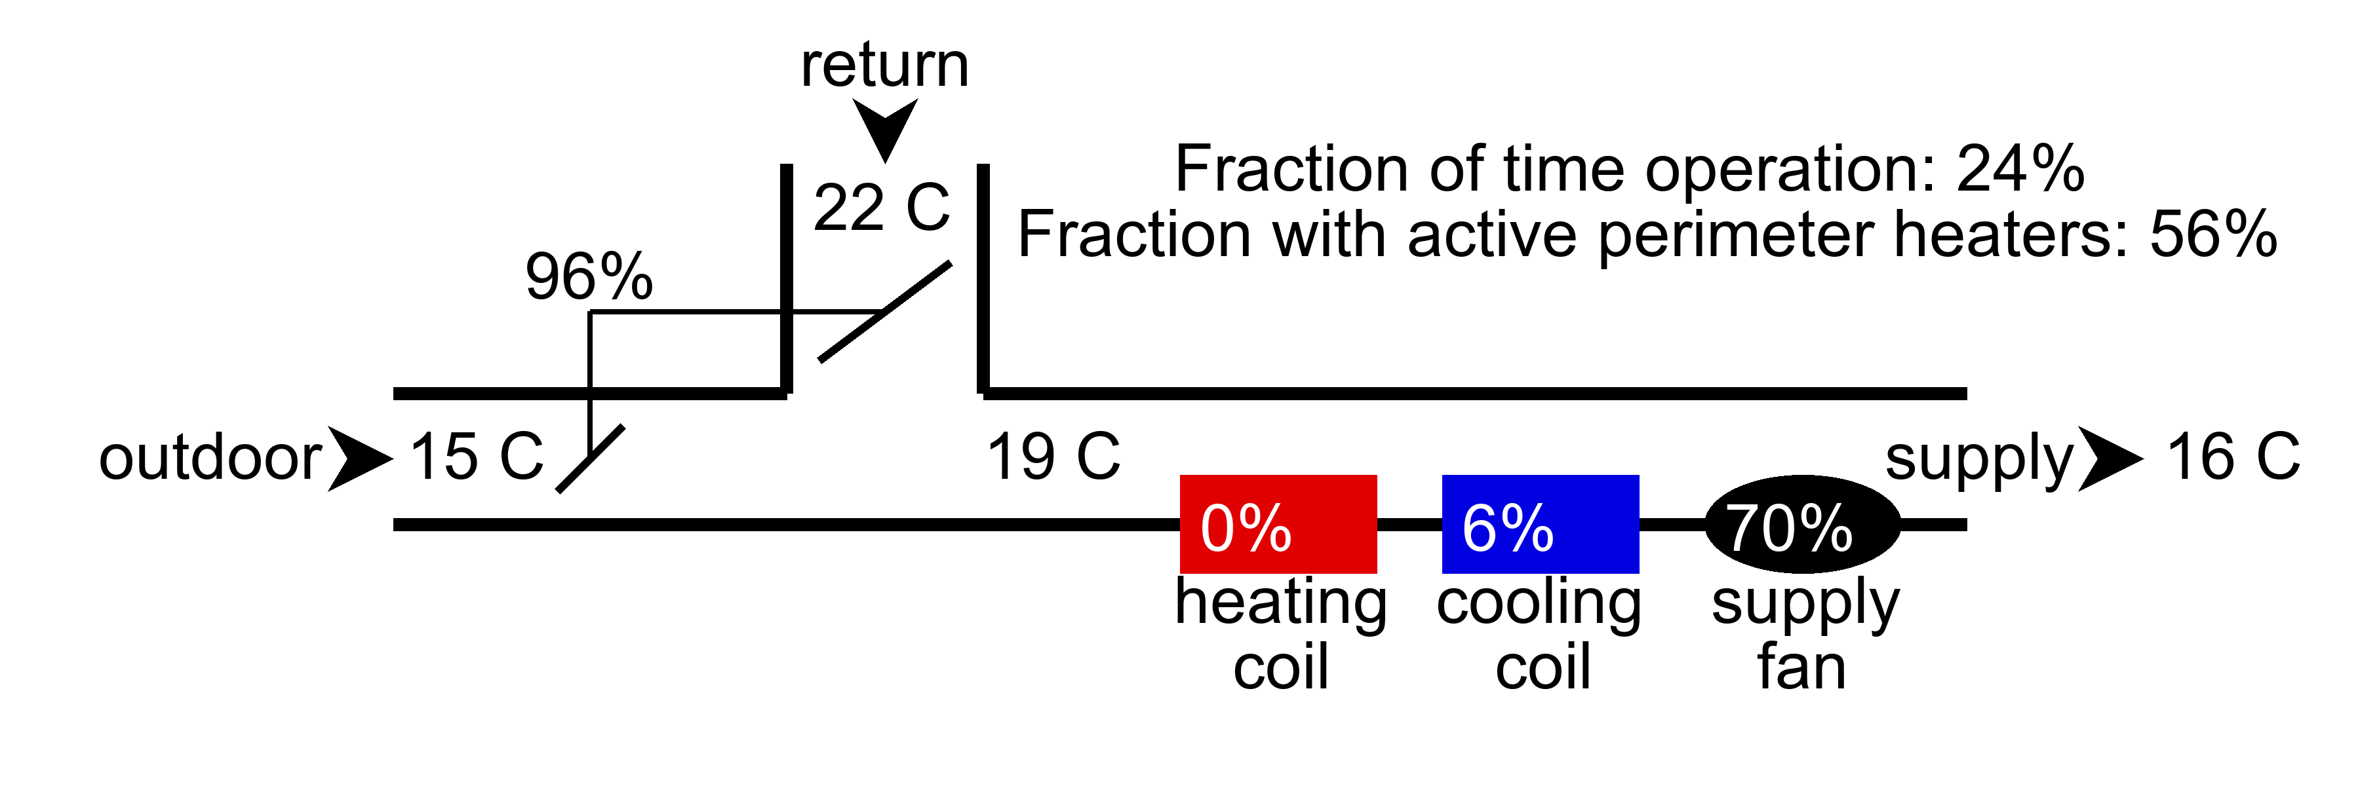

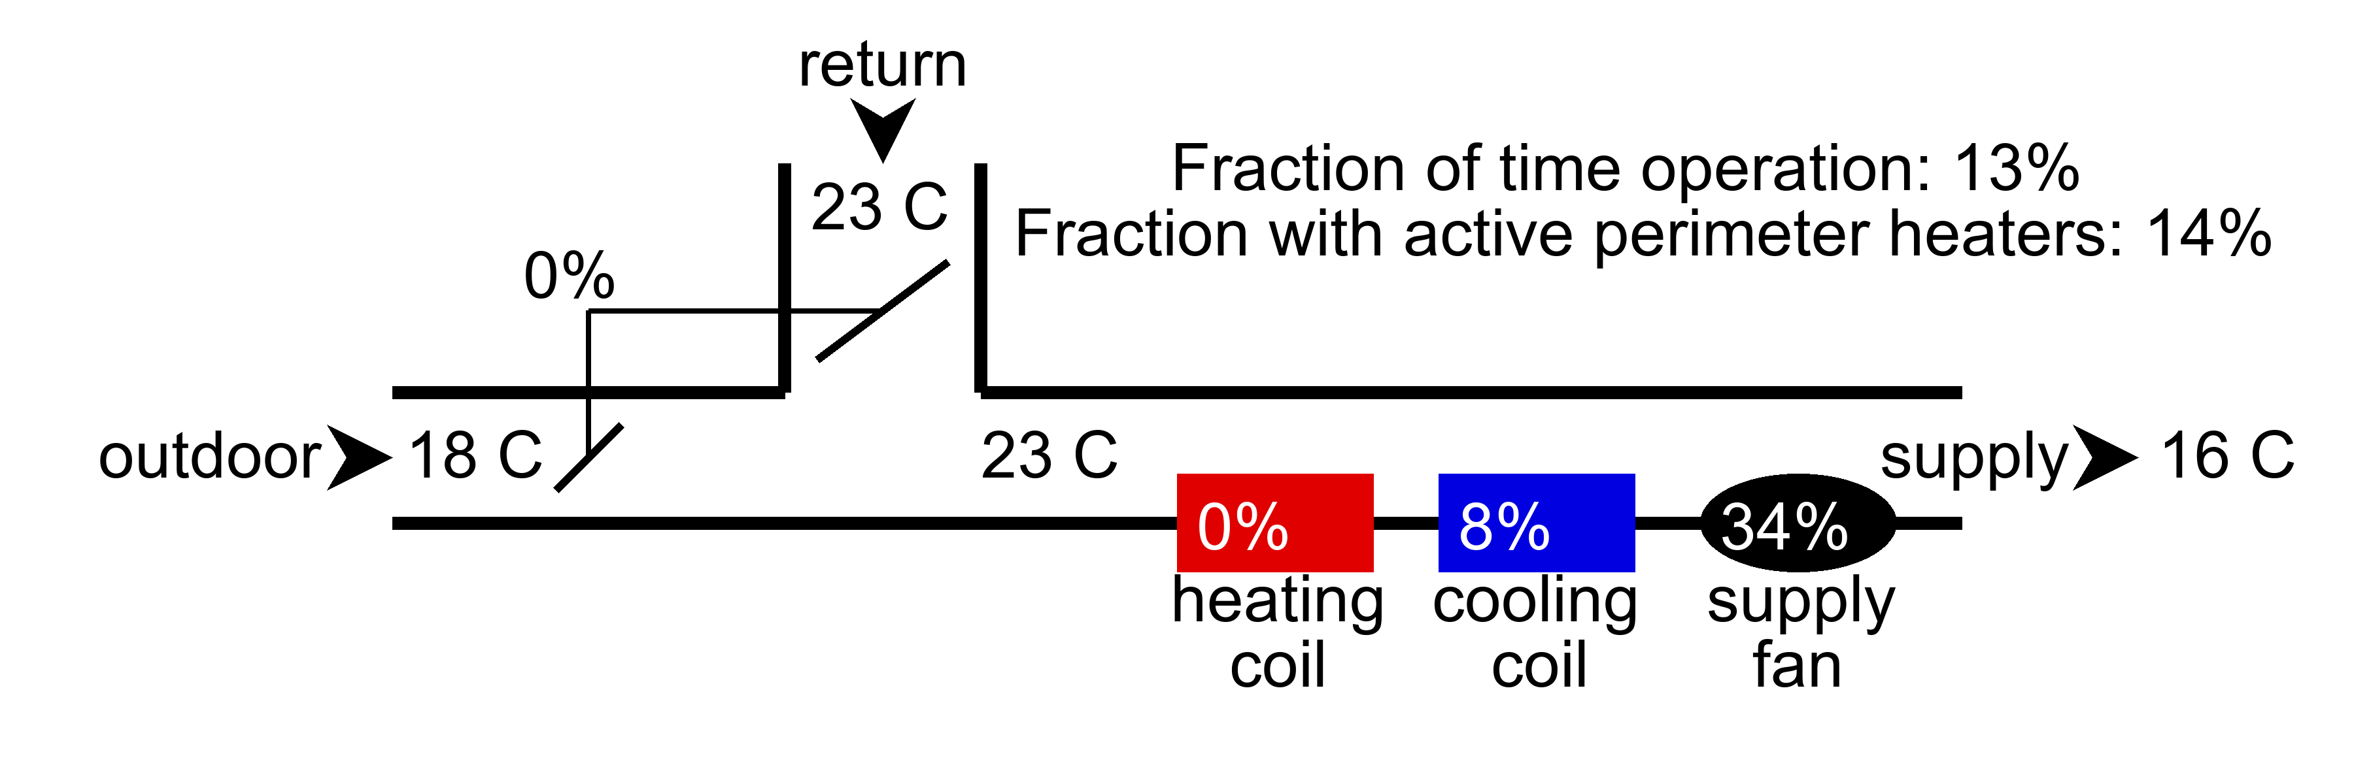

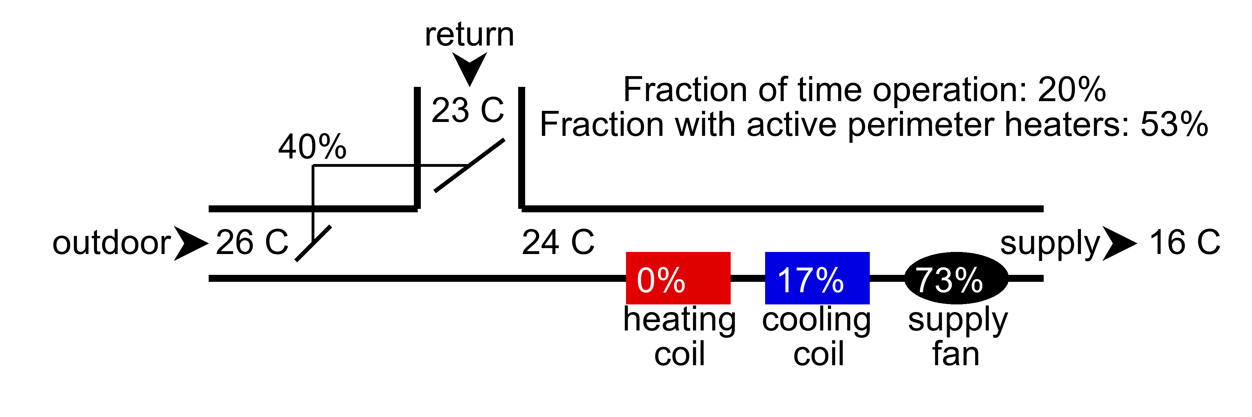

## AHU: ahu2.csv

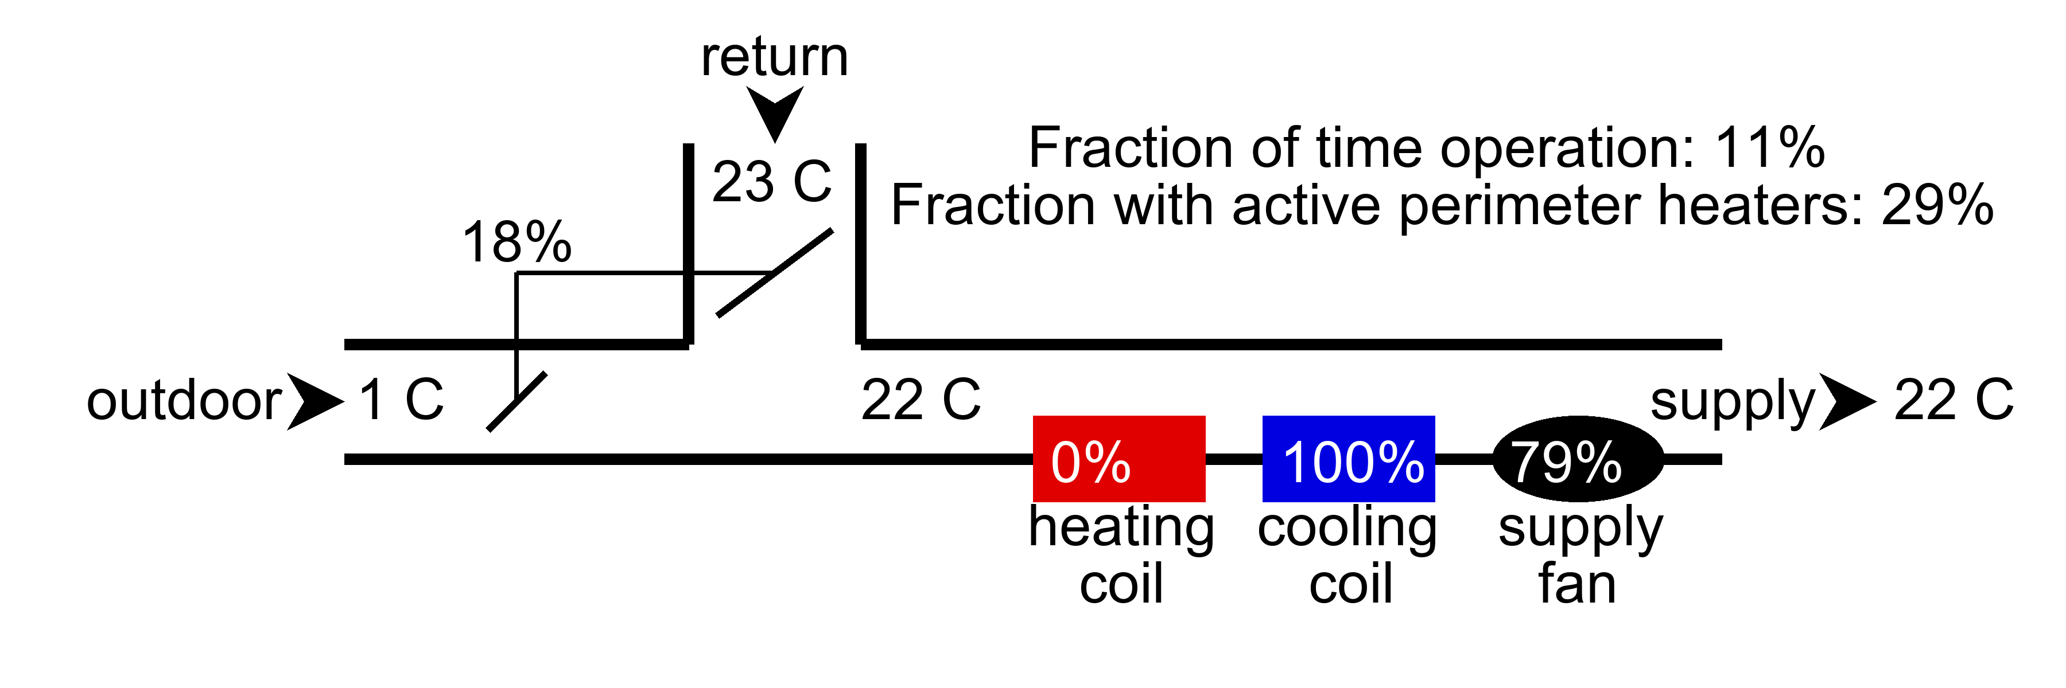

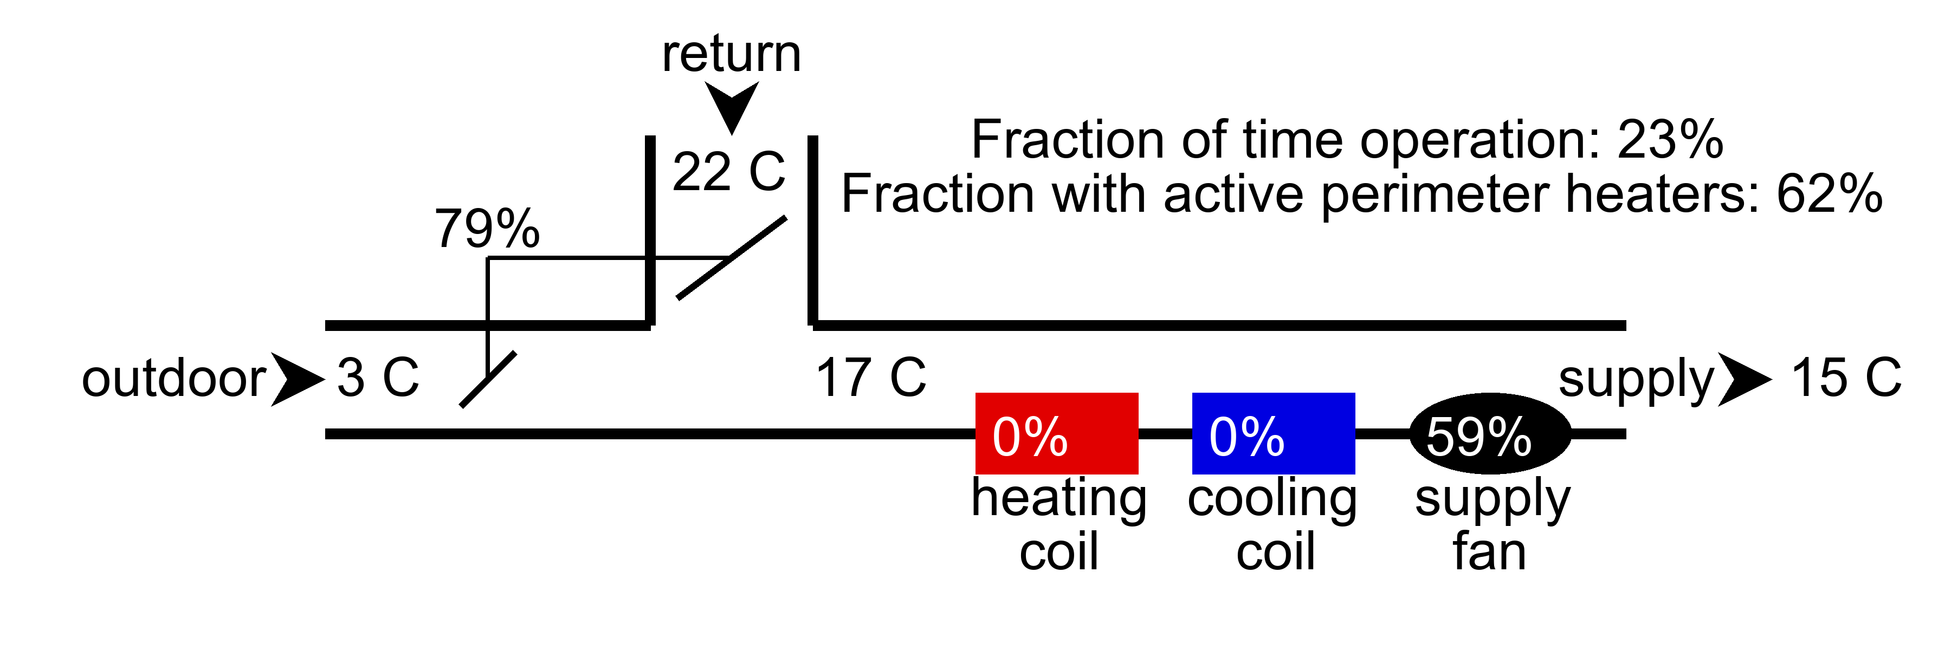

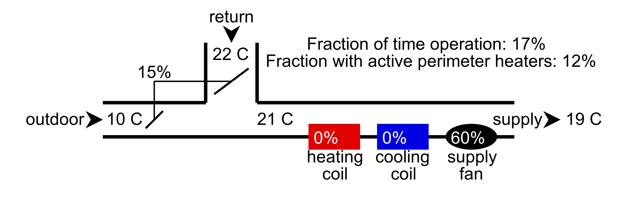

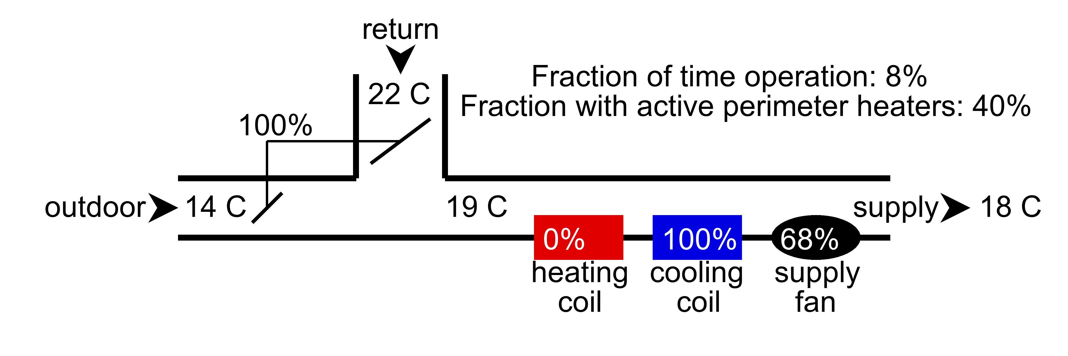

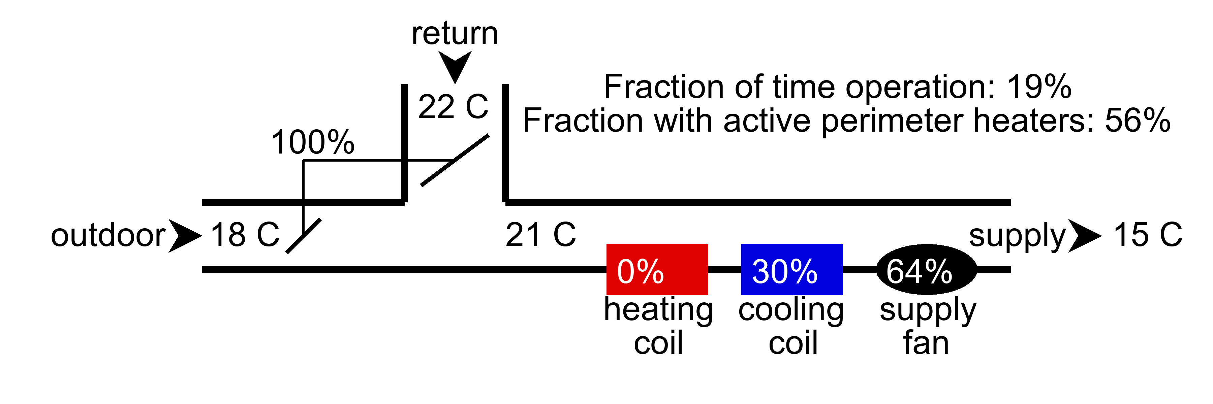

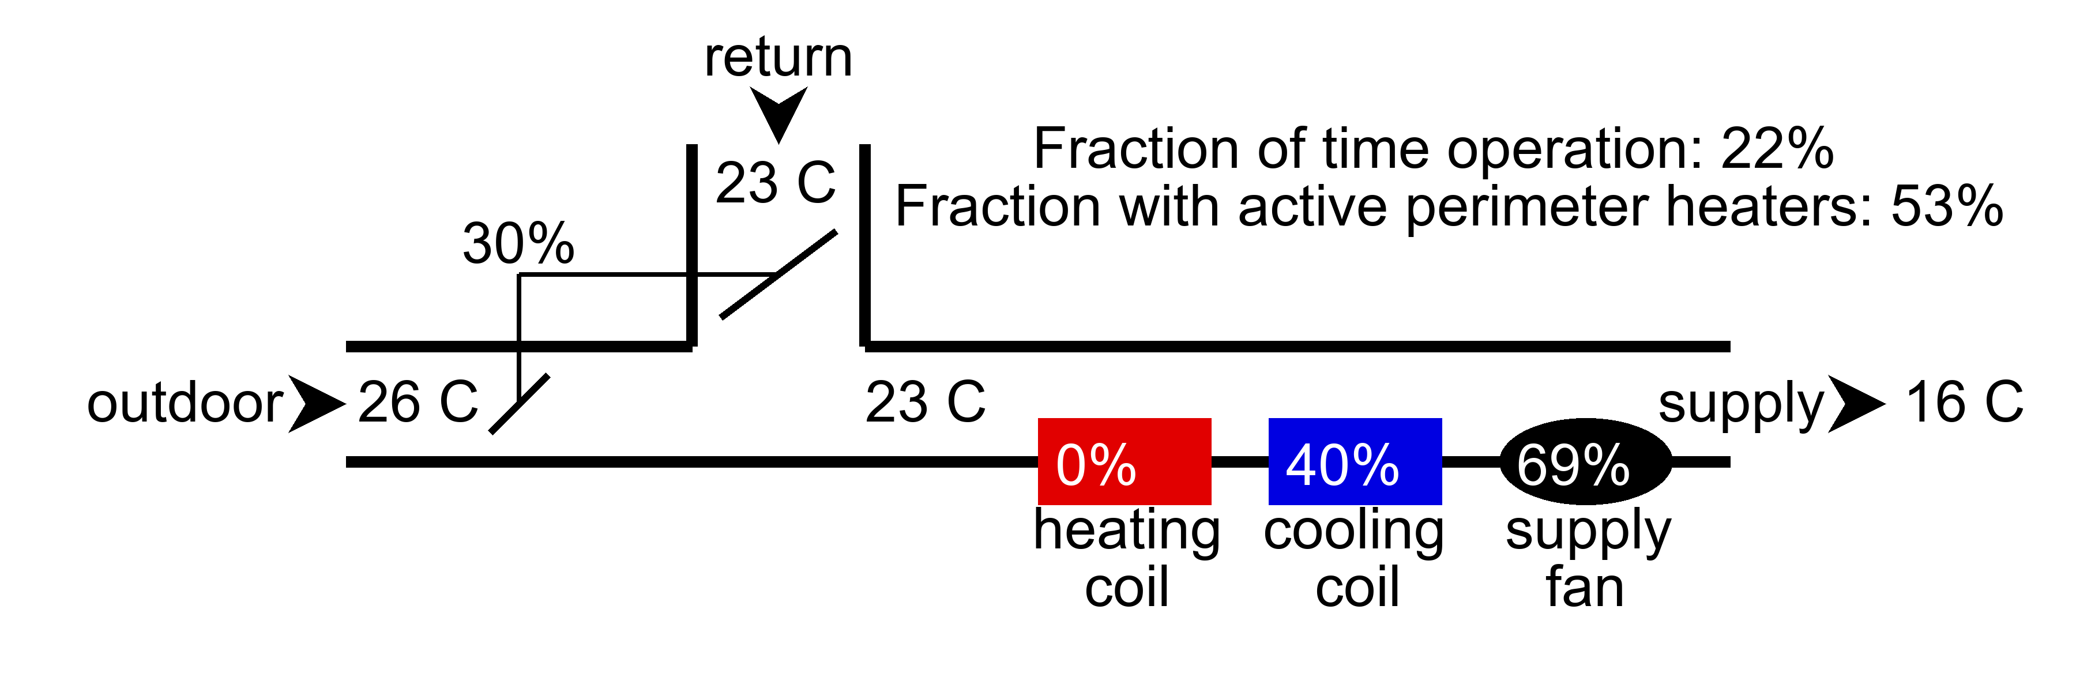

## AHU faults and anomalies

|  |  |  |  |  |  |  |  |
| --- | --- | --- | --- | --- | --- | --- | --- |
| AHU | AHU Health Index | Cooling coil | Economizer | Heating Coil | Outdoor Air Damper | Schedule | Supply air temperature |
| ahu1.csv | 50 | Normal | Normal | Stuck | Normal | Check mode of operation logic | Check supply air temperature reset logic |
| ahu2.csv | 50 | Normal | Normal | Stuck | Normal | Check mode of operation logic | Check supply air temperature reset logic |