Occupancy - Analysis Report

The occupancy function inputs Wi-Fi device count data and determines typical **earliest arrival times, latest departure times,** and **highest recorded occupancy** for weekdays and weekends separately. This report outputs the results of the function and a set of visualizations illustrating building-level and floor-level occupant count profiles.

# Visualizations

The first set of visualizations are building-level hourly occupant count profiles for weekdays and weekends separately. The profiles are shown as the 25th, 50th (median), and 75th percentile whereby the 25th percentile represents the lower range of typical occupancy and the 75th represents the higher range. The second set of visualizations are occupant count profiles taken at the 75th percentile and broken down by floor.

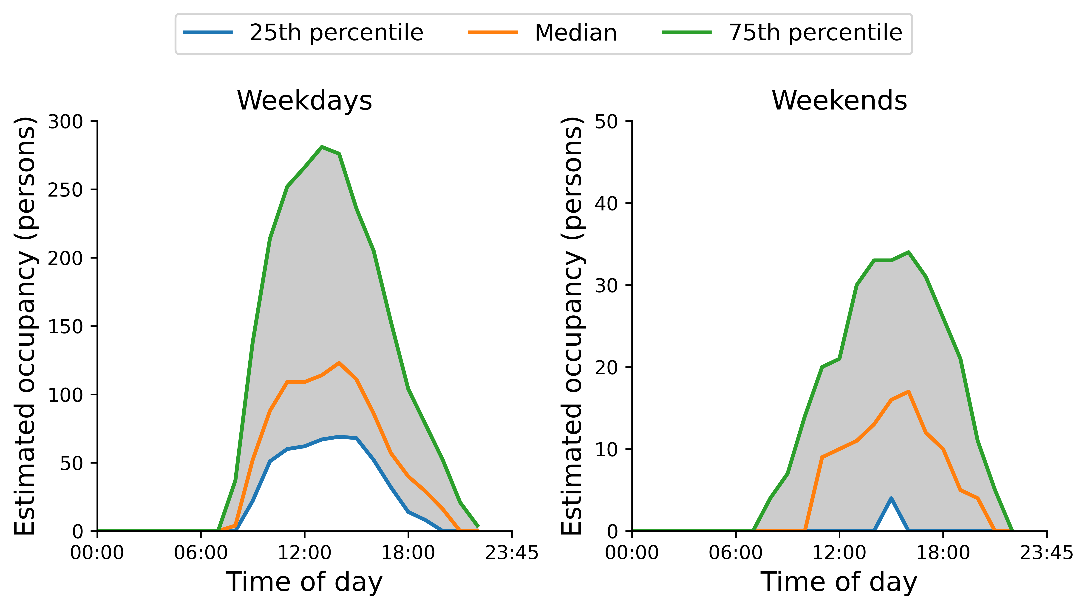

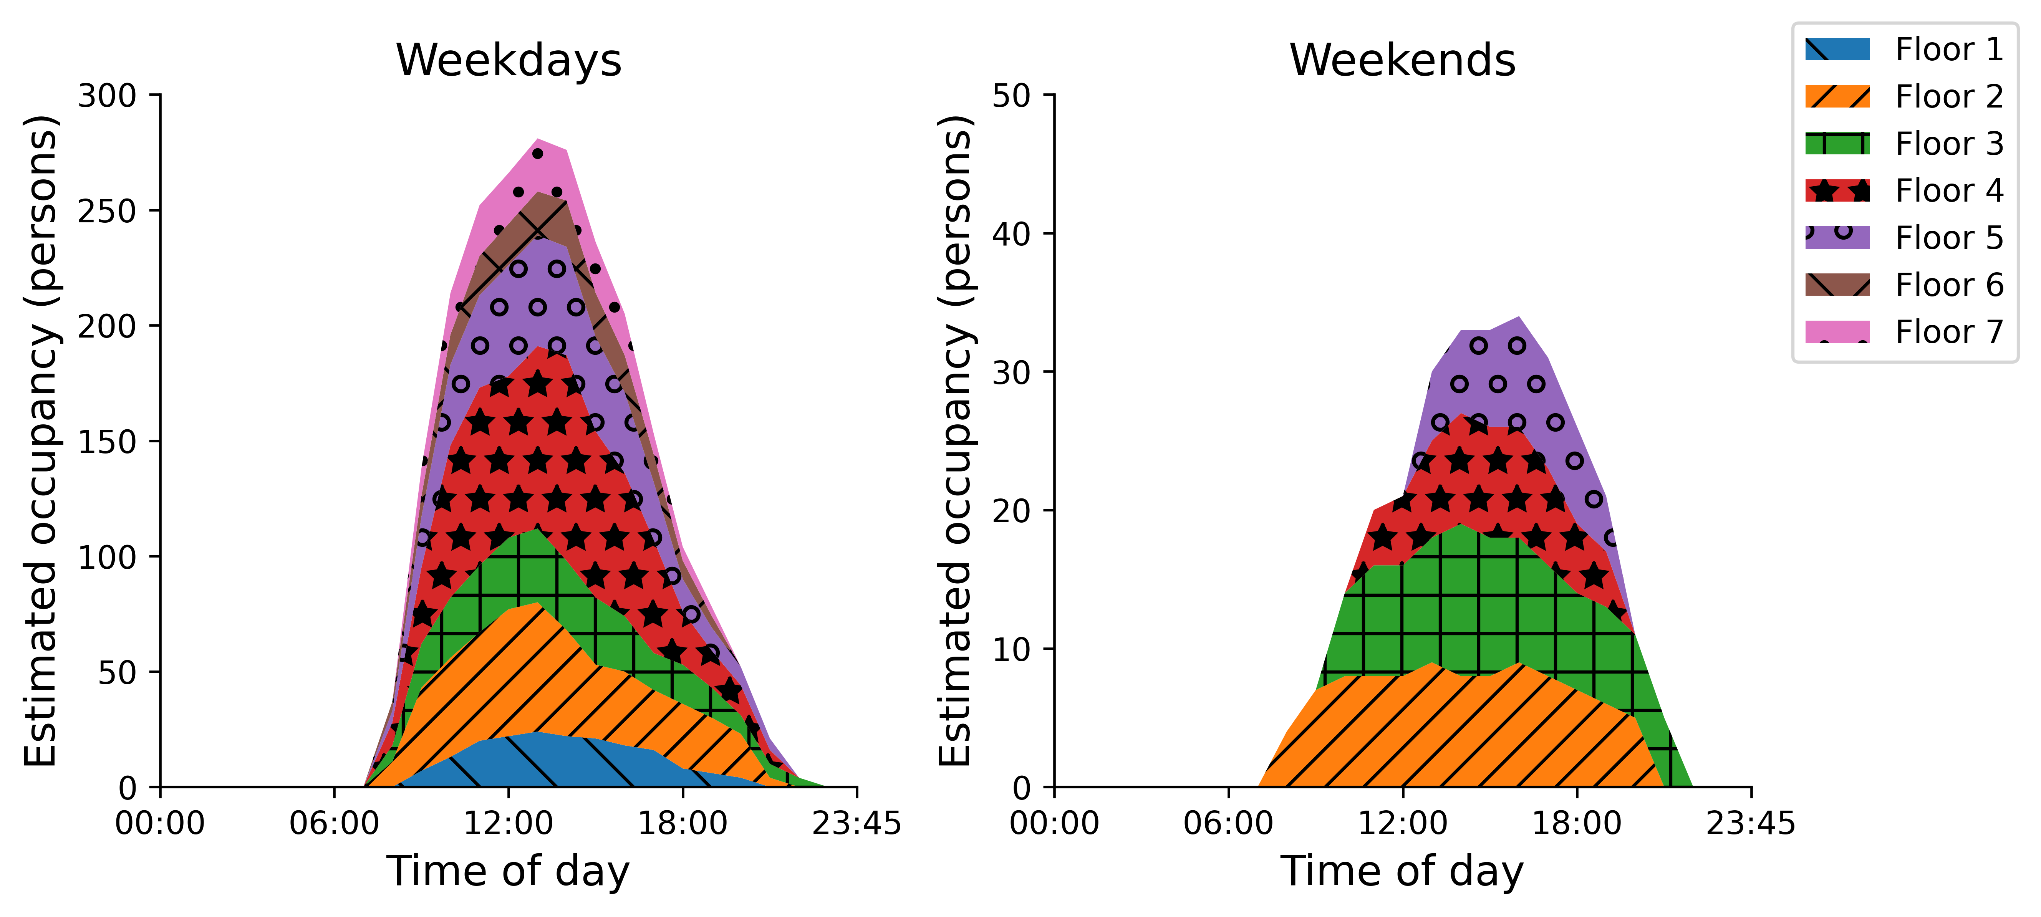

# Key performance Indicators

This section presents the generated KPIs - **typical earliest arrival times, latest departure times, and highest occupant count** which are broken down by floor and determined sparately for weekdays and weekends. Typical earliest arrival times are determined at the hour whereby the 75th percentile occupant count exceeds 10% of the maximum recorded count per floor. Similiarily, typical latest departure times are determined whereby the 75th percentile occupant count dips below 10% of the maximum recorded count per floor. The highest occupant is taken as the highest recorded occupant count at the 75th percentile.

## Earliest arrival times, latest departure times, and highest occupant count

|  |  |  |  |  |  |  |
| --- | --- | --- | --- | --- | --- | --- |
| Floor | Weekday earliest arrival time (hours after midnight) | Weekday latest departure time (hours after midnight) | Weekday highest occupant count | Weekend earliest arrival time (hours after midnight) | Weekend latest departure time (hours after midnight) | Weekend highest occupant count |
| 1.0 | 8.0 | 19.0 | 24.0 | nan | nan | 0.0 |
| 2.0 | 7.0 | 19.0 | 56.0 | 7.0 | 19.0 | 9.0 |
| 3.0 | 7.0 | 21.0 | 32.0 | 9.0 | 20.0 | 11.0 |
| 4.0 | 7.0 | 19.0 | 89.0 | 10.0 | 18.0 | 8.0 |
| 5.0 | 7.0 | 20.0 | 48.0 | 12.0 | 18.0 | 8.0 |
| 6.0 | 7.0 | 18.0 | 20.0 | nan | nan | 0.0 |
| 7.0 | 8.0 | 18.0 | 23.0 | nan | nan | 0.0 |