Occupancy (Wi-Fi device count) - Analysis Report

The occupancy function determines typical **earliest arrival times, latest departure times,** and **highest recorded occupancy** for weekdays and weekends separately. This function can be used to inform ventilation schedules which can minimize excessive ventilation during unoccupied hours, or even serve as a bssis for an occupant-driven demand controlled ventilation scheme. Visuals plot building-level and floor-level occupant count profiles.

# Visuals - Building-level occupant count

This set of visuals plots hourly building-level occupant count profiles for weekdays (to the left) and weekends (to the right) separately. The profiles are shown as the 25th, 50th (median), and 75th percentile. The 25th percentile represents the lower range of typical occupancy and the 75th represents the higher range. The second set of visualizations are occupant count profiles taken at the 75th percentile and broken down by floor.

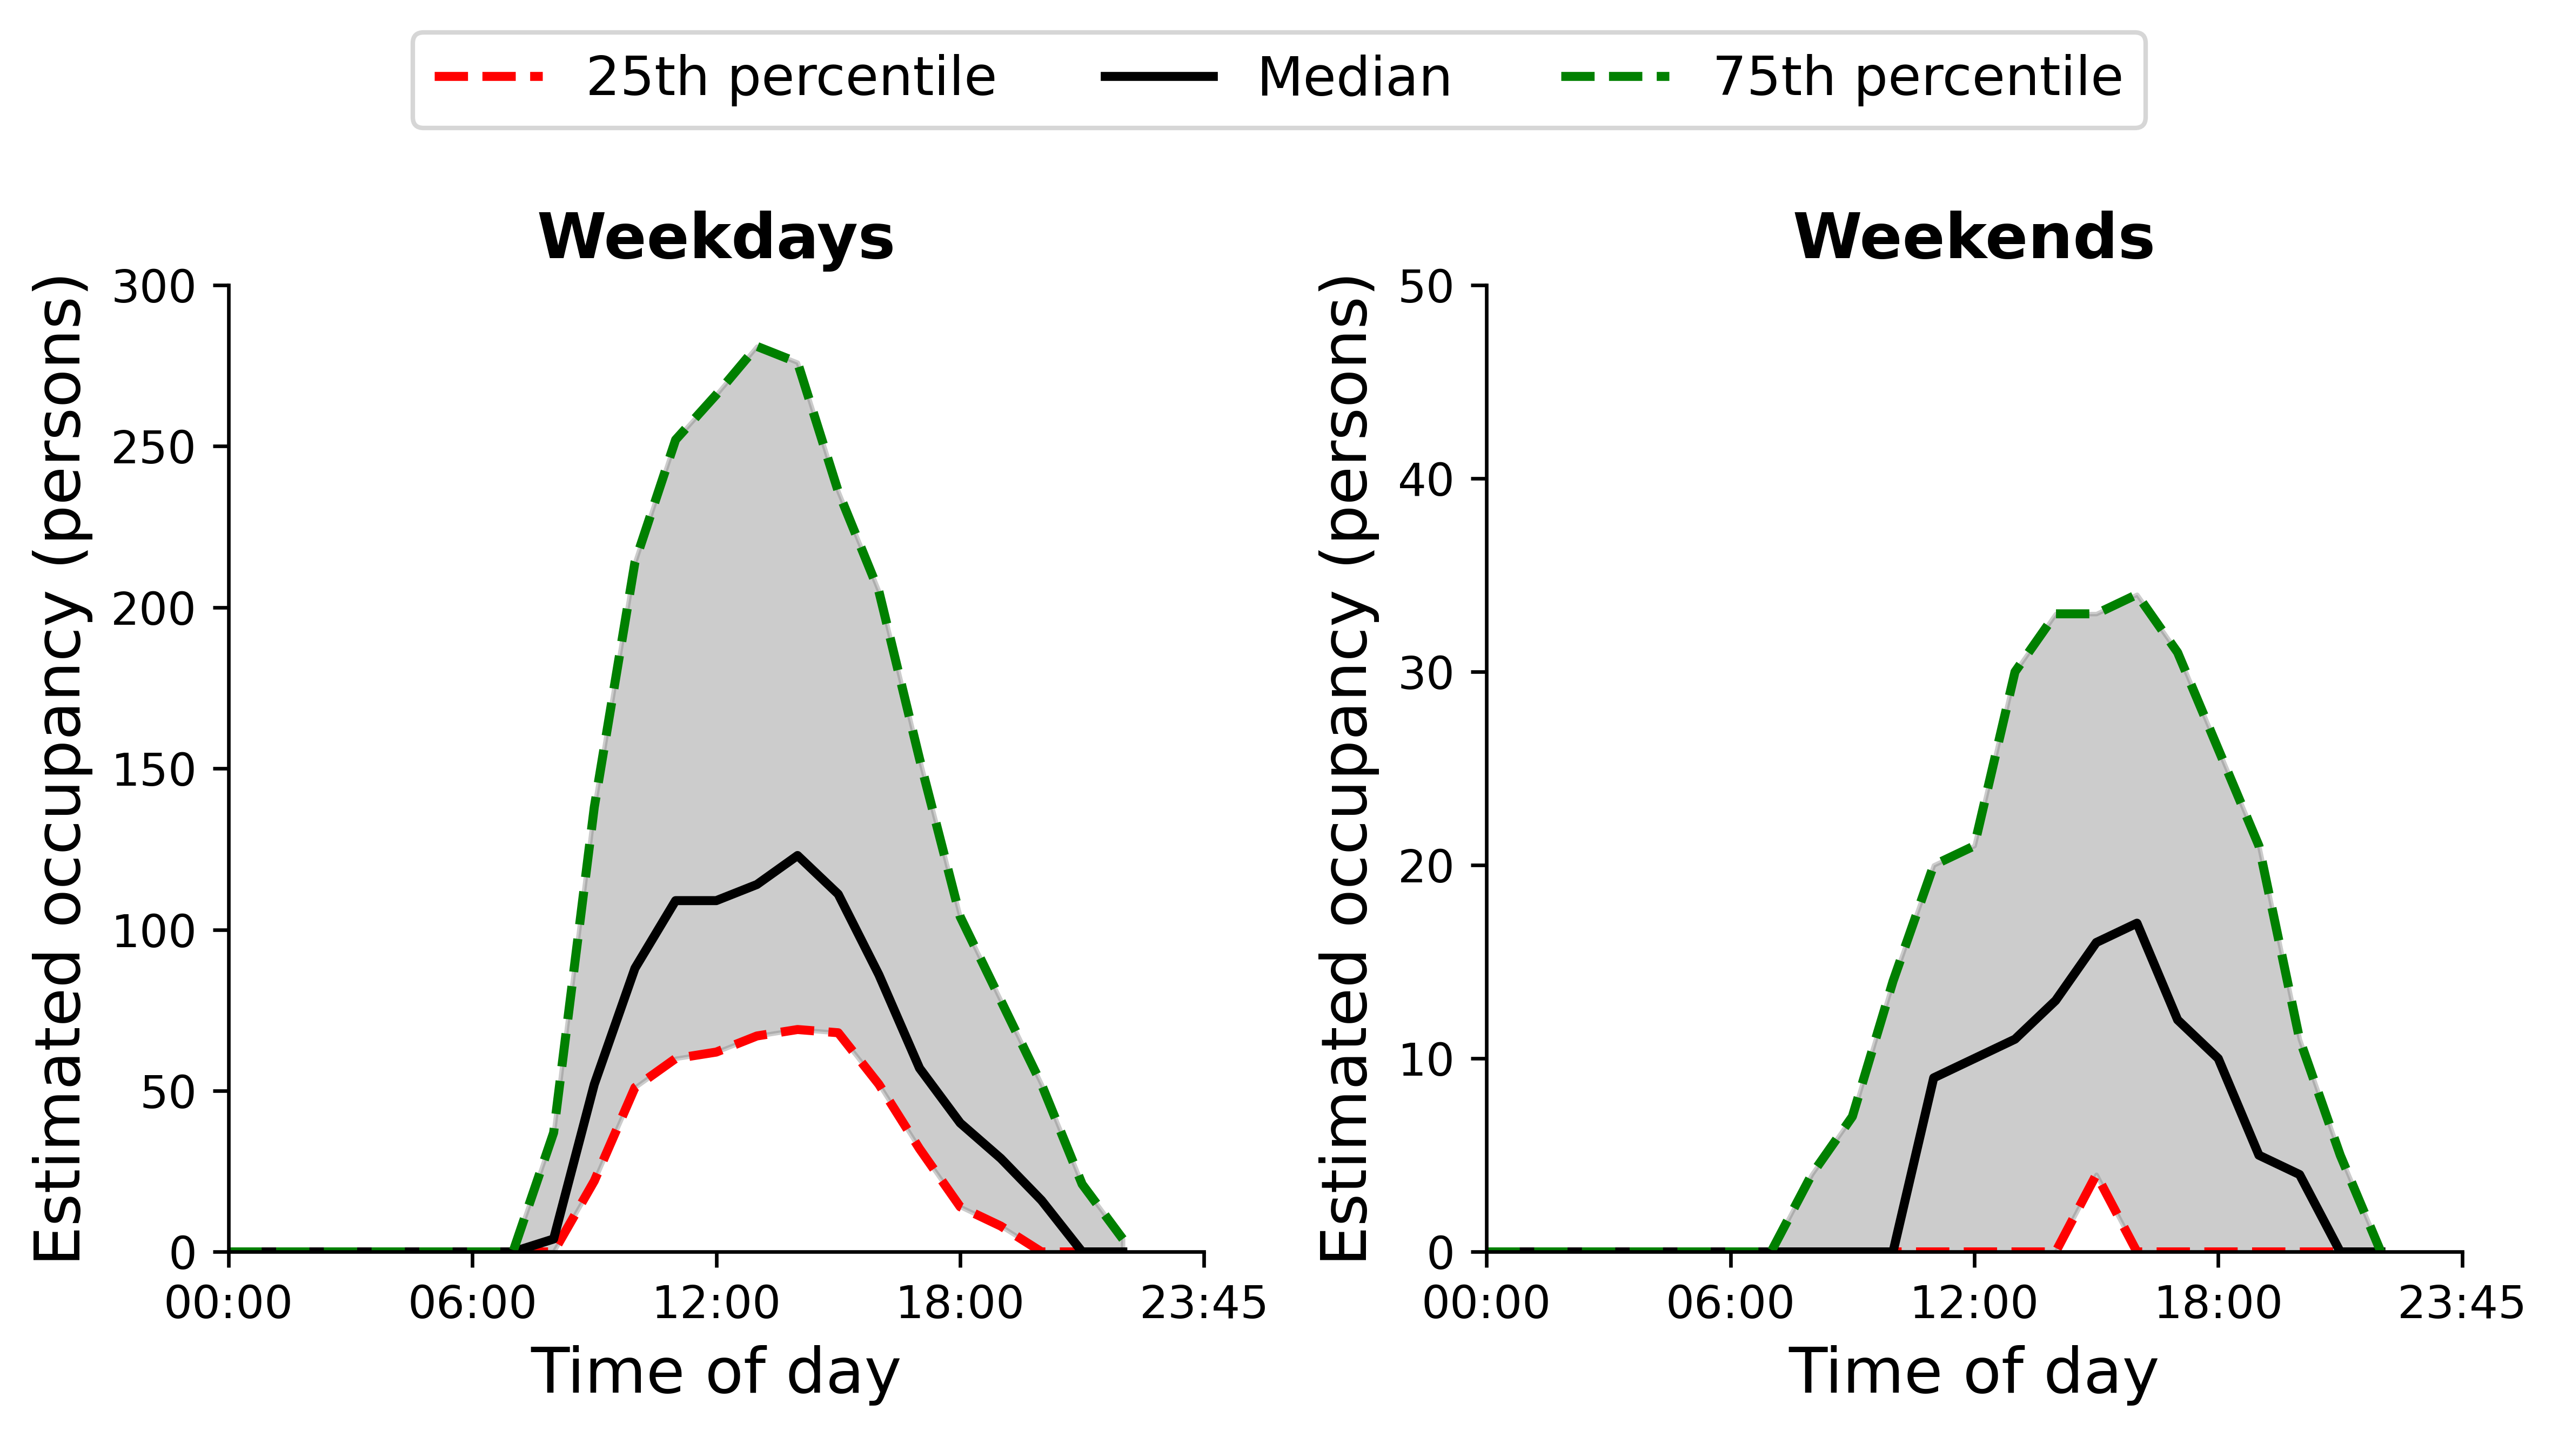

# Visuals - Floor-level occupant count

This set of visuals plots hourly floor-level occupant count profiles for weekdays (to the left) and weekends (to the right) separately. The profiles are broken down by floor and are shown as the 75th, which is the higher range of typical occupancy.

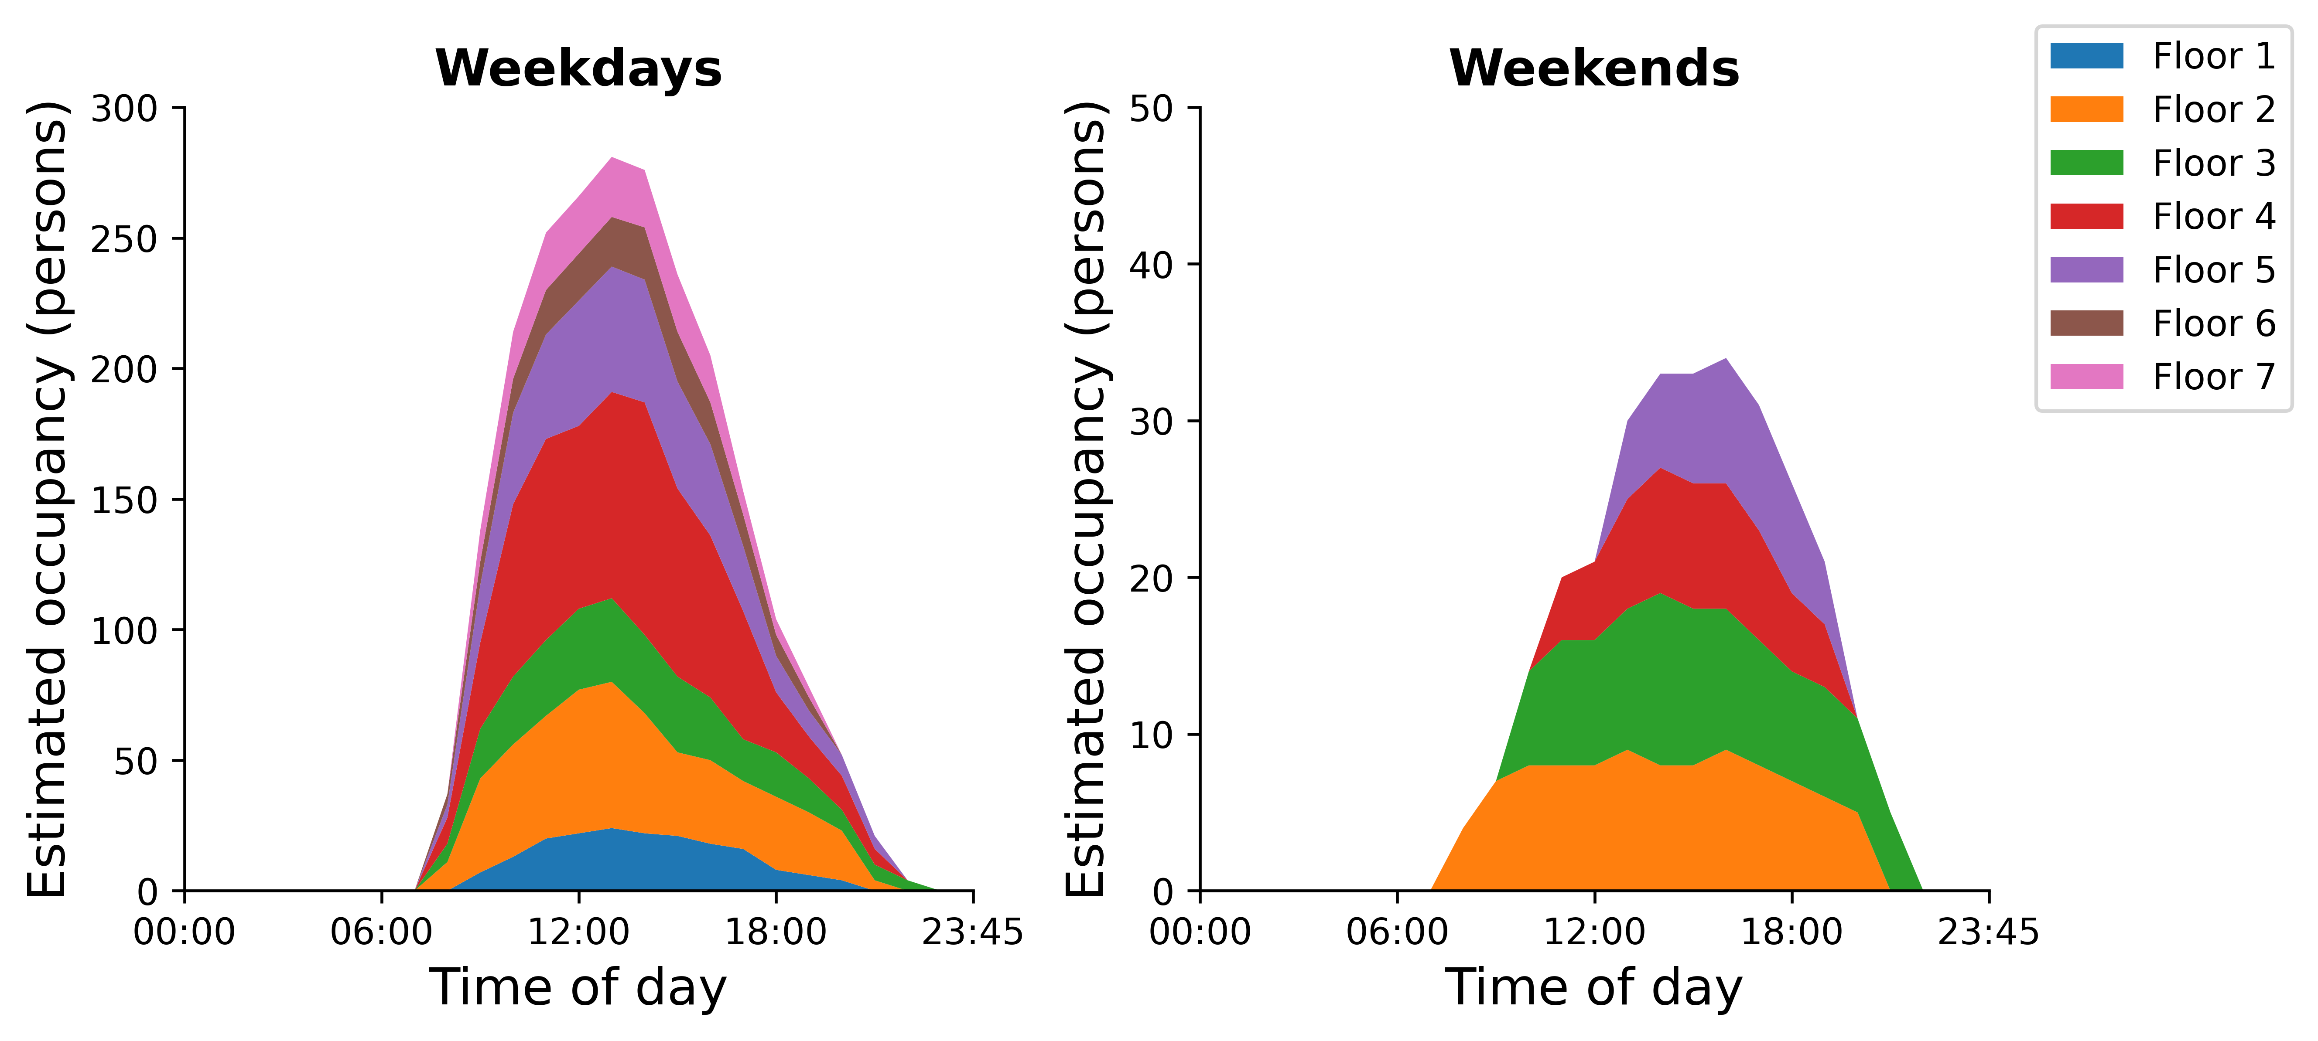

# Key performance Indicators

This section presents the generated KPIs - **typical earliest arrival times, latest departure times, and highest occupant count** which are broken down by floor and determined sparately for weekdays and weekends. The typical earliest arrival time is the hour when the occupant count exceeds 10% of the maximum recorded count per floor. Similiarily, the typical latest departure time is the hours when occupant count dips below 10% of the maximum recorded count per floor. The highest occupant count is taken as the highest recorded occupant count. Note all these calculations are determined at the 75th percentile, meaning the higher range of typical occupancy.

## Earliest arrival times, latest departure times, and highest occupant count

|  |  |  |  |  |  |  |
| --- | --- | --- | --- | --- | --- | --- |
| Floor | Weekday earliest arrival time (hours after midnight) | Weekday latest departure time (hours after midnight) | Weekday highest occupant count | Weekend earliest arrival time (hours after midnight) | Weekend latest departure time (hours after midnight) | Weekend highest occupant count |
| 1 | 8 | 19 | 24 |  |  | 0 |
| 2 | 7 | 19 | 56 | 7 | 19 | 9 |
| 3 | 7 | 21 | 32 | 9 | 20 | 11 |
| 4 | 7 | 19 | 89 | 10 | 18 | 8 |
| 5 | 7 | 20 | 48 | 12 | 18 | 8 |
| 6 | 7 | 18 | 20 |  |  | 0 |
| 7 | 8 | 18 | 23 |  |  | 0 |