Occupancy - Analysis Report

The occupant complaints function inputs occupant complaints logs and weather data and determines the **daily frequency of hot/cold-related occupant complaints.** Visualizations are generated which depict the distribution of complaints by month and by the period of the day by which the complaint was registered, the relationship of hot/cold complaints to indoor and outdoor air temperature, and the predicted proportion of the cold/hot complaints based on time of day, day of the week, and outdoor air temperature

# Occupant complaints breakdown

The first set of visualizations categorize the complaints by the type of complaint (hot or cold related), and quanitify the number of complaints by the month and period of the day the complaint was registered.

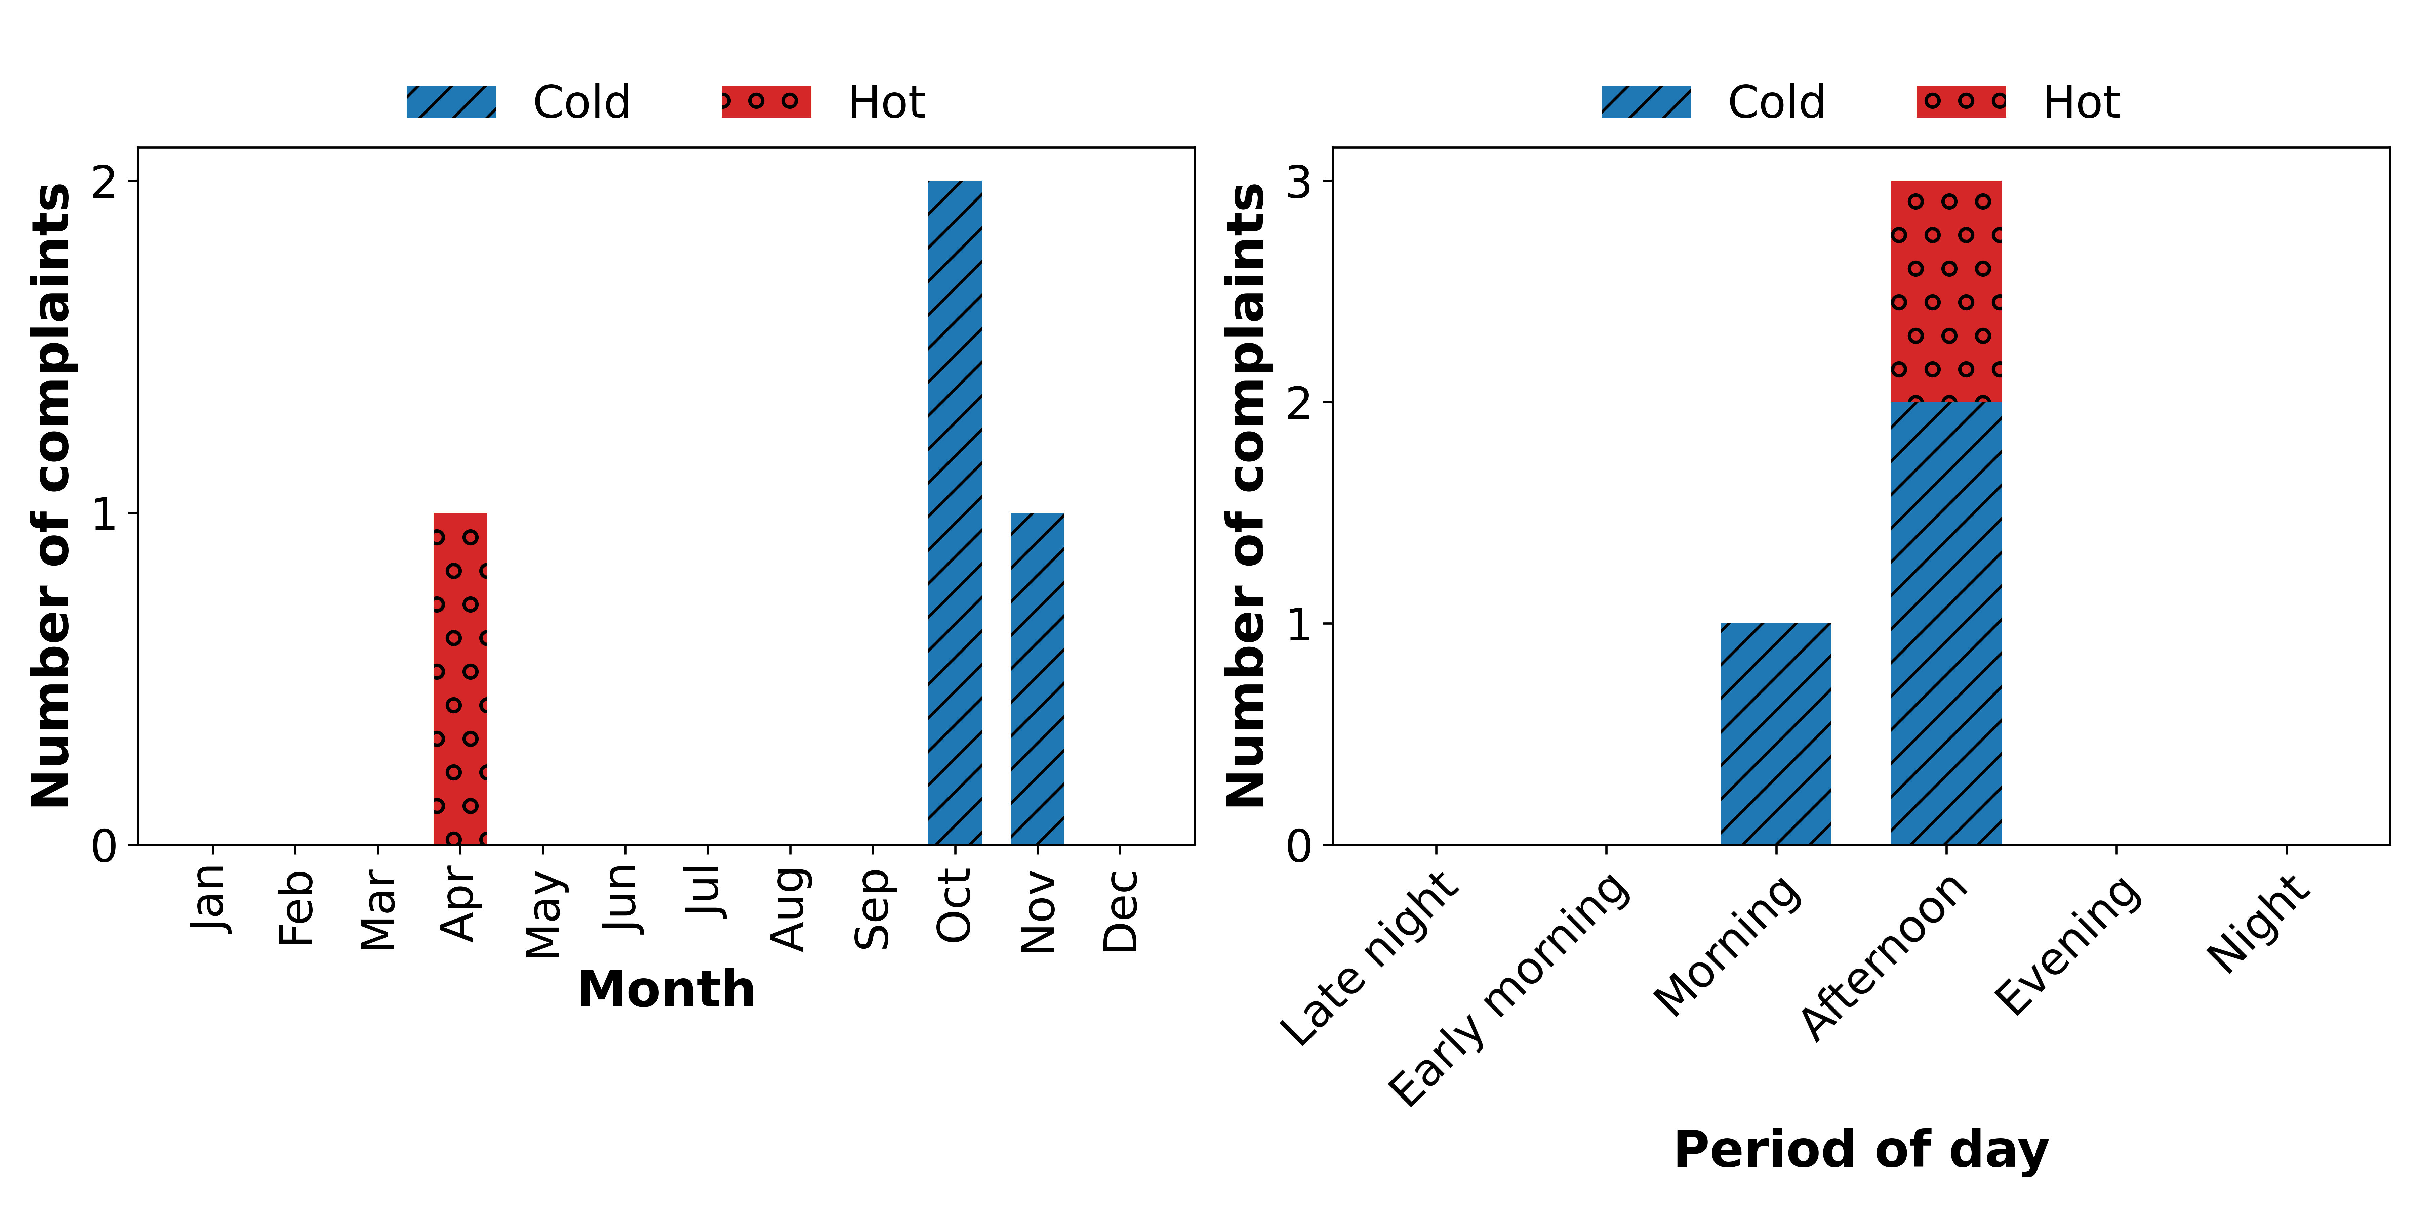

# Occupant complaints with indoor/outdoor air temperature

The second visualization depicts the relationship between a hot/cold complaint and the indoor and outdoor air temperature at the time the complaint was registered.

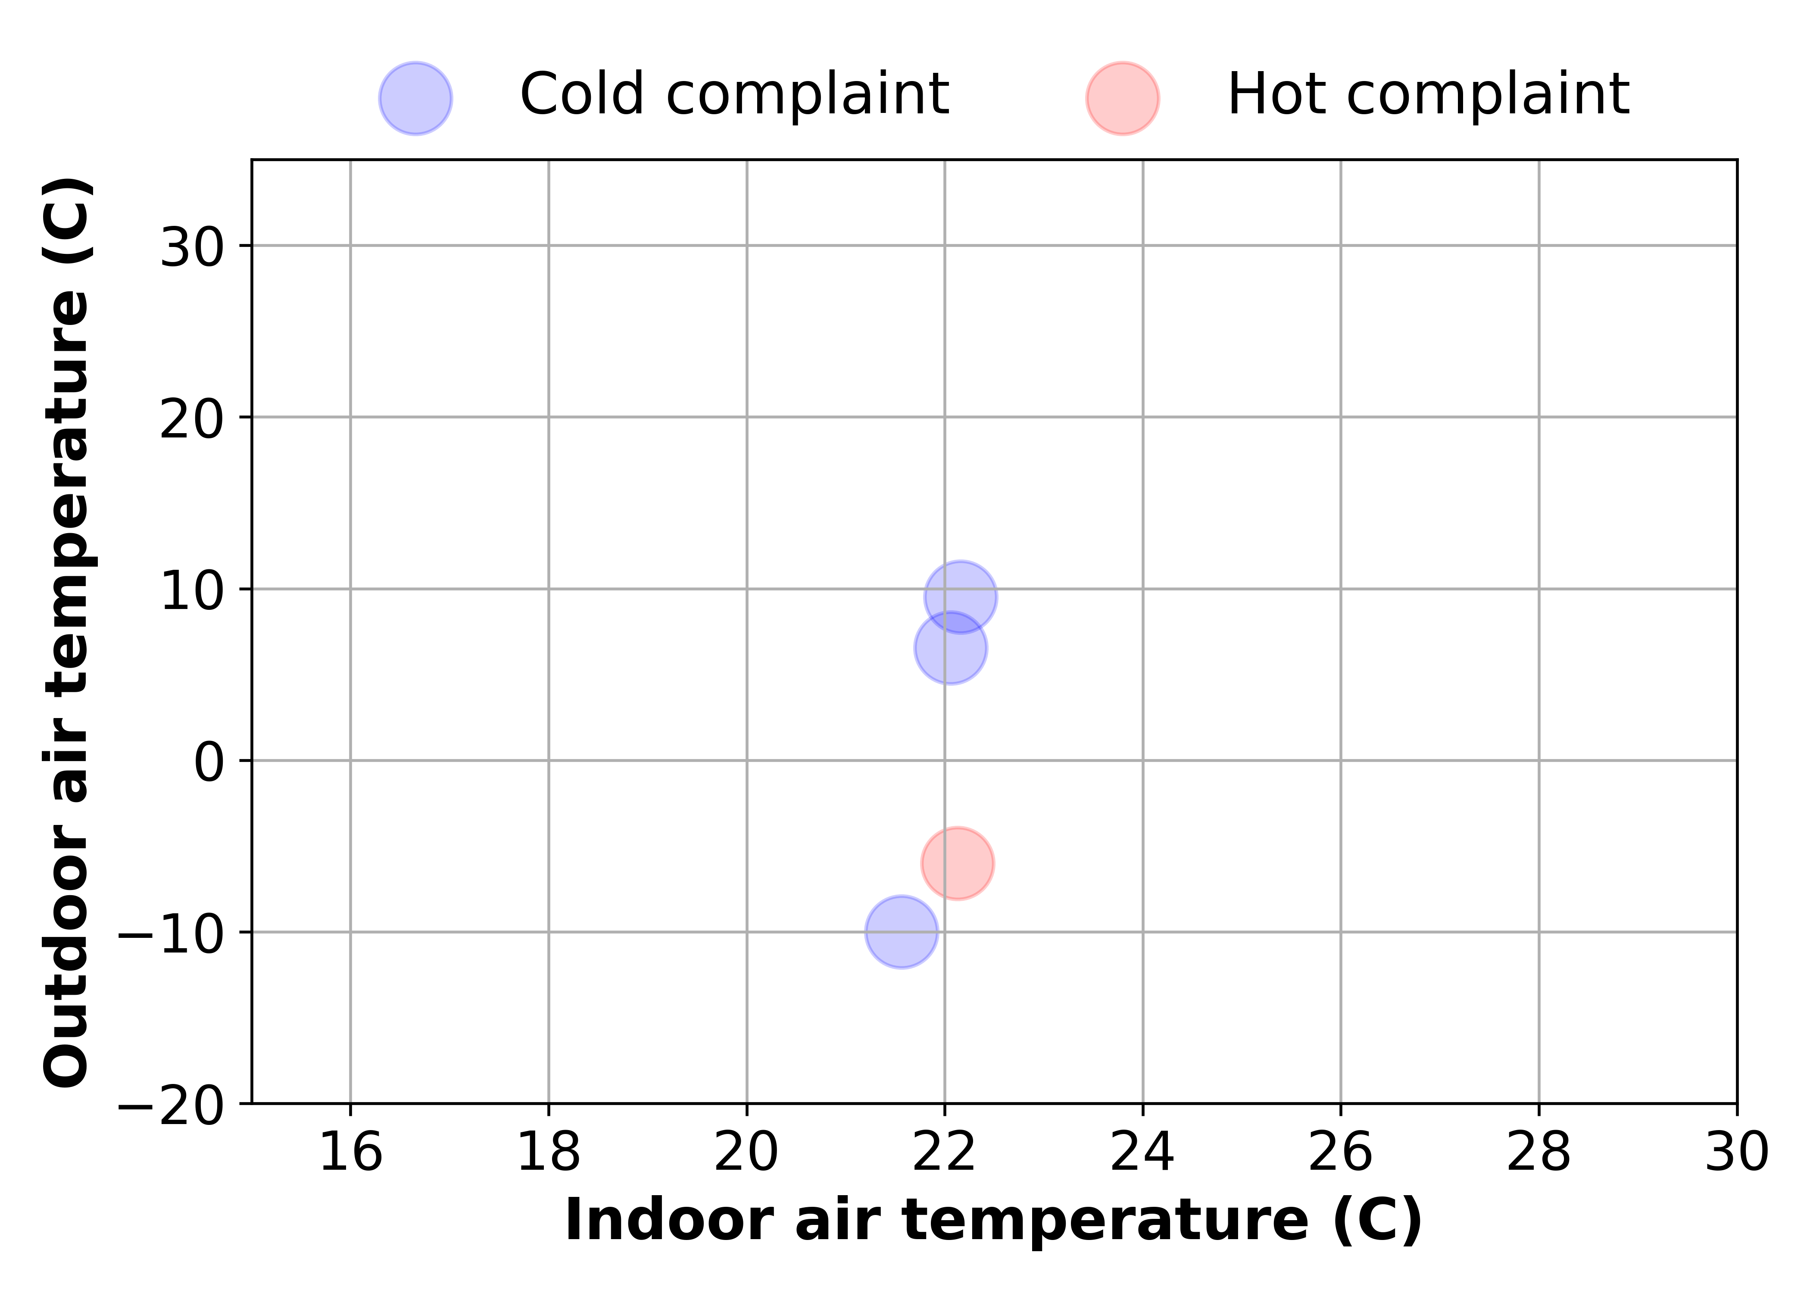

# Predicted proportion of complaints

The third visualization predicts the proportion of complaints that would be made with respect to certain conditions in time of day, day of the week, and outdoor air temperatures. The decision tree diagram can be interpreted whereby boxes branching to the left represent the predicted proportion of complaints when the condition in the preceding box is satisfied. For example, if a box with the condition, 'Hour of the day <= 10' has a left node with 40% and a right node with 60%, it is predicted that 40% of all complaints made will occur before 10 am. The condition is displayed at the top of the box and the predicted proportion of displayed at the center of each box between the 0.0s.

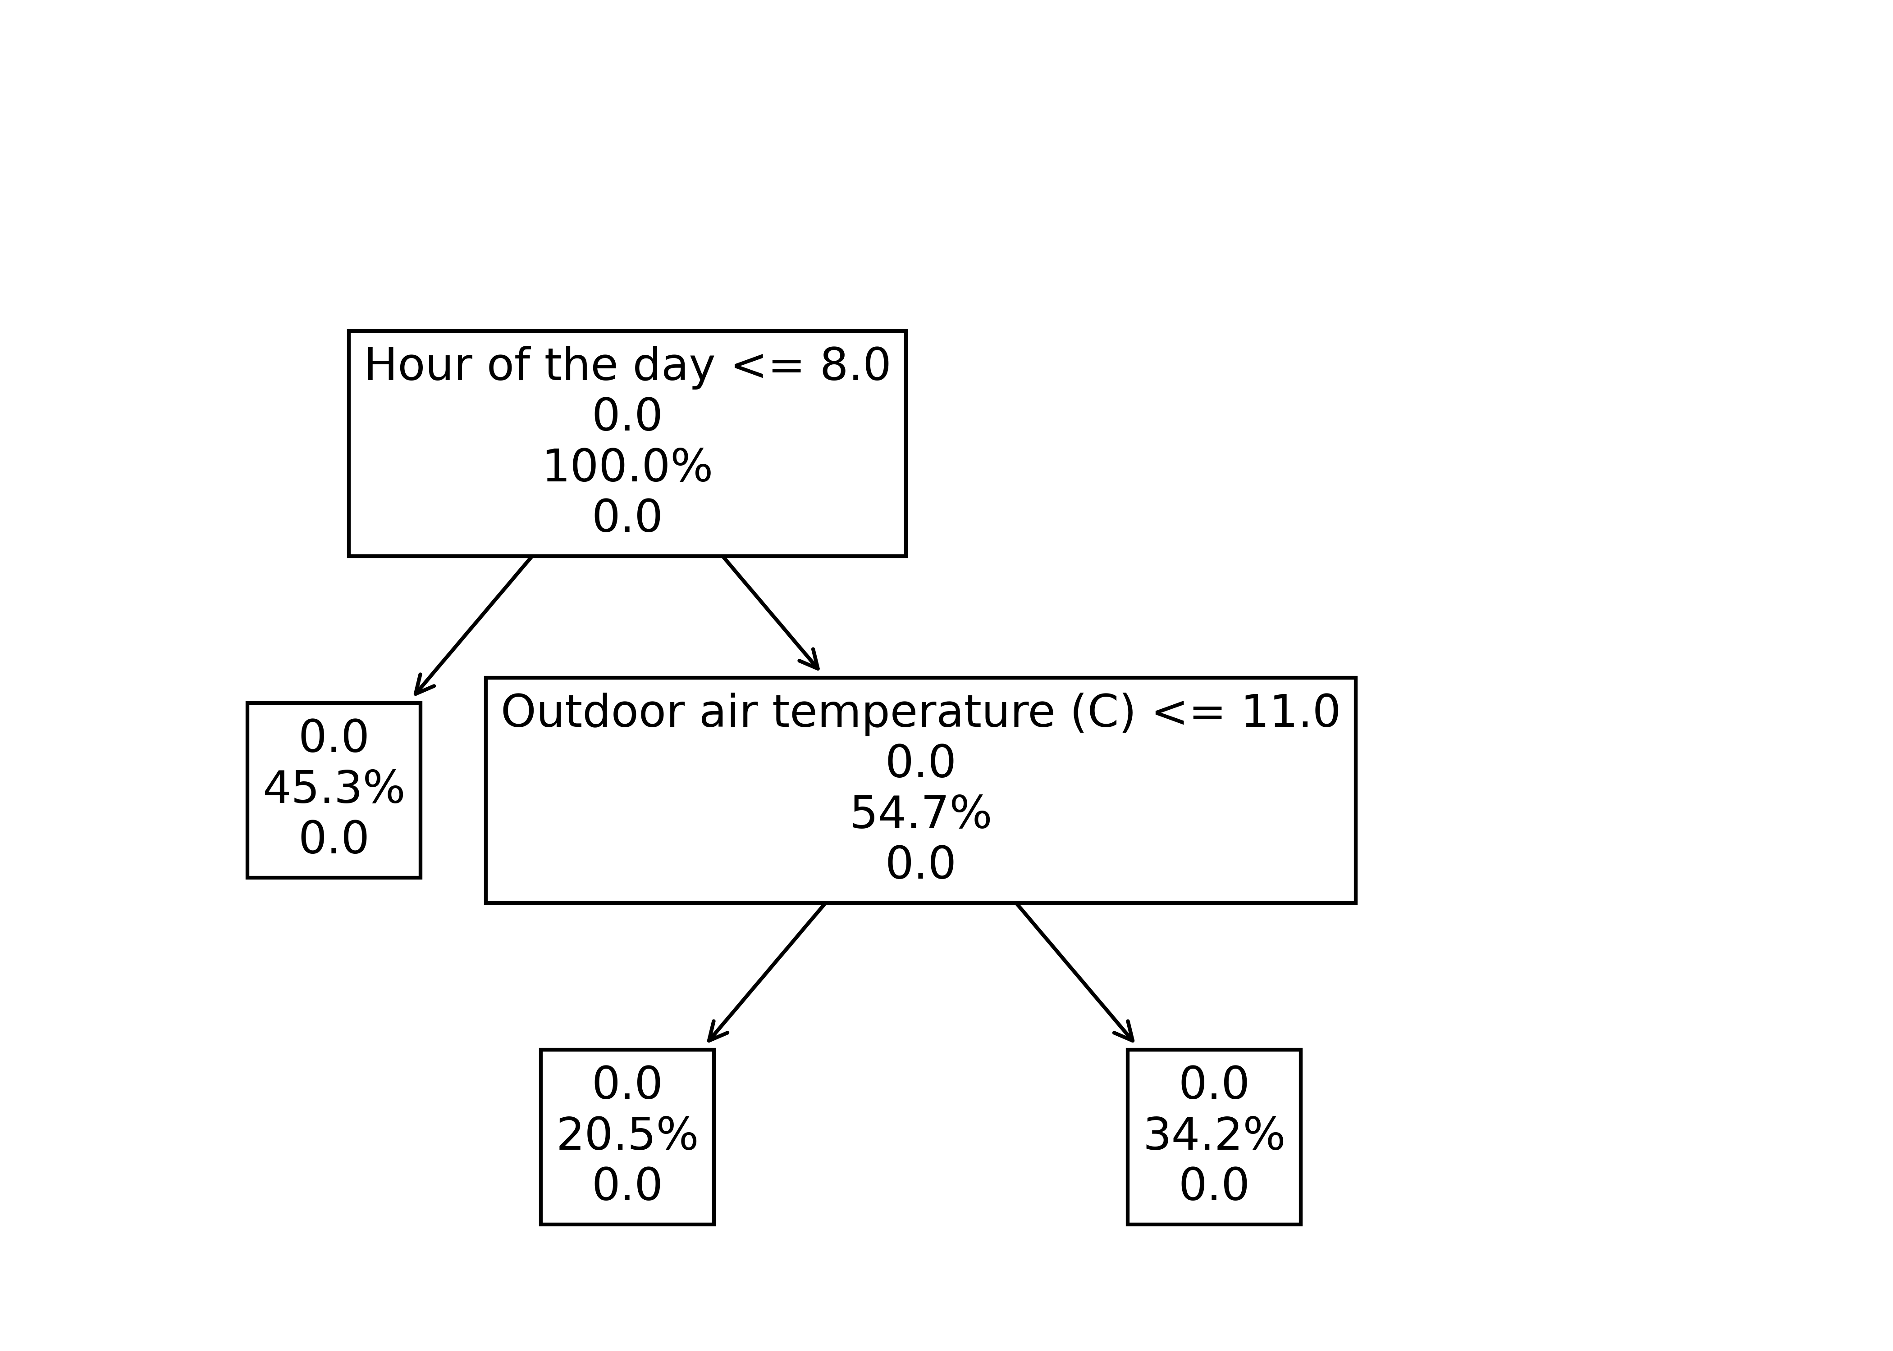

# Key performance Indicators

This section presents the generated KPIs - **daily frequency of hot and cold complaints in the heating and cooling season.** Higher frequencies indicate a higher rate of occurence of a type of complaint for the particular season.

## Daily frequencies of hot/cold occupant complaints

|  |  |  |
| --- | --- | --- |
| Type of complaint | Daily frequency for heating season (complaints per day) | Daily frequency for cooling season (complaints per day) |
| Hot complaint | 0.001254363205345976 | 0 |
| Cold complaint | 0.003763089616037929 | 0 |