Occupancy - Analysis Report

The occupant complaints function determines the **daily frequency of hot/cold-related occupant complaints.** This function can be used to assess the effects of temperature setpoint or schedule adjustments on building occupants. The visuals depict the distribution of complaints by month and by the period of the day, the relationship between the complaints and indoor and outdoor air temperature, and the predicted proportion of the complaints based on time of day, day of the week, and outdoor air temperature. More information is available at the respective sections.

# Visuals - Occupant complaints breakdown

This set of visuals categorizes the complaints by the type of complaint (hot or cold related), and counts the number of complaints by the month and period of the day the complaint was registered.

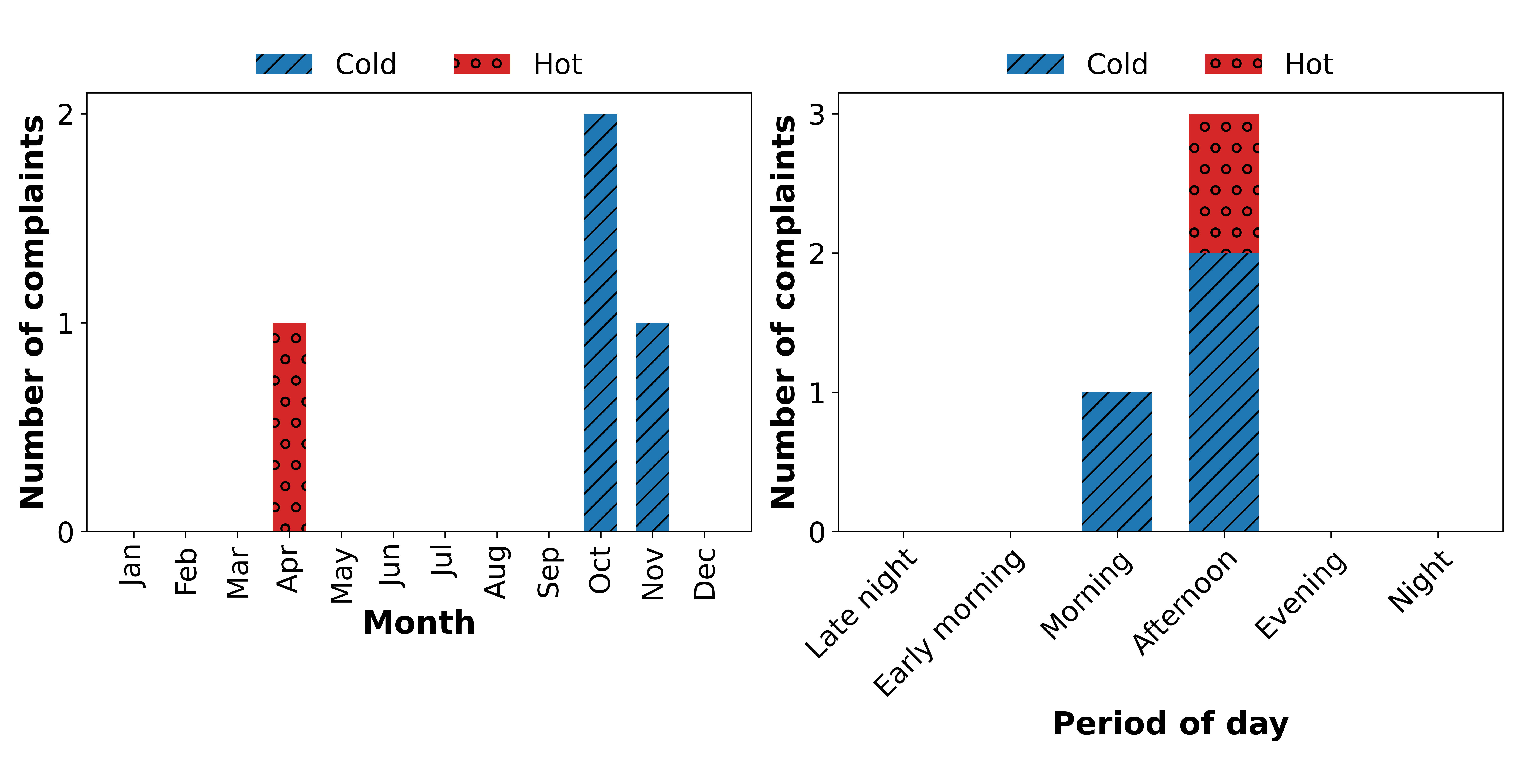

# Visuals - Indoor and outdoor air temperature

This visual plots the relationship between a hot/cold complaint and the indoor and outdoor air temperature at the time the complaint was registered.

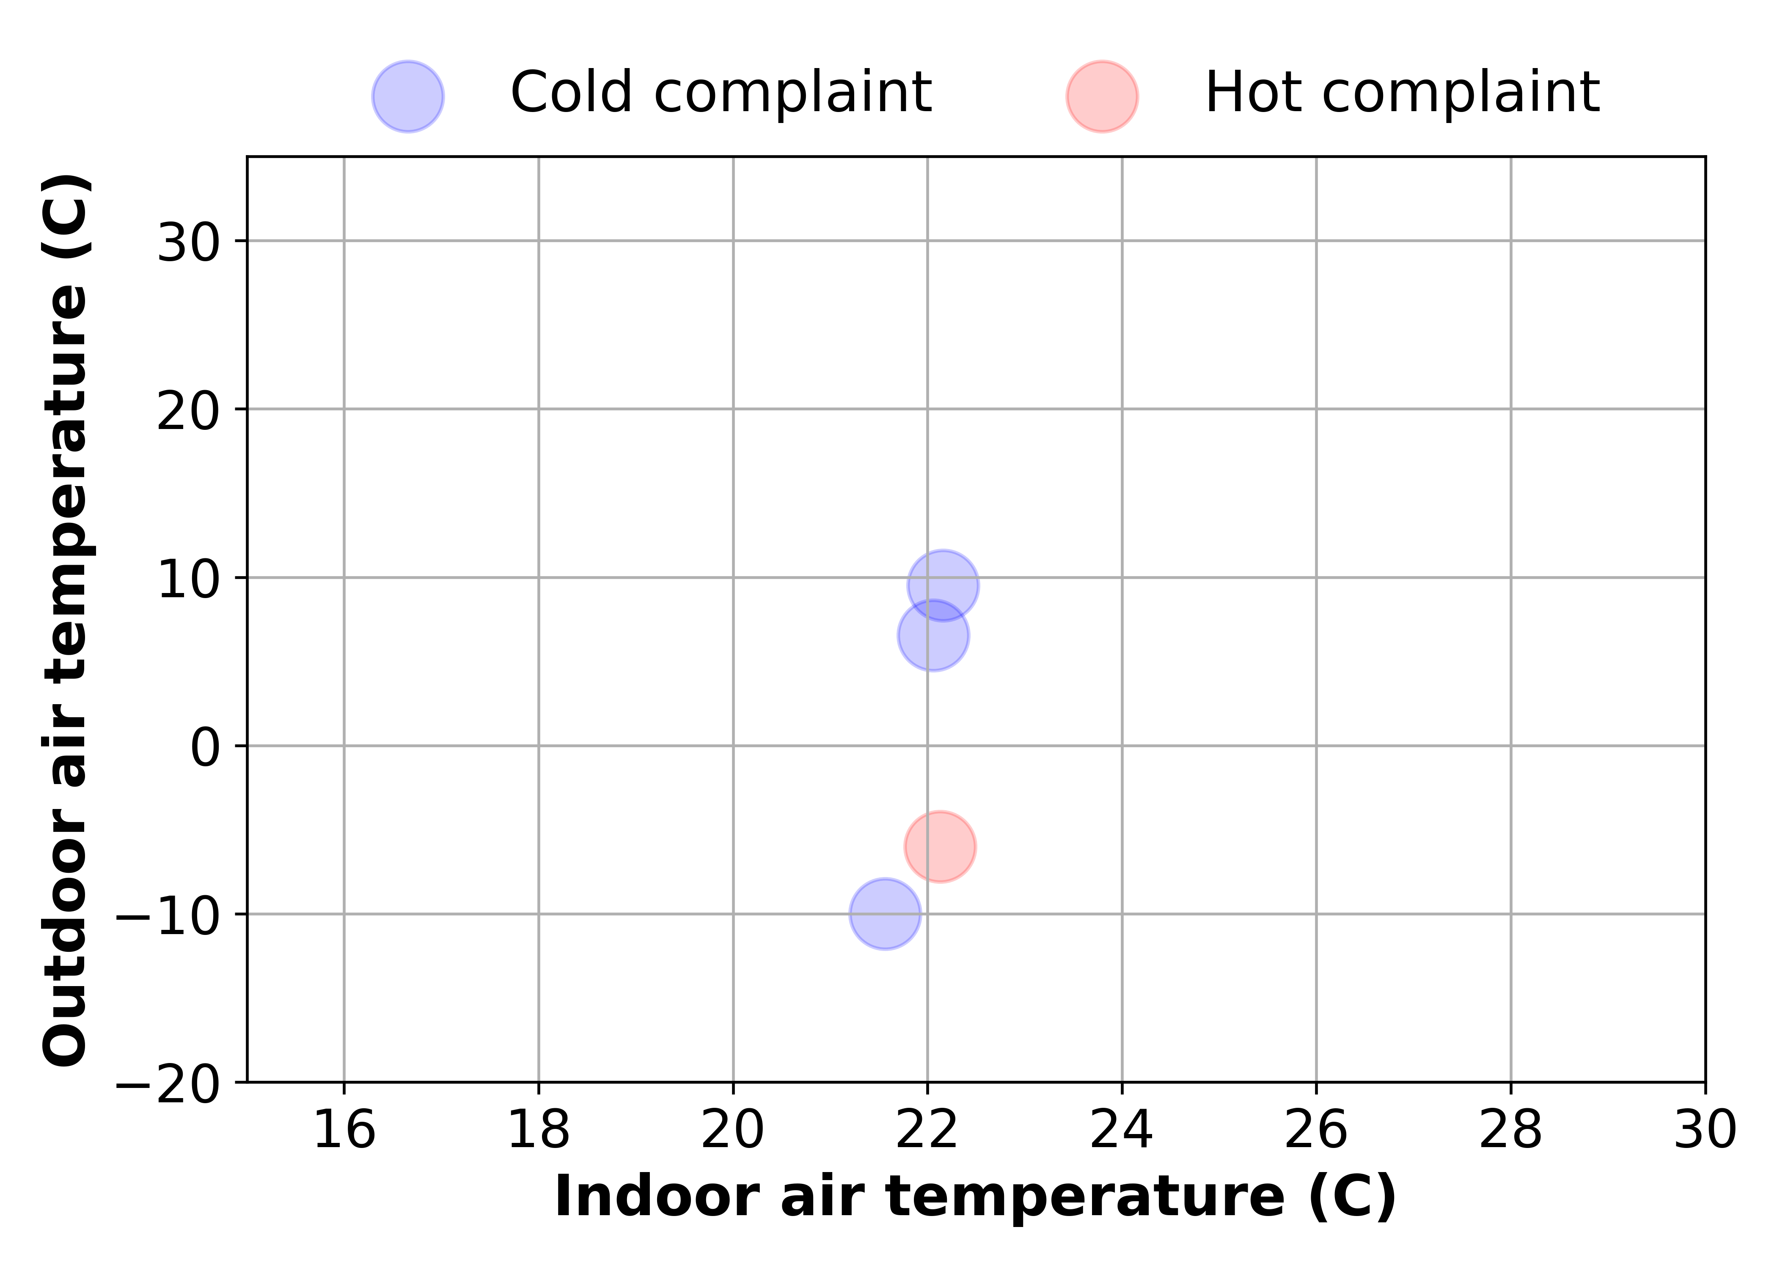

# Visuals - Predicted proportion of complaints

This visual predicts the proportion of complaints that would be made with respect to certain conditions. The boxes which branch to the left represent the predicted proportion of complaints when the condition in the preceding box is satisfied. For example, if a box with the condition, 'Hour of the day <= 10' has a left branch with 40% and a right branch with 60%, it is predicted that 40% of all complaints made will occur before 10 am. The condition is displayed at the top of the box, and the predicted proportion is displayed at the center of each box between the 0.0s.

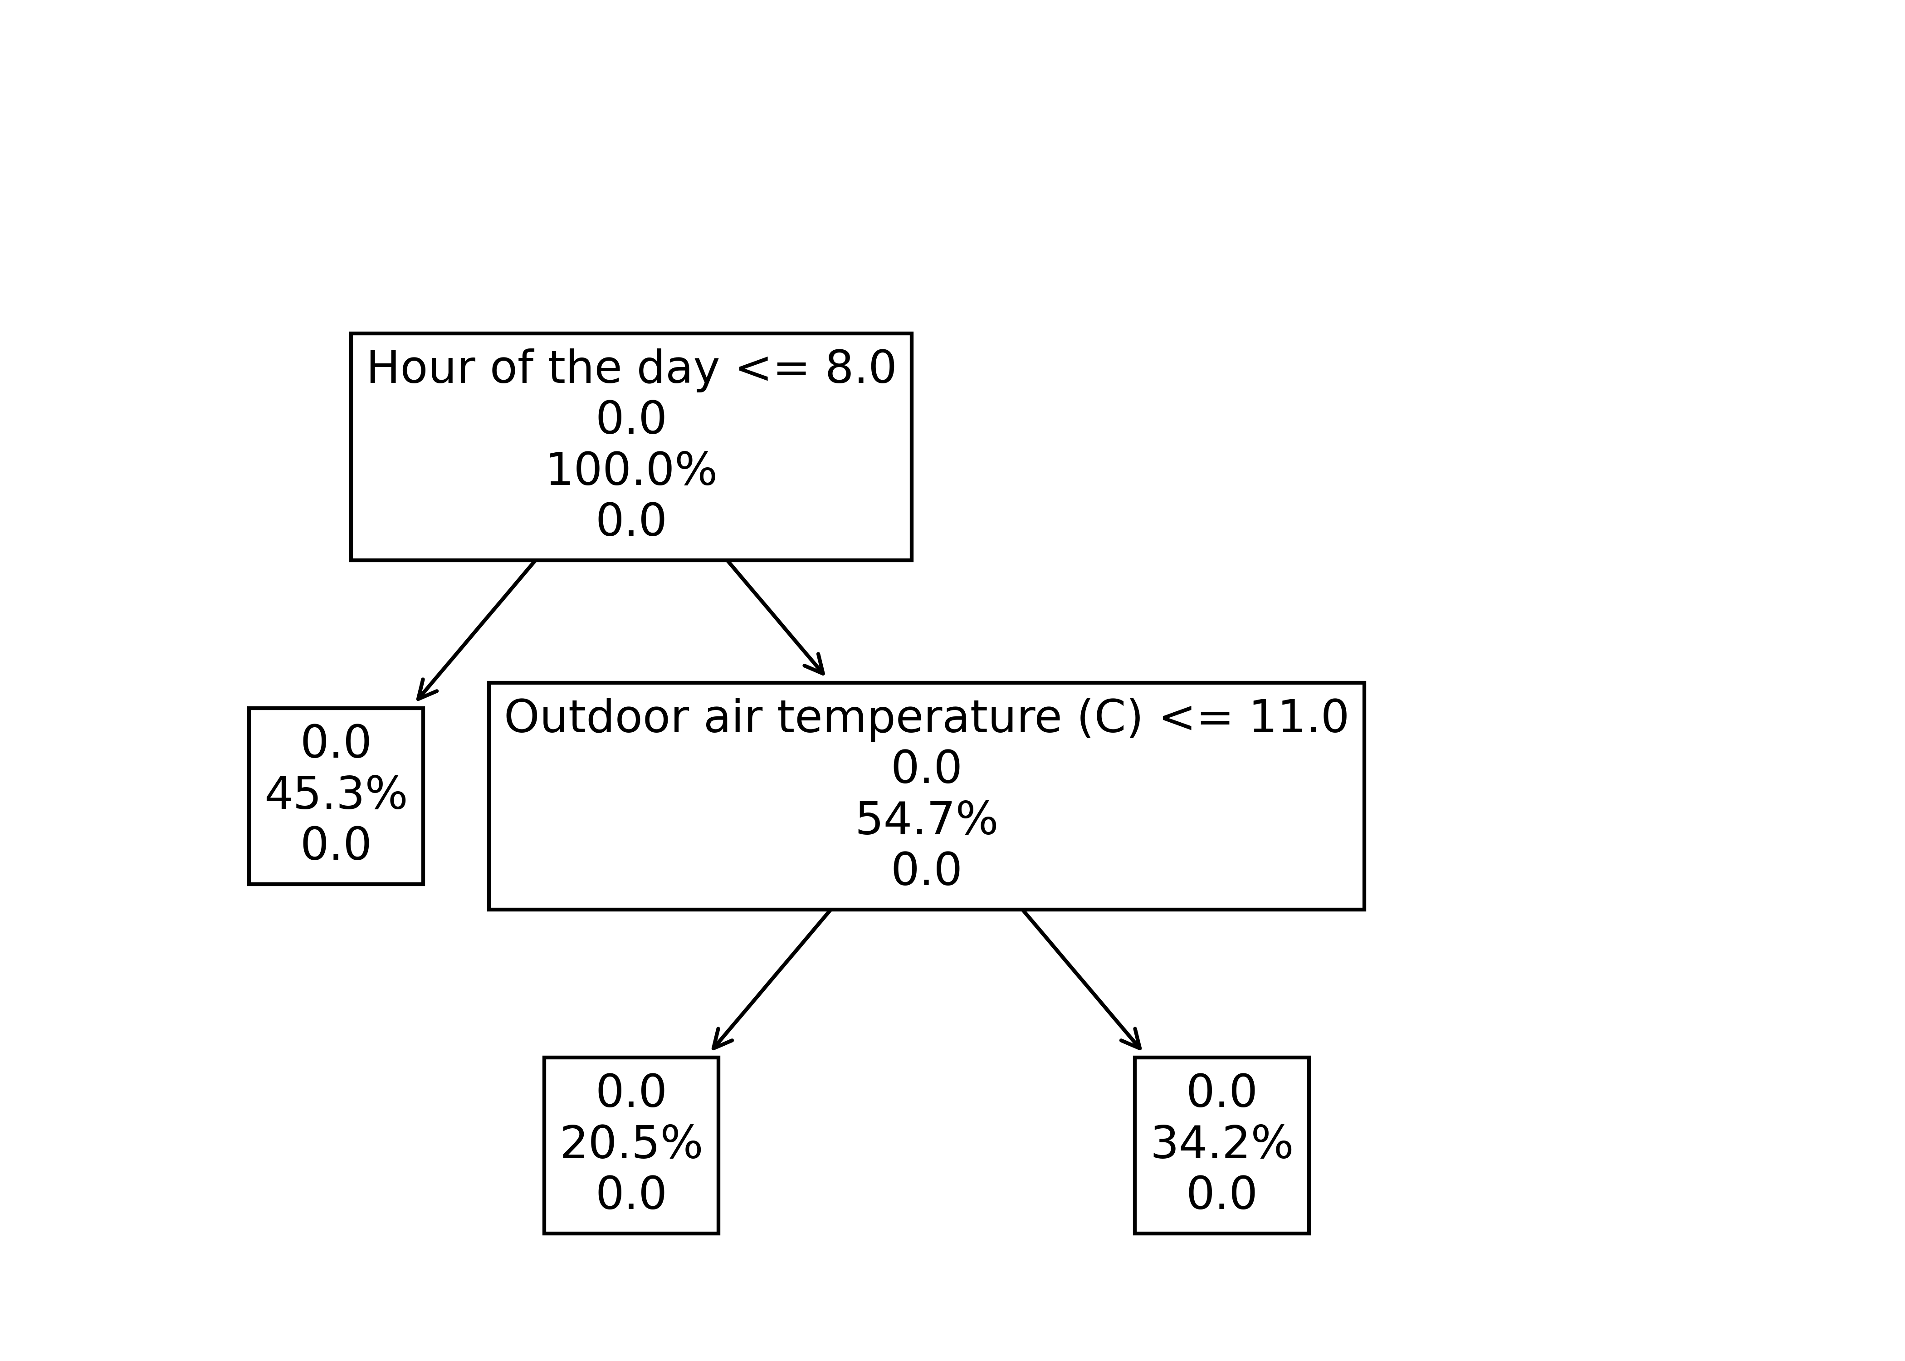

# Key performance Indicators

This section presents the generated KPIs - **daily frequency of hot and cold complaints in the heating and cooling season.** The values represent the number of complaints made per day. Higher frequencies indicate a higher rate of occurence of a type of complaint for the particular season.

## Daily frequencies of hot/cold occupant complaints

|  |  |  |
| --- | --- | --- |
| Type of complaint | Daily frequency for heating season (complaints per day) | Daily frequency for cooling season (complaints per day) |
| Hot complaint | 0.001 | 0.0 |
| Cold complaint | 0.004 | 0.0 |