APPENDIX - LEVER ARM DYNAMICS

Lever Arm Dynamics

The following equations are used to compute the applied lever Arm Offset, Rate, and Acceleration effects.

Lever Arm Equations

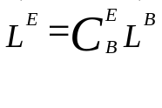
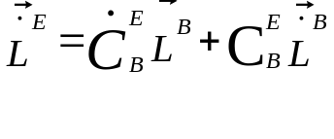
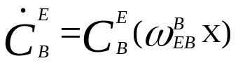
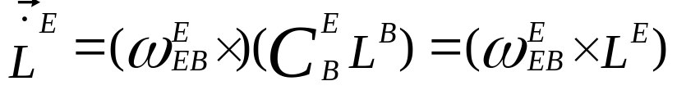
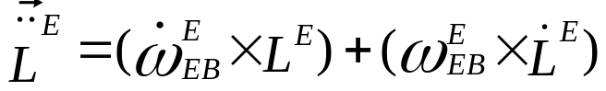
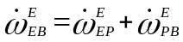
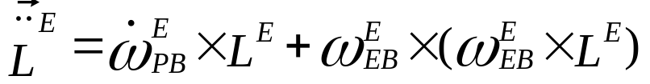
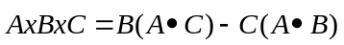
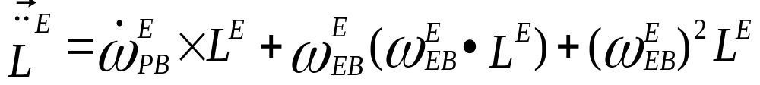
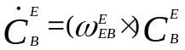
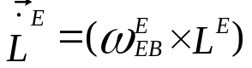
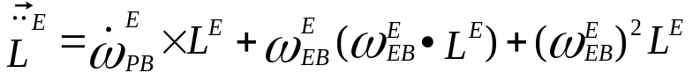
0
SMALL ~ a/Re
P = Platform frame (local level tangent frame) computed

