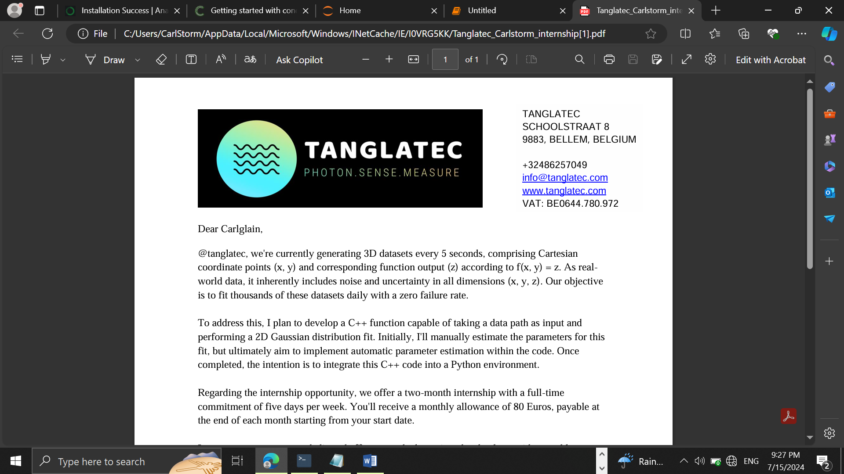

TANGLATEC SCHOOLSTRAAT 8 9883, BELLEM, BELGIUM +32486257049 info@tanglatec.com www.tanglatec.com VAT: BE0644.780.972

**7/15/2024**

**Daily Progress report**

Presented by **Nyuysemo Calglain Nyuykidzem**

**Week 1 task (aim):** with the provided data set create a model that will plot the two D data in python

**Day 1:**  Task identification and environmental set-up

**Introduction**

Machine learning generally is classified into; supervised learning (labeled data), unsupervised learning (unlabeled data) and Reinforced learning.

The data provided enables us to determine which machine learning technique to use. If the provided data has the input and expected output we are dealing with labeled data and if we only have inputs we are dealing with unlabeled data (unsupervised learning).

**Procedure**

the provided data had both the input and the expected data hence it’s a supervised learning problem and since the output is voltage it’s continues data hence a type of **supervised learning called regression.**

**Environmental set-up:**

To set-up the environment to perform the task above I downloaded and installed anaconda then lunched it and created a new environment using the command

conda create --name carlstorm.

I then installed Jupiter notebook, pandas,numpy matplotlib,Scikit-learn using the command

conda install nameOfApp.

I then imported the installed extensions in the jupyter notebook.

**Difficulties:**

was unable to import the dataset due to it’s nature and hence will look for a way to separate the X input from the expected output Y.