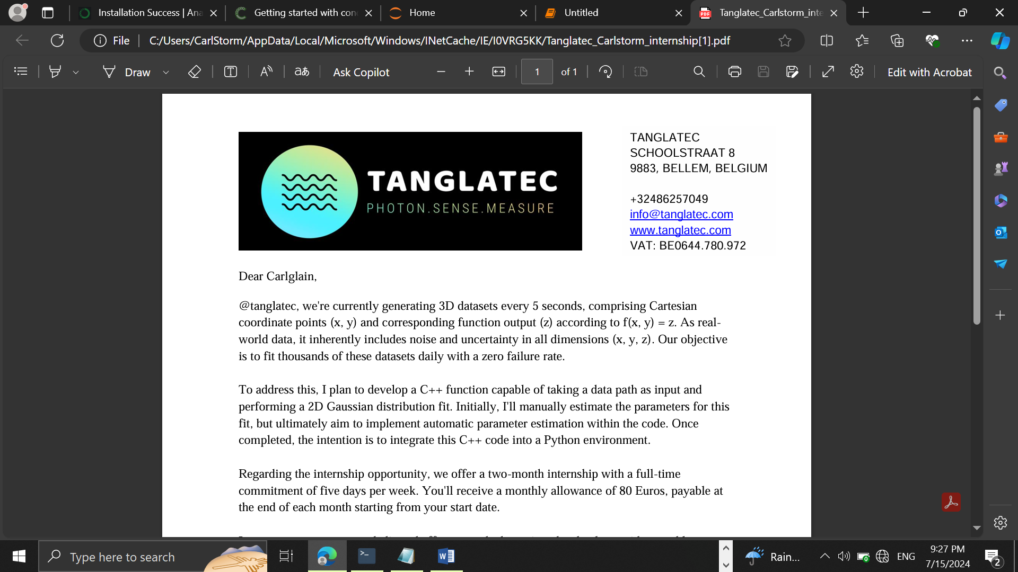

TANGLATEC SCHOOLSTRAAT 8 9883, BELLEM, BELGIUM +32486257049 info@tanglatec.com www.tanglatec.com VAT: BE0644.780.972

**7/16/2024**

**Daily Progress report(day2)**

Presented by **Nyuysemo Calglain Nyuykidzem**

**Week 1 task (aim):** with the provided data set create a model that will plot the two D data in python

**Day 2:**  Data format conversion and upload to jupyter notebook

**Achievements**

After research and studies, I discovered how to upload the data that was given in word (.docx) format to my **jupyter notebook**.

**Procedure**: I simply need to open the word document copy the data paste in Notepad and while saving it I choose all formats then write the name of the file with a “.tsv” extension. I could also use “.csv” extension if I want.

**Difficulties**

Due to poor internet connection here I was unable to lunch my work space and upload my data but I studied the material I need to achieve the weekly target and will still continue tomorrow. I’ll have to wake up at midnight when the connection is faster in order to install and continue working with the project.   
below is a proof of the above difficulty

**Screenshot:**

