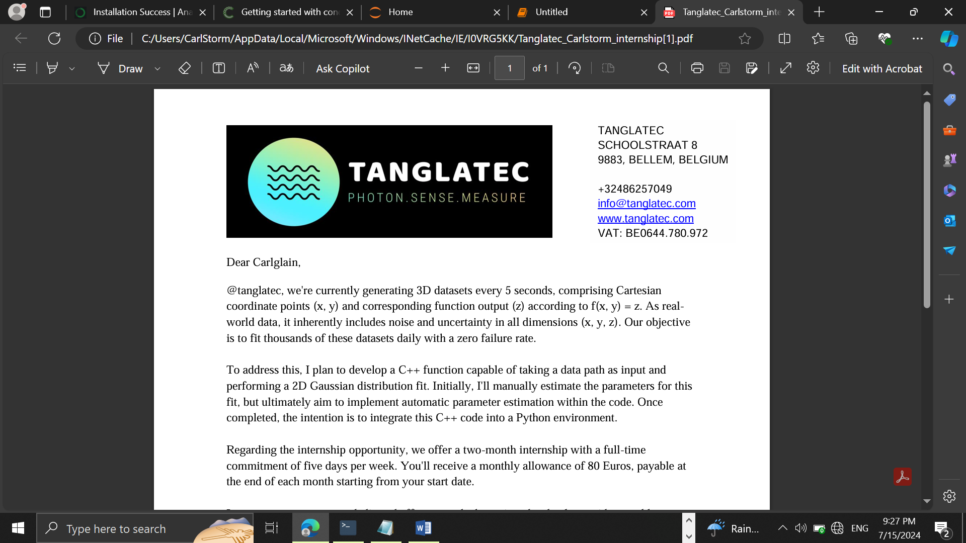

TANGLATEC SCHOOLSTRAAT 8 9883, BELLEM, BELGIUM +32486257049 info@tanglatec.com www.tanglatec.com VAT: BE0644.780.972

**7/17/2024**

Presented by **Nyuysemo Calglain Nyuykidzem**

Daily Progress report(day3)

Contents

1. Week 1 task (aim) 1

2. Day 3: 1

3. Achievements 1

Procedure: 1

Screenshot: 1

1. Week 1 task (aim)**:** with the provided data set create a model that will plot the two D data in python
2. Day 3: Data upload to jupyter notebook, importation of libraries and display of data.
3. Achievements

After studies today, I was able to upload my data to jupyter notebook, import the necessary libraries and used pandas to display data in a tabular format.

Procedure: Before using pandas, I used numpy to load data from the datasheet document then derived the x and y components from the uploaded data. this implementation can be seen on the screenshot below.

Screenshots:

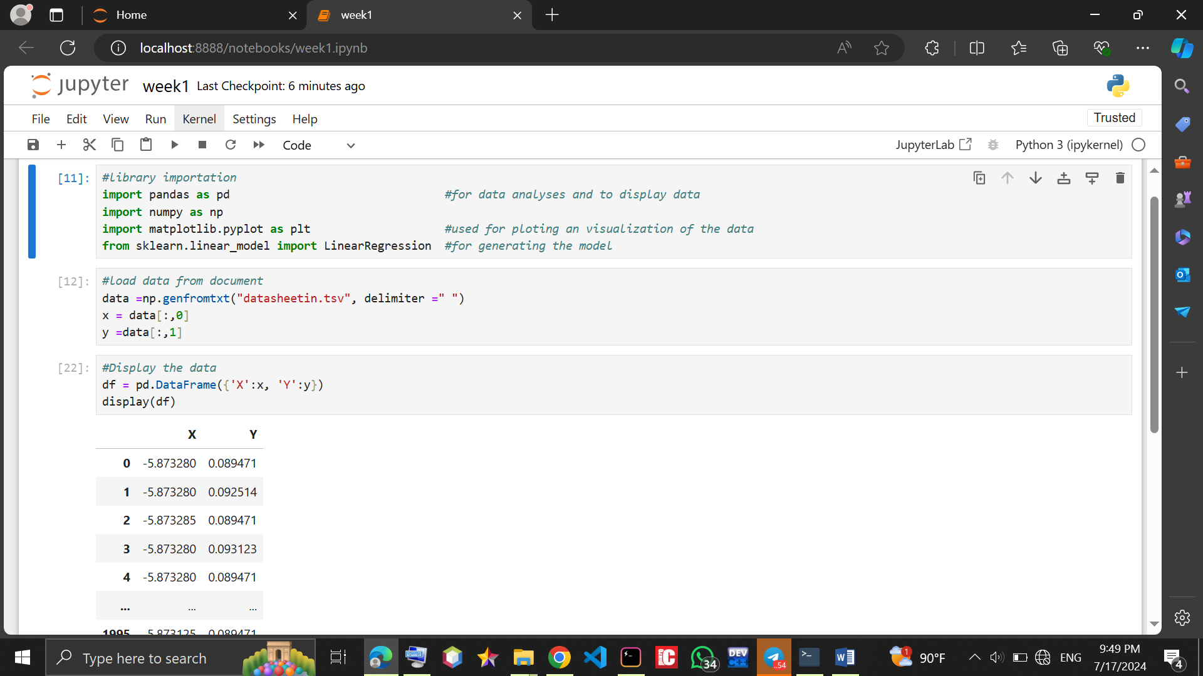

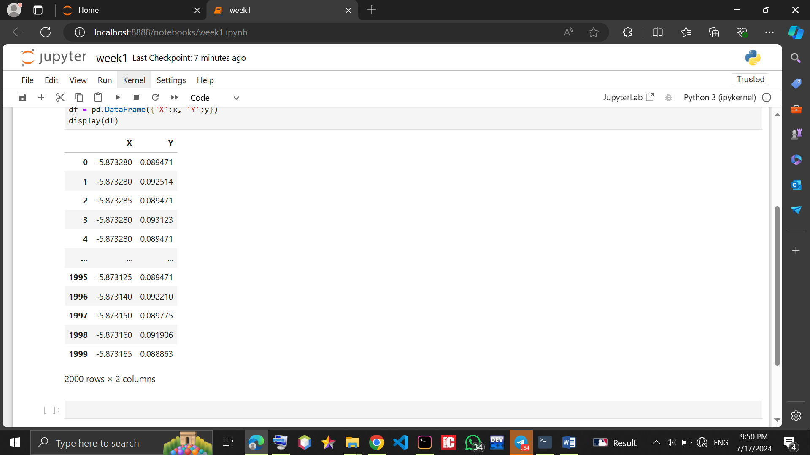

**I did the project in a folder called week1projectworking and uploaded it to my github account.**