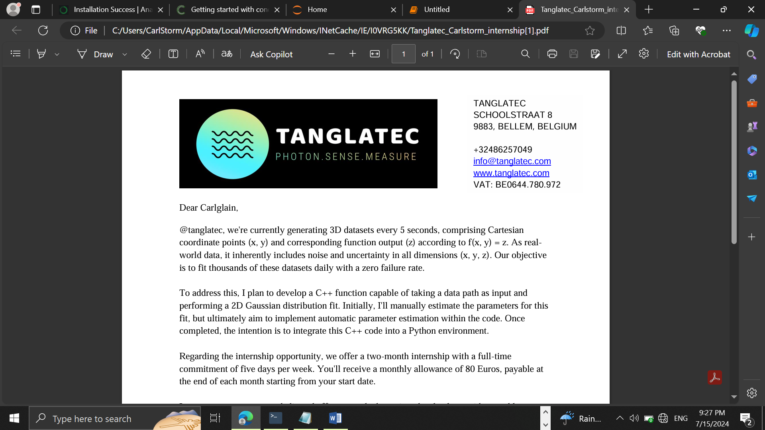

TANGLATEC SCHOOLSTRAAT 8 9883, BELLEM, BELGIUM +32486257049 info@tanglatec.com www.tanglatec.com VAT: BE0644.780.972

**7/18/2024**

Presented by **Nyuysemo Calglain Nyuykidzem**

Daily Progress report(day4)

Contents

1. Week 1 task (aim) 1

2. Day 4: 1

3. Achievements 1

Procedure: 1

Screenshot: 2

1. Week 1 task (aim)**:** with the provided data set create a model that will plot the two D data in python
2. Day 4: Data upload to jupyter notebook, importation of libraries and display of data.
3. Achievements

Today I was able to learn and implement data description and basic data analysis and also did a scattered and a histogram plot of the problem.

Procedure

From where we ended yesterday I went forward to use the pandas describe function which displays the mean, standard deviation, min and max values of the datasheet. I also used sklearn.pyplot(plt) to visualize the data graphically as seen In the screenshots below

Screenshots:

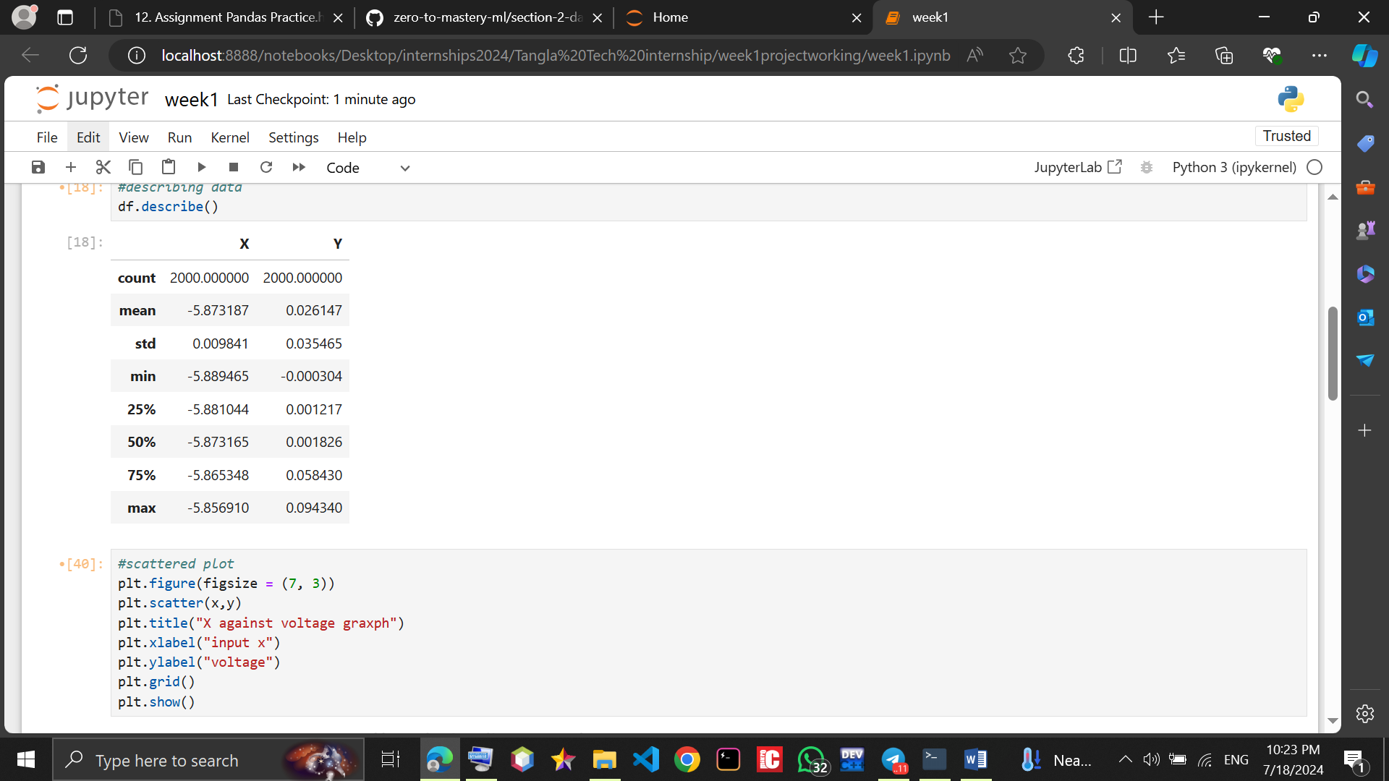

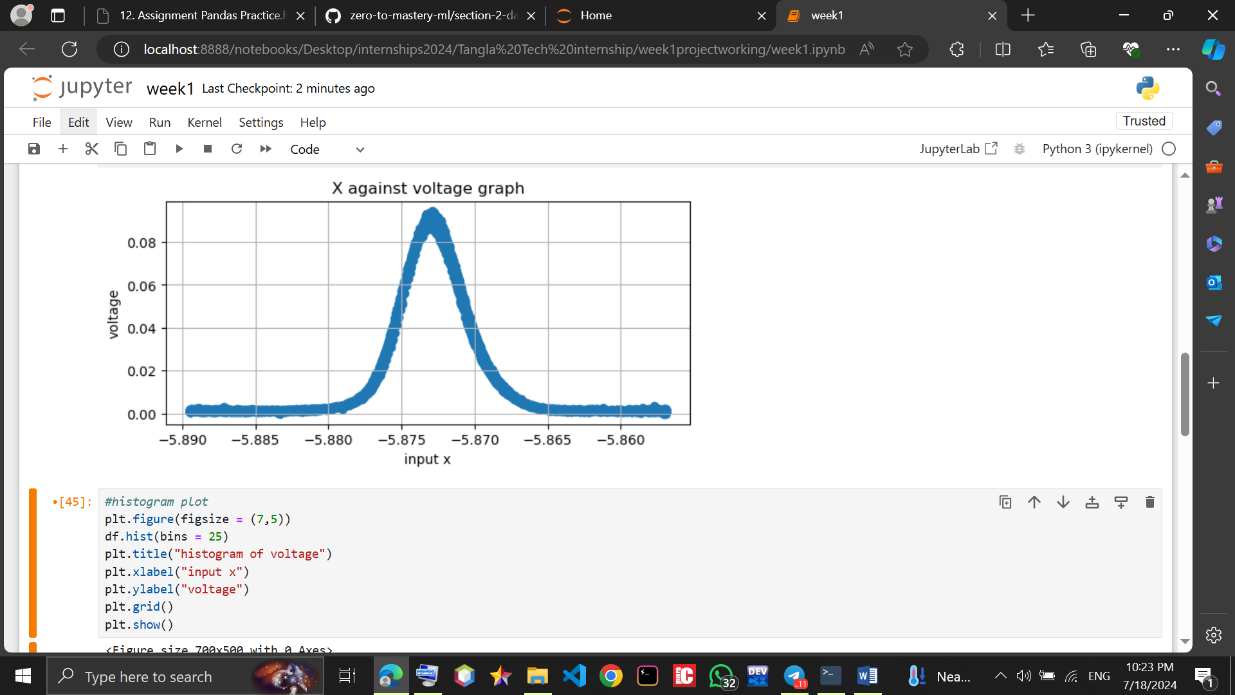

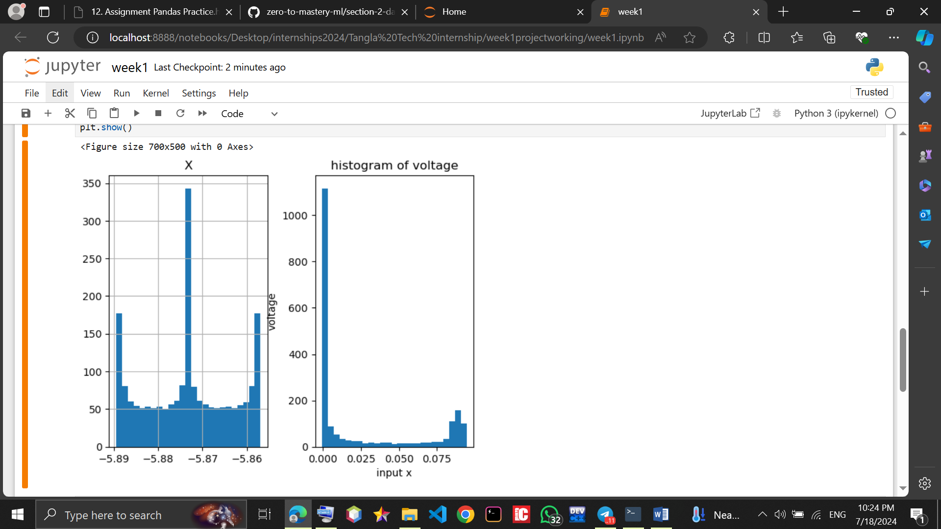

**I uploaded it to my GitHub account.**