Carli McAvoy
11/22/25
Module 6.2 Assignment

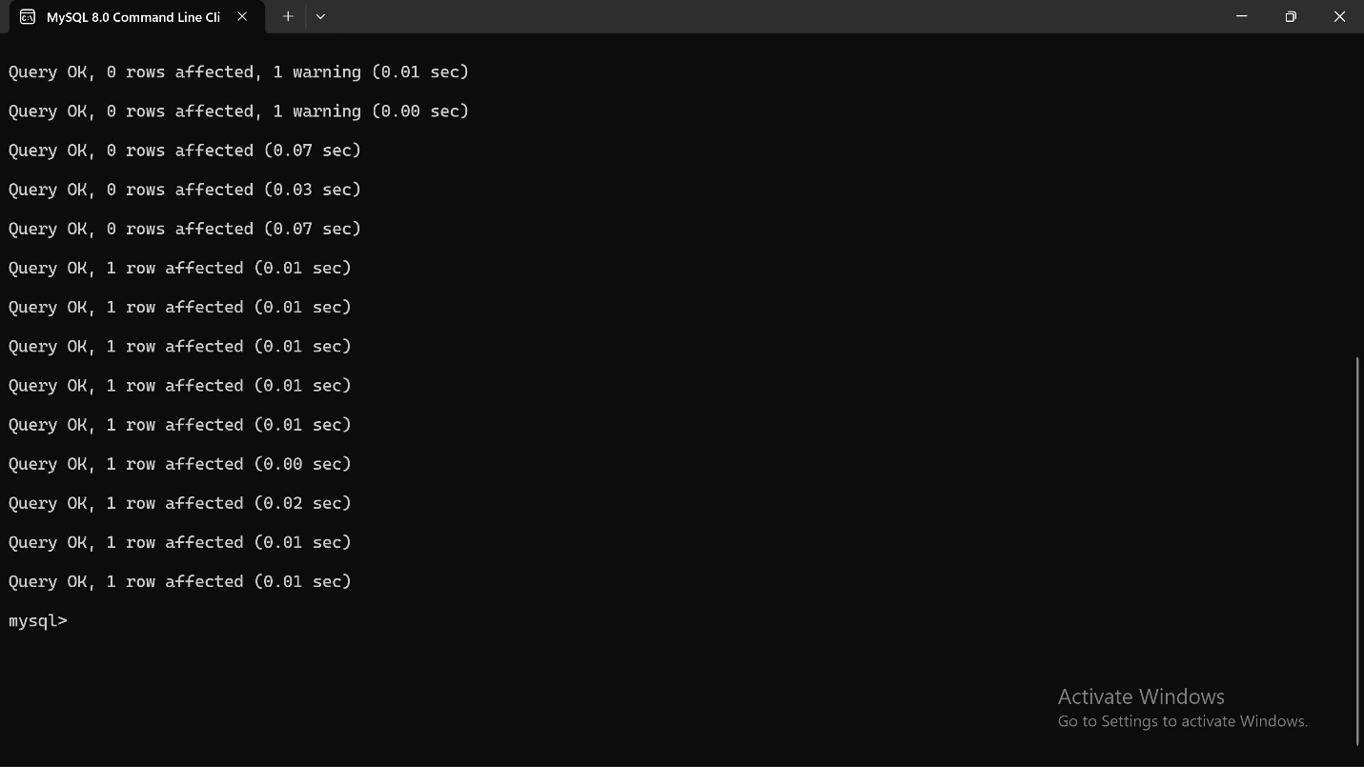
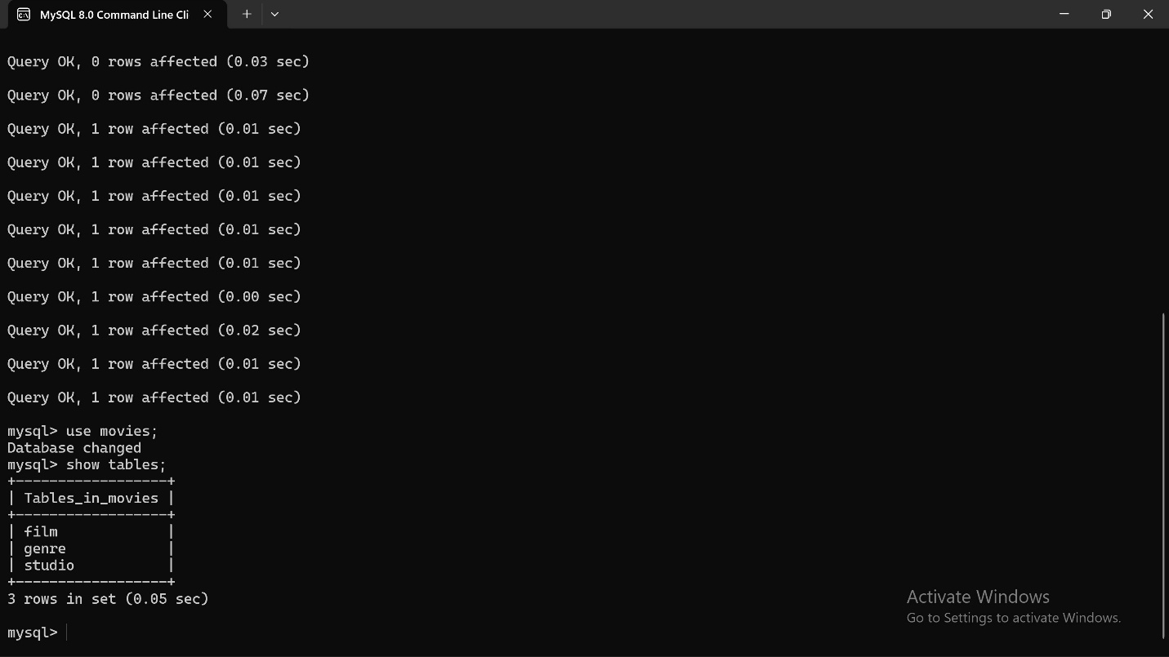
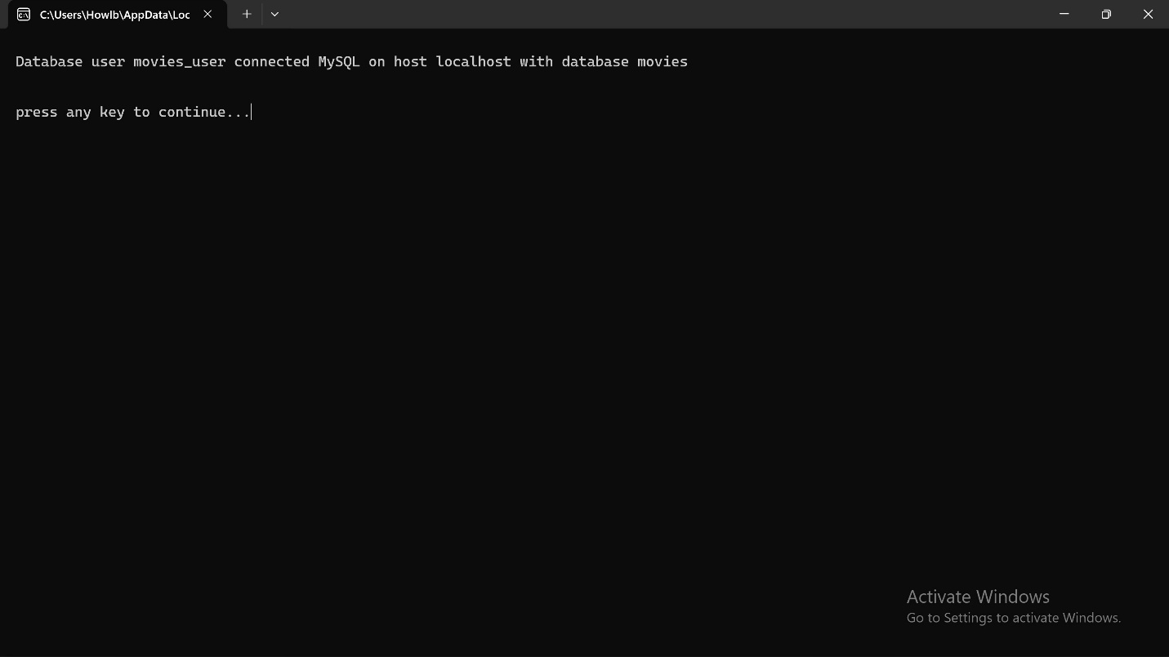

Github repository: https://github.com/CarliMcAvoy/csd-310.git

