Carli McAvoy
11/16/2025
Module 5.2
MySQL Functions
- The CREATE TABLE function in mysql is used to create new tables in a database. This function is used to organize data into sections. Here is an example of creating a table for specific book information in a database named “library”:
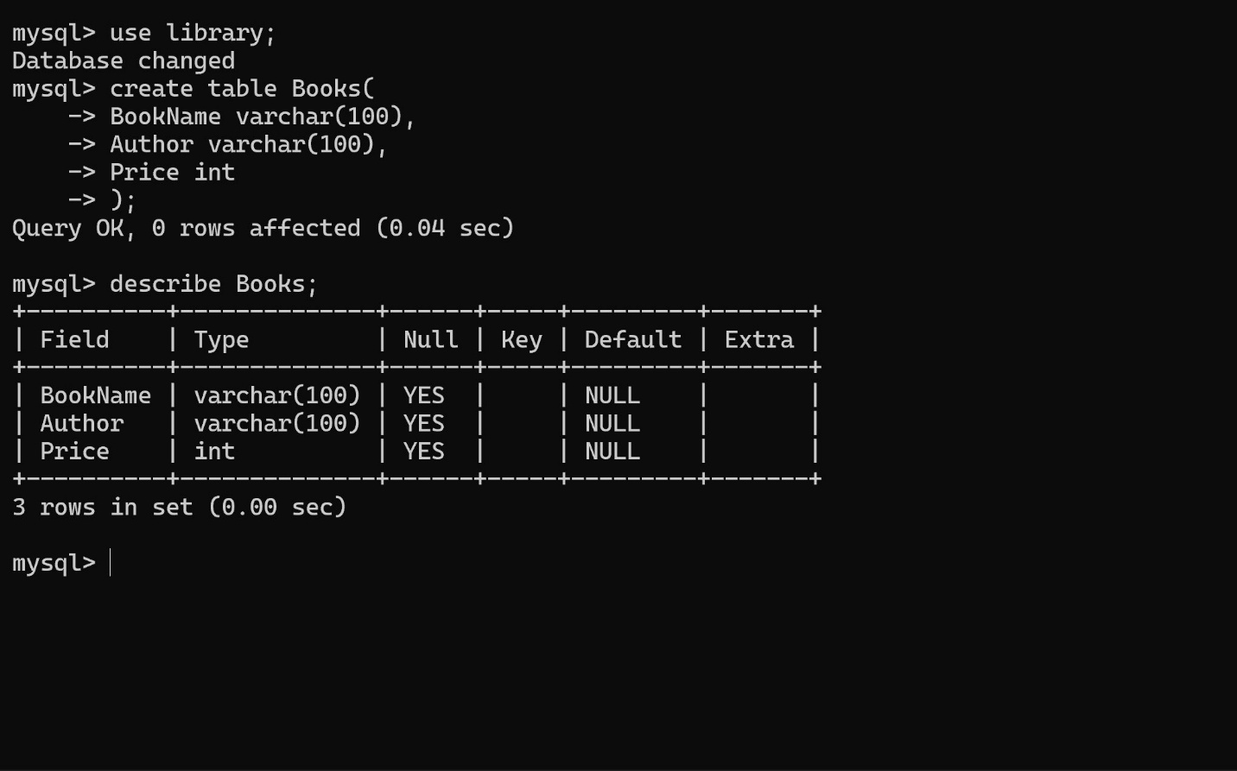
- The INSERT INTO function is used to put new records in a table. This function is needed to organize data into its appropriate sections. Here is an example of adding records to the Books table:
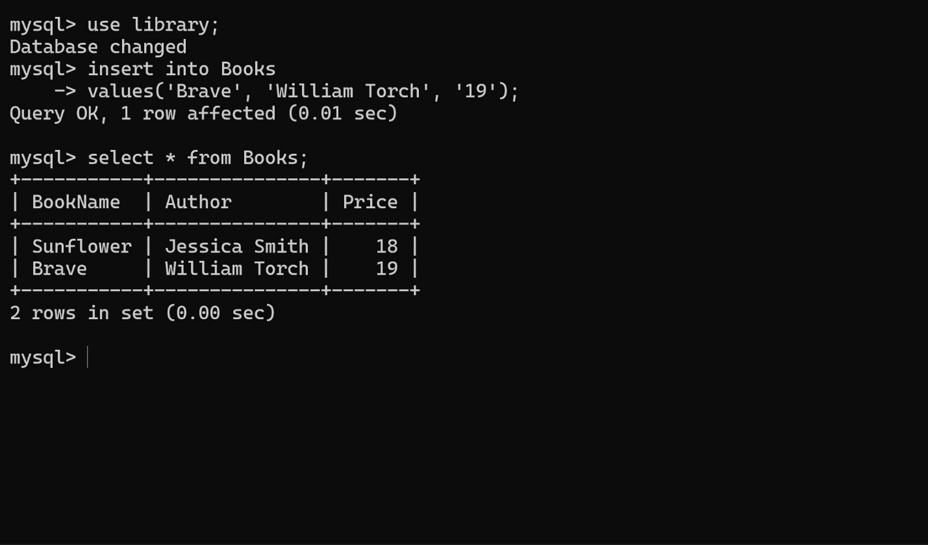
- The UPDATE function is used to alter existing records in a table. This function is crucial to ensuring data remains up to date. Below is an example of updating a book’s price in the Books table:


