Group 2:
Mitchel Cotton
Carli McAvoy
Johnathan Smith
Christopher Villarreal
Milestone #2
Finished ERD:
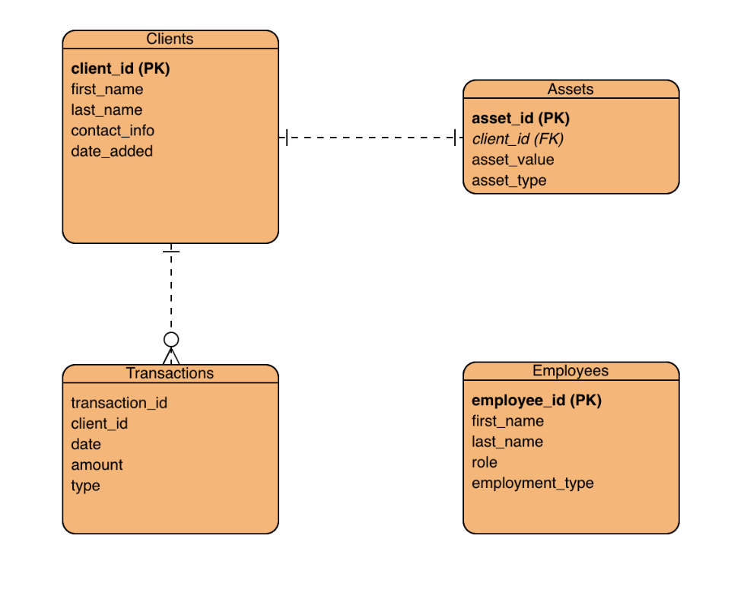

Displayed Tables:
